UDC 911.91.9
INVESTIGATION OF THE FEATURES OF TRANSPORTATION OF SOIL COVER DURING THE EXAMPLE OF NOVOTROITISK REGION AND AZOV-SIVAS NATIONAL NATURE PARK UNDER THE INFLUENCE OF NATURAL AND ANTROPOGENIC FACTORS
I.S. Polova, assistant
Email: polevayaira95@gmail.com
S.V. Fokina, assistant
Email: sfokina19862013@gmail.com
State higher education institution «Kherson state agricultural university»
Abstract. The article deals with the peculiarities of the transformation of the Prisivashshya soil on the example of a comparative analysis of soil transformation in the Novotroitsky region and the Azov-Sivash National Natural Park under the influence of natural and anthropogenic factors.
Soils of the Northern Prisivashia, namely the Novotroitsky area, undergo significant transformations caused by human activity, quickly lose their positive properties in the case of inappropriate agricultural use.
Long-term use of soils in arable land and, in particular, their reclamation (ameliorative plowing, irrigation by waters of different quality) cause the existence of soil processes that are different from those existing in the natural environment and are currently under-studied. In modern conditions of land use exact information on the qualitative state of saline soils is necessary for monitoring and rational agricultural use, in connection with which the research issues acquire special scientific and practical significance.
On the basis of the comparative analysis, the differences between soils of agricultural use and the soils that are in the natural state within the protected areas are determined. It is proved that the soils of the protected area in comparison with the soil cover of the Novotroitsky district will not undergo significant anthropogenic influence. The territory of the Novotroitsky district is characterized by large scale devastation of agricultural land.
Key words: Azov-Syvash national natural park, soil cover, agro-transformed soils, reclamation, natural and anthropogenic factors.
Topicality.
The urgency of the comparative analysis of soil transformation of the Novotroitsky region and the Azov-Syvash National Natural Park is due to the fact that the soil cover of the region of the study undergoes significant transformations as a result of anthropogenic activity. As a result, secondary soil salinization, wind erosion, and decrease in the content of humus occur in this territory, which in turn leads to a decrease in soil fertility in the region.
The long-term use of saline soils in arable land, and in particular their reclamation, causes the appearance of soil processes that are different from those existing in the natural environment and are currently under-studied. That is why, on the basis of the comparative analysis, we need to find out the differences between soils of agricultural use and soils that are in the natural state within the protected areas. It is also important to determine the causes and consequences of changes in soil-forming processes.
Analysis of recent research and publications.
By definition, many soils soil soils belong to the most complex natural formations, so many questions of their genesis and evolution, despite the long history of their research, remain to this day insufficiently studied.
The scientific approach to the development of agro-transformed soils has been described in works by O. M. Mozheyk, G. M. Sambur, S.P. Semenova-Zabrodina, V.D.Muha, M.P.Panova.
In the conditions of land reform and private ownership of land, precise information on the qualitative state of the soil for monitoring and rational agricultural use is required, in this connection the research issues become of special scientific and practical significance.
Therefore, improving the quality of soil requires the analysis of previously obtained data and their use in further research.
The purpose of the research is to determine the patterns of changes in properties and the direction of the evolution of Agro-transformed soils of the Srivashshya on the basis of a comparative analysis of the soil cover of the Novotroitsky District and the Azov-Syvash National Natural Park.
Materials and methods of research.
Used literary and online sources, as well as materials of their own research. In the course of the study, the method of field research was used to study the features of soil transformation as a result of the influence of various factors on the ground; the method of analysis, systematization and generalization of literary sources for determining the conditions and processes of formation of the soil cover of the region of research, its dynamics; the cartographic method is used to create a mapping pattern for the distribution of soil types, vegetation cover within the Novotroitsky region; the comparative-geographical method is used to analyze the differences in the composition and fertility of irrigated and non-irrigated soils; The method of analysis of interconnections and interdependencies is used to analyze the influence of climatic conditions on the formation of soil composition and its fertility.
Results of the research and their discussion.
The territory of the Northern Prisivashia covers the south of the Black Sea Lowland. In tectonically, the studied region is located in the Black Sea basin, which corresponds to the Black Sea lowlands in the relief and is a steppe plain (Fig. 1). For the coastal part are characterized by shallow bays and depressions of salt lakes [2].
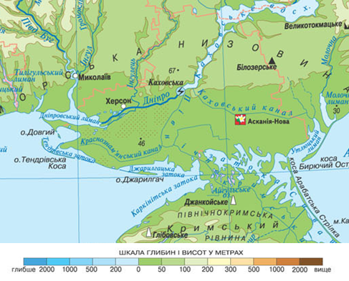
Fig. 1. Morphometric features of the region of the study
The general features of the geological-geomorphological structure of the territory of the Northern Prisivash are determined by its position on the border of the ancient and young platforms. The geological structure of the territory concerned is due to sedimentary rocks with a capacity up to 3000 m, which lie on the Precambrian crystalline foundation.
During the Quaternary period, the Prisivash subsoil was subjected to epyrogenic motions mainly of a negative sign, resulting in the corresponding section constantly flooding with the sea, as a consequence the parent rock has salt-rich properties (Fig. 2). At present, slow elevations of individual sites are observed against the backdrop of general epirogenetic subsidence. Disjunctive disturbances of the crust and depleted phenomena in the Prisivash are not observed [4].
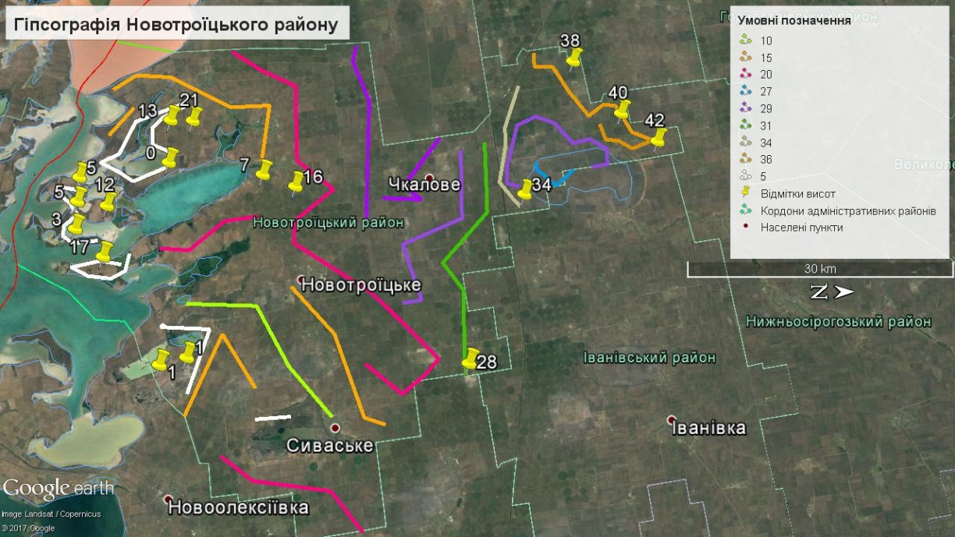
Fig. 2. Map of absolute altitudes of Novotroitsky district of Kherson region
The soil-forming process of the investigated zone proceeds against the background of a clearly expressed vertical zoning. The arid climate, salinity of the soil-forming rocks and the small natural drainage of the territory led to the formation of dark chestnut, chestnut saline soils, soot-and-chestnut soot soils and chestnut solonets here [6]. The structure of the soil is complicated by a large set of salt and saline soils, as well as semi-hydromorphic and hygromorphic soils (Fig. 3).
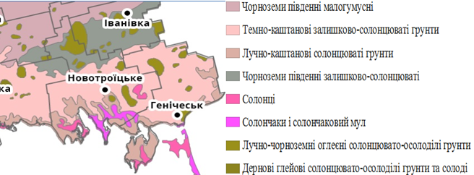
Fig. 3. Chart of the soil of the Srivashsha
Soil cover of Novotroitsky district undergoes significant transformations as a result of anthropogenic activity, the consequences of which are secondary salinization of soils, wind erosion, decrease in the content of humus in the soil, which in turn leads to the soil losing its positive properties at irrational agricultural use [5, 7].
1. Dynamics of the total content of humus (%) in the salinity of the chestnut territory of the Novotroitsky district
Year | Depth, centimeters | Version
Year | Depth, centimeters | Plot | Control
2016 | 0-30 | 1,7 | 2,0
2016 | 30-40 | 1,6 | 1,6
2016 | 40-60 | 1,4 | 1,0
2017 | 0-30 | 2,3 | 2,0
2017 | 30-40 | 1,8 | 1,8
2017 | 40-60 | 1,7 | 1,0
2018 | 0-30 | 2,2 | 2,0
2018 | 30-40 | 1,9 | 1,7
2018 | 40-60 | 1,7 | 1,0

Fig. 4. Dynamics of the total content of humus in the solonets of chestnut territory of Novotroitsky region during 2018
Studies have shown that the content of humus in the 0-60 cm layer of both planted and unplaced soils has not changed significantly. In the arable layer of both variants, the content of humus varies within 1.9-2.0%. It is evenly distributed over a soil profile with a tendency to a slight decrease with depth. However, its reserves in the layer of 0-60 cm of planted variants are somewhat larger (123.4 t / ha on the plantation at 116.9 t / ha on the control) (Fig. 4).
Azov-Sivash National Natural Park is a protected area under the protected steppes, where the soil cover along the Gulf of Sivash has a certain specificity associated with the conditions of formation [3]. Soils of the protected area in comparison with the soil cover of Novotroitsky district, will not undergo significant anthropogenic influence.
The territory of the Novotroitsky district is characterized by large scale devastation of agricultural land. As a result of the attraction of saline soils to arable land, the morphological structure of their profile gets some changes. The salt layer consists of a honey-eluvial, eluvial and partly illuvial horizons. At the same time, the power of the illuvial horizon decreases by 5-10 cm. Annual plowing leads to an enhanced interaction of soils with the atmosphere, and wind and water erosion of soils spread. The direct consequence of the plow is the transformation of the mechanical composition of the soil.
The structure of the profile of the chestnut salt can be judged from the description of the section and stationary study from 2017-2018 in the territory of Novotroitsky district (Fig. 5).
In the long-term post-militia development of planted solonetnes and dark chestnut sootloctious soils, the restoration of the solonetinous process does not occur during the investigated period, which is confirmed by the lack of texture differentiation of the soil profile according to the eluvial-illiual type, and therefore indicates a continuation of the positive aftermath of reclamation plantation plowing [1].
0  30  40  60  75 | 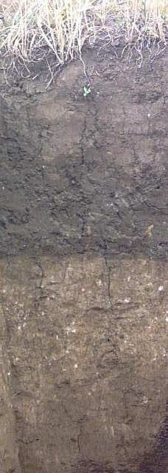
 | Плантажований
Fig. 5. Structure of the profile of the salt of chestnut deep deep-sunny-grassy light-flask on the wood of the territory of Novotorichy district
Also, one of the main reasons for the transformation of the soil cover of the study area is irrigation - bringing water to fields that are lacking in moisture, and increasing its reserves in the soil layer. Land reclamation is one of the most important means of increasing agricultural production, reducing its dependence on adverse climatic conditions. Intensive development of irrigation reclamation causes not only positive but also negative changes in natural conditions, which are manifested in increasing levels of groundwater, flooding of territories, secondary salinization, landslide, deterioration of physical and mechanical and water-physical properties of soils, etc. [7].
Conclusions and perspectives
Consequently, a comparative analysis of the current state of soil cover and the results of studies of the late 20th century, we can conclude the following:
- the transformation of the soil cover of the territory of Novotroitsky district occurs both under the influence of natural and anthropogenic factors;
- the transformation of the ground cover of the Azov-Sivash National Natural Park occurs mainly under the influence of natural factors;
- the attraction of salt and dark chestnut soils of the Novotroitsky region to arable land and their long agricultural use, the use of reclamation measures (amelioration plowing and irrigation) made some changes to their salt composition. They undergo a positive agrogenic transformation and lose most of those morphological features, according to which in the virgin state they were identified as their own solonettes or salt-soils, which in turn determines plowing plowing as a positive measure of soil optimization in the Novotroitsky region.
- the multilateral influence of irrigation on the chemical properties of the soil is carried out. Irrigation water acts primarily as a solvent and as an environment in which chemical processes are easily carried out. As the amount of water increases in soil, the concentration of soil solution decreases and its soluble action rises. That is why land reclamation plowing is one of the most important means of optimizing the use of saltinent soils, namely, increasing agricultural production and reducing its dependence on adverse climatic conditions.

References
1. Baliuk , S.A., Novikova, H.V., Havrylovych, N.Yu. (2009). Vykorystannia solontsevykh gruntiv Ukrainy [The use of soot-rich soils in Ukraine]. Visnyk ahrarnoi nauky. Science, 12-15.
2. Pylypenko, I. O., Malchykova, D. S., Yermakova, S. L., Rudenko, M. M. ta in. (2007). Heohrafiia Khersonshchyny [Geography of Kherson region]. Navch. posibnyk. Kherson, PP Vyshemyrskyi V.S. 221.
3. Davydov, O.V., Roskos, N.O., Roskos, O.M. (2013). Zahalni osoblyvosti poshyrennia roslynnosti na berezi zatoky Syvash, Azovske more [General features of the spread of vegetation on the shore of the Gulf of Sivash, the Sea of ​​Azov]. Visnyk ONU, Ser. Heohrafichni ta heolohichni nauky, 18/3(10), 57-64.
4. Davydov, O.V., Kriuchkova, T.M., Roskos, O.M. (2008). Suchasnyi hidrolohichnyi rezhym zatoky Syvash yak dominuiuchyi faktor rozvytku berehovoi smuhy [The modern hydrological regime of the Sivash Bay as a dominant factor in the development of the coastal strip]. Visnyk ONU. Ser. Heohrafichni ta heolohichni nauky, 13/6, 50-66.
5. Yermolaev, M.M. (2002). Transformatsiia rodiuchosti solontsevykh gruntiv Lisostepu Ukrainy pid vplyvom melioratsii [Transformation of the soil fertility of the forest-steppe of Ukraine under the influence of reclamation]. Kyiv, – 39s.
6. Liubymova, I.N. (2010). Suchasni protsesy hruntoutvorennia v rozoranykh ta melioratyvnykh hruntakh solontsevykh kompleksiv sukhostepovoi zony [Modern processes of soil formation in cultivated and reclamation soils of the solonethic complexes of the dry-steppe zone]. Moscow, Hruntoznavchyi instytut im. V.V.Dokuchaieva: Science, 390-413.
7. Novikova, A.V. (2000). Prohnozuvannia vtorynnoho zasolennia hruntiv pid chas zroshennia [Forecasting of secondary salinization of soils during irrigation]. Urozhai, 166.

І.С. Польова, С.В. Фокіна
ДОСЛІДЖЕННЯ ОСОБЛИВОСТЕЙ ТРАНСФОРМАЦІЇ ГРУНТОВОГО ПОКРИВУ ПРИСИВАШШЯ НА ПРИКЛАДІ НОВОТРОЇЦЬКОГО РАЙОНУ ТА АЗОВО-СИВАСЬКОГО НАЦІОНАЛЬНОГО ПРИРОДНОГО ПАРКУ ПІД ВПЛИВОМ ПРИРОДНИХ ТА АНТРОПОГЕННИХ ФАКТОРІВ
Анотація. У статті розглядаються особливості трансформації грунтового покриву Присивашшя на прикладі порівняльного аналізу трансформації грунтів Новотроїцького району та Азово-Сиваського національного природного парку під впливом природних та антропогенних факторів.
Грунти Північного Присивашшя, а саме Новотроїцького району зазнають значних перетворень спричинених антропогенною діяльністю, швидко втрачають свої позитивні властивості при нераціональному сільськогосподарському використанні.
Довготривале використання ґрунтів у ріллі і, особливо, їх меліорація (меліоративна плантажна оранка, зрошення водами різної якості) обумовлюють існування ґрунтових процесів, які відрізняються від існуючих у природних умовах і є на сьогодні недостатньо вивченими. В сучасних умовах землекористування необхідна точна інформація про якісний стан солонцевих ґрунтів для проведення моніторингу та раціонального сільськогосподарського використання, у зв’язку з чим досліджувані питання набувають особливої наукової і практичної значимості.
На основі порівняльного аналізу з’ясовано відмінності між ґрунтами сільськогосподарського використання та ґрунтами які знаходяться у природному стані, в межах природоохоронних територій. Доведено, що грунти заповідної території у порівнянні з грунтовим покривом Новотроїцького району, не зазнають значного антропогенного впливу. Територія Новотроїцького району характеризується значними масштабами розорення сільськогосподарських угідь.
Ключові слова: Азово-Сиваський національний природний парк ,грунтовий покрив, агроперетворені грунти, меліорація, природні та антропогенні фактори.
****
И.С. Полевая, С.В. Фокина
ИССЛЕДОВАНИЕ ОСОБЕННОСТЕЙ ТРАНСФОРМАЦИИ ПОЧВЕННОГО ПОКРОВА ПРИСИВАШЬЯ НА ПРИМЕРЕ НОВОТРОИЦКОГО РАЙОНА И АЗОВО-СИВАШСКОГО НАЦИОНАЛЬНОГО ПРИРОДНОГО ПАРКА ПОД ВОЗДЕЙСТВИЕМ ПРИРОДНЫХ И АНТРОПОГЕННЫХ ФАКТОРОВ
Аннотация. В статье рассматриваются особенности трансформации почвенного покрова Присивашья на примере сравнительного анализа трансформации почв Новотроицкого района и Азово-Сивашского национального природного парка под влиянием природных и антропогенных факторов.
Почвы Северного Присивашья, а именно Новотроицкого района испытывают значительных преобразований вызванных антропогенной деятельностью, быстро теряют свои положительные свойства при нерациональном сельскохозяйственном использовании.
Длительное использование почв в пашне и, особенно, их мелиорация (мелиоративная плантажная вспашка, орошение водами разного качества) обуславливают существование почвенных процессов, которые отличаются от существующих в естественных условиях и является на сегодня недостаточно изученными. В современных условиях землепользования необходима точная информация о качественном состоянии солонцовых почв для проведения мониторинга и рационального сельскохозяйственного использования, в связи с чем исследуемые вопросы приобретают особую научной и практической значимости.
На основе сравнительного анализа выяснено различия между почвами сельскохозяйственного использования и почвами которые находятся в естественном состоянии, в пределах природоохранных территорий. Доказано, что почвы заповедной территории по сравнению с почвенным покровом Новотроицкого района, не подвержены значительному антропогенному воздействию. Территория Новотроицкого района характеризуется значительными масштабами разорения сельскохозяйственных угодий.
Ключевые слова: Азово-Сивашский национальный природный парк, почвенный покров, агроперетворени почвы, мелиорация, природные и антропогенные факторы.

