LAND MANAGEMENT EDUCATION OF UKRAINE IN CONDITIONS OF EUROINTEGRATION
O.V. Drebot, Ph. D. in Agriculture ,
O.V. Zubova,
O. P. Lukianenko,
Zhytomyr National Agroecological University
O.V. Krasnolutsky, Ph. D. in Economics
The State Service of Ukraine for Geodesy, Cartography and Cadastre
E-mail: odrebotznau@gmail.com
The article deals with current problems of Eurointegration process in the field of land management education. The need for changes in the field of higher education in the process of teaching disciplines of land management specialities is proved, taking into account the importance of raising students’ knowledge level to develop a consciousness of the European values unity and provide future employment, including the European labor market. The purpose of the article is to develop approaches and principles of educational process, as well as the activities of higher educational institutions in general in order to increase the level of students’ knowledge and develop essential professional skills and social involvement in European processes in the field of land management. A method of scientific analysis, synthesis and generalization of current national and European approaches to teaching land management disciplines to students is used in the article. As a result of the research it was established that a comprehensive approach should be applied to teaching discipline. It includes introduction of new disciplines or subjects on European principles of land management into educational process; conducting scientific research in this area; cooperation with other educational institutions, and representatives of the StateGeoCadastre (Ukrainian land management state executive bodies), land management organizations; as well as free dissemination of scientific research. The material presented in this article is the foundation for organizing and improving the educational process in the field of land management education.
Keywords. European integration and education, land management education, land management.
Relevance. In the framework of European integration an important condition for Ukraine is training of high-quality specialists able to prove their proficiency and be in demand both on the national and European labor markets. For this purpose an important task is to develop students’ consciousness as to the need and opportunity of every person seeking education not only to be involved into the problems of European society, but also to participate in solving these problems. In land management sphere land relations in Ukraine are very far from the principles and methods of land management in the EU countries. Therefore, it is important to develop and disseminate new knowledge to improve national approaches to land use.
Providing such knowledge and skills to future specialists allows to increase the level of professional training in the field of land management, gives the opportunity to get job, including in the EU countries, to be involved in European problems, and become the part of European society.
The purpose of the article is to form approaches and principles for improving educational process of higher educational institutions, raising the level of knowledge and skills of students of land management field in order to develop their consciousness as to public involvement in European values and successful employment.
Research methods. To study the principles and approaches to the educational process in the context of European integration of Ukraine the theoretical methods of research have been used. In particular, current approaches to teaching disciplines to land management students as well as the disciplines of the leading European universities have been analyzed. The analyzed components related to the classes and activities of higher educational institutions in general are combined to develop a national strategy to raise the level of students’ knowledge in the field of land management education.
Analysis of recent research and publications. Issues of education in Ukraine are topical in the context of European integration. Under such conditions, a number of scholars argue that the national educational process can not be separated from the European one; there is a need to study land relations of the EU in the process of teaching the disciplines on the speciality. Principles which should be the base of educational programs are a prerequisite for achieving competitiveness on the global labor market and should create conditions for involving the students into the world educational process, increasing their mobility, and broadening their outlook [1, 2, 3]. Scientists are inclined to the unanimous opinion that the country’s development is impossible without taking into account global trends and universal values [4, 5, 6]. Modern training of land managers should include partnership between the university and the community: cooperation with industry, government, and society [7, 8]. It is also essential to introduce into the educational process a holistic multidisciplinary approach to the management of natural resources to ensure the sustainable development of ecosystems [9, 10, 11, 12]. The problem of increasing diversity in land use still remains topical [13].
Results of the research and their discussion. The goal set has been achieved under combination of several stages and fulfillment of a number of conditions. First of all, such task requires increasing the teachers’ awareness of the events within the European Union via studying all scientific publications of European scientists disseminated via digital technologies, as well as regulatory requirements of legislative documents in the field of land management, and a detailed understanding of the processes of state land management. The problems of rational land use, consideration of the natural features of landscapes under their land management, functioning of sustainable lands, preservation of biodiversity, and the peculiarities of land use under conditions of climate change still remain relevant in European society.
The decision of such tasks takes place at the state level, as evidenced by the established laws and regulatory requirements in the fields of ecology and management of agricultural lands. The ideas of sustainable development of agricultural lands are promoted and implemented due to the laws and programs of support of farms. The process of improving the skills of teachers in the field of land management involves studying the conditions for sustainable development, minimizing the negative effects of anthropogenic interference in natural processes by linking the territorial-resource, production and natural aspects in the process of modern farms functioning. Its base is the study, implementation, approbation and dissemination of legislative and scientific approaches to land use, land policy, land use standards and successful management in the EU countries. The introduction into the educational process of topics related to the development of land-use approaches based on the European model is extremely relevant. There is a lack of effective state management of land use in Ukraine, which leads to deterioration of its condition, while also there is a need to develop new strategic approaches to land management. Under such conditions training of skilled professionals is required in the field.
In order to improve the skills and training of specialists experienced in solving such problems, there is a need to improve the educational process of higher education institutions including new disciplines in curricula, or introducing new topics within the disciplines which are already taught. Consequently, the task of new subjects or disciplines is to broaden students’ horizons and acquire new knowledge close to the problems of the European society. To give land management classes it is important to select not only the direction of the discipline, but also to develop new approaches to teaching. Business games, debates, seminars, as well as comprehensive teaching approach will help to improve the quality of the teaching process and increase interest to the material of the new discipline. Introduction of new disciplines in the educational process does not mean to adopt curricula of the EU universities. It means the combination of the topics already taught with the latest trends in the field of land management, which will enable to disseminate as many European techniques in the nature preservation theories as possible, make aware of the need to develop knowledge of the European land use model. While studying the land management disciplines, it is important to combine the topics related to land management, organization of the territory, the application of advanced digital technologies, land monitoring to find effective land management solutions (Tab. 1). Given that approximately 70% of Ukraine’s lands belong to agriculture, the actual topic is the study of standards for using such lands, the involvement of the EU scientists in working out the strategy for the development of sustainable agro-landscapes lands; biodiversity preservation under agricultural production; the development of geoinformational technologies and remote land sounding; and their application in agro-landscapes land management. Changes in agro-ecosystems in the large area sooner or later will lead to negative changes in surrounding areas outside the national territory. Therefore teaching new knowledge to students will help them to better adjust in the professional field of this area within the EU. The dissemination of knowledge of progressive European approaches in the field of land management, land use, nature preservation will help to create standards and methods to use agricultural landscapes, train specialists who will be in demand in the European labor market. It is important to develop thrifty attitude towards nature in students while mastering disciplines of land management speciality. For this purpose, it is necessary to study the achievements of the scientists of the European community, and apply European methods of rational land use. The spread of European knowledge in this direction is an integral part of the process of European doctrine integration into Ukraine.

Tab. 1. Analysis of the Master’s programs of land management direction of the leading European universities
Country/  University | Course name | Main modules | Course content overview
1 | 3 | 4 | 5
UK/  Bangor University | Conservation and Land Management | Agriculture & the environment  Conservation science  Natural Resource Management  Botanical Ecology & Ecosystem | A sustainable use of the countryside. It examines habitats, wildlife, landscapes, and the natural and human factors influencing them. The integrated land use approach. Economic activities management of farming and forestry in an environmentally acceptable way.
UK/  Cranfield University | Land Reclamation and Restoration | Landscape Ecology  Soil Engineering, Contaminant and Nutrient Management  Ecological Restoration  Soil Erosion Control: Principles and Practices  Soil Systems  GIS Fundamentals | Ways, methods, stages and procedure for the damaged land restoration. Soil Properties. Soil erosion processes. Possibilities and functions of geographic information systems on land restoration.
UK/ University of Exeter | Surveying and Land and Environmental Management | Soil and Water Contamination  Advanced Surveying  Project Management  GIS and Law for Surveyors  Land Management  Land Surveying | All surveying activities concerned field measuring and office recording information.  Water- and land resources- ecology. Use of GIS in the field of geodesy and land management.
UK/ Harper Adams University | Rural Estate and Land Management | Land Tenure Systems  Research and Information Skills  Rural Asset Valuation  Rural Estate Taxation and Planning | Practice training in a diverse range of agricultural and rural sector work. This can include providing advice to owners, landlords and tenants on the value of their assets, tenancy matters, sale and purchase, taxation, compulsory purchase, auctioneering, conservation matters and farm business management.

1 | 2 | 3 | 4
Germany/ Technical University of Munich | Land Management and Land Tenure | Land management  Land tenure systems and land economics  Photogrammetry, Remote Sensing and Positioning  Cartography, GIS  Environmental risk management  Land policy, land governance and land conflicts management | Interdisciplinary approaches to land management and land tenure in an international context. Theoretical and practical background for future experts in all processes of land use field.
Denmark/ Aalborg University | Surveying, Planning and Land Management | Land Development And Property Law  Spatial Development And Planning  Professional Development | Spatial development, governance and land administration systems. the development and implementation of land-use related policies and regulation, as well as specific land management strategies and spatial plans in both urban and rural areas.
Germany/  Technical University of Munich | Sustainable Resource Management | Environmental Economics and Policy  Management and Protection of Forest Ecosystems  Wildlife and Protected Area Management  Landscape Management  Agricultural Land-Use | Taking into consideration social, economic and ecological dimensions of environment protection. Conveying of suitable analysis- and management- methods. Soils and Soil Management
Sweden/  Stockholm University | Landscape Ecology | Landscape Ecology - Theory and Design  Applied Remote Sensing, and GIS for Landscape Analysis  Applied Aerial Photographic Techniques for Landscape Analysis | Research in applied historical ecology, landscape analysis and resource with Remote Sensing, and GIS application. Ecology and restoration and management of both terrestrial and marine environments.
Poland/  Warsaw University of Life Sciences | Environmental Engineering | Spatial planning  Environmental management  Proecological technologies  Environmental monitoring and information systems  Soil physics and hydrology  Advanced meteorology  Water reservoirs, Land and water development | Development of sustainable and technically effective solutions to land and water resources management. An application of the Information Systems in the operational management and environmental monitoring, planning the territory.

While mastering disciplines, it is also important to use active teaching methods which allow to closer communicate between the students of the groups and the teacher, as well as to test the theoretical material more quickly and effectively, using as many examples and current models of agricultural land use within the European experience as possible. Among the active methods, a method of situational research is suggested. It enables the natural combination of theory and practice, the opportunity to develop professional skills, the organization of knowledge based on past experience supported by theory. This method will allow to test the model of European land use experience within national agro-landscapes. The method of individual research is also essential. It involves application and implementation of the latest European approaches to land use, which includes simulating of certain processes and selection of the most effective solutions for sustainable areas. The method uses elements of land use planning based on a scientific approach. It is interesting to carry out group and individual students’ projects, which enables students to apply theoretical knowledge in practice, to learn how to assess and compare the suggestions of the participants of the training project, and assess the level of their own knowledge and their own skills. An important stage is the discussion of the results of the project implementation and the tasks set during the classes. It is possible to use role-playing games for better understanding the material as to the development of land policy and the process of organizing the territories functioning.
One of the measures that will improve the teaching process and skills development of land management students is cooperation with production structures. The system of such structures is quite widespread in Ukraine. Land management organizations develop various types of land management documentation and are most familiar with modern land policy innovations, have appropriate equipment for land management works. Therefore, the combination of educational topics of disciplines aimed at studying the methods of land management of the EU with industrial relations will enable to support the practical training of students, to analyze the implementation of land policy requirements in land use and compare the national and European principles of land management.
An integral part of the educational process of higher educational institutions in the context of European integration should be scientific research aimed at studying European principles of land management. Modern direction of all scientific and social European processes concerns the unification of European values and the increase of their target audience. In the field of land management the development of land policy is emphasized taking into account environmental indicators of land use. The study of European policy in the field of nature management will help to implement the most effective methods of land’ decisions in the production conditions of the land management sector in Ukraine.
Further research based on the study of current scientific developments, and especially on approaches to land use, will also create the base for the implementation of advanced European ideas of rational land use in making political decisions in agrarian sector of Ukraine.
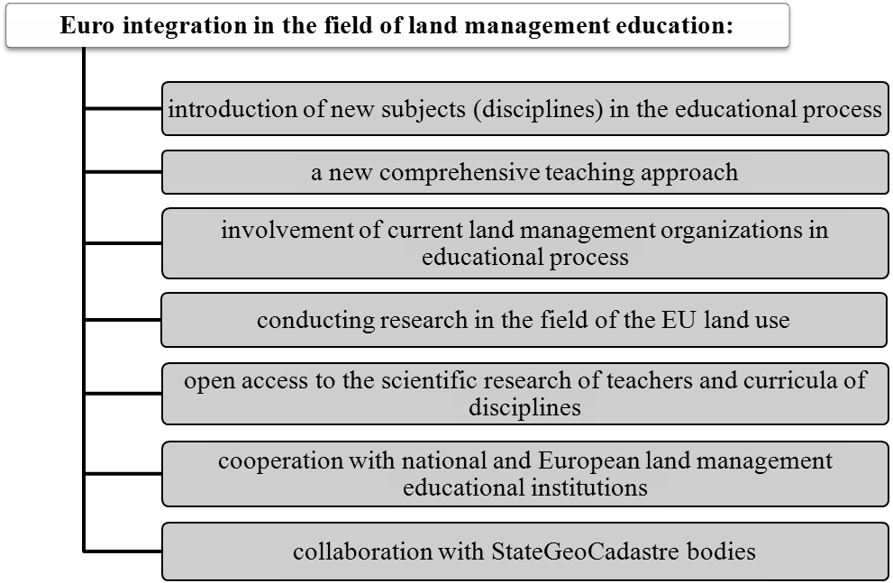Fig. 1. The process of European integration in the field
of land management education
The university’s activity aimed at cooperation with other educational institutions enhances, summarizes and unites the level of knowledge, allows us to work out a unified strategy for teaching disciplines and stresses current major issues of the entire European society. Cooperation with representatives of the state and local government, public organizations will allow to join the European values and apply advanced methods at the level of development of law-making documents concerning the use of land. The most effective method of cooperation is to hold conferences and roundtables. Scientific materials of teachers based on new European knowledge, and directed to representatives of the StateGeoCadastre bodies should be of a recommendatory nature; defining the main European approaches to land use and management of territories, and including the EU land use standards. For successful cooperation, the necessary precondition is the free access to educational programs of disciplines, texts of scientific works of teachers. The dissemination of the European knowledge and principles will enable students to apply their professional skills in the future, to enter a new level of professional life, to be a part of the European community.
Conclusions and perspectives. In order to improve the knowledge of students of land management specialities, a comprehensive approach is needed in the educational process and activities of the university in general. It will facilitate the successful employment of future graduates, both in Ukraine and abroad. New knowledge will help students to develop and implement the most up-to-date methods of successful operation of the land management service in Ukrainian educational institutions, as well as enable them to be involved in the problems of the European community. European integration in the field of land management involves a range of activities and includes a huge target audience. The set of measures is based on new principles and methods of educational process of land managers. Among them is the introduction of new topics and disciplines which study approaches to land use in the EU, application of the most effective methods of giving classes, conducting research based on the study of European principles of land management, dialogue with other educational institutions, land management organizations, representatives of the StateGeoCadastre bodies, dissemination of the results of scientific research and new educational programs of disciplines.

References
- Azhazha, M. A. (2018). Napriamy derzhavnoho upravlinnia modernizatsiieiu osvity v konteksti yevrointehratsii Ukrainy. [Directions of state management of education modernization in the context of European integration of Ukraine]. Investytsii: praktyka ta dosvid, № 8, 94 – 99.
- Voloshchuk, M. (2018). Antropohenna evoliutsiia zemlekorystuvannia zakhidnoho rehionu Ukrainy [Anthropogenic evolution of land use of the western region of Ukraine]. Ahrarna nauka ta osvita v umovakh yevrointehratsii: zbirnyknaukovykh prats mizhnar. nauk.–prakt. konf. Ch.1. (20–22 bereznia 2018 r., m. Kam’ianets–Podilskyi). Ternopil: Krok, 19 – 21.
- Semenchuk, I. M., & Sklyaruk, T. I. (2017). Upravlinnia zemelnymy resursamy v umovakh yevrointehratsii [Land management in the context of European integration]. Ahrosvit, № 3, 18 – 23.
- Andrushchenko, T. V. (2015). Natsionalne ta zahalnoliudske yak dominantni tsinnosti suchasnoi osvitnoi polityky (ievropeiskyi kontekst). [National and universal as the dominant values of modern educational policy (European context)] Multyversum. Filosofskyi almanakh, № 9 – 10, 117 – 134.
- Komisarov, V. F., & Kovalova, L.P. (2013). Problemy ta perspektyvy osvitnoi yevrointehratsii Ukrainy. [Problems and perspectives of educational eurointegration of Ukraine] Vseuk. nauk. – prakt. konf. «Naukovo–metodychni pidkhody do vykladannia upravlinskykh dystsyplin v konteksti vymoh rynku pratsi» 11 – 12 kvitniia 2013 r., 46 – 49.
- Adomßent, M., Fischer, D., Godemann, J., Herzig, C., Otte, I., Rieckmann, M., & Timm, J. (2014). Emerging areas in research on higher education for sustainable development–management education, sustainable consumption and perspectives from Central and Eastern Europe. Journal of Cleaner Production, 62, 1–7. doi: /10.1016/j.jclepro.2013.09.045 . Available at: https://www.sciencedirect.com/science/article/pii/S0959652613006586
- Frank, A. I., & Silver, C. (2018). Envisioning the Future of Planning and Planning Education. (pp. 235 – 250). In Cham (ed.), Urban Planning Education. Springer International Publishing. doi: 10.1007/978-3-319-55967-4_16 . Available at: https://www.researchgate.net/publication/318163177_Envisioning_the_Future_of_Planning_and_Planning_Education
8. Wezel, A., Goette, J., Lagneaux, E., Passuello, G., Reisman, E., Rodier, C., & Turpin, G. (2018). Agroecology in Europe: Research, education, collective action networks, andalternative food systems. Sustainability, 10(4), 1214 – 1232. doi: 10.3390/su10041214. Available at: https://www.mdpi.com/2071-1050/10/4/1214
9. Nölting, B., & Mann, C. (2018). Governance strategy for sustainable land management and water reuse: Challenges for transdisciplinary research. Sustainable Development, 26(6), 691 – 700. doi: /10.1002/sd.1739. Available at: https://onlinelibrary.wiley.com/doi/pdf/10.1002/sd.1739
10. García–Martín, M., Bieling, C., Hart, A., & Plieninger, T. (2016). Integrated landscape initiatives in Europe: multi–sector collaboration in multi–functional landscapes. Land Use Policy, 58, 43 – 53. doi: 10.1016/j.landusepol.2016.07.001. Available at: https://www.sciencedirect.com/science/article/abs/pii/-S0264837715301976
11. Budziak, O. S., Budzyak, V. M. (2018). Ekolohizatsiia zemlekorystuvannia v konteksti yevrointehratsiinykh protsesiv. [Ecologization of land use in the context of European integration processes] Investytsii: praktyka ta dosvid, № 11, 6 – 11.
12. Yasinetska, I.A. (2016). Mozhlyvosti zastosuvannia mizhnarodnoho dosvidu upravlinnia zemelnymy resursamy v Ukraini. [Possibilities of applying international experience of land resources management in Ukraine]. Mykolaivskyi natsionalnyi universytet imeni V.O. Sukhomlynskoho, №12, 188 – 192.
13. Hochkirch, A. , Schmitt, T. , Beninde, J. , Hiery, M. , Kinitz, T. , Kirschey, J. , Matenaar, D. , Rohde, K. , Stoefen, A. , Wagner, N. , Zink, A. , Lötters, S. , Veith, M. and Proelss, A. (2013), Europe Needs a New Vision for a Natura 2020 Network. Conservation Letters, 6, 462 – 467. doi: 10.1111/conl.12006. Available at: https://www.researchgate.net/publication/235759158_Europe_needs-_a_new_vision_for_a_Natura_2020_network

