UDC 332.64(477)
MODERN ROLE OF ASSESSMENT AS A FACTOR OF FULL-FUNCTIONING LAND MARKET IN UKRAINE.
Koshel A., Candidate of Economic Sciences (Ph.D.)
e- mail: koshelao@gmail.com ORCID ID: 0000-0001-9032-1622
National University of Life and Environmental Sciences of Ukraine,
The current state of the market of non-agricultural land and agricultural land that are not under the moratorium is analyzed. The legislatively fixed definition of monetary valuation, which is one of the bases for opening the land circulation of commodity agricultural production, is investigated.
The main features of land valuation for which the process of land valuation should be conducted in terms of market relations are noted. The disadvantages of the existing system of regulatory monetary valuation of agricultural land outside the settlements of Ukraine, which are formed not on the market valuation, are presented.
The method of group estimation of land according to the common characteristics of land on a market basis, which is used in most countries of the world and is called mass estimation, is proposed. Advantages and disadvantages of methods of mass land valuation are shown in the conditions of expectation of opening of a complete land market.
The directions of improvement of the modern system of land valuation for the purposes of their taxation and determination of real value are determined. The extreme importance of land valuation as the main regulatory factor for the proper functioning of the land market is shown.
Keywords: land market, valuation, regulatory monetary valuation, market price, mass valuation, land taxation.

Formulation of the problem. The current political and economic situation in Ukraine gives rational grounds for expecting the opening of the land market for commodity agricultural production. Taking into account that all the legal basis for starting the market of agricultural commodity land has already been prepared, it is necessary to analyze the existing state of the already existing markets of non-agricultural lands, agricultural lands not subject to the moratorium (personal farming) and the rental market.
In fact, having formed a complete picture of existing markets, one can predict what tendencies can be expected when starting the sale and purchase of land of commodity agricultural production, outline certain risks and prospects.
One of the main roles will be played by an objective assessment of land as a territorial basis for the placement of buildings and structures, etc. and the main means of agricultural commodity production. Thus, the quality of land resources valuation is of particular relevance in the context of the prospect of opening a full-fledged land market in Ukraine.
Purpose of the study. Determining the contemporary role of valuation as a factor in the proper functioning of the land market in Ukraine and substantiation of the principles by which the process of valuation of land plots in terms of market relations with separation of advantages and disadvantages should take place.
Research results and discussion. According to the latest data from the State Geocadastre [2] on monitoring the land market for 2018, 2798 land plots with a total area of ​​882 hectares were sold in Ukraine with a total value of UAH 1151.105 million. Of these, 66 land plots were sold outside the settlements.
The analysis of land lease sales for 2018 showed that 4383 land plots were sold with a total area of ​​68501 hectares with a total rent, which was established as a result of bidding around UAH 197 million. The vast majority of land (3633) to which the lease rights were sold is located outside the settlements. If we analyze the purpose of land plots for which the lease rights have been sold, then in the vast majority it is code 01.01. - for commodity agricultural production.
In accordance with paragraph 1 of Article 201 of the Land Code of Ukraine [1], the legislation determines that the monetary valuation of land plots is determined on a rent basis. Accordingly, the calculation of such an assessment should be made taking into account market indicators that determine the value of land rent. In practice, the Ukrainian system of valuation has the opposite option of calculating monetary valuation of land.
An analysis of the current state of monetary valuation of land in Ukraine shows that in the vast majority of cases there is a significant amount of distortion of its results due to the application of the methodology of regulatory valuation where the non-market basis is taken as the basis of valuation.
Thus, according to the latest data of the State Geocadastre [2] regarding the normative monetary valuation of lands within settlements, the vast majority of them require the conduct of new valuation companies (Fig. 1).
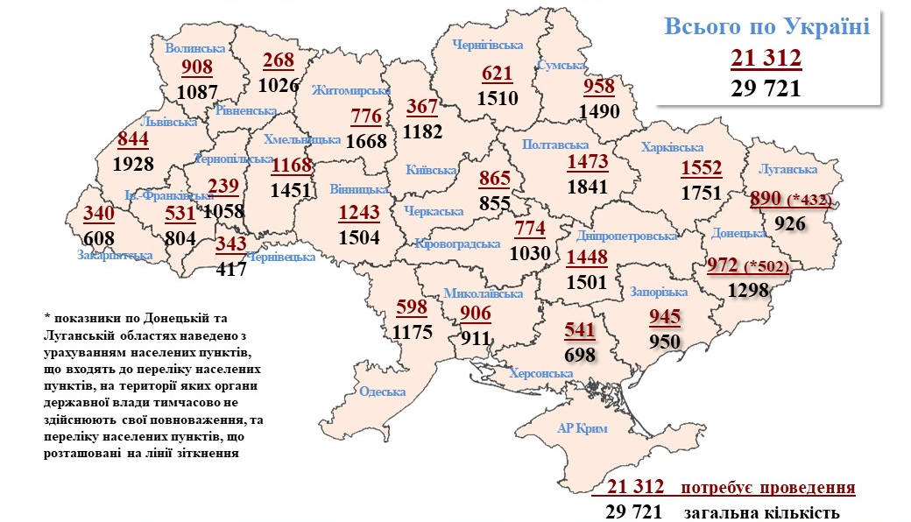
Fig. 1. Indicators of the number of settlements in Ukraine requiring a new monetary valuation of land by region as of 01.10.2019 [2]
Source: State Geocadastre - https://land.gov.ua
Thus, according to Fig. 1 as of 2019, more than 70% of settlements in Ukraine require updating of the normative monetary valuation of land, which in turn is a burden on local budgets of local self-government bodies.
A separate component is the analysis of indicators of regulatory monetary valuation of agricultural land outside settlements of Ukraine. As of 01.01.2019, the indicators of the normative assessment of agricultural lands in terms of administrative and territorial units have the following form (Fig. 2)

Fig. 2. Indicators of the number of settlements in Ukraine requiring a new monetary valuation of land by region as of 01.10.2019 [2]
Source: State Geocadastre - https://land.gov.ua
Based on the data of Fig. Cherkasy Oblast has the highest indicator of the value of one hectare of agricultural land under arable land and is 33646 UAH. and the smallest has Zhytomyr region - 21411 UAH. per hectare.
When analyzing the data of the normative monetary valuation of agricultural land under perennial crops, we have the following distribution: the highest indicator of the normative value is the Cherkasy region, which is 74144 UAH. per hectare and the smallest is Lviv region with the value of 27091 UAH. per hectare.
When allocating data on the values ​​of the regulatory monetary valuation of agricultural land under hayfields - the most expensive are hayfields in the Crimea with an indicator of 10145 UAH. per hectare and the cheapest in Vinnytsia region with the cost of 3140 UAH. per hectare.
The analysis of indicators of the normative monetary valuation of agricultural lands under pastures showed that the highest value of one hectare of pastures is in the Odessa region and is 7011 UAH. and the lowest in Vinnytsia region with an indicator of 1558 UAH. per hectare.
It is worth noting that the regulatory indicators of monetary valuation with a favorable coincidence of factors of influence on land can be ten times different from the real market, as a rule in the smaller side.
Summarizing the data presented above on the indicators of the current land market that are not subject to the moratorium and the indicators of the normative monetary valuation of land, it can be said that the non-market base of land valuation is ambiguous and has a significant impact on the regulation of land values, especially within settlements.
In addition to the official statistics, one must also take into account the existence of a "gray" land market, which in the conditions of the unstable Ukrainian economy functions and causes an impact on the value of land.
In the conditions of anticipation of opening of a full-fledged market of agricultural commodity lands, which make up more than 70% of the whole territory of Ukraine, it is necessary to improve the existing system of assessment by switching to market methods. The author proposes a method of group assessment of land on common grounds and many factors that are not taken into account in the regulatory assessment. This method is the standard market method of valuation for tax purposes, called mass valuation.
The whole methodology is based on the statistical analysis of groups of land on common grounds, which is performed in an automated mode and significantly reduces the cost of evaluation procedures. This may be especially true in the context that 2/3 of all settlements require a new regulatory monetary assessment.
The disadvantage of this method is a slightly lower level of accuracy compared to the individual expert evaluation of land plots, but there is no need for constant updating of the normative land valuation data.
With an open land market, there may be a need for an objective market valuation of land, and most importantly large arrays and in a short period of time. Just automated land valuation can satisfy the demand for a quality reliable market valuation base.
The main areas of improvement of the modern land valuation system should be to bring its existing indicators to market values. One of the main goals that modern land valuation has to fulfill is to ensure fair science-based tax rates, which in turn are possible by establishing the real value of the land.
Findings. Therefore, land valuation is extremely important in the field of land relations. It serves as a stabilizing factor for market pricing, serves as a key element for efficient taxation of land and for filling local budgets. Formation of a system of land valuation based on grouping methods by common factors and characteristics should become the basis for the development of the land market for agricultural commodity production.

References
- Zemelnyi kodeks Ukrainy. Rezhym dostupu : Zemelnyi kodeks Ukrainy. Avaliable at : https://zakon.rada.gov.ua/laws/show/2768-142.
- The State Service of Ukraine for Geodesy, Cartography & Cadastre. Avaliable at : http://land.gov.ua

Кошель А.О.,
СУЧАСНА РОЛЬ ОЦІНКИ ЯК ФАКТОРУ ПОВНОЦІННОГО ФУНКЦІОНУВАННЯ РИНКУ ЗЕМЕЛЬ В УКРАЇНІ
Проведено аналіз сучасного стану ринку земель несільськогосподарського призначення та земель сільськогосподарського призначення, які не перебувають під дією мораторію. Досліджено законодавчо закріплене визначення грошової оцінки на рентній основі, яке є однією з основ для відкриття обігу земель товарного сільськогосподарського виробництва.
Відзначено головні особливості оцінки земель за якими має відбуватися процес оцінювання земельних ділянок в умовах ринкових відносин. Наведено недоліки існуючої системи нормативної грошової оцінки земель сільськогосподарського призначення за межами населених пунктів України, яка формується не на ринковій оціночній базі.
Запропонована методика групового оцінювання земель за спільними характеристиками земельних ділянок на ринковій основі, яка використовується в більшості країн світу і має назву масова оцінка. Показані переваги та недоліки методів масового оцінювання земель в умовах очікування відкриття повноцінного ринку земель.
Визначено напрями удосконалення сучасної системи оцінки земель для цілей їх оподаткування та визначення реальної цінності. Показано надзвичайну важливість оцінки земель як основного регулюючого фактору повноцінного функціонування ринку земель.
Ключові слова: ринок земель, оцінка, нормативна грошова оцінка, ринкова ціна, масова оцінка, оподаткування земель

Кошель А.О.
СОВРЕМЕННАЯ РОЛЬ ОЦЕНКИ КАК ФАКТОРУ ПОЛНОЦЕННОГО ФУНКЦИОНИРОВАНИЯ РЫНКА ЗЕМЕЛЬ В УКРАИНЕ
Проведен анализ современного состояния рынка земель несельскохозяйственного назначения и земель сельскохозяйственного назначения, которые не находятся под действием моратория. Исследовано законодательно закрепленное определение денежной оценки на рентной основе, которое является одной из основ для открытия оборота земель товарного сельскохозяйственного производства.
Отмечено главные особенности оценки земель по которым должен происходить процесс оценки земельных участков в условиях рыночных отношений. Приведены недостатки существующей системы нормативной денежной оценки земель сельскохозяйственного назначения за пределами населенных пунктов Украины, которая формируется не на рыночной оценочной базе.
Предложенная методика группового оценивания земель по общим характеристикам земельных участков на рыночной основе, которая используется в большинстве стран мира и называется массовая оценка. Показаны преимущества и недостатки методов массового оценки земель в условиях ожидания открытия полноценного рынка земель.
Определены направления совершенствования современной системы оценки земель для целей их налогообложения и определения реальной ценности. Показано чрезвычайную важность оценки земель как основного регулирующего фактора полноценного функционирования рынка земель.
Ключевые слова: рынок земель, оценка, нормативная денежная оценка, рыночная цена, массовая оценка, налогообложения земель

