DETERMENING ECONOMIC ASPECT OF CONTEMPORARY URBANIZATION: THE CASE OF KYIV
Volodymyr Nazarenko
Abstract. In today's world, the decision-making process of urban development in the context of its economic development is implemented by governments, local authorities, international organizations or private bodies, as well as officials, based on a wealth of information, analytical data and scientific assumptions. According to the author, the main challenge in planning and making adjustments to existing documents, such as a city development plan, is the lack of a holistic picture and general theoretical models that could be used by the above institutions and officials in practice. Undoubtedly, in this scientific work we are only making the first step towards building such a model. That is why it is advisable to start by analyzing existing data and accepted models in order to have a clear picture of the situation and to take further steps towards the creation of a common urbanization model, taking into account environmental, industrial and other contemporary challenges, without repeating the mistakes of existing models and systems, and focus on the practical implementation of such a model and direction for the future.
The problem of inconsistency of the existing norms and regulations in Ukraine, concerning the rational and effective land use and planning in the long term, is noted. The author places an emphasis why economics in the context of urbanization needs a new look. The author studies as a city planning case, the of the city of Kyiv, as such that it is possible to develop and develop a new approach that will solve the existing problems of urbanization and positively influence the development of the economy of the city and the region.
Urbanization is an important factor in the development of the economy of the city and the state, which to some extent does not directly dictate the path of development of the micro- and macroeconomics of the regions. Under this condition’s globalization can play a significant role in influencing them. The issues of suburban areas development, industrialization, post-industrialization, environmental problems, and issues of the continued existence and development of agricultural regions bordering urban centers (urban agglomerations) cannot be excluded.
Keywords: urbanization, economics, modern city problems, land management, zoning, spatial planning, strategic planning
INTRODUCTION
The city is the main territorial unit and one of the key places of economic development of the state in the present conditions. It accounts for a significant proportion of the economy in developed countries, with a higher level of GDP observed in the countries with higher levels of urbanization (60% and above). In Ukraine, there are constant changes and expansion of urban areas, intensive construction is underway and land use and use are changing. For example, in the city of Kyiv, the rate of housing constructions has increased by 43.4 percent, while civilian buildings constructions increased by 25 percent, while agricultural areas decreased by 76 percent and industrial areas by 6.2 percent. As the level of development increases first of all, while the percentage of industrial and agrarian territories decreases, it is advisable to investigate the extent to which these factors affect the development and state of the state's economy as a whole, and what consequences these processes will lead in the future. Urban ecology is an important contemporary problem of urban development and urbanization. The massive construction of the city, the development of transport infrastructure, whose territory in Kyiv grew by 37.3 percent, can have a negative impact on the health of the population. It is worth exploring how the above factors affect the economic development of the capital and make a forecast for the future.
We see that a lot of publications are devoted to land use, town planning, economic forecasting and real estate prices. Particularly detailed is the question of pricing and their constant changes in real estate. Also, due attention has been paid to the research and analysis of environmental issues by various authors. Ecology is a very important factor that has an impact on the state and development of the economy, it must be considered when conducting research and building models. Urban development, urbanization, industrialization and ecology are all closely linked in the modern world. However, we see that many authors focus only on one issue or point to the negative effects of urbanization on the environment. We plan to conduct a more detailed study and link urbanization with the environment in today's economic development, considering the social and political challenges. In this paper, we will focus on the basic criteria and general factors of the interconnection of ecology and economy under the influence of urbanization.
It should be noted that the peculiarity of Ukraine is the very intensive development and development of certain administrative-territorial units, the city of Kyiv. In practice, there is a big difference between what is planned by the government or local government and actual land use. Many authors point to existing problems with outdated regulations and conclude that it is advisable to develop new microeconomic models based on urbanization. However, in their studies they do not consider, or do not consider, and do not comprehensively use the full completeness of information and interrelationships of various factors. In our work we are trying to comprehensively analyze the main factors that have an impact on the economy and urbanization, such as planning, ecology, urban design, strategic planning, economic and financial planning, as well as the use of land resources and basic factors of real estate pricing in Ukraine. , and above all based on data and research in Kyiv.
It is important to note that in Ukraine there are significant inconsistencies of actual data on construction, economic and environmental indicators to master plans, legislation and regulations, as well as state standards and norms. The authors note that they are not fully disclosed by existing systems of legislation.
The purpose of this work is to create the preconditions for further study of urbanization and its identification as a factor of economic development. We plan to substantiate the need for a new perspective on urban planning, urbanization and the importance of a comprehensive view and analysis of factors to build a flexible and practical model of planning and development of a modern economy, taking into account the issues of industrialization, efficient and appropriate use of land resources and ecology, as a major lever and litmus test. . After all, all the above factors are interrelated and have a complex effect. In the context of the development of the land market in Ukraine, the implementation of land reform, as well as the creation of databases and registers of land resources for various purposes, it is advisable to analyze and understand the actual state of affairs in the country.
The laws of Ukraine, normative legal acts, the city master plan, as well as the city development plan are the main documents that determine the city development.[1] Economic and financial plans for the development of the state are also important, as they determine the volume and distribution of the use of funds. The author used during the research: practical materials on urban planning, city development, typical models of construction, land use, urban and suburban infrastructure development options, developed by international design institutions, consortia, as well as private institutions and organizations. In today's context, Ukraine is pursuing a policy of decentralization and allocation of funds to places. Therefore, the author further notes the need to collect data and analyze economic indicators for cities before and during the decentralization process. In our work we will carry out quantitative and static analysis, build economic and analytical models for further implementation of the results of work. To build theoretical models, we used the basics of system analysis and data processing. Project documentation, town planning documents and national statistical reports were used to understand the development strategy.

RESULTS AND DISCUSSION
Having carefully analyzed the statistics of Kyiv and Ukraine on the development of districts, enterprises and socio-economic indicators, it can be argued that the capital of our country is now the center of urbanization. [2] That is why special attention should be paid to the activity and development of Kyiv and to study the economic indicators of urbanization as an integral part of microeconomics based on the data obtained. The intensive development of the city, several its districts and adjacent territories indicate uneven economic development and the state of the environment. An important direction for the further development of the capital is decentralization, revision of the economic development plan and giving considerable attention to environmental issues in the city. To solve these problems, the author plans to develop a flexible economic model of urbanization of cities, which can be applied to both Kyiv and other cities.
Important indicators of the economy of Kyiv as an urban center are the low number of unemployed - 8.2 thousand people, the volume of industrial production is UAH 147912.5 million, while the import of goods exceeds the export by USD 8256.6 million, and the volume of industrial production is below this difference and is about US $ 6100 million. [3] As Kyiv is one of the urban centers of Ukraine, its freight and passenger turnover rates are high - 6352.7 million km and 26729.1 million km respectively. According to the Kyiv state plan Institute, 5.4% of the population of Ukraine live in Kyiv, 6.4% of those employed in Ukraine work in all spheres of economic activity. [4] At the same time, more than 6% of all production and non-productive funds of Ukraine are in Kyiv. In terms of economic indicators, namely the volume of gross value added created in all sectors of the economy of the city of Kyiv per capita, it is twice higher than the average in Ukraine twice, with its share in the national volume being 10.7%. The above data indicate that Kyiv is ahead of other regions of Ukraine in terms of key economic growth indicators. Urbanization in Ukraine is characterized by a strong degree of centralization and concentration of the economy, income inequality, environmental and social components. It should be noted that the peculiarity of the study of urbanization economy in Ukraine is the analysis of the impact of local economies on macroeconomic indicators at the state and regional levels.
According to official data of the Kyiv City State Administration, the area of ​​Kyiv is 853 km2 with administrative division into 10 districts and population - 2576,6 thousand people. [4] In Fig. 1 presents the administrative and territorial structure of Kyiv by districts: Desnyansky with an area of ​​148 km2 and a population of 358.3 thousand people; Sviatoshynsky with an area of ​​110 km2 340.7 thousand people; Dniprovsky 67 km2 354.7 thousand people; Pechersk 27 km2 152 thousand people; Holosiivsky 156 km2 247.6 thousand people; Darnytsky 134 km2 314.7 thousand people; Solomiansky 40 km2 64.8 thousand people; Obolonsky 110 km2 315.5 thousand people; Shevchenkivsky 27 km2 230,2 thousand people; Podilsky 34 km2 198.1 thousand people. As of October 2019, the average value of m2 of real estate in new buildings in Kyiv was UAH 24,000. The highest average real estate value is in the Pechersk district and is 47300 UAH, while the lowest one in the Darnytsky district is 18500 UAH. Data on other districts of Kyiv in UAH are as follows - Shevchenkivsky 33900, Holosiyivsky 25000, Podolsky 22000, Solomiansky 22000, Dniprovsky 21800, Obolonsky 21100, Svyatoshinsky 20000. It is worth noting that in the suburbs of Kyiv the average cost is 13500 m2. In the future, it is worth investigating the impact and proportion of new neighborhoods on the average cost of real estate, the total value by districts and city. It is also worth carrying out a detailed analysis of suburban development and the dynamics of changes in real estate prices depending on the distance to Kyiv. [6]
Here are the main socio-economic indicators of the capital's development for January-September 2019, namely: the average salary per employee amounted to UAH 15378; the number of registered unemployed - 8.2 thousand; sales of industrial products - UAH 147912,5 million; the volume of manufactured construction products - 26966540 thousand UAH; cargo turnover - 6352.7 million tkm; passenger turnover - 26729.1 million passengers. km; retail trade turnover amounted to UAH 152507,4 million. However, it should be noted that the rate of growth of output of construction products is faster, and the index of construction production for the year was 124, 8%, ie in 2019 increased by 24.8% compared to 2018, while the growth rate of industrial production decreased by 2.8%, and the industrial production index reached 97.2 in the same comparison. The growth rate of freight turnover for the year increased by 40.8% and the passenger turnover by 23.9%. According to official data, the average salary for full-time employees for 2018 amounted to UAH 13542, the highest in the mining industry (UAH 44905), and the lowest in construction (UAH 8311) and health care (UAH 8406).
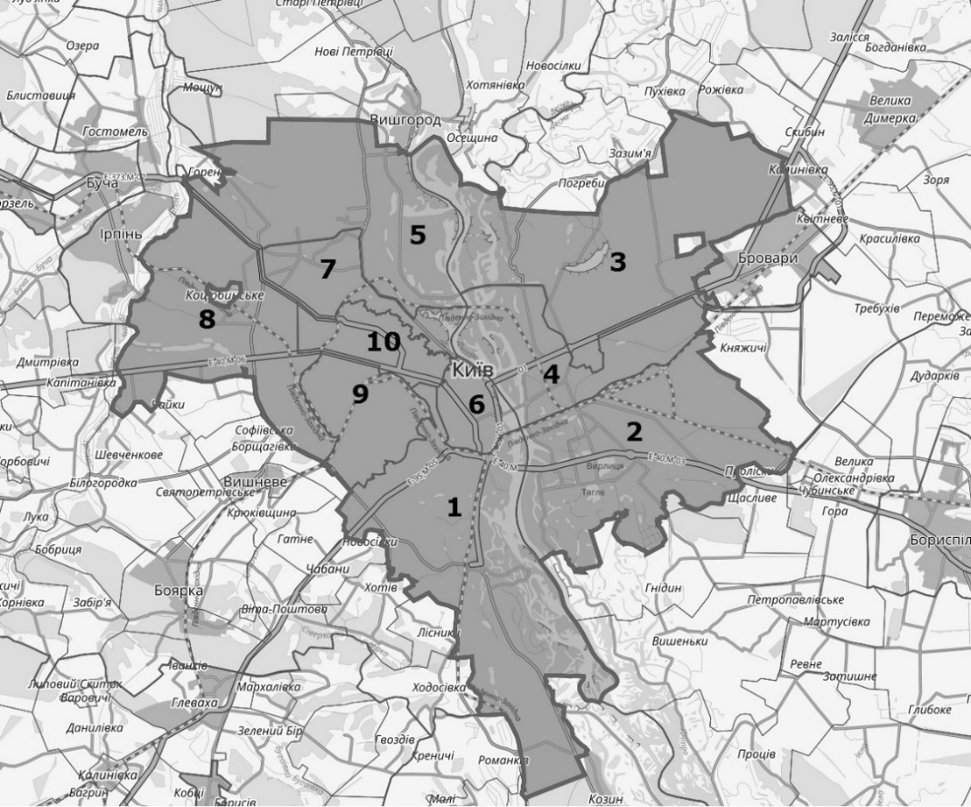
Fig. 1. Administrative and territorial structure of Kyiv, by region: 1 - Holoseevsky; 2 - Darnytsky; 3 - Desniansky; 4 - Dniprovsky; 5 - Obolonsky; 6 - Pechersky; 7 - Podilsky; 8 - Svyatoshinsky; 9 - Solomensky; 10 - Shevchenkivsky
In the context of the territorial structure of the city of Kyiv, the analysis of the main economic indicators and settlement, it is important to get a comprehensive picture of the activities of enterprises, their contribution to the economy of the district and the city. [5] Figure 2 presents a chart of the number of economic entities by type of economic activity in Kyiv in 2018. [3] The analysis of the given data shows that the largest part in the capital are wholesale and retail trade (30.30%), information and telecommunication activity (17.68%), professional, scientific and technical activity (13.87%), as well as real estate transactions (8.23%). Based on Kyiv city development data, it is clear why agriculture (0.52%) and industry (5.71) have some of the lowest rates in the number of businesses in Kyiv.
A further important factor for analysis is the compilation of information on the number of economic entities before the change in economic indicators in the city, as well as the zoning and location of these entities by districts, together with the area data of the districts and the main financial indicators (profitability and expenditures).
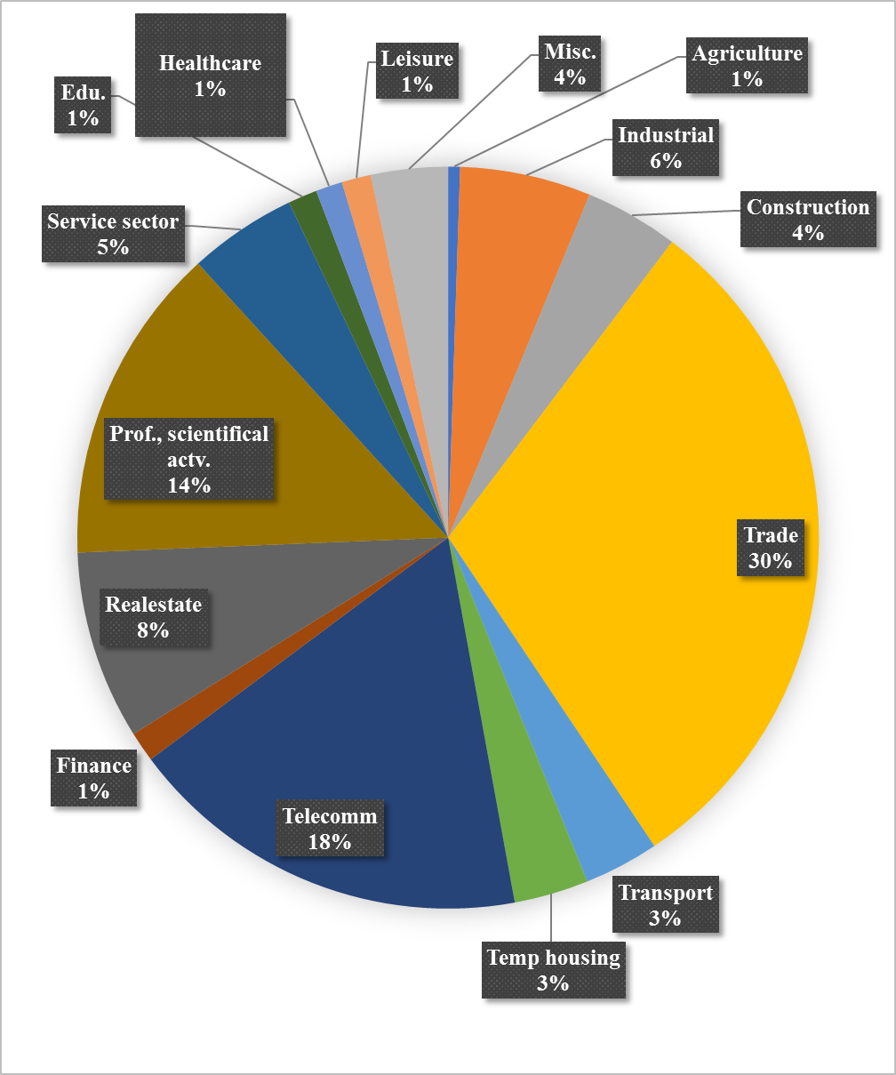Fig. 2. Chart of relative number of economic entities by type of economic activity in Kyiv in 2018
Table 1 shows the indicators of the number of economic entities by districts of Kyiv, data presented for 2018. [3] The largest burden on the number of economic entities is 19.7% in the Shevchenkivsky district of the capital, while in the area of ​​27 km2 it is one of the smallest, as is the Pechersk district of the capital, which has 17.7% of enterprises. And the smallest number of enterprises is located in the largest districts of Kyiv - in Desnyansky (3.8%, with an area of ​​148 km2), Dniprovsky (6.7%, with an area of ​​67 km2) and Svyatoshynsky (7.2%, with an area of ​​40 km2)). Based on the analyzed information it can be noted that in Kyiv there is a classic model of the central city, where the main business activity and real estate value are available in the so-called city center while the suburbs serve as a housing stock. It is worth noting that the data in Fig. 2 and Table 1 are given without considering the results of banks and budgetary institutions. It should be noted that there is a significant disparity in the location of enterprises by districts and in the ratio of individual entrepreneurs to the total number of enterprises.
- Number of economic entities by districts of Kyiv in 2018
Districts | Quantity,  units | Enterprises, as a percentage of the total number of enterprises | Individual entrepreneurs, as a percentage of the total number of individual entrepreneurs
Kyiv | 264707 | 100 | 100
Shevchenkivsky | 34086 | 19,7 | 19,3
Darnytsky | 32684 | 7,7 | 14,8
Solomensky | 29121 | 10,2 | 11,4
Dniprovsky | 26571 | 6,7 | 11,8
Holoseevsky | 25822 | 11,7 | 8,7
Pechersky | 25669 | 17,7 | 5,5
Obolonsky | 25072 | 7,7 | 10,4
Svyatoshinsky | 24800 | 7,2 | 10,5
Desniansky | 22706 | 3,8 | 11,1
Podilsky | 18176 | 7,6 | 6,5
To analyze the level of economic development and the potential of the capital, we will determine the specific indicators of economic activity by districts of Kyiv, based on the indicators of the Main Statistics Office in Kyiv. For this purpose, we will use the following data: volume of sold products (goods, services), number of enterprises, number of employed workers and labor costs. The results of the calculations are given in Table 2. [2]
- Specific indicators of economic activity by districts of Kyiv for 2018
Districts | Volume of sales, produced by one (average) enterprise, thousand UAH | Average number of employees in one enterprise, persons | Costs for payment of labor of one worker, thousand UAH
Holoseevsky | 45106,9 | 12 | 142,3
Darnytsky | 18712,4 | 12 | 100
Desniansky | 22494,9 | 9 | 87,9
Dniprovsky | 30126,5 | 15 | 102,5
Obolonsky | 33076,8 | 13 | 116,6
Pechersky | 50980,2 | 30 | 129,7
Podilsky | 50913,5 | 15 | 160,9
Svyatoshinsky | 28592,7 | 17 | 116,1
Solomensky | 24889,9 | 12 | 123,7
Shevchenkivsky | 63539,7 | 23 | 143,8
One of the most important factors is the impact of the urbanization process on the city's ecology, as well as the knowledge of how changing the environmental situation can affect the economic performance of a city district. The most polluted area of ​​the capital is Pechersk (the smallest by area - 27 km2), the volume of pollutant emissions for 2018 in which amounted to 18254,3 t; it is followed by Holosiivsky - 3534.6t; Desniansky - 2424.7 tons and Darnytsky - 1099.6 tons (Fig. 3). The cleanest area is the largest in the Obolon district of the capital (491.5 tons of emissions) and Podilsky (493.5 tons of emissions). However, it should also be noted that the environmental situation regarding pollutant emissions during the year only worsened in Obolonsky (by 5.9%) and Svyatoshinsky (1.7%) districts, and in the Dnieper, Holosiivsky and Desnyansky significantly improved.
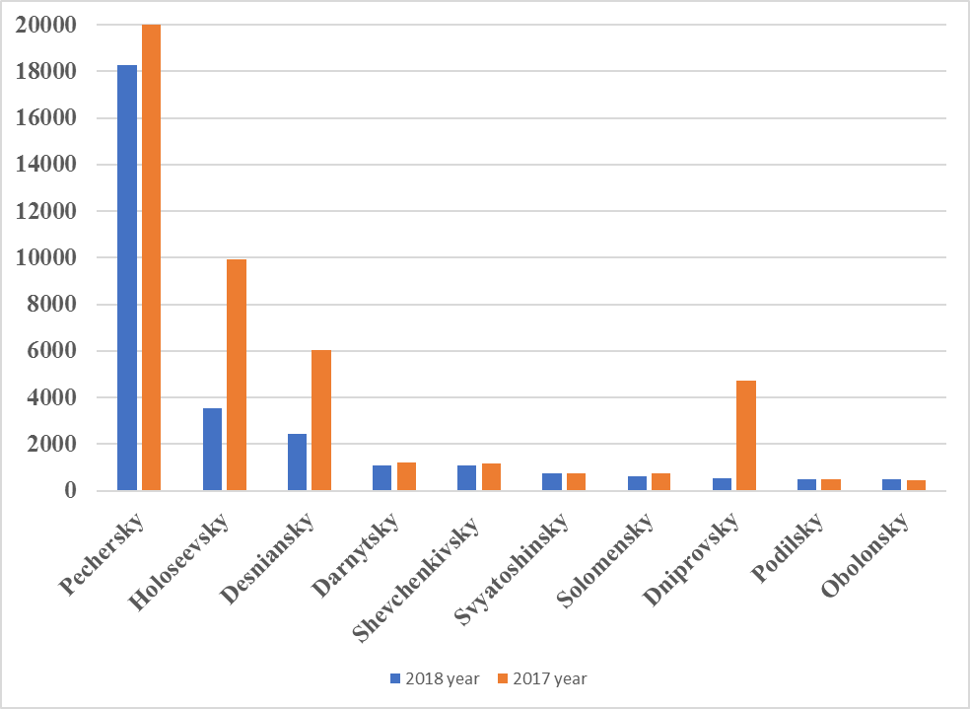
Fig. 3. Diagram of pollutant emissions into the atmosphere from stationary sources of pollution in Kyiv by 2018
Total emissions of pollutants into the atmospheric air of Kyiv from stationary sources of pollution by districts in 2018 amounted to 29,239.3 tons, representing 64.3% of the 2017 figures. The most polluted capital in 2018 was the supply of electricity, gas, steam and air conditioning - 25456.4 tons of emissions; manufacturing - 1814.3 tons of emissions; transport, warehousing, postal and courier activities - 729.2 tons of emissions; operation of water supply, sewerage, waste management systems - 252.2 tons of emissions.
Based on the above data, it can be argued that the environmental situation in Kyiv is difficult, in some areas it is close to dangerous. The most polluted in Kyiv are the Pechersk, Holosiivsky and Desnyansky districts. At the same time, the main enterprises of the city (Pechersky) are concentrated in these districts, they are the largest by area (Holosiivsky and Desnyansky) relative to other districts of the city. According to observations over the last ten years and their comparison with similar data on the environmental situation in different capitals of European countries, the health of Kyiv's population has deteriorated. [7] In addition, the city of Kyiv has lower rates of economic development and income than the European capitals. All these data will inevitably be considered in the future, with a more detailed consideration of economic indicators regarding the urbanization of the city of Kyiv and its suburban territories, as well as throughout Ukraine. [5]
CONCLUSIONS
The studies show that the economic and environmental situation in Kyiv is uneven. The factors that affect this are the high rates of housing, transport and civilian development, and the concentration of businesses in certain individual sub-areas. In the future, it is advisable to investigate the economic efficiency of the location of industrial objects, types of construction (civil, transport, residential, etc.) in the city areas, to offer the effect of a model of urban planning. In the context of the construction of microeconomic models, the author considers it expedient to conduct a study of the value of construction, land and lease for commercial real estate in Kyiv and the suburbs.
The issues of urbanization need to be considered and analyzed comprehensively, taking into account various factors that have an impact on the economy of the city and the state, namely: planning, urban design, strategic planning, economic and financial planning, environmental situation, as well as the use of land resources and basic factors of pricing for real estate in Kyiv and Ukraine. Particular attention in the fast time of urbanization and urban development needs to study the question - how changing the environmental situation can affect the economic performance of the district, city, state.
References
- The Verkhovna Rada of Ukraine (2019). The Law of Ukraine «On Regulation of City Planning Activity». Available at: https://zakon.rada.gov.ua/laws/main/3038-17
- State Statistics Service of Ukraine. Available at: http://www.ukrstat.gov.ua/
- State Statistics Service of Ukraine Kyiv Statistics. Available at: http://kiev.ukrstat.gov.ua/
- Kyiv State general plan for 2020. Available at: https://kga.gov.ua/generalnij-plan
- Nazarenko V.A. (2018). Suchasni vyklyky urbanizatsii - ekonomichnyi pohliad [Current challenges of urbanization - economic view]. Land management, cadastre and land monitoring, 2, 97-104.
- Ibatulin S.I. (2007) Kapitalizatsiia zemel prymiskykh zon velykykh mist: teoriia, metodolohiia, praktyka. [Capitalization of suburban areas of large cities: theory, methodology, practice] Kyiv. Ukraine: NAU, 260.
- Capello R., Nijkamp P. (2004). Urban Dynamics and Growth: Advances in Urban Economics. Contributions to Economic Analysis, 266, 1-863.

