УДК 556.53(477.82)
DYNAMICS OF EROSION-ACCUMULATION PROCESSES ALONG THE STREAM BED OF TURIYA RIVER (KOVEL HYDROPOST)

T. S. Pavlovska, PhD in geography, associate professor of the chair of physical geography in Lesya Ukrainka Eastern European National University
I. P. Kovalchuk, PhD in geography, professor, head of the chair of geodesy and cartography in National University of Life and Environmental sciences of Ukraine
Yu. V. Biletskyi, PhD in biology, associate professor of the chair of physical geography in Lesya Ukrainka Eastern European National University
О. V. Rudyk, senior lecturer of the chair of geodesy, Earth ordering and cadaster in Lesya Ukrainka Eastern European National University
R. M. Henaliuk, 1st year master’s student of specialty 014.07 „Secondary education (Geography)” in Lesya Ukrainka Eastern European National University
e-mail: kovalchukip@ukr.net
pavlovska2011@gmail.com
The article reflects the results of the study of deformations of the stream bed of the Turiya River (Kovel Hydropost, hydro range No. 5) during 1983–2018. For this purpose, multiple cross-sections of the channel and various combined flow curves were constructed and analyzed, the levels of water in the river, the relationships between the course of erosion-accumulation processes along the course and the dynamics of natural and anthropogenic factors are revealed. The information base of the study was the theoretical basis of the doctrine of channel processes, which are substantiated in the works of foreign and Ukrainian scientists, the materials of our own observations, data from the Volyn Center for Hydrology and Meteorology (hereinafter VCGM). In the process of solving the tasks, the methods of comparative analysis, synthesis, graphic, mathematical and statistical methods were applied; the system approach was applied.
During the study it was established that during the specified time interval in the stream bed there was an alternation of erosion and accumulation processes, which was expressed by the alternation of periods of some erosion of the stream bed and its siltation. The transverse profiles of the Turiya stream bed indicate that during the period 1983–1988, mainly accumulative processes prevailed in the channel, and in the following period (1988–2008) they changed to erosion ones. In recent years, rechargeable processes have become dominant and the profile of the stream bed in 2018 has come closer to its stream bed in 1988.
The flow and water level curves of Turiya confirm our conclusions about trends in erosion-accumulation processes along the stream bed. During the periods 1983–1988 and 1996–2000, the accumulation processes dominated, and at the interval of time from 1988 to 1996 and in 2000–2008 erosion processes dominated. The 2009, 2012, 2013, 2014, 2017 curves are in almost one field, which attests to the stability of the Turiya River over the last decade.
The development of channel deformations depends, mainly, on the hydrological regime of the river. The dynamics of erosion-accumulation processes along the river Turiya is consistent with the long-term regime of its maximum runoff: in the 80-ies of the last century a significant fall in the values of maximum discharge (some decrease in annual precipitation, the influence of the Kovel reservoir) was observed, which led to their erosion. Compared to this time period, around the 1990s and during the 2000s, the values of maximum discharge increased slightly. As a consequence, the eroding ability of the watercourse during floods and freshets increased, which slightly increased the cross-sectional area of the channel. In the last four years, the values of maximum discharge have been significantly lower than normal, and as a result erosion processes have weakened.
Reduction of the maximum discharge of the Turiya River, absence of runoff during the 2015–2018 boundary, dominance of accumulative processes in the channel leads to eutrophication of the watercourse, which, in turn, reduces its transport capacity and contributes to the further accumulation of solids. If this trend continues in the future, then the risks of flooding the Turiya floodplains in the event of heavy floods or freshets will increase.
Keywords: Volyn region, hydrological regime, hydropost, water flow and water level curves, transverse profile of river bed, Turiya River, surface runoff, stream bed deformations.

Actuality of theme. River systems and erosion-accumulation processes occurring in floodplain complexes under the action of constant watercourses have always been closely monitored by scientists and businessmen because of their widespread distribution on the earth's surface and of great importance for human life. After all, the processes occurring along river beds affect not only their morphology and hydrological characteristics, but also create certain advantages or threats to the effective conduct of economic activities. Hydrogeomorphological phenomena can be caused by both natural and anthropogenic factors.
The importance of the study of erosion-accumulation processes in the river system of the Turiya (right tributary of the Pripyat River) is dictated by several reasons: the very sensitive response of the river system to anthropogenic influence, due to the low water content and low transport capacity of the river, a small part of the underground component in the formation of its runoff; the need to predict the state of Polesia reservoirs in the face of global climate change; the great importance of the river for water supply to local settlements, in particular Kovel; the need to optimize the use, conservation and enhancement of the restorative potential of small rivers, to improve the quality of their water resources and to improve the environmental situation in the basin geosystems of Volyn Polesia.
Analysis of recent publications. Most practical and theoretical questions and provisions on channel processes are formulated on the basis of a considerable number of different observations, studies and generalizations of two major Russian scientific schools: erosion-accumulation doctrine (founders M. Makkaveiev and R. Chalov) and hydromorphological theory of bed-stream theory M. Kondratiev, I. Popov and others) [10]. Among the prominent scientists who investigated the stream bed there are the names S. Altunin, O. Andreiev, V. Bazylevych, N. Baryshnikov, M. Velikanov, M. Volman, V. Honcharov, N. Znamenska, A. Kahanov O. Kaftan, I. Krylenko, O. Kroshkin, I. Kuzmin, I. Levi, L. Leopold, V. Lokhtin, M. Rzhanitsyn, K. Rosynskyi, B. Snishchenko, S. Khakimov, Ye. Tsaitts, I. Yaroslavtsev and others [1].
In Ukraine in recent decades, studies of channel erosion-accumulation processes, the study of the intensity of horizontal and vertical deformations of river beds were engaged H. Bairak, S. Baranovskyi, Kh. Burshtynska, V. Vyshnevskyi, P. Horishnyi, V. Hrebin, L. Dubis, Yu. Karavan, A. Kyryliuk, B. Kindiuk, L. Kovalska, I. Kovalchuk, O. Kozytskyi, O. Konovalenko, L. Kosteniuk, A. Mykhnovych, Ya. Molchak, I. Nakonechnyi, O. Obodovskyi, V. Onyshchuk, V. Opechenyk, O. Palanychko, M. Pasichnyk, O. Pylypovych, O. Pochaievets, Z. Rozlach, Yu. Ryabokrys, V. Selskyi, M. Tsependa, V. Shevchuk, L. Shynkaruk, P. Shuliarenko, O. Shchodro, Yu. Yushchenko and others [2−7; 9−10; 12–20]. This is due to the significant intensification of these processes and phenomena under the influence of natural (climate change) and anthropogenic (deforestation, hydrotechnical and road construction, recreation) factors and the increasing scale of the negative effects of their impact on settlements and populations, lands and communications.
The purpose and task of the article. The purpose of the article is to detect deformations of the Turiya river bed in the range No. 5, located 135 m below the main Kovel hydropost, during 1983–2018, to find out the orientation of erosion-accumulation processes in the river channel and the conditions and factors of their development. To achieve this goal, the following tasks were set and solved: 1) to analyze the theoretical basis of studies of stream bed processes in the nineteenth and twentieth centuries, as well as the modern heritage of stream bed studies; 2) to study the stream bed regime of the rivers of Ukraine, types of stream bed deformations and the factors of their development; 3) to analyze the main factors and conditions of development of erosion-accumulation processes along the river Turiya (geological and geomorphological structure, climate, water runoff, anthropogenic influence); 4) to construct and analyze the combined time profiles (as of 1983, 1988, 2008, 2018) of the Turiya bed in the studied hydro range; 5) construct and analyze time-varying (1983, 1988, 1996, 2000, 2005, 2008, 2009, 2012, 2013, 2014, 2016, 2017) combined flow and water level curves in the river; 6) identify the links between the course of erosion-accumulation processes in the course and the dynamics of their natural and anthropogenic factors; 7) to evaluate the prospects for the development of channel processes in the studied hydro range.
Materials and methods of research. Methodology base of the study was the theoretical basis of the doctrine of channel processes, which are substantiated in the works of foreign and Ukrainian scientists, the materials of our own observations, data from the Volyn Center for Hydrology and Meteorology (hereinafter VCGM). In the process of solving the tasks, the methods of comparative analysis, synthesis, graphic, mathematical and statistical methods were applied; the system approach was applied.
Presentation of the main material and substantiation of the results of the research. With the help of Microsoft Office Excel 2003, we built computer models of the Turiya cross-section as of 1983, 1988, 2008 and 2018. For graphical constructions of each time slice, we chose depths at medium, maximum and minimum water levels. The constructed transversal profiles were superimposed on each other, which made it possible to analyze periodic changes of the section of the stream bed at different water levels during each of these years. In order to analyze the deformations of the channel over a multi-year period, we combined different profiles on one graph (Fig. 1). For this purpose, we selected the cross sections of the channel of the specified time sections at maximum water levels.
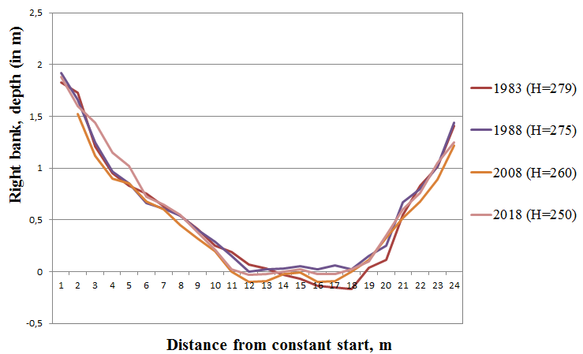
Fig. 1. Combined multiple times cross-sectional profiles of the Turiya River stream bed (Kovel hydropost, constructed by us according to VCGM)
Analyzing the state of the Turiya bed in 1983, we can see a more active manifestation of erosion processes near the left bank. The transverse profile of the bed in 1988 is somewhat different: in the part of the riverbed where the greatest depths were observed in the previous time slice, accumulation processes are now being traced. Thus, the maximum depth of the stream bed decreased by approximately 20 cm. In 2008, compared to 1988, the stream bed become deeper. However, the erosion rates do not exceed the previous alluvium accumulation indicators: the stream bed become deeper by 20 cm. The main difference the 2008 stream bed profile of the previous ones is that the erosion processes were directed to the right bank, whereas at the beginning of the study period they predominated near the left one. If we compare the cross-sections of the river bed in 2018 and in 2008, we can see that the accumulation processes have intensified closer to our time. Since the section of the riverbed in 2018 is most relevant for practice, it should be noted that during 2018 the riverbed was stable: its transverse profile did not undergo any special deformations during the change of hydrological phases (to construct the channel profile in 2018, we chose depth measurements during the spring flood (H = 250 cm, 14.04.2018), summer low water flow (H = 187 cm, 06.05.2018), winter low water flow (H = 224 cm, 13.01.2018). The slight deviations of the 2018 profile lines are within the permissible errors in determining the depths [8].
In order to determine as objectively as possible the orientation of the erosion-accumulation processes along the river Turiya, especially from 1988 to 2008 and from 2009 to 2017 (in this interval no profile of the stream bed was carried out, so its cross sections are missing), we analyzed the connection curves measured flow rates and water levels in 1983, 1988, 1996, 2000, 2005, 2008, 2009, 2012, 2013, 2014, 2017. Microsoft Office Excel 2003 was used to create graphical constructs. Shifts of the curves in the graphs of the relationship of water levels and flows up or down allows us to indicate river alluvium accumulation (accumulation) or erosion of the stream bed (erosion) [10].
The flow and water level curves of Turiya water in Figure 2 confirm our conclusions about the development of erosion-accumulation processes along the river bed over the study time, which are made on the basis of cross-section analysis. As can be seen from the constructions, the curve in 1988 deviates from the curve as of 1983, indicating the accumulation of alluvium along the river bed. The curve in 1996 shifts downward from the previous curve, which speaks of „subsidence levels” and therefore of the development of erosion processes. The reason for this is the increase in maximum water flow in 1996 to the level of the norm (note that in the previous 15 years the maximum costs were very low) (Fig. 3). The 2000 curve slightly exceeds the 1996 curve. It is likely that the accumulation processes have intensified again during this period. In 2005 and 2008, the flow and water level curves occupy one of the lowest positions on the graph, indicating the dominance of erosion processes at this time due to the surge in the values ​​of maximum water flow in 2005 and 2006 compared to 2001–2004, when the maximum runoff indicators were substantially below normal (see Fig. 3). The flow and water levels of Turiya in 2009, 2012, 2013, 2014, 2017 are in almost one field, indicating the stability of the river bed in the studied hydro range over the last decade.

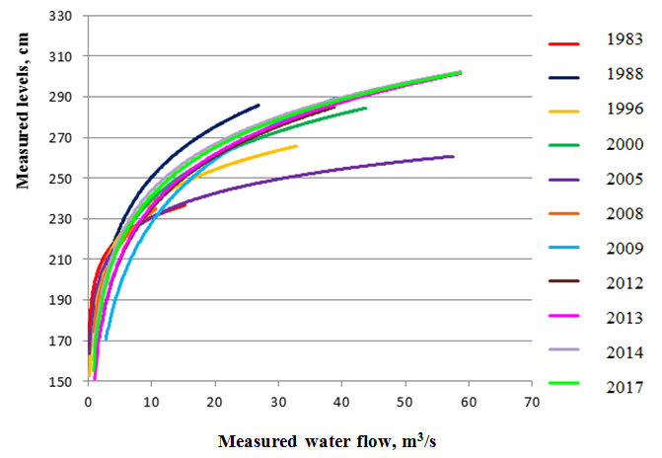
Fig. 2. Combined multiple times water flow and levels curves of the Turiya River
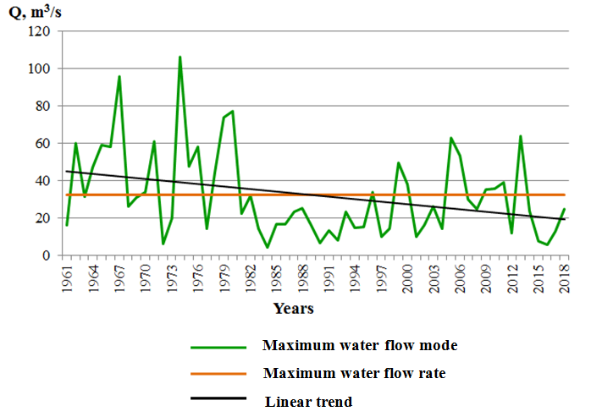
Fig. 3. Long-term dynamics of the maximum runoff of the Turiya River

Summary. During the study it was established that during the specified time interval in the stream bed there was an alternation of erosion and accumulation processes, which was expressed by the alternation of periods of some erosion of the stream bed and its siltation. The transverse profiles of the Turiya stream bed indicate that during the period 1983–1988, mainly accumulative processes prevailed in the channel, and in the following period (1988–2008) they changed to erosion ones. In recent years, rechargeable processes have become dominant and the profile of the stream bed in 2018 has come closer to its stream bed in 1988.
The flow and water level curves of Turiya confirm our conclusions about trends in erosion-accumulation processes along the stream bed. During the periods 1983–1988 and 1996–2000, the accumulation processes dominated, and at the interval of time from 1988 to 1996 and in 2000–2008 erosion processes dominated. The 2009, 2012, 2013, 2014, 2017 curves are in almost one field, which attests to the stability of the Turiya River over the last decade.
The development of channel deformations depends, mainly, on the hydrological regime of the river. The dynamics of erosion-accumulation processes along the river Turiya is consistent with the long-term regime of its maximum runoff: in the 80-ies of the last century a significant fall in the values of maximum discharge (some decrease in annual precipitation, the influence of the Kovel reservoir) was observed, which led to their erosion. Compared to this time period, around the 1990s and during the 2000s, the values of maximum discharge increased slightly. As a consequence, the eroding ability of the watercourse during floods and freshets increased, which slightly increased the cross-sectional area of the channel. In the last four years, the values of maximum discharge have been significantly lower than normal, and as a result erosion processes have weakened.
Reduction of the maximum discharge of the Turiya River, absence of runoff during the 2015–2018 boundary, dominance of accumulative processes in the channel leads to eutrophication of the watercourse, which, in turn, reduces its transport capacity and contributes to the further accumulation of solids. If this trend continues in the future, then the risks of flooding the Turiya floodplains in the event of heavy floods or freshets will increase.

References
- Bairak, H. (2018). Metody heomorfolohichnykh doslidzhen : navch. posibnyk [Methods of geomorphological research: tutorial]. Ivan Franko National University of Lviv, 292.
- Bairak, H. R. (2012). Riznochasovi ta suchasni doslidzhennia aktyvnosti ruslovykh protsesiv na Verkhnobeskydskii diliantsi Dnistra [Contemporary and contemporary studies of the activity of channel processes at the Upper Bieskid section of the Dniester]. Physical Geography and Geomorphology, 66, 216−225.
- Burshtynska, Kh. V., Shevchuk, V. M. (2012). Metodyka doslidzhennia zmishchen rusla riky Dnister [Methodology for the study of displacements of the Dniester River bed]. Available at : vlp.com.ua/node/10111
- Horishnyi, P. (2014). Horyzontalni deformatsii nyzhnoi techii rusla richky Stryi u 1896–2006 rr. [Horizontal deformations of the lower riverbed of the Stryy river in 1896−2006]. Problems of geomorphology and paleogeography of the Ukrainian Carpathians and surrounding territories, 68−74.
- Dubis, L., Kuzio, N. (2016). Typy rusla richky Bystrytsia Nadvirnianska [Types of the Bystrycya Nadvirnianska riverbed]. Problems of geomorphology and paleogeography of the Ukrainian Carpathians and surrounding territories, 1, 261−274.
- Eroziino-akumuliatyvni protsesy i richkovi systemy osvoienykh rehioniv [Erosion-accumulation processes and the river systems of developed territories] (2006), Lviv : Vydavn. tsentr LNU im. Ivana Franka, 315.
- Kovalchuk, I. P. (2006). Holovni rezultaty i perspektyvy doslidzhen richkovykh system ta eroziino-akumuliatyvnykh protsesiv na terytorii Ukrainy [The main results and perspectives of the researches of river systems and erosion-accumulation processes in Ukraine]. Erosion-accumulation processes and the river systems of developed territories, 263−276.
- Nastavlenie gidrometeorologicheskim stancijam i postam. Ch. 1. Gidrologicheskie nabljudenija i raboty na rekah. [The manual to hydrometeorological stations and posts. P. 1. Hydrological observations and river work] (1957). Leningrad : Gidrometeorologicheskoe izdatel'stvo, 6, 400.
- Obodovskyi, O. H., Onyshchuk, V. V., Tsaitts, Ye. S., Hrebin, V. V., Konovalenko, O. S., Riabokrys, Yu. O., Kozytskyi O. M. (2001). Hidromorfolohichnyi analiz ruslovykh protsesiv r. Teresvy [Hydromorphological analysis of river processes of the Teresva River]. Hydrology, hydrochemistry and hydroecology, 2, 343−351.
- Obodovskyi, O. H. (2001). Hidroloho-ekolohichna otsinka ruslovykh protsesiv (na prykladi richok Ukrainy) [Hydrological and ecological assessment of riverbed processes (on the example of rivers of Ukraine)]. Nika–Tsentr, 274.
- Pavlovska, T. S., Bondarchuk, R. I., Lykhach, M. I., Liashuk, K. M. (2018). Bahatorichna dynamika richkovoho stoku Turii (hidropost Kovel) [Long-term dynamics of the Turiya river runoff (Kovel hydropost)]. Proceding of the scientific and practical conference of Contemporary Science and Education in Volyn. Volodymyr-Volynskyi (Ukraine), 242−246.
- Pylypovych, O., Mykhnovych, A. (2016). Suchasni protsesy reliefoutvorennia u baseini richky Oriava (livyi doplyv Oporu) [Recent relief-forming processes in the Oriava river basin (left tributary of the Opir)]. Problems of geomorphology and paleogeography of the Ukrainian Carpathians and surrounding territories, 1, 194−205.
- Pochaievets, O. O., Rozlach, Z. V. (2014). Pavodky na richkakh baseinu Stryia ta yikh vplyv na morfolohichni zminy rusel [Floods on the rivers of the Stryi basin and their influence on the morphological changes of the riverbeds]. Land reclamation and water management, 101, 259−272.
- Selskyi, V., Kovalska, L. (2007). Pryrodno-istorychnyi aspekt formuvannia rusla r. Bystrytsia [The natural and historical aspect of the formation of the Bystrica Riverbed]. Scientific notes of Ternopil National Pedagogical University, 2, 26−30.
- Shuliarenko, I. P. (1998). Otsinka horyzontalnykh ruslovykh deformatsii ta stiikosti rusel malykh i serednikh richok baseinu Dnipra (v mezhakh Ukrainy) [Estimation of horizontal channel deformations and durability of river beds of small and medium-sized rivers of the Dnieper basin (within Ukraine)]. Taras Shevchenko National University of Kyiv. Kyiv, 16.
- Shchodro, O. Ye., Shynkaruk, L. A. (2014). Imitatsiine modeliuvannia ruslovoho protsesu ta prohnozuvannia ruslovykh deformatsii [Simulation of channel process and prediction of bed deformations]. Bulletin of the National University of Water Management and Nature Management, 4, 101−109.
- Shchodro, O. Ye., Baranovskyi, S. V., Nakonechnyi, I. M. (2010). Pobudova planovoi kartyny techii ta prostorovykh deformatsii rusla dovilnoi formy [Construction of a planned picture of the flow and spatial deformations of the riverbed of arbitrary shape]. Hydropower of Ukraine, 3, 36−39.
- Yushchenko, Yu. S. (2005). Heohidromorfolohichni zakonomirnosti rozvytku rusel [Geohydromorphological regularities of riverbeds development]. Ruta, 319.
- Yushchenko, Yu. S., Kyryliuk, A. O., Karavan, Yu. V., Pasichnyk, M. D., Palanychko, O. V. (2011). Rusloznavchi aspekty staloho rozvytku (na prykladakh richok Peredkarpattia) [Channellogic aspects of sustainable development (for examples of Precarpathian rivers)]. Hydrology, hydrochemistry and hydroecology, 3 (24), 8−14.
- Yushchenko, Yu. S., Kyryliuk, A. O., Kosteniuk, L. V., Opechenyk, V. M., Palanychko, O. V., Pasichnyk, M. D. (2012). Terytorialna struktura umov ta proiaviv rusloformuvannia richok [Territorial structure of conditions and manifestations of river bed formation]. Physical Geography and Geomorphology, 2 (66), 72−78.

Динамика эрозионно-аккумулятивных процессов в русле р. Турья (гидропост Ковель) Т. С. Павловская, И. П. Ковальчук, Ю. В. Билецкий, А. В. Рудик, Р. М. Геналюк. В статье отражены результаты исследования деформаций русла реки Турья (гидропост Ковель, створ № 5) в течение 1983−2018 гг. Для этого были построены и проанализированы разновременные поперечные профили русла и разновременные совмещеные кривые связи расходов и уровней воды в реке, обнаружены связи между ходом эрозионно-аккумулятивных процессов в русле и динамикой природных и антропогенных факторов. Методологической базой исследования были теоретические основы учения о русловых процессах, обоснованные в трудах зарубежных и украинских ученых, материалы собственных наблюдений, данные Волынского центра по гидрологии и метеорологии (далее ВЦГМ). В процессе решения поставленных задач использовались методы сравнительного анализа, синтеза, графический, математико-статистический; применялся системный подход.
В процессе исследования установлено, что в течение указанного временного интервала в русле реки происходило чередование эрозионных и аккумулятивных процессов. Поперечные профили русла Турьи свидетельствуют о том, что в течение 1983−1988 гг. в русле господствовали преимущественно аккумулятивные процессы, а в следующий промежуток времени (1988−2008 гг.) − эрозионные. Главными факторами такой динамики процессов выступали режим осадков и хозяйственная деятельность. В последние годы доминирующими стали аккумулятивные процессы и профиль русла 2018 приблизился по своим очертаниям к профилю русла 1988 г.
Кривые связи расходов и уровней воды Турьи подтверждают наши выводы о тенденциях развития эрозионно-аккумулятивных процессов в русле реки. В периоды 1983−1988 гг. и 1996−2000 гг. доминировали аккумулятивные процессы, а с 1988 по 1996 и в 2000−2008 гг. − эрозионные. Кривые 2009, 2012, 2013, 2014, 2017 находятся почти в одном поле, что свидетельствует о стабильности русла р. Турьи в течение последнего десятилетия.
Развитие русловых деформаций зависит прежде всего от гидрологического режима реки. Динамика эрозионно-аккумулятивных процессов в русле р. Турья согласуется с многолетним режимом ее максимального стока: в восьмидесятых годах прошлого века отмечается существенное падение значений максимальных расходов (некоторое уменьшение годовых сумм осадков, влияние Ковельского водохранилища), что и привело к затуханию эрозионных процессов. По сравнению с этим временным промежутком, примерно с 1990-х гг. и на протяжении двухтысячных годов значения максимальных расходов несколько возросли. Как следствие, усилилась эрозионная способность водотока во время наводнений, что несколько увеличило площадь поперечного сечения русла. В последние четыре года значения максимальных расходов были значительно ниже нормы, в результате чего эрозионные процессы замедлились.
Уменьшение максимальных расходов реки Турьи, отсутствие стока во время межени в течение 2015−2018 гг., доминирование аккумулятивных процессов в русле приводит к эвтрофикации водотока, что, в свою очередь, уменьшает его транспортирующие возможности и способствует дальнейшему накоплению твердого материала в русле. Если эта тенденция будет иметь продолжение в будущем, то риски затопления поймы р. Турьи в случае мощных наводнений будут возрастать.
Ключевые слова: Волынская область, гидрологический режим, гидропост, кривые связи расходов и уровней воды реки, поперечный профиль русла, река Турья, речной сток, русловые деформации.

Динаміка ерозійно-акумулятивних процесів у руслі р. Турії (гідропост Ковель). Т. С. Павловська, І. П. Ковальчук, Ю. В. Білецький, О. В. Рудик, Р. М. Геналюк. У статті відображено результати дослідження деформацій русла річки Турії (гідропост Ковель, гідроствор № 5) упродовж 1983−2018 рр. Для цього було побудовано та проаналізовано різночасові поперечні перерізи русла та різночасові суміщені криві зв’язку витрат і рівнів води в річці, виявлено зв’язки між перебігом ерозійно-акумулятивних процесів у руслі й динамікою їх природних та антропогенних чинників. Інформаційною базою дослідження були теоретичні основи вчення про руслові процеси, які обґрунтовані у працях зарубіжних та українських вчених, матеріали власних спостережень, дані Волинського центру з гідрології та метеорології (далі ВЦГМ). У процесі вирішення поставлених завдань було застосовано методи порівняльного аналізу, синтезу, графічний, математико-статистичний; дослідження базувалося на засадах системного підходу.
У процесі дослідження встановлено, що впродовж зазначеного часового інтервалу в руслі річки відбувалося чергування ерозійних та акумулятивних процесів. Поперечні профілі русла Турії засвідчують, що протягом 1983–1988 р. у руслі панували переважно акумулятивні процеси, а впродовж 1988−2008 рр. − ерозійні. В останні роки панівними стали акумулятивні процеси і профіль річища 2018 р. наблизився за своїми обрисами до профілю русла 1988 р.
Криві зв’язку витрат і рівнів води Турії підтверджують наші висновки про тенденції розвитку ерозійно-акумулятивних процесів у руслі річки. У періоди 1983–1988 рр. і 1996–2000 рр. домінували акумулятивні процеси, а на відтинку часу з 1988 до 1996 та у 2000–2008 рр. – ерозійні. Криві 2009, 2012, 2013, 2014, 2017 рр. знаходяться майже в одному полі, що засвідчує стабільність річища р. Турії упродовж останнього десятиріччя.
Розвиток руслових деформацій залежить, насамперед, від гідрологічного режиму річки. Динаміка ерозійно-акумулятивних процесів у руслі р. Турії узгоджується із багаторічним режимом її максимального стоку: у 80-их роках минулого століття відмічається суттєве падіння значень максимальних витрат (деяке зменшення річних сум опадів, вплив Ковельського водосховища), що й призвело до затухання ерозійних процесів. Порівняно з цим часовим проміжком, приблизно із 1990-их і впродовж 2000-их рр. величини максимальних витрат дещо зросли. Як наслідок, посилилася еродуюча здатність водотоку під час повеней і паводків, що трохи збільшило площу поперечного перерізу русла. В останні чотири роки значення максимальних витрат були значно нижчими від норми, у результаті чого ерозійні процеси послабилися.
Зменшення максимальних витрат річки Турії, відсутність стоку під час межені упродовж 2015−2018 рр., домінування акумулятивних процесів у руслі призводить до евтрофікації водотоку, що, своєю чергою, зменшує його транспортуючу здатність і сприяє подальшому нагромадженню твердого матеріалу в річищі. Якщо ця тенденція матиме продовження в майбутньому, то ризики затоплення заплав р. Турії у разі потужних повеней і паводків зростатимуть.
Ключові слова: Волинська область, гідрологічний режим, гідропост, криві зв’язку витрат і рівнів води річки, поперечний профіль русла, річка Турія, річковий стік, руслові деформації.

