ANALYSIS OF THE BIDDING IN UKRAINE: PROBLEMS AND PROPOSALS FOR IMPROVEMENT
Dorosh O., Doctor of Economics, Professor, National University of Life and Environmental Sciences of Ukraine, Kyiv, dorosholgas@ukr.net
Dorosh I., Doctor of Economics, Associate Professor, National University of Life and Environmental Sciences of Ukraine, Kyiv, dorosholgas@ukr.net
Tarnopolskyi Ye., Senior Researcher at the Institute of Land Use of the National Academy of Sciences of Ukraine kiev.cadastre@gmail.com
The state of legislative support as a basis for holding land auctions in Ukraine is analysed and the requirements for organizing and holding land auctions for creating, above all, conditions for their conducting on a competitive basis and in accordance with the economic interests of the state are found. In order to remedy the current situation, we collected, systematized and analysed statistical data on the conduct of land auctions during 2017-2019, the level of revenue for the right to lease or sell land, the effectiveness of the auction. It has been found that the purchase and sale of the right to lease land and land themselves through a land auction is a of selling them in the shortest possible time, but not at the best possible price. The not received funds for the right to lease or sell land during the period under review amounts to UAH 746 million 989 thousand, which is primarily indicative of the absence of financially viable buyers among Ukrainians. Against this background, problems with land bidding were identified, and proposals were made to address them.
Keywords: land auctions, electronic land auctions, land revenue, bidding performance
Introduction. Today, the land market in Ukraine operates and there is only one limitation - the sale of agricultural land and not for all types of purpose. However, instability, economic crisis, threat to territorial integrity - on the one hand, and on the other - the lack of formation of institutions in the field of land relations, in our opinion, are a precaution for lifting the moratorium on the sale of agricultural land without defining fuses for the development of speculators and fraudulent activity. In addition, local and foreign experts, scientists, politicians, financiers, representatives of agroholding companies, newly formed public associations, who consider themselves to be reliable “defenders” of peasants for the sake of urging them to lift the moratorium as soon as possible. However, according to research, starting from 2016 and up to now, the average weighted demand for offered agricultural land in Ukraine has been in the range of 60-70 percent [7]. The fact is that there are many willing to buy such land and rights to it, but there are no financially viable buyers among Ukrainians.
In order to confirm or refute the above, it is necessary to investigate in more detail the tendencies of holding traditional land auctions and electronic land auctions in Ukraine, their effectiveness in the dynamics (over the last three years) and to justify their conformity with the economic interests of the state.
Analysis of recent research and publications.
Among the recognized scientists who have investigated the issues of the evolution of the economic laws of the land market, the institutional features of its functioning, regulation of the agricultural land market, we note the works of I. Bystryakov, A. Danylenko, D. Dobryak, I. Dorosh, V. Zayats, S. Ibatullin, P. Kulynych, L. Novakovskyi, M. Stupen, A. Tretyak and others. The works of Y. Dekhtyarenko, Y. Mantsevych, Y. Palekha, A. Tarnopolskyi are devoted to the elucidation of contemporary theoretical and practical problems of formation of the urban land market. Specification of essence, substantiation of methods of development of the market of agricultural land plots is devoted to the works of V. Budziak, V. Dankevich, O. Dorosh, R. Kuryltsiv, G. Shary, R. Stupen and others. Collection of information related to the land auction in Ukraine, its systematization is presented in the publications of T. Molodid and O. Prutenko. Considering that introduction of the market of agricultural land is the most debatable problem among politicians, scientists, specialists, the public is in need of in-depth study of tendencies of holding land auctions in Ukraine, analysis of their effectiveness, scientific justification for compliance with the public interest.
The purpose of the research is to analyse the status of conducting traditional land auctions, electronic land auctions during 2017-2019, to assess the level of revenue for the right to lease / sell land, the effectiveness of auctions, to substantiate the compliance of the current system of preparation and holding of land auctions with the legislative requirements and economic interests of the state of Ukraine.
Results of the study and their discussion. In accordance with the Law of Ukraine "On Amendments to the Land Code of Ukraine on the Procedure of Land Auctions in the Form of Auction", which entered into force on 19 August 2012 [2], the content of Articles 135-139 of Chapter 21 "Sale of land or rights to them on a competitive basis »determined the procedure and rules for holding land auctions under which the land market operates in Ukraine. Article 135 of the Land Code of Ukraine [3] stipulates that land auctions are conducted in the form of an auction, the results of which conclude a contract of sale, lease, superficies, emphyteusis of the land plot with the participant (winner). The land auction must provide full conditions for the purchase of land plots subject to price competition between buyers (the winner of the tender is the tenderer who has offered for the lot the highest price offered for sale, or the highest fee for using it, recorded during the land auction ). Article 136 of the Code [3] provides for the procedure and mechanisms for the selection of land in state or communal ownership and the preparation of lots for sale at land auctions. The rules of preparation for holding land auctions (auctions) and the procedure for their holding are regulated by Art. 137 of the Land Code of Ukraine [3]. Determination of the rules for establishing the results of tendering and their publication is regulated by Articles 138 and 139 of the Land Code of Ukraine [3].
The Land Code of Ukraine also defines the rules of sale of land or rights to them based on the conclusion of civil contracts. Articles 127 to 129 define the procedure for the sale of land in state or communal ownership to citizens, legal entities and foreign states and foreign legal entities [3].
Electronic land auctioning in Ukraine is introduced with the adoption of the resolution of the Cabinet of Ministers of Ukraine "Some issues of improvement of management in the field of use and protection of agricultural land of state property and their disposal" of 7 June 2017 under No. 413 [5]. This resolution approved the Strategy for Improving the Mechanism of Management in the Field of Use and Protection of Agricultural Land of State Property and their disposal [9], which provides for the introduction of electronic land auctions only for lands of state property. And the sale of the right to lease land plots of communal property is carried out at the traditional auction, at their location, as provided by the Land Code of Ukraine.
However, according to the lawsuit of 45 Deputies, this resolution was considered by the Constitutional Court of Ukraine regarding its constitutionality. According to the communication department of the Constitutional Court of Ukraine and legal monitoring, resolution №413 was amended as not in conformity with the Constitution of Ukraine (is unconstitutional) [6]. Nevertheless, the State Geocadastre, since October 18, 2018, neglecting the general procedure for land auctions provided for by Articles 135-136 of the Land Code of Ukraine, has been active in conducting electronic auctions for land (plots of state property for conducting commodity agricultural production, which are managed by the State Geocadastre). Thus, electronic land auctions are outlawed, but they are actively conducted and announced on the website of the State Geocadastre.
The Law of Ukraine “On Land Auctions” guarantees the openness of the process of buying and selling land accessible to citizens and upholding the economic interests of the state. Does today's land bidding system meet these requirements?
Due to the functioning of the website of the State Geocadastre, information about the conducted and planned land auctions (contractors, land plots offered to be sold, the possibility of downloading technical documentation, obtaining an extract of the regulatory monetary valuation, photos) is considered as available to the public. Upon completion of the bidding, information on the price at which the lease right and a video of the bidding process are exercised is also included. However, the information obtained regarding the auctions, their results are not always sufficient. But the process of buying and selling land plots, contrary to the Land Code of Ukraine, is not transparent.
From these positions we analysed the course of holding land auctions in the dynamics during the 2017-2019 years by area of the land plots put up for auction; land plots (as the difference between the planned minimum land plots and the result of the auction – land plots lease/sale); bidding performance (by the number of auctioned lots, sold land use rights, cancelled bidding, the number of bidding results missing, the number of lots/plots missing from the announced list and the number of bidding that did not take place) and establish interdependence with the receipt of additional revenues in the budgets of different levels (Table 1).
The starting price of lots in accordance with the Land Code of Ukraine is a normative monetary assessment of land plots, so the risk of leasing them at a lower market price becomes obvious. After all, according to the calculations of economists, the market value of agricultural land in Ukraine amounts to $225 billion, and according to the normative monetary assessment, they are estimated at $40 billion [4].
Forming the market value of the land through the introduction of electronic land bidding for the sale of land leases for state-owned land plots for commodity agricultural production, is only possible if these bids are held at many auction centres and regularly.
Taking into account the current legal rules regarding the starting price of land auctions for state and communal land, their result is a non-market value that exceeds the expectations of most market participants. Moreover, it reflects the specific interest of bidders in the land, not the market conditions of its specific use. In this regard, competitively priced land and municipal land lease sales prices cannot be considered as an acceptable benchmark for private property market participants, for whom contracting is an act of voluntary will on the basis of their own and expert assessments.
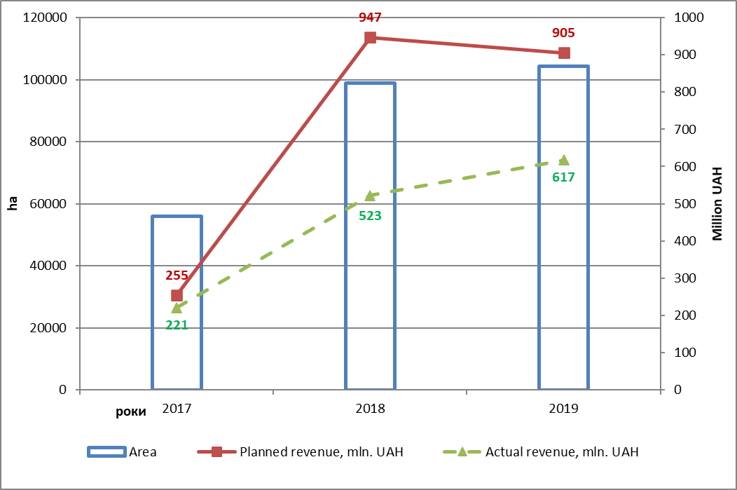
Comparisons of the land market indicators for 2017, 2018 and 2019 do not appear to be entirely encouraging. With the planned minimum revenue – 255 million 160 thousand UAH for land with a total area of 55.9 thousand hectares in 2017, their performance reached the level of 220 million 936 thousand UAH. Therefore, according to the results of the auctions for the nine months of 2017, budgets of different levels did not receive nearly 34 million 224 thousand UAH. The situation is similar in 2018 (data for twelve months is analysed). At a starting price of UAH 947 million, 164 thousand UAH for the lease or sale of land with a total area of 98.8 thousand hectares reached UAH 522 million 625 thousand, and as a result, budgets of various levels did not receive nearly 424 million 540 thousand UAH. The situation did not change in 2019 as well, for which the data were estimated for ten months (at the planned minimum revenue of UAH 905 million 282 thousand UAH for land with a total area of almost 104,4 thousand hectares, revenue for the lease or sale of land was 617 million 57 thousand UAH). Budget losses of various levels amount to UAH 288 million 225 thousand. Thus, according to the results of the auctions, during the period 2017-2019, budgets of different levels didn’t receive 746 million 989 thousand UAH, which was expected. (Fig. 1).
-424 million UAH
-288 million UAH
-34 million UAH
55928 ha
98827 ha
104371 ha

Figure 1. Land auctions revenue in 2017-2019
This is the price of lost opportunity to fill local budgets. The analysis of the statistics shows that even with the increase of the starting lease or sale prices of land plots in general, the expected results of the profits during the studied years were not achieved - they have a negative indicator.
The success of land auctions is significantly influenced by the successful selection of land plots, taking into account such factors as the location of the land plot, its area and the type of land.
If the land is located in the middle of a cultivated array, the area of which is up to 15 hectares, in most cases interest in the struggle for this lot is minimal, then a dummy participant is selected in order for the auction to take place without competition. In practice, land bidding is often offered for sale adjacent or adjacent land plots (5 to 15 ha) in separate lots. However, it would be more expedient to consolidate them to the size of 30 hectares and such a lot would be much more attractive.
The type of land also significantly influences the demand for the offered land for sale. The vast majority of tendered lots is arable land, but it is also offered to sell the lease of land occupied by pastures or hayfields. These lands are mostly used in agricultural production, but they have a limited use regime (it is forbidden to plow and grow crops), which is often neglected by business entities.
In addition, the legislation permits a procedure for changing the composition of land plot (such as arable land to pastures) that will have a much lower regulatory monetary value. For example, if a land user pays 2474 UAH of rent per hectare for the use of arable land, then only 454 UAH/ha for pastures will be paid, so the state will not receive almost 80% of the rent, bur the land plot will still be used as arable land [1].
Estimating the results of the bidding, we believe that the market offers are higher than the queries – 2069 lots or 58.6% of the total in 2017 remained unaddressed, respectively 4766 lots or 67.8% in 2018 and 4815 lots or 58.8% in 2019. The weighted average during 2017-2019 was 11650 lots, or 62.1%. It is also striking that during the study period, the number of cancelled bids reached 1081 (in most cases due to the winner not paying in due time for the purchased lot), 2674 – the number of bids that did not take place (due to lack of required number of participants), 339 – cancelled bidding (negligence of the auction organizers, auction announcements are placed at the same time as the results, etc.) and the number of bids whose results were not published – 283 (violation of the law by the auctioneers) (Fig. 2).

Fig. 2. Auctions performance in 2017-2019
Considering the results of the land auctions during the period under review, we consider them disappointing as they do not ensure the proper functioning of the land market to strengthen the Ukrainian economy, which is explained by a number of reasons, which include:
first, non-compliance with the requirements of the legislation regarding their organization and holding (reducing the duration of the lottery by one to two minutes instead of three; not signing the minutes of the auction immediately after the completion of the lottery, which is a risk for other participants in the auction; and their contractors a significant increase in the starting price for the lot, etc.);
second, the absence of financially viable buyers among Ukrainians;
third, insufficient number of bidders - two, three (bidding takes place without competition);
fourth, the formality of the land auction, as evidenced by the viewing of videos;
fifth, bidding only on one electronic platform – SE Setam (without any competition);
sixth, switching to electronic bidding format reduces the level of transparency of bidding, awareness of potential tenants and rural residents, the vast majority of whom are unable to monitor ads on the Internet regularly and so on.
In view of the above, we suggest that you consider the following recommendations:
1) to legalize the requirement to increase the number of land bidders (for example, auctions with the participation of four or more bidders have the corresponding results – In the Onufrieivskyi district of the Kirovograd region the starting fee has increased by 1003 percent, and for the rent of 1 hectare of land will be payed UAH 5613 annually; In the Karlovsky district in Poltava region respectively, the given figures reach 1159 percent and 6602 hryvnias, and in Romensky in Sumy region – 1464 percent and 4582 hryvnias. It should be noted that these are only few such cases [8].
2) In order to increase the level of awareness of stakeholders about planned land auctions, there is a need to make it mandatory and obligatory to place advertisements not only on the State Geocadastre's website, but also for district councils, state administrations and information booths of local authorities and local media;
3) in case of non-compliance with the requirements of the legislation by the organizers and performers of land auctions at the legislative level to provide for penalties;
4) in order to enhance the attractiveness of lots that are not in demand, it is advisable to introduce tenders as an additional type of land auction;
5) in order to conduct land auctions on a competitive basis, several electronic sites should be established. However, such electronic sites should operate according to the algorithm defined in Chapter 21 of the Land Code of Ukraine (sale of land or rights to them on a competitive basis) and ensure open competitive conditions for participation of all comers.
Restriction of bidding by three rounds, as foreseen by the draft Law of Ukraine No. 2195 “On Amendments to Certain Legislative Acts on and Sale of State and Communal Land Plots or Rights (Leases, Superficies, Emphysites) Through Electronic Auctions” will not achieve the maximum price as a result of the auction (Fig. 3).
6) Given the significant decrease in the size of the regulatory monetary valuation of land, which has come into force since 2019, compared to the previous one, it is advisable to determine the starting price of the land for sale at auctions by expert monetary valuation. Otherwise, the winners will be able to buy the land at a price approximately 20% less than the existing market. Once the land market is opened, this difference will continue to grow, and the auctions themselves, subject to restrictions on the resale of the land, can stimulate an increase in the number of speculative transactions (Fig. 4).

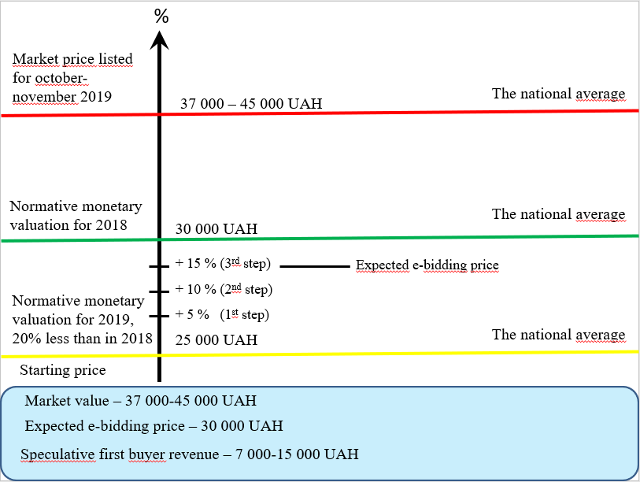
Figure 3. The ratio of the level of regulatory monetary valuation for 2018 and 2019 and the market price, formed in the autumn of 2019

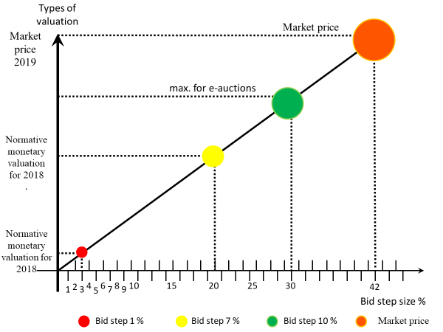
Figure 4. Expected results of the auction
Conclusion. Summarizing the above, there are reasons to believe that buying and selling land through a land auction is one way of selling them in the shortest possible time, but not at the best possible price. The current conditions undoubtedly require the regulation of a number of requirements at the legislative level regarding the organization and holding of land auctions in order to create, above all, conditions for their conduct on a competitive basis. And given the statistics of the last three years, the overall picture of auctions has had negative results. Insufficiency of filling the budgets of different levels during the studied period is measured at UAH 746 million 989 thousand, which does not correspond to the economic interests of the state and shows, first of all, the absence of financially able buyers among Ukrainians. Therefore, we should refute the thesis of certain experts-economists about the mad and rapid increase of GDP after the lifting of the moratorium on the sale of agricultural land in Ukraine.

Table 1. The area of the land, the lease of which is put up for auction. Bid results.
Year | Date of execution | The area of the auctioned land,  ha | Revenues for land, UAH |  |  | Bid performance |  |  |  |  |  |  | The price of the right to lease 1 ha as a result of bidding, UAH
Year | Date of execution | The area of the auctioned land,  ha | The planned minimum revenue for the land is the starting price | The result of the bidding is the auction for the lease / sale of land | +, -  to the scheduled revenue - the starting price | Number of lots auctioned | Number of land use rights sold | (%)  of the number of sites auctioned | Number of bids canceled | Number of trades that did not take place | Number of bids canceled | The number of bidding results that are missing
2017 | January | 2227,9414 | 12656933,83 | 5352300,85 | -7571327,19 | 136 | 74 | 54,4 | 7 | 29 | - | 24 | 2402,353
2017 | February | 2146,1110 | 48225855,60 | 44255604,64 | -3970250,96 | 151 | 110 | 72,8 | 9 | 24 | - | 3 | 20621,3
2017 | March | 6888,8402 | 28600154,39 | 28449219,46 | -150934,93 | 401 | 244 | 60,8 | 47 | 83 | - | 24 | 4129,755
2017 | April | 5832,5610 | 23164333,29 | 19908925,70 | -3255407,59 | 409 | 227 | 55,5 | 34 | 103 | - | 14 | 3413,411
2017 | May | 5308,4709 | 32584862,59 | 22807868,96 | -9776993,63 | 416 | 246 | 59,1 | 33 | 69 | - | 55 | 4296,504
2017 | June | 5816,8309 | 42405405,71 | 20276107,73 | -22129297,98 | 389 | 222 | 57,1 | 33 | 104 | - | 25 | 3485,765
2017 | July | 4110,0282 | 30067339,33 | 22588726,22 | -7478613,11 | 281 | 172 | 61,2 | 29 | 56 | - | 21 | 5496,003
2017 | August | 13680,8627 | 73901390,27 | 20813519,59 | -53087870,68 | 668 | 359 | 36 | 168 | - | 105 | - | 1521,36
2017 | December | 9915,9175 | 126937814,02 | 36483381,27 | -90454432,75 | 680 | 415 | 61,0 | 54 | 124 | 68 | 14 | 3679,274
2017 | Sum of 2017 | 55927,5638 | 255159754,94 | 220935650,27 | -34224104,67 | 3531 | 2069 | 58,6 | 282 | 760 | 68 | 180 | 3950,389
2018 | January | 2364,5126 | 90660779,36 | 13015410,56 | -77645368,80 | 218 | 149 | 68,3 | 5 | 50 | 1 | 7 | 5504,479
2018 | February | 6020,4245 | 45905351,43 | 21388579,69 | -24516771,74 | 357 | 249 | 69,7 | 19 | 82 | 2 | 1 | 3552,67
2018 | March | 8880,5597 | 41201126,12 | 32076542,99 | -9124583,13 | 605 | 402 | 66,4 | 27 | 153 | 2 | 17 | 3611,996
2018 | April | 7981,9994 | 380020804,05 | 41746523,65 | 3725719,60 | 554 | 421 | 76,0 | 21 | 96 | 8 | 7 | 5230,084
2018 | May | 7478,9282 | 103604713,99 | 36648761,34 | -66955952,65 | 577 | 375 | 65,0 | 33 | 153 | 6 | 5 | 4900,269
2018 | June | 11623, 7159 | 46188806,54 | 40870217,17 | -5318589,37 | 639 | 417 | 65,3 | 9 | 151 | 46 | 16 | 3516,106
2018 | July | 7736,4580 | 62358637,99 | 33042040, 48 | -29316597,51 | 545 | 375 | 68,8 | 40 | 111 | 9 | 9 | 4270,952
2018 | August | 9129,5389 | 62273645,98 | 41126114,79 | 21147532,19 | 602 | 427 | 70,9 | 36 | 130 | 8 | 1 | 4504,731
2018 | September | 8580, 0464 | 69668281,03 | 58676814,02 | -10991467, 01 | 679 | 491 | 72,3 | 31 | 148 | 2 | 4 | 6838,753
2018 | October | 7588,5362 | 60495137,77 | 41552277,28 | -18942860,49 | 575 | 375 | 65,2 | 20 | 144 | 28 | 6 | 5475,664
2018 | November | 8837,1170 | 38403398,34 | 75752447,64 | 37349049,30 | 697 | 441 | 63,3 | - | - | - | - | 8572,077
2018 | December | 12605,2046 | 124150804,30 | 86728851,69 | -37421952,61 | 983 | 644 | 65,5 | - | - | - | - | 6880,4
2018 | Sum of 2018 | 98827,0414 | 947164226,07 | 522624576,97 | -424539649,1 | 7031 | 4766 | 67,8 | 241 | 1218 | 112 | 73 | 5288,275
2019 | January | 4137, 4924 | 21765049,49 | 20216536,03 | -1548513,46 | 386 | 220 | 57,0 | 33 | 117 | 10 | 2 | 4886,181
2019 | February | 5070, 5418 | 122245665,14 | 120074694,76 | -2170970,38 | 425 | 218 | 51,3 | 11 | 94 | 100 | 1 | 23680,84
2019 | March | 10598,7938 | 105169085,74 | 102867947,93 | -2301137,81 | 827 | 489 | 59,1 | 61 | 232 | 32 | 4 | 9705,628
2019 | April | 9632,1093 | 54062383,86 | 44610224,04 | -9452159,82 | 554 | 281 | 50,7 | - | - | - | - | 4631,408
2019 | May | 13677,0000 | 46969000,00 | 50475000,00 | +3506000,00 | 1031 | 645 | 62,6 | 386 | - | - | - | 3690,502
2019 | June | 11997,0196 | 38927450,77 | 34238260,77 | -4689190,00 | 875 | 464 | 53,0 | - | - | - | - | 2853,897
2019 | July | 13061,2768 | 72410904,24 | 45470727,77 | -25940176,47 | 971 | 602 | 62,0 | 67 | 253 | 17 | 23 | 3481,339
2019 | August | 13876, 0883 | 158379449,57 | 54450922,95 | -103928526,62 | 1052 | 627- | 59,6 | - | - | - | - | 3924,083
2019 | September | 21622,8280 | 168005827,21 | 70382864,59 | -97622962,62 | 1382 | 780 | 56,4 | - | - | - | - | 3255,026
2019 | October | 6978,2533 | 117347207,64 | 74269882,07 | -43077325,57 | 688 | 489 | 71,1 | - | - | - | - | 10643,05
2019 | Sum of 2019 | 104371,3633 | 905282019,85 | 617057056,66 | -288224963,19 | 8191 | 4815 | 58,8 | 558 | 696 | 159 | 30 | 5912,13
 | Sum of 2017-2019 | 259125,9633 | 2 107606000,85 | 1 360617283,66 | -746988716,19 | 18753 | 11650 | 62,1 | 1081 | 2674 | 339 | 283 | 5250,795
Calculated by the authors on the basis of the data of the State Geocadastre and publications of the magazine "Land Surveying Bulletin" for 2017-2019.
References
- Hrab R. (2017). 5 faktoriv uspishnoho provedennia zemelnykh auktsioniv [5 factors for successful land auctions]. Ukrainian agrarian business club. Available at: http://ucab.ua/ua/pres_sluzhba/blog/roman_grab/5_faktoriv_uspishnogo_provedennya_zemelnikh_auktsioniv
- Law of Ukraine "On Amendments to the Land Code of Ukraine on the Procedure of Land Auctions in the Form of Auction" (2012). Available at: https://zakon.rada.gov.ua/laws/show/5077-17
- Land Code of Ukraine (2001). Available at: https://zakon.rada.gov.ua/laws/show/2768-14
- Ibatullin Sh. (2019). Normatyvna hroshova otsinka zemel Ukrainy [Normative monetary assessment of the lands of Ukraine]. Available at: https://www.facebook.com/shamil.ibatullin.5/posts/641325006312892
- Resolution of the Cabinet of Ministers of Ukraine “Some Issues of Improving Management in the Use and Protection of State-Owned Agricultural Lands and Management of them” (2017). Available at: https://zakon.rada.gov.ua/laws/show/413-2017-%D0%BF
- Pravovyi rezhym prava vlasnosti no zemliu maie vyznachatysia vykliuchno zakonamy Ukrainy [The legal regime of land ownership should be determined solely by the laws of Ukraine] (2019). Zemlevporiadnyi visnyk. Available at: http://zemvisnuk.com.ua/page/arkh-v-zemelnikh-novin-p-vr-chchya-2019-roku.
- Propozytsii bilshe nizh pokupstiv [There are more offers than buyers] (2019). Zemlevporiadnyi visnyk, 8. Available at: http://zemvisnuk.com.ua/sites/default/files/content/07-19.pdf
- Prutenko O. (2019). Rekord 2018-ho: u Velykykh Mostakh na Lvivshchyni richna plata za korystuvannia sotkoiu zemli siahnula maizhe 359 tysiach hryven [2018 record: in Velyki Mosty in Lvivska Oblast, the annual fee for the use of 0.01 ha of land has reached almost 359 thousand hryvnias]. Zemlevporiadnyi visnyk, 1, 20-25.
- Stratehiia udoskonalennia mekhanizmu upravlinnia v sferi vykorystannia ta okhorony zemel silskohospodarskoho pryznachennia derzhavnoii vlasnosti ta rozporiadzhenni nymy [Strategy for improving the management mechanism in the area of use and protection of agricultural land of state ownership] (2017). Available at: https://zakon.rada.gov.ua/laws/show/413-2017-%D0%BF#n12

