SCIENTIFIC AND METHODOLOGICAL FOUNDATIONS FOR ANALYZING THE STATE OF LAND USE BY INSTITUTIONS AND ENTERPRISES OF THE NAAS
Dorosh Y., Doctor of Economics
E-mail: landukrainenaas@gmail.com
Shkuratov O., Doctor of Economics
E-mail: shkuratov@nas.gov.ua
Avramchuk B., PhD in Economics
E-mail: avramchuk.bogdan@gmail.com
Kharytonenko R., PhD in Economics
E-mail: kharytonenkor@gmail.com
Institute of Land Management of the
National Academy of Agrarian Sciences of Ukraine

It is noted that the current procedure for conducting an inventory of land does not fully take into account the specific features of land use of individual land use industries. Emphasis is placed on the specialized activities of the National Academy of Agrarian Sciences of Ukraine (NAAS), which uses land and real estate in combination for scientific and research activities. It is emphasized that land resources and property of NAAS institutions and enterprises appear in two planes of the available information of the State Land Cadastre (GOK) and the data of the State Register of Real Property Rights (DRRP). At the same time, the existing land inventory procedure is limited in the plane compared to the information of GOK and DRRP data. The need to compare the data of GOK and DRRP of the current state of land use of institutions and enterprises of NAAS through analysis as a method of scientific knowledge is noted. The basic approaches, requirements to structural elements of carrying out the analysis in scientific, methodological and practical directions are offered. The structure of interaction of constituent elements at carrying out the analysis of a modern condition of use of the earths of establishments, the enterprises of NAAS is resulted.
Key words: research land use, analysis, land inventory.

Formulation of the problem. In preparation for the opening of the market for agricultural land, land management should play an important role in accounting and ensuring the sustainable use of land resources. Land registration in accordance with the Law of Ukraine "On State Land Cadastre" must be ensured by inventory of land and real estate. But the existing methodology of land inventory works does not take into account the specifics and features of a number of land users who have their own peculiarities in land use. Today, the problem of rational use, control and conservation of land resources is extremely acute. Lands of institutions and enterprises of the National Academy of Agrarian Sciences of Ukraine (hereinafter - NAAS) are one of the land users where it is necessary to take into account the specifics of the activity. This feature of NAAS is the use of land and real estate for research activities. From this it can be stated that land resources and property appear in two planes of available information, data of the State Land Cadastre (hereinafter - SCC) and data of the State Register of Real Property Rights (hereinafter - DRRP). However, land inventory may not fully combine the comparison of the two planes of available information, taking into account the specifics of research activities.
Today there is a need to analyze the available data on the composition of land resources and property on the example of institutions, enterprises of NAAS, because there is a problem of accounting, preservation and control of their rational use, and the existing land inventory is limited in comparing information data DZK and DRPP.
Analysis of recent research and publications. Scientific works on the analysis of the current state of land use are of a general nature in relation to administrative-territorial units. Insufficient attention was paid to the analysis of the state of land use of different types of land use. Currently, some scientific issues related to the inventory of land and accounting of these institutions, enterprises of NAAS, taking into account the specialized activities of land use and real estate for research activities have been covered in the works of domestic scientists:
Novakovsky L., Dorosh Y., Tarnopolsky A., Ibatullin Sh. conducted research, which revealed conceptual approaches to the formation of an automated management system of land and property complex of the National Academy of Agrarian Sciences of Ukraine. They considered “the main components of the automated land and real estate management system of NAAS: object composition of data, roles and levels of access to the system, information security, business processes and functionality, spatial and organizational structure, data quality, retrospective, data analysis and reporting, planning, etc. " [1].
Dorosh Y., Dorosh O., Kharytonenko R., Melnyk D. investigated the issues of the industry standard of land inventory of state institutions and enterprises of NAAS. They proposed the structure, content and composition of the main provisions of this industry standard, which takes into account the "specific" features in the use of land institutions and enterprises of NAAS [2].
Further research on the lands of NAAS institutions and enterprises should be aimed at finding new approaches to accounting, land inventory and filling the information of the automated land management system of NAAS. In view of this, there is a need to study the current state of land use of institutions and enterprises of NAAS through analysis as one of the main methods of scientific knowledge.
The aim of the study: determination of the main approaches and requirements to the structure of the analysis of the current state of land use of institutions and enterprises of NAAS.
Results of research and discussion. Analysis of the current state of land use of institutions and enterprises of NAAS should be considered in scientific, methodological and practical areas.
The term scientific direction should mean, first of all, the field of scientific research of a scientist or a group of scientists, a scientific school, aimed at solving significant problems in a particular field of science. Complex problems directly arise as structural units. Second, they are the most developed and recognized new theories or sets of interrelated theories (methods) that relate to a single object of study, but are based on different axiomatic doctrines and conceptual principles.
The object of study of this analysis are the land plots of a particular institution and enterprise of NAAS.
To solve new problems and apply new knowledge to solve specific problems, research is conducted by research (hereinafter - GDR). These are scientific works related to scientific research, research, experiments to expand existing and gain new knowledge, test scientific hypotheses, establish patterns that occur in nature and society, scientific generalizations and scientific substantiation of projects. In this case, the GDR to analyze the current state of land use of institutions and enterprises of NAAS acts as a scientific basis for the inventory of land for a particular institution and enterprise of NAAS.
- Methodology is a set of research techniques and methods in scientific knowledge. One of its main methods that will assess the current state of land use of institutions and enterprises of NAAS is analysis. Analysis is a method of research that studies an object, imaginary or real, dividing it into constituent elements, as part of the object, its features, properties, relations, or considers each of the selected elements separately within a single whole.
- Assessment of the current state of land use of institutions and enterprises of NAAS for a full analysis of the object of study is divided into five components:
- introduction;
- analysis of data of the State Land Cadastre;
- analysis of data from the State Register of Real Property Rights;
- conclusions and suggestions;
- applications.
The introduction is a section that explains the significance of the research topic, the objectives of the study, the legal component for the work, a description of the source materials provided by the customer, and their preliminary comparison with a possible description of the discrepancies.
The legal component for the performance of works on the analysis of the current state of land use of institutions and enterprises of NAAS are:
- Service agreement;
- Law of Ukraine "On scientific and scientific-technical activities";
- Land Code of Ukraine;
- Law of Ukraine "On Land Management";
- Law of Ukraine "On the State Land Cadastre";
- Resolution of the Cabinet of Ministers of Ukraine of June 5, 2019 № 476 "On approval of the Procedure for conducting an inventory of lands and recognizing as invalid some resolutions of the Cabinet of Ministers of Ukraine";
- Resolution of the Cabinet of Ministers of Ukraine of July 28, 2003 № 1180 "On approval of the list of paid services that may be provided by budgetary scientific institutions";
- Charter of the Institute of Land Use of the National Academy of Agrarian Sciences of Ukraine;
- other regulations, if necessary.
The source materials that allow to have a legal status, confirming the affiliation of these land plots to a specific institution or enterprise of NAAS and to systematize the information for a comprehensive analysis of data include:
- A copy of the state act on the right of permanent land use. Given the transition period and formation, changes in land legislation during the implementation of the Land Reform there were three types of forms of state acts on land:
1. a state act that did not contain the cadastral number of the land plot and could have data on several land plots with different purpose. It was issued to land users in the period from 1992 to 2001.
2 and 3 forms of state acts had a cadastral number indicating only one land plot. Published in the period from 2002 to 2008 (second type) and in the period from 2008 to 2012 (third type).
Copies of State Acts on Permanent Use of Land Issued to Collective Farms may be used to analyze the comparison of land boundaries;
- Certificate from the state statistical reporting on the availability of land and their distribution by land owners, land users, land (according to the form 6-land);
- Copying from the map (plan) of land plots of the research farm according to the information from the territorial departments of the State Geocadastre (State Land Agency);
- Decision of the Presidium of the National Academy of Agrarian Sciences of Ukraine on the withdrawal of land from land use;
- Developed technical or design documentation for land management of the studied farm;
- Information from the State Land Cadastre on property rights and property rights to land;
- Information from the State Register of Real Property Rights and the Register of Property Rights to Real Estate, the State Register of Mortgages, the Unified Register of Prohibitions; Expropriation of real estate in relation to the subject;
- Other materials, which include: report on sown areas of crops for harvest in the form № 4-sg (annual) and agrochemical cartogram of soils.
Analysis of the data of the State Land Cadastre for more detailed research, identification of problems and their specification should be divided into several subsections:
- Identification of the boundaries of registered land plots in accordance with State acts on the right of permanent use;
- Analysis of the compliance of land plots within the land use of the investigated institution or enterprise NAAS documents certifying the right of permanent use.
In the identification of the boundaries of registered land plots in accordance with the State acts on the right of permanent use, it is necessary to analyze the area of ​​land use within the study area. Indicate land plots within the land use, which are registered in the State Land Cadastre. Indicate the presence of third-party land users who are registered in the State Land Cadastre and are within the given surveyed institution or enterprise NAAS.
- In the analysis of compliance of land plots within the land use of the investigated institution or enterprise NAAS documents certifying the right of permanent use, it is necessary to compare the differences of areas under the state act on the right of permanent land use and data of the State Land Cadastre. Such an analysis is carried out both in general within the relevant village council and in comparison with a specific land plot under the state act on the right of permanent land use and the data of the State Land Cadastre.
- The analysis of the data of the State Register of Real Property Rights should be divided for more detailed research, identification of problems and their specification into several subsections:
- Identification of real rights to land in accordance with State acts on the right of permanent use;
- Analysis of the compliance of property rights to land within the land use of the studied institution or enterprise NAAS documents certifying the right of permanent use.
In the identification of real rights to land in accordance with the State acts on the right of permanent use it is necessary to analyze the land within the land use of the investigated institution or enterprise NAAS, real right, which are registered in the State Register of Real Property Rights.
In the analysis of compliance of property rights to land within the land use of the surveyed institution, NAAS enterprises with documents certifying the right of permanent use, indicate if there is a difference in the area of ​​surveyed land use under state acts on the right of permanent use in the State Land Cadastre data from the State Register of Real Property Rights (DRRP). Also conduct a comprehensive analysis of the compliance of the data of the State Land Cadastre with the data of the State Register of Real Property Rights in relation to the studied land use, comparing the cadastral numbers and the correspondence of land areas.
Conclusions and suggestions. The conclusion in the scientific literature is understood as the final thought, the logical result on the basis of the analysis of observation, reasoning or the result of factors. In the research work on the analysis of the current state of land use of institutions and enterprises of NAAS, the result is the generalization of information from the State Land Cadastre and the State Register of Real Property Rights. In the conclusions separately allocate offers, councils, recommendations on the decision of problem questions (Fig. 1).
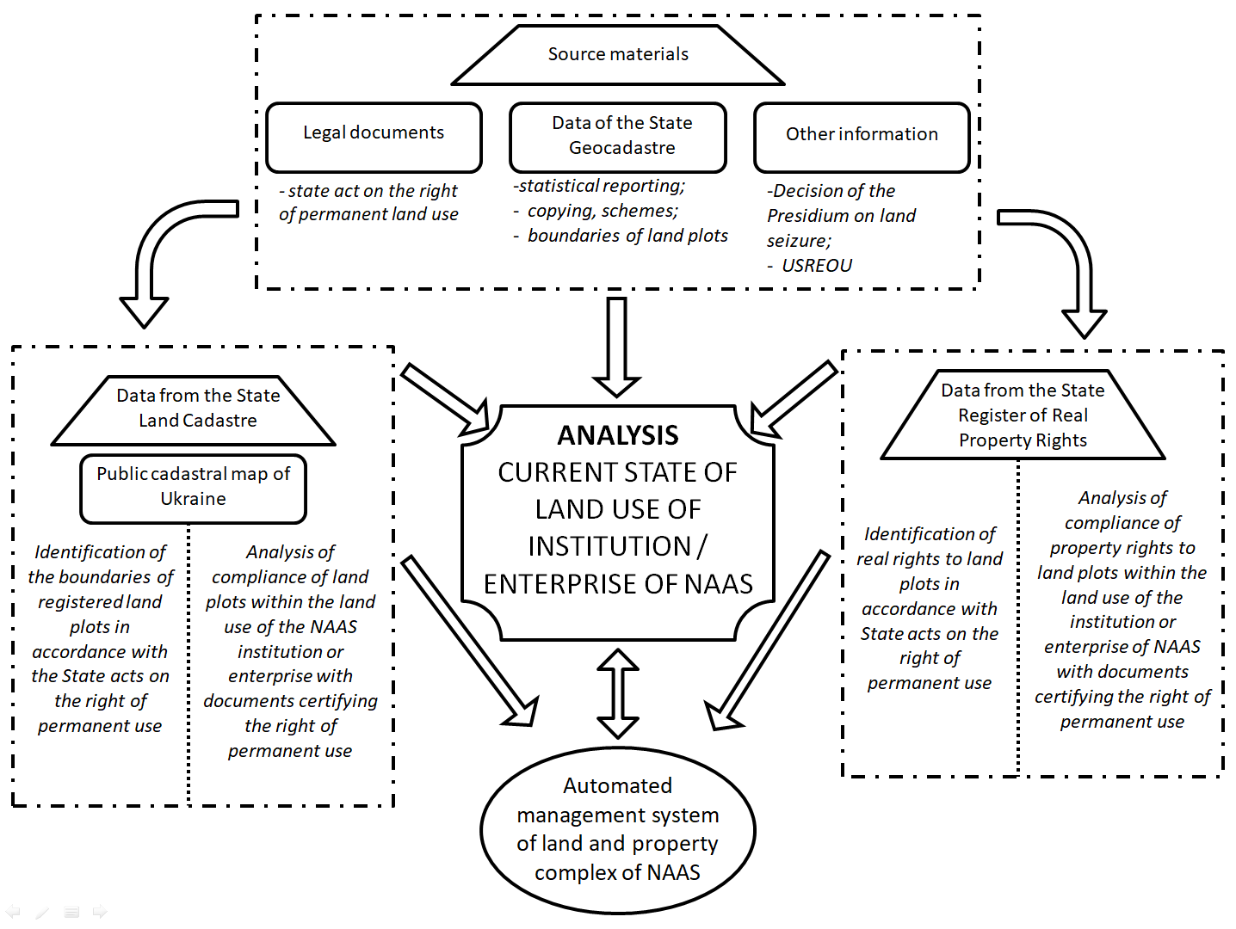
Fig. 1. Scheme of the structure of interaction of constituent elements in the analysis of the current state of land use of institutions, enterprises of the National Academy of Agrarian Sciences of Ukraine

A separate section of information that complements the research work, which in its content is not included in the main text of the study, are the annexes. In the analysis of the current state of land use of institutions and enterprises of NAAS applications can be:
- Scheme of land plots of the surveyed institution or enterprise registered in the State Land Cadastre;
- Scheme of land plots of the investigated institution or enterprise registered in the State Register of Real Property Rights;
- Copying from the Public cadastral map of existing and archival land plots registered in the State Land Cadastre.
Also, additional materials are supplemented by copies of title documents and extracts of information obtained from the State Land Cadastre, the State Register of Real Property Rights and the Register of Real Property Rights, the State Register of Mortgages, the Unified Register of Prohibitions.
Conclusions. In practical terms, thanks to the analysis of the current state of land use of institutions, enterprises of NAAS, were able to clarify the actual boundaries of specific land uses. This made it possible to identify and specify problematic issues, which in the legal field were not revealed only by conducting an inventory of land according to the existing methodology. Such problems included the registration of the real right to land plots in the State Register of Real Rights to Immovable Property. Also, the obtained analysis data supplemented and updated the information for the automated management system of the land and property complex, which combines land resources and property of institutions, enterprises that are part of the NAAS network. In turn, the existing inaccuracies and errors within the land use will be corrected, which will ensure the rational use of land and save land in the loyal institutions, enterprises of NAAS.

References
1. Novakovskyi L.Ia., Dorosh Y.M., Tarnopolskyi A.V., Ibatullin Sh.I. (2019). Kontseptualni pidkhody do formuvannia avtomatyzovanoi systemy upravlinnia zemelno-mainovym kompleksom Natsionalnoi akademii ahrarnykh nauk Ukrainy. Zemleustrii, kadastr ta monitorynh zemel, 2, 4–12. DOI: http://dx.doi.org/10.31548/zemleustriy2019.02.01
2. Dorosh Y.M., Dorosh O.S., Kharytonenko R.A., Melnyk D.M. (2019). Propozytsii shchodo struktury, zmistu ta skladu haluzevoho standartu inventaryzatsii zemel derzhavnykh ustanov ta pidpryiemstv NAAN. Zemleustrii, kadastr ta monitorynh zemel, 3, 15–22. DOI: http://dx.doi.org/10.31548/zemleustriy2019.03.02

Дорош.И.М., Шкуратов А.И., Аврамчук Б.О., Харитоненко Р.А.
НАУЧНО-МЕТОДИЧЕСКИЕ ОСНОВЫ ПРОВЕДЕНИЯ АНАЛИЗА СОСТОЯНИЯ ИСПОЛЬЗОВАНИЯ ЗЕМЕЛЬ УЧРЕЖДЕНИЙ И ПРЕДПРИЯТИЙ НААН
Отмечено существующем порядке проведения инвентаризации земель, не в полной мере учитывает специфические особенности использования земель отдельных отраслей землепользования. Акцентировано внимание на специализированной деятельности Национальной академии аграрных наук Украины (НААН), которая использует земли и недвижимое имущество в сочетании для научной и исследовательской деятельности. Акцентировано внимание, что земельные ресурсы и имущество учреждений и предприятий НААН выступают в двух плоскостях имеющейся информации данных Государственного земельного кадастра (ГЗК) и данных Государственного реестра вещных прав на недвижимое имущество (ДРРП). При этом существующий порядок инвентаризации земель ограничен в плоскости по сравнению информации данных ГЗК и ДРРП. Отмечена необходимость проведения сравнения данных ГЗК и ДРРП современного состояния использования земель учреждений и предприятий НААН через анализ как метод научного познания. Предложены основные подходы, требования к структурным элементам проведения анализа по научному, методологическом и практическом направлениях. Приведена структура взаимодействия составляющих элементов при проведении анализа современного состояния использования земель учреждений, предприятий НААН.
Ключевые слова: научно-исследовательское землепользования, анализ, инвентаризация земель.

Дорош.Й.М., Шкуратов О.І., Аврамчук Б.О., Харитоненко Р.А.
НАУКОВО-МЕТОДИЧНІ ОСНОВИ ПРОВЕДЕННЯ АНАЛІЗУ СТАНУ ВИКОРИСТАННЯ ЗЕМЕЛЬ УСТАНОВ ТА ПІДПРИЄМСТВ НААН
Наголошено на існуючому порядку проведення інвентаризації земель, який не в повній мірі враховує специфічні особливості використання земель окремих галузей землекористувань. Акцентовано увагу на спеціалізованій діяльності Національної академії аграрних наук України (НААН), яка використовує землі та нерухоме майно в поєднанні для наукової та дослідної діяльності. Акцентовано увагу, що земельні ресурси та майно установ та підприємств НААН виступають в двох площинах наявної інформації даних Державного земельного кадастру (ДЗК) та даних Державного реєстру речових прав на нерухоме майно (ДРРП). При цьому існуючий порядок інвентаризації земель є обмежений в площині у порівнянні інформації даних ДЗК та ДРРП. Наголошено на необхідності проведення порівняння даних ДЗК та ДРРП сучасного стану використання земель установ та підприємств НААН через аналіз як метод наукового пізнання. Запропоновано основні підходи, вимоги до структурних елементів проведення аналізу по науковому, методологічному та практичному напрямках. Наведено структуру взаємодії складових елементів при проведенні аналізу сучасного стану використання земель установ, підприємств НААН.
Ключові слова: науково-дослідне землекористування, аналіз, інвентаризація земель.

