УДК 529.46+004.67+332.3

DEVELOPMENT OF THE STRUCTURE OF THE GEOSPATIAL DATABASE FOR BEEKEEPING
I. Domina,
National University of Life and Environmental Sciences of Ukraine
E-mail: i_diomina@nubip.edu.ua
Abstract. The work draws attention to the importance of beekeeping to provide the population of Ukraine with food, as pollination is necessary to obtain many foods and more. The method of collecting information using Remote sensing is mentioned. And how is the operational approach to identifying possible locations of apiaries. The main problems of accumulation of a large amount of data are revealed, namely the methods of storing geospatial data. The main purpose is to develop a model of geographic information database that will store information about land (areas) safe and dangerous for bees. The necessity of such a database is substantiated, its constituent parts (land plots, safe zones with fodder base of beekeeping, buffer zones around dangerous objects, annual and perennial vegetation) are defined and described. The paper also gives examples of similar geoinformation databases of the European Union, the purpose of which is to monitor the forest stands of Europe (The Forest Information System for Europe). An example of application of the developed database in the country is presented and the direction of development with the help of geoinformation technologies is determined.
Keywords. Geospatial database, fodder base of beekeeping.

Introduction. Beekeeping is an important component of providing food for the population of Ukraine. Growing most vegetables, fruits and nuts is impossible without pollination. The security of this important area depends on many factors, but the most important are the forage base and the safety of bees. [1].
An important part of bee food is annual crops and forest plantations. Unfortunately, we do not have a single crop rotation registration system. Just as there is no single source of information about the location of trees with pollen in forest areas. The lack of automated collection and storage of spatial information on the location of the fodder base of beekeeping makes it impossible to effectively develop this area.
To improve the situation, it is necessary to study new modern approaches. Which will provide operational mapping and analysis of the location of land suitable for beekeeping [2].
Analysis of recent researchesand publications. The following scientists were engaged in the problem of determining the location of agricultural plants through the use of automated systems, as well as the development of solutions for land use planning: Olshevsky A., Pyatkova A. [3][4].
Studies of fodder base accounting and beekeeping development are covered in the works of Boyarchuk S., Zhuchenko D. [5][6].
The following scientists were engaged in the methodology of database development in geographic information systems: Burachek V., Zheleznyak O., Tereshchenko A. [7].
In the previous articles [8][9][10] the following issues were revealed: search of fodder base of beekeeping with the help of remote sensing data; automation of finding the optimal location of plots for the needs of beekeeping. The model of creating a geoimage of areas suitable for the apiary was built. However, the method of storing the obtained geospatial information was not provided.
Example of a modern geospatial database system is the European FISE system, which provides continuous monitoring of Europe's forest stands. [11][12].
Objectives of the article. The objectives of the work is to build a model of a geospatial database to provide a fodder base for beekeeping.
To achieve this goal it is necessary to solve the following tasks: to analyze the structure of such geospatial databases; to analyze the characteristics of the content of the future geospatial database on the basis of acquired knowledge; develop a model of the structure of the geodatabase; substantiation of the advantage of using the geoinformation database for the fodder base of beekeeping.
Materials and methods. To develop the structure of the geospatial database, the data from previous works [8] [9] [10] were chosen as the basis, where operational approaches to detecting honey vegetation using Remote Sensing of the Earth were considered. To achieve the goal of the study, the program “Diya” was used, where a UML diagram was built. The main research methods were: theoretical; method of analysis of characteristics of geospatial information; principle of geoinformation modeling.
The main materials. Examining the method of detecting honey vegetation in previous years [8][9][10] and methods of finding optimal places for beekeeping, the problem of accumulation and storage of the obtained data was revealed. Methods of geoinformation analysis of territories were used, but the method of building a knowledge base for geospatial information was not used. there was a question in the development of geographic information system for spatial data management with storage of attributive information about them.
So, it was decided to develop the structure of a geospatial database for beekeeping.
The geospatial database provides interoperability [13] of data considered in previous studies [8] [9] [10]: analysis of the distance to the fodder base of beekeeping and objects near which beekeeping is prohibited. This information should be accumulated in one place, characterize specific land plots and be publicly available. The figure below (Fig. 1) shows a diagram of the interaction of the components of the future geospatial database using a class diagram in UML.

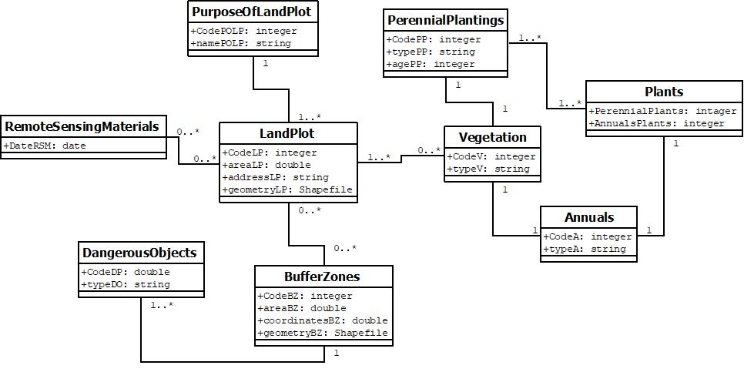
Figure 1 - The scheme of interaction of the components of the geospatial database for the needs of beekeeping is presented using a class diagram in UML

Description of the components of the developed scheme:
Land plot - territory on which the apiary can or cannot be located. It has area, geometry, exact location and unique code;
Purpose of land plot is one of the basic characteristics of any land plot, which determines its legal regime; [14] [15]
Remote sensing materials - Earth remote sensing data is the main operational source of geoinformation data and the main source of information support in the current state. With the help of remote sensing data it becomes possible to quickly find sites for the location of apiaries;
Dangerous objects - for the location of apiaries it is necessary to comply with the requirements of sanitary norms and rules. The location of apiaries near industrial facilities, roads, power lines, airports, farms and similar facilities is impossible; Buffer zones - used to place apiaries at a safe distance from industrial facilities;
Plants - to ensure the fodder base of beekeeping, honey vegetation is searched among the vegetation cover. Plants can be divided into annuals and perennials. Annuals are mostly agricultural crops, perennials are forest crops;
Safe zones - land plots containing honey plants and together with the buffer zone (not more than 2 kilometers) around them. They are the optimal areas for apiaries near the fodder base of beekeeping.
This database should collect data on flowering time, location, quantitative and qualitative characteristics of crops and forest plantations related to the fodder base of beekeeping. Remote sensing data should be updated automatically from open sources.
One of the options for implementing this project of a geospatial database at the state level is to introduce it into the National Structure of Geospatial Data [13].
To do this, it is necessary to ensure the introduction of up-to-date sustainable information from such resources as "Public cadastral map" [16] with verticalized land plots. In addition, it is necessary to create global vector layers with dangerous objects [2] and perennial vegetation, which is necessary for the calculation of buffer and safe zones.
Preservation of these data and open access to them: will provide up-to-date information to the beekeeping industry, facilitate the work of beekeepers, help prevent bee morbidity and death, make it possible to make spatial and temporal analysis in future studies.
In the following works it is planned to study the ways of development of this geoinformation database in the conditions of Ukraine. And development of ways to implement systems for storage and accumulation of information on agriculture. That will promote the development of beekeeping through a strategic plan for the development of crop rotation.
Conclusions. For effective management of beekeeping it is necessary to have stable information resources in this area. Prompt provision of up-to-date information on the fodder base of beekeeping and areas dangerous for bees is a necessary condition for sustainable management and development. With the help of modern technologies it is possible to facilitate the work of beekeepers, save thousands of bee families and increase the yield of crops that need pollination.
Using the research methods mentioned in the work, a geoinformation database was developed to provide beekeeping, which stores the operational and useful information needed in this field.

References

1. Law of Ukraine “On Beekeeping” Available Retrieved from: https://zakon.rada.gov.ua/laws/show/1492-14
2. Decree “On approval of the Instructions for the prevention and elimination of diseases and poisoning of bees” Available Retrieved from: https://zakon.rada.gov.ua/laws/show/z0131-01
3. Olshevsky, A.V. (2012). Ispol’zovaniye prostranstvennykh sistem podderzhki prinyatiya resheniy pri planirovanii zemlepol’zovaniya. Land of Belarus: Scientific and Production Journal, 2, 42-45
4. Pyatkova A.V (2016). Otsinka mozhlyvostey prostorovoyi HIS-realizovanoyi modeli ratsionalʹnoho vykorystannya zemelʹnykh resursiv. Bulletin of the ONU. Ser. Geographical and geological sciences, 2 (29), 85-95
5. Boyarchuk S.V (2015). Optimizacia zabespechennia kormami bdjolinih simey. Scientific Bulletin of the National University of Bioresources and Nature Management of Ukraine. Series: Technology of production and processing of livestock products, 223, 57-64. Retrieved from:http://nbuv.gov.ua/UJRN/nvnau_ tevppt_2015_223_10
6. Zhuchenko D. B (2013). Peredymovi efectivnogo fynctionuvannia galizi bdjilnitstva. Collection of scientific works of Uman National University of Horticulture, 83, 275-282. - Access mode: http://nbuv.gov.ua/UJRN/zhpumus_2013_83_46
7. Burachek V., Zheleznyak O., Tereshchenko A. (2014). Geoinformaciini systemy i bazy danyh, 492, 321-210. Retrieved from: https://studfile.net/preview/5377091/
8. Moskalenko, A., Domina, І. (2017). Identyfikatsiya osnovnykh medonosnykh kulʹtur zadanymy dystantsiynoho zonduvannya Zemli Land management, cadastre and land monitoring, 2, 66–74.
9. Moskalenko, A., Domina, І. (2018). Mappingbee forage trees. Land management, cadastre and land monitoring, 4: 61-67
10. Moskalenko A., Domina, І. (2019). Geoinformation modeling for location optimization of land parcels. Land management, cadastre and land monitoring, 2: 17–24.
11. The Forest Information System for Europe, official presentation. Retrieved from:https://www.unece.org/fileadmin/DAM/timber/meetings/20151102/ToS_Meeting/12-FISE-SANMIGUELAYANZ.pdf
12. Open Forest «Vidkrytyi Lis», Retrieved from:https://www.openforest.org.ua/127935/
13. Law of Ukraine “National geospatial data infrastructure”, Retrieved from: https://zakon.rada.gov.ua/laws/show/554-20#Text
14. Purpose of the land and responsibility for its violation. Legal Adviser, 5: 41. Retrieved from: http://yurradnik.com.ua
15. Land code of Ukraine, article 18-19. Retrieved from:
http://zakon.rada.gov.ua/ laws/show/2768-14
16. Public cadastral map of Ukraine, Retrieved from:https://map.land.gov.ua/?cc=3461340.1719504707,6177585.367221659&z=6.5&l=kadastr&bl=ortho10k_all

Дьоміна І.І.
РОЗРОБЛЕННЯ СТРУКТУРИ БАЗИ ГЕОПРОСТОРОВИХ ДАНИХ ДЛЯ ПОТРЕБ БДЖІЛЬНИЦТВА
Анотація. Робота звертає увагу на важливість бджільництва для забезпечення населення України продовольством, так як опилення є необхідним для отримання багатьох харчових продуктів і не тільки. Згадується спосіб збору інформації за допомогою Дистанційного моніторингу Землі, за допомогою якого здійснюється оперативний підхід у визначені можливих місць розташування пасік. Виявляються основні проблеми накопичення великої кількості даних, а саме способи зберігання геопросторових даних. Основною метою даної робити є розробка моделі геоінформаційної бази даних, що буде збегірати в собі інформацію про земельні ділянки (території) безпечні та небезпечні для бджіл. Обґрунтовано необхідність такої бази даних, визначено і описано її складові частини (земельні ділянки, безпечні зони з кормовою базою бджільництва, буферні зони навколо небезпечних об’єктів, однорічна та багаторічна рослинність). Також в роботі дано приклади подібної геоінформаційних баз даних Європейського союзу, метою якої є моніторинг лісових насаджень Європи (The Forest Information System for Europe). Представлено приклад застосування розроблюваної бази даних в масштабах країни та визначено напрямок розвитку за допомогою геоінформаційних технологій.
Ключові слова. База геопросторових даних, кормова база бджільництва.
Дёмина И.И.
РАЗРАБОТКА СТРУКТУРЫ БАЗЫ ГЕОПРОСТРАНСТВЕННЫХ ДАННЫХ ДЛЯ НУЖД ПЧЁЛОВОДСТВА
Аннотация. Работа обращает внимание на важность пчеловодства для обеспечения населения Украины продовольствием, так как опыление необходимо для получения многих пищевых продуктов и не только. Упоминается способ сбора информации с помощью Дистанционного мониторинга Земли, с помощью которого осуществляется оперативный подход в определение возможных мест расположения пасек. Выявляются основные проблемы накопления большого количества данных, а именно способы хранения геопространственных данных. Основной целью этой работы является разработка модели геоинформационной базы данных, которая будет сохранять информацию о земельных участка (территориях) безопасных и опасных для пчел. Обоснована необходимость такой базы данных, определена и описана ее структура (земельные участки, безопасные зоны где находится корм для пчёл, буферные зоны вокруг опасных объектов, однолетняя и многолетняя растительность). Также в работе даны примеры подобной геоинформационной базы данных Европейского союза, целью которой является мониторинг лесов Европы (The Forest Information System for Europe). Представлены пример применения разрабатываемой базы данных в масштабах страны и определено направление развития с помощью геоинформационных технологий.
Ключевые слова. База геопространственных данных, кормовая база пчеловодства.

