UDK 322
PROSPECTS FOR INTRODUCTION OF THE AGRICULTURAL LAND MARKET IN UKRAINE
H.M KOLISNYK
Phd of Economic Sciences, Senior Lecturer of the Department of Land Resources Management NULES of Ukraine
I. V Trokhymenko
Master of the Department of Land Resources Management NULES of Ukraine

The evolution of agricultural land use development in Ukraine has been studied. The main factors influencing the land market on the formation of agricultural land use are identified, they include: the number of potential buyers (land users) and sellers, the expiration of the lease, the structure of the land bank of the agricultural enterprise (lease, ownership), land consolidation based on land purchase and sale . The article, based on the example of Narizhanska village council of Poltava district, established that only 30 percent of landowners will be able to sell their land plots due to the expiration of the lease agreement.
The authors study the factors influencing the efficiency of agricultural land use in the land market, the main ones are: violation of crop rotation, a lot agricultural and arable lands, low rents and competition of land users, low percentage of small land use and low level of their financial support, changes in natural and climatic conditions, lack of effective tools for terminating leases.
The authors propose to make proposals to the legal framework regarding the possibility of one-time termination or renegotiation of lease agreements due to changes in significant conditions (turnover of agricultural land), which will intensify the sale process, increase investment attractiveness of enterprises with increasing private property portfolio. , as well as positively affect the welfare of landowners of land shares (units) and more. The article proposes to ensure the formation of sustainable land use by improving the regulatory framework, promoting the involvement of various investors in the purchase and sale of land, ensuring an environmentally friendly structure of sown areas, inclusion in land management documentation of land consolidation projects and more.
Keywords: agricultural land use, agricultural land market, land lease, landowners, land users

Formulation of the problem. The issue of theory and practice of agricultural land use occupies a key place in the agricultural policy of the state because agribusiness is one of the main sources of currency, while agricultural land occupies most of the country. This issue becomes especially acute under the influence of the introduction of the agricultural land market [12].
In the context of today's deteriorating conditions for sustainable development of nature, the widespread predominance of economic priorities over the principles of sustainable development and public interests in Ukraine as a whole, it is necessary to make extremely important decisions on the introduction of the agricultural land market.
Many tasks, including the formation of an effective owner, and others that were set before the land reform have not been completed today, and the opening of the market will take place this year.
Given the above, further research requires theoretical, methodological and practical principles of agricultural land use in the functioning of the market, namely: market limitations; fiscal policy; establishing the necessary initial conditions; fullness of the State Land Cadastre, including restrictions on land use; as well as scientifically sound spatial parameters of land use; guaranteeing competitiveness, etc.
Analysis of recent research and publications. In recent years, research on the introduction of the market for agricultural land is being conducted quite actively. The analysis of different stages of transformation of agrarian relations, formation of land uses in market conditions, creation of conditions for ecologically safe, development of lease relations and economically efficient land use in Ukraine is devoted to the works of such scientists D.S. Dobriak, A.H. Martyn, L. Y. Novakovskyi , A.M. Tretiak, M.M. Fedorov and others. Issues of development of the market of agricultural lands - Zaiats V.M. Scientific and methodological principles of transformation of agricultural land use were studied by Kolisnyk H.M. Theoretical and methodological principles of formation of restrictions (encumbrances) in land use were dealt with by J.M. Dorosh, OS Dorosh., R. Levek, O.V. Khodakivska, and I.V. Yurchenko studied the international experience of agricultural land market formation.
Nevertheless, there is a wide range of debatable issues to identify trends in land relations, including scientific and methodological support for the formation of united territorial communities, definition and formation of its own model of agricultural business development, differentiation of methods of state and market regulation of land and property relations.
The purpose of the article is to study the prospects for the introduction of the agricultural land market.
Results of the research. As a result of the evolution of land relations, including forms of ownership of land and other natural resources, the main forms of ownership have been formed, which are equal to each other - state, communal, private. Depending on the socio-economic development of each territory or country, the relationship between them may vary. At the same time, each form of ownership plays its important function: communal - aimed at organizing the full life of the inhabitants of territorial communities; state - to ensure security, law enforcement, innovation, social, recreational, special functions or to ensure the priority of economic development of various sectors of the economy (land for defense, nuclear energy, natural resources, unsuitable areas for economic activity, etc.); private - focuses on meeting personal or market priorities [5].
Since each form of ownership has equal rights and common interests of use, they can also be combined into land use to achieve economic, social or environmental goals, and it is believed that only the owner can use their property most effectively. In this aspect, the main tasks of land reform in Ukraine were formed - to create an effective owner. Of course, from the economic point of view, the most approximate form of ownership for the enslavement of economic interests is private, but all forms of ownership have their advantages and disadvantages.
Ukraine's gradual transition to a market economy has led to the need to begin the process of transforming land relations. The process of land privatization has begun. Accordingly, agricultural land use has undergone an evolutionary path in Ukraine, which can be divided into the following stages [7,8]:
state monopoly on land;
land reform (unbundling of lands of collective and state farms);
mass privatization of land;
crushing of land;
functioning of agricultural land uses based mainly on lease relations;
formation of full-fledged agricultural land use with the introduction of the circulation of agricultural land.
An important aspect of influencing the development of the land market is the study of international experience in the functioning of the agricultural land market. Summarizing the experience of other countries in the introduction of the land market and the state of development of agricultural land use can be identified key characteristics, see table. 1.
Most of the countries with developed economies have a free market for agricultural land, along with this, each country has certain features (restrictions). At the same time, the production of agricultural products from the above list of the country occupies a small part of the total gross product of the country, usually not more than 10 percent. The predominant form of ownership of agricultural land is private ownership. Given the data in Table 1 and the experience of other countries, we can say that despite the reasons, features and path to the introduction of the market of agricultural land in most countries, it operates successfully and is an integral part of the economy, and agricultural land on a number of others are a commodity.

Table. 1 Foreign experience in the functioning of the market of agricultural land
Country | Area of agricultural lands | Presence of land market | Market restrictions | Price, $ / ha | Level of plowing,% | GDP of agricultural sector in the general structure,% | Predominant form of ownership
England | 36,3% | + | Present | 23450 | 25,9 % | 0,7% | proprietary
France | 43,18% | + | Present | 6270 | 33,5% | 2,3% | proprietary
Netherlands | 54,9% | + | Present | 68200 | 10,1% | 1,8% | proprietary
Poland | 47,1% | + | Present | 10300 | 35,2% | 3,3% | proprietary
Israel | 24,1% | + | Present | _ | 13,7% | 2,5% | proprietary
USA | 44,3% | + | Present | 10200 | 16,6% | 1,4% | proprietary
Canada | 7,0% | + | Present | 4450 | 5,0% | 9,0% | proprietary
Argentina | 54,5% | + | Present | 14000 | 26,6% | 8,3% | proprietary
Australia | 53,20% | + | Present | 1600 | 6,0% | 3,0% | proprietary
Formed on the basis of materials [1, 9, 10]

Today in Ukraine there are almost 41.4 million hectares of agricultural land, of which 32.7 million hectares are arable land, which is the level of plowing about 54% in Central Europe - 35%, which indicates an excessively high level of plowing in Ukraine. It should be understood that 31 million hectares are privately owned, which is 25.3 million landowners and land users, of which 6.9 million are unit holders. At the same time, the structure of agricultural use lands are as follows: cultivated by owners - 29%, leased - 56, leased from the state - 8, not cultivated 7. The area of ​​chernozems, potentially the most attractive for agricultural production according to various sources is 15.6-17.4 million hectares , which is actually half of the arable land. A poll by the Institute of Agrarian Economics of the National Academy of Sciences of Ukraine showed that only 13 percent of Ukrainians plan to sell land from those who inherited it, and only 5 percent who received a share at work. The share of owners who want to start their own business or leave it for their own use is 22% (who inherited) and 13 (who received it for the first time). The largest number of landowners plan to lease their land, namely 38% of those who inherited and, accordingly, the first 48 landowners [6]. In this case, we are talking only about intentions, not about the actual sale. In general, the above data indicate restrained expectations of the population regarding the sale of their own land plots.
In addition to the survey data and the intentions of landowners, an objective deterrent to the lease of land, which actually eliminates any desire to sell or increase the cost of rent. We analyzed the data of the State Land Cadastre (Public Cadastral Map) on the duration of land lease on the example of land located in the Narizhanskaya village council of Semenivsky district of Poltava region with the assumption of the shortest possible lease of land (7 years), according to the Law of Ukraine About land lease » [4, 11].
The most popular are contracts concluded for 7 years, given the current trends leading to the open market of agricultural land, and consequently the possible increase in the cost of land lease, most tenants are already trying to re-sign leases for more than 10 years.
The duration of the lease of land should depend on the intention of the lessee to rationally use the land and the specifics of growing crops. As the moratorium distorts the functioning of the agricultural land market, most private agricultural land is leased. Currently, about 4.7 million private owners (70% of the total) lease their land to agricultural producers - the total size of the official rental market is about 17 million hectares.

Fig. 1. Term of expiration of lease agreements for agricultural land plots on the territory of Narizhanska village council,% [Error: Reference source not found]

After analyzing agricultural land plots with an area of ​​more than 0.8 hectares on the territory of the community, the results were obtained on the terms of the end of the lease of land plots on the territory of Narizhanska village council. This chart highlights the three largest sectors, which correspond to 2022, 2026 and 2027. At the same time, in 2026 and 2027 there are 45.66% of contracts, if we add 2025 to this figure, we get more than 56% of contracts whose validity expires in 4-6 years after the introduction of the agricultural land market. That is, from the very beginning of the introduction of the agricultural land market, not all landowners will be able to feel its benefits. Given the above, to create favorable conditions for the formation of a fair and transparent market of agricultural land, we propose to amend the laws of Ukraine the possibility of one-time termination and / or revision of land lease agreements after the launch of the agricultural land market, because there is a situation when someone can sell someone will have to wait for the end of the lease. Such changes will stimulate the market, accelerate the process of land consolidation, increase supply and increase state budget revenues, and so on.
In addition to the expiration dates of leases, the main market factors that will determine the value of land, including leases, are supply and demand. Focusing on the study of the "Institute of Agrarian Economics" NAAS and the time periods of completion of leases, we can talk about a moderate supply of land in the market.
Demand for lease rights will remain stable or grow slowly, but there will be far fewer people willing to buy agricultural land. For example, we analyzed the structure of tenants of land plots (land shares) according to which a sufficient number of potential buyers and / or tenants in the village council, but three tenants have about 67 percent of agricultural land in use (see Fig.2). But it is clear that the mere presence of potential buyers does not make an agricultural enterprise attractive for investment.
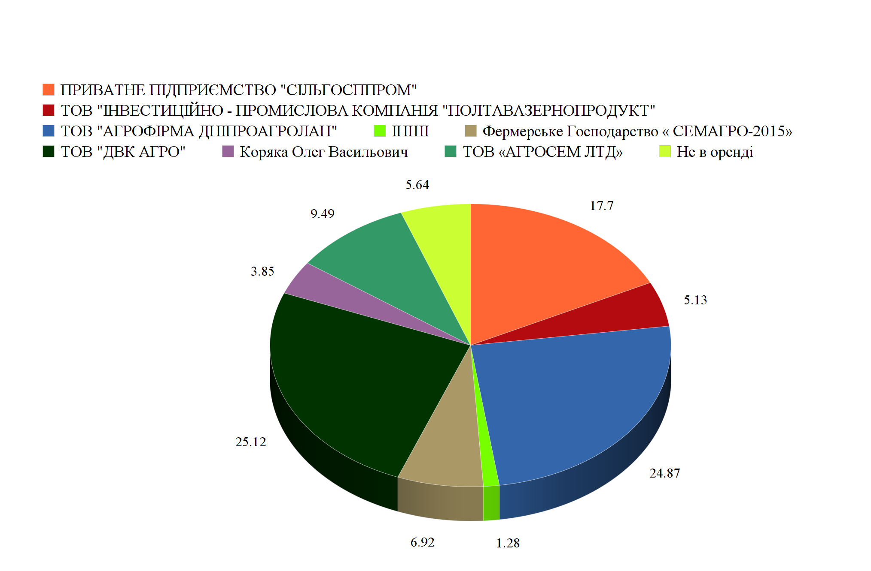
Fig. 2. The structure of leased land in terms of land users,%

To ensure successful investment and the formation of rational land use, it is necessary to ensure the possibility of land consolidation, which will take place transparently, rationally and legally. To date, the state does not actually benefit from the exchange of land between land users, which carries it out without any notarization and payment of taxes, while violating the rights of landlords. In fig. Figure 3 shows a fragment of the field, which most likely confirms this fact (Fig. 3). For example, land plots shown in blue and yellow are leased, but not to the land user whose land plots are highlighted in red, but are most likely to be in his actual land use.
One of the important factors of investment attractiveness of enterprises is its size (market share) and the ratio of assets and liabilities, then the amount of resources involved and the corresponding ratio of own and leased means of production are of key importance. [5]. With regard to agricultural enterprises (land use), the importance is also the value of the share of the land bank, which owns the enterprise, and which is in use, which will certainly affect the investment attractiveness. Also an important role is played by the part of the company's portfolio depending on the duration of land lease and the degree of their consolidation, which will take place in parallel with the development of the land market.
In the formation of land use, in addition to the investment portfolio of the enterprise, an important role is played by the existing restrictions on the use of land, which are currently included in the State Land Cadastre in small quantities. The restrictions themselves provide for the regulation of the legal regime of land in the conditions of private property and become especially acute in the conditions of functioning of the market of agricultural lands. At the same time, restrictions on land use and encumbrances on land rights should ensure the harmonization of private, state and public interests, including ensuring environmentally friendly land and nature use. [Error: Reference source not found,13]. Today, land users actually level the issue of implementation and compliance with environmental and agro-technical restrictions, especially in the formation and use of agricultural land, which is important for the formation of sustainable agricultural land use.
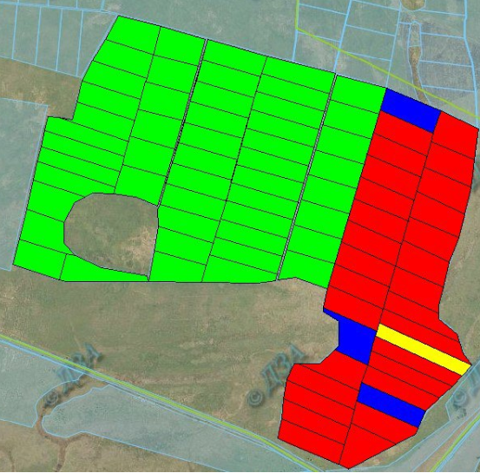

Fig. 3. Schematic representation of a fragment of land use from the Public cadastral map

In general, the question of the effectiveness of agricultural land use in the land market lies in the solution of environmental, economic and social problems. The main ones include:
• Low rent;
• Lack of effective state control over land use and protection;
• Violation of the crop rotation system and non-compliance of the structure of sown areas with standards;
• Excessive agricultural development and plowing;
• Actual complete lack of access to cheap loans to small producers, including in the functioning of the land market;
• Neglect by land users of environmental safety standards in the cultivation of crops;
• Mass nature of lease relations (small share of small producers);
• Destructive processes of changing climatic conditions;
• Lack of effective tools on the part of the landowner to ensure proper use of land by the lessee, including grounds for termination of the lease agreement;
• Limited demand for leasehold land on agricultural land, with high supply.
To ensure the formation of sustainable agricultural land use in the functioning of a full-fledged land market, it is necessary to focus on solving the above problems, namely:
• Amendments to the legislation regarding the possibility of one-time termination and / or revision of the terms of the lease agreement in connection with changes in significant terms, namely the introduction of the land market will fundamentally affect the value of land and lease price;
• Simplification of the procedure for termination of lease agreements and / or revision of conditions, compensation for damage caused by non-compliance by the lessee not only the terms of the agreement, violation of the optimal crop ratio in crop rotations and non-compliance with agri-environmental restrictions;
• Inclusion of land consolidation projects in the land management documentation;
• Formation of a unified methodology for state, self-government and public control over land use and protection, which will meet the conditions of equality for all participants, transparency and publicity. It is also necessary to include in this methodology the possibility of using spatial data materials from official sources of information;
• Introduction of fines into the legislation and development of a methodology for calculating losses for non-compliance of the crop rotation system with the standards of the optimal structure of sown areas;
• Withdrawal of degraded and eroded lands from active agricultural land use with their involvement in alternative uses (horticulture, forestry, animal husbandry, renewable energy, bioenergy, etc.);
• State programs for lending to national producers, including in the field of agricultural production. Financing of land protection measures. State advertising support for producers who implement sustainable land use;
• Inclusion in the regulatory framework of agro-technical restrictions;
• Promoting the active involvement of as wide a range of investors as possible in the purchase and sale of agricultural land, including public authorities and local governments.
Taking into account these proposals will contribute to the efficient and active functioning of the agricultural land market during the first year after its launch. Especially if at the legislative level to make provisions on the possibility of re-concluding lease agreements in the first year of the land market at the request of one of the parties.

Conclusions:
The analysis of the structure of land in terms of tenants on the territory of Narizhanska village council showed that only 1.28% of land is not leased, and more than 67% of land is leased by three land users.
The terms of expiration of lease agreements for agricultural land on the territory of Narizhanska village council reflect that under the existing legal framework in the first 2 years only 30% of landowners terminate lease agreements.
This paper proposes options for improving land use in the introduction of the agricultural land market, and proves the need for changes in legislation regarding the possibility of one-time termination or renegotiation of lease agreements (sale or increase of lease value) for agricultural land with the introduction of the land market. This eliminates the discriminatory approach to the possibility of selling land, accelerates the development of the agricultural land market, increases tax revenues to the state budget, and increases the percentage of independent land use.
With the launch of the agricultural land market, a new way of consolidating land through their sale will become available. One of the key tasks that has not been solved is the establishment of restrictions on land use, including agro-technological, which has a negative impact on the environmental aspects of land use.

References
- Agricultural land prices by region Available at: https://appsso.eurostat.ec.europa.eu/nui/submitViewTableAction.do.
- Dobriak D. S., Kolisnyk H.M. (2014) Development of lease relations in the conditions of transformation of agricultural land use in Poltava region. Visnyk Sumskoho natsionalnoho universytetu seriia "Ekonomika i menedzhment", 5, 47–51. [in Ukrainian]
- Dorosh Y. M., Dorosh O. S. (2017) Formation of restrictions and burdens in land use. Kherson: Vydavets Hrin D.S. [in Ukrainian]
- Law of Ukraine on the about land lease № 161-XIV. (1998, October 6). Vidomosti Verkhovnoyi Rady Ukrayiny, 46, 280 [in Ukrainian]
- Zaiats V.M. (2011) Agricultural land market development. Kyiv: NNTs IAE [in Ukrainian]
- Land Directory of Ukraine 2020 - a database of land funds of the country. Available at: https://agropolit.com/spetsproekty/705-zemelniy-dovidnik-ukrayini--baza-danih-pro-zemelniy-fond-krayini.
- Kolisnyk H.M. (2015). Ecological and economic assessment of the transformation of agricultural land use in market conditions. PhD thesis. Kyiv: NUBiP [in Ukrainian]
- Kolisnyk H.M. (2016). Scientific and methodological principles of agricultural land use transformation. Zemleustrii, kadastr i monitorynh zemel, 1-2, 101-109 [in Ukrainian]
- Levek R., Khodakivska O. V., Yurchenko I. V. (2017) Models of regulation of market circulation of agricultural lands in the countries of the European Union. Ekonomika APK, 10, 5-12 [in Ukrainian]
- Martyn A.H., Avramchuk B.O. (2016) Improving the agricultural real estate market of Ukraine on the basis of international experience. . Zemleustrii, kadastr i monitorynh zemel, 1-2, 116-127 [in Ukrainian]
- Official information of the State Land Cadastre (Publichna kadastrova karta Ukrainy). Available at: https://map.land.gov.ua
- Law of Ukraine on the about modification of some legislative acts of Ukraine concerning conditions of circulation of the lands of agricultural purpose № 552-IX. . (2020, March 31). Vidomosti Verkhovnoyi Rady Ukrayiny, 30, 13 [in Ukrainian]
- Tretiak A. M., Dorosh Y. M. (2017) Features of the methodological process of formation of restrictions on the use of land and land plots. Zemleustrii, kadastr i monitorynh zemel, 2, 13-19 [in Ukrainian]

* * *
Досліджено еволюцію розвитку сільськогосподарського землекористування в Україні. Визначені основні чинники впливу ринку земель на формування сільськогосподарського землекористування, до них варто віднести: кількість потенційних покупців (землекористувачів) та продавців, терміни закінчення договору оренди, структура земельного банку сільськогосподарського підприємства (оренда, власність), консолідація земель на основі купілі-продажу земельних ділянок. У статті, на прикладі Наріжанської сільської ради Полтавського району встановлено, що лише 30 відсотків землевласників зможуть продати свої земельні ділянки у зв'язку із закінчується строків договір оренди.
Авторами досліджуються фактори впливу ефективності використання сільськогосподарських землекористувань в умовах функціонування ринку земель, до основних варто віднести: порушення системи сівозміни, надмірна сільськогосподарська освоєність та розораність, низький рівень орендної плати та конкуренції землекористувачів, низький відсоток дрібних землекористувань та низький рівень їх фінансового забезпечення, диструктиіні процеси зміни природно-кліматичних умов, відсутність дієвих інструментів розірвання договорів оренди.
Авторами пропонується внесення пропозицій до нормативно-правової бази у частині можливості одноразового розірвання або перезаключення договорів оренди у зв'язку із зміною істотних умов (обіг земль сільськогосподарського призначення), що спричинить активізацію процесу продажу, дасть можливість підвищити інвестиційну привабливість підприємств із збільшенням портфелю приватної власності, а також позитивно вплине на добробут землевласників земельних часток (паїв) та інше. У статті пропонується забезпечити формування сталого землекористування шляхом удосконалення нормативно-правової бази, сприянння залученню різних інвесторів до купівлі-продажу земель, забезпечення еколого-безпеної структури посівних площ, включення до землевпорядної документації проектів із консолідації земель тощо.

Ключові слова: сільськогосподарське землекористування, ринок земель сільськогосподарського призначення, оренда земель, землевласники, землекористувачі
* * *
Исследована эволюция развития сельскохозяйственного землепользования в Украине. Определены основные факторы влияния рынка земель на формирование сельскохозяйственного землепользования, к ним следует отнести: количество потенциальных покупателей (землепользователей) и продавцов, сроки окончания договора аренды, структура земельного банка сельскохозяйственного предприятия (аренда, собственность), консолидация земель на основе купли-продажи земельных участков. В статье на примере Нарижанского сельского совета Сёмоновского района Полтавской области установлено, что только 30 процентов землевладельцев смогут продать свои земельные участки в связи с окончанием сроков договор аренды.
Авторами исследуются факторы влияния эффективности использования сельскохозяйственных землепользования в условиях функционирования рынка земель, к основным следует отнести: нарушение системы севооборота, чрезмерная сельскохозяйственная освоенность, низкий уровень арендной платы и конкуренции землепользователей, низкий процент мелких землепользований и уровень их финансового обеспечения, диструктивные процессы изменения природно-климатических условий, отсутствие действенных инструментов расторжения договоров аренды.
Авторами предлагается внесение предложений в нормативно-правовой базы в части возможности однократного расторжения или перезаключення договоров аренды в связи с изменением существенных условий (оборот земли сельскохозяйственного назначения), что повлечет за собой активизацию процесса продажи, позволит повысить инвестиционную привлекательность предприятий с увеличением портфеля частной собственности , а также положительно повлияет на благосостояние землевладельцев земельных долей (паев) и прочее. В статье предлагается обеспечить формирование устойчивого землепользования путем усовершенствования нормативно-правовой базы, сприянння привлечению различных инвесторов к купле-продаже земель, обеспечения эколого-безпенои структуры посевных площадей, включение в землеустроительной документации проектов по консолидации земель.

Ключевые слова: сельскохозяйственное землепользование, рынок земель сельскохозяйственного назначения, аренда земель, землевладельцы, землепользователи

