528.46+004.67+332.3
GEOINFORMATION MODELING OF SELECTION OF TERRITORIES FOR NON-AGRICULTURAL USE
A. Moskalenko, PhD
National University of Life and Environmental Sciences of Ukraine
E-mail: Moskalenko_a@nubip.edu.ua
A. Zakharova, student
National University of Life and Environmental Sciences of Ukraine

Possibilities of application of geoinformation modelling for the selection of land plots of non-agricultural purpose are considered. An analysis of the state of the study of issues related to the automation of decision support and the use of geographic information support for environmental issues. The use of geoinformation modelling for the selection of non-agricultural land plots is considered.
This study describes the structuring of the general algorithm for establishing the necessary and impossible locations of objects and their limitations through a functional model. The functional model of site selection is generally common, i.e.: it is necessary to determine the desired location and exclude areas with restrictions, but for each object, it is necessary to set restrictions based on the environment. The article analyses the requirements for the selection of areas for two types of facilities: filling station and disposal tip. Geoinformation models of a selection of non-agricultural land plots for the placement of certain objects have been developed and implemented.
As a result of this work, it is determined that the selection of land for the location of some non-agricultural facilities can use an algorithm that allows you to automate some stages of determining the territory.
The results of the work can be used in community planning to form spatial decisions on the use of non-agricultural facilities.
Key words: geoinformation modeling, model, selection of territories, geoimage.

Introduction. In the process of life, humanity, even unwillingly, is still the cause of increasing the negative impact on the environment. Some sites pose an increased environmental risk due to their impact on the surrounding areas. The location of such objects must take into account a variety of requirements and this requires the collection of a large amount of spatial and attributive data on the study area. To optimize the work on the rational use of land resources, it is necessary to integrate disparate data and use them comprehensively, and the sequence of actions to automate through models. Thus, there is a task in creating a geoinformation model that can support the selection of land for non-agricultural use.
Analysis of recent research and publications. The development of a problem of creating systems for automation support of decision was covered in papers [1-3]. The research [1] presented the GIS approach to identify changes in land use and soil cover is presented. The study [2] describes the use of GIS for decision-making for land allocation planning to implement urban public projects. The article [3] reflects the approach to the formation of spatial decisions on land use and identifies a set of data needed for planning land management measures for the formation of spatial decisions on land use.
The issue of using geoinformation for ecology and natural resources has been and is the subject of study by many scientists [4-6]. The paper [4] analyzed the use of modelling and structuring data to develop a cadastre of natural healing resources. The study [5] describes the design of the location of objects of the Danger Category IV on the example of gas stations using three-dimensional modelling. The article [6] considers a spatial model of rational use of erosion-hazardous lands is presented.
However, the considered works do not address the issue of automated selection of areas suitable for the location of dangerous objects.
The purpose and objectives of the study. The work aims to develop geoinformation models for automated selection of areas for non-agricultural use. To achieve this goal, the task was set as follows: to determine the initial and final data, to build models to justify the selection of areas to determine the location of environmentally hazardous objects, taking into account favourable and unfavourable factors.
Research methodology. When selecting areas for non-agricultural use, a geoinformation modelling approach is used, which provides the interaction of spatial data from attributive to the study of land use and related objects. In geoinformation modelling, the tools of geoinformation analysis were used: proximity analysis, construction of buffer zones and layering. A Unified Modelling Language (UML) was chosen for model development. The implementation was carried out in the ArcGIS software.
Presentation of the main research material. The solution of the land management problem of the location of non-agricultural facilities is carried out in a set of operations, which based on the analysis of the established conditions allow finding the option that is the most optimal.
For the optimal selection of areas for non-agricultural use, it is necessary to take into account the needs of both users and agriculture, as well as environmental requirements. The solution to this problem requires the processing of various data that can provide modern geoinformation systems. For the effective implementation of such a system, it is necessary to collect a sufficient amount of data and accumulate them in a single system, the basis of which is a database of geospatial data [4].
There are many factors to consider when choosing a plot of land for any site, as you need to find the optimal area. But there are always two sides: these are areas that are suitable for location, on the one hand; and these are areas where accommodation will be inappropriate due to restrictions, on the other hand. To describe the process, a functional model was constructed through a UML activity diagram (Fig. 1). The key components of this model include, namely selection of a suitable site; search for the best conditions, construction of buffer zones; determination of suitable territory; the search of dangerous objects for determination of buffer zones; and identification of unsuitable territories, which show the final result as a thematic map.
Selection of suitable territory
Find the best location
Search for unfavorable objects
Construction of buffer zones
Finding of buffer zones
Identification of necessary territories
Identification of areas where location is impossible
Thematic map of territory selection
Fig.1. Functional model of searching for areas suitable for the location of non-agricultural facilities

The selection of a suitable area should be performed after studying the regulations that establish a list of requirements for the location of the object. The description of the process of geoinformation modelling of the search for areas suitable for the location of non-agricultural facilities is divided into two parallel processes: taking into account the best-desired position and the search for unsuitable areas.
The functional model is visualized through ArcGIS Model Builder, as a graphical environment for model development and execution. The model is built on the following basic elements: data, connections, buffers and commands.
In solving this problem, criteria were identified that affect the placement of non-agricultural facilities that satisfy all parties to the process. The filling station and disposal tip were selected for this study.
To select the areas under the filling station, it has been determined that it is impossible and dangerous to place it near some objects. The model for determining the zones of impossible location for filling stations was developed in ArcGIS Model Builder and presented in Fig. 2 (Block No. 1).
Lake
Buffer (100)
()
Lake_Buffer
PowerLine
Pipeline
Railway
Buffer (13)
Buffer (10)
Buffer (100)
PowerLine_ Buffer
Pipeline_Buffer
Railway_ Buffer
Union
Union (2)
Union1
Union2
Union (3)
Union3
Soil
Select
Soil_Select
Union (4)
Bad
Block №1
Roads
Buffer (75)
Good
Block №2
Erase
Final
Block №3
Fig.2. Model of defining territories for gas filling location

In this model, the list of initial data is marked in blue, the processing modules in yellow, and the processing results in green. The model identifies and performs the installation of buffer zones: powerline - 13 m, lakes - 100 m, pipeline - 10 m and railway - not less than 100 m [7]. To begin with, set the buffer: Lake - Buffer (100), Power Line - Buffer (13), Pipeline - Buffer (10), Railway - Buffer (100), (the number next to the buffer indicates its size). It is forbidden to locate gas stations on particularly valuable soils, so the SELECT function selects areas with particularly valuable soils to exclude them from further consideration of the territory for which the placement of environmentally hazardous facilities is possible. Next, a combination of thematic layers through the module "Union" resulting in areas where the location of the filling station is impossible (Fig. 3 a)
The next step is to build a part of the model that selects the desired location of the filling station: near the roads (Fig. 2, block №2). The result is illustrated in Fig. 3 b.
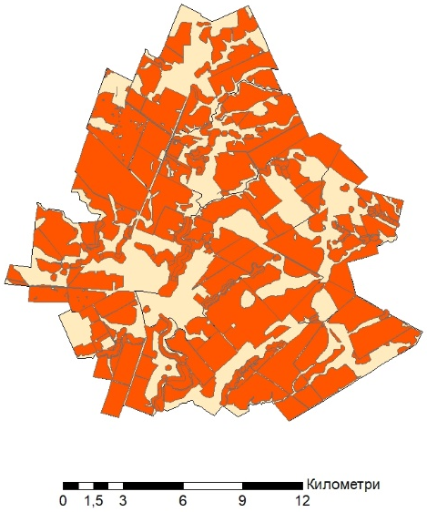 | 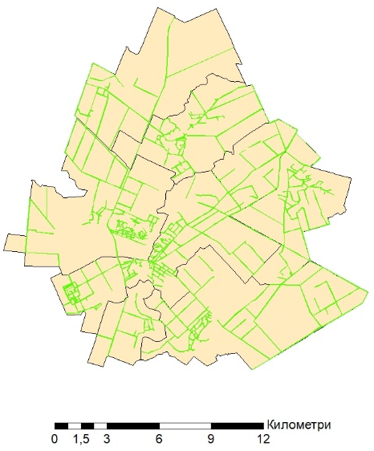 | 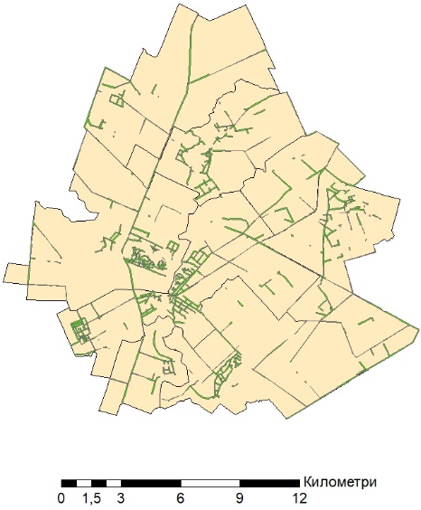
а | b | c
Legend: 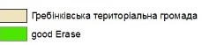 Hrebinka territorial community
desired location; 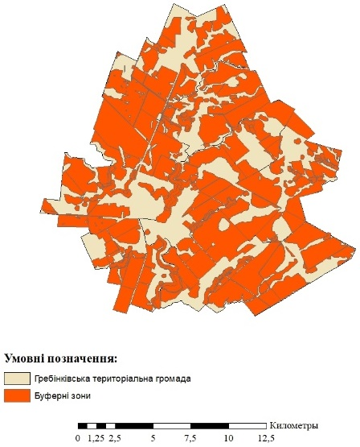 impossible location;  possible location

Fig. 3. Thematic maps of the research territory: a - the territory of the impossible location of the filling station, b - the territory of the desired location of the filling station, c - the territory of the possible location of the filling station.

To create the final thematic map of the area, it is necessary to combine the resulting images from two blocks: Blok No. 1 and Block No.2. For this purpose, the function ‘erasure’ is selected excluding from the desired areas of the impossible location (Fig. 2, Block No. 3). The result is shown in Fig. 3c.
The model for disposal tip is built on a similar principle but based on other criteria. The model is divided into blocks: Block №1 – definition of zones of impossible location, Block №2 – select of the desired location, Block №3 – combination of conditions and creation of the resulting image. In the first side we add the necessary initial data and we construct buffers (road_Buffer200, Power_line_Buffer30, Lake2000_Buffer, Settlements_Buffer 500), we exclude especially valuable soils through the Select module and union the received data in one layer “no recommended” The model is presented in Fig. 4, and thematic maps on which restrictions concerning disposal tip are given are given in fig. 5a and the possible location in Figure 5.b.
In the study area, the location of the disposal tip is impossible due to many objects nearby that make their location impossible.
Road
Powerline
Lakes
Soil
Buffer (200)
Buffer (30)

Buffer (2000)
Select
road_Buffer2
PowerLine_ Buffer2
Lakes_ Buffer2
soil_ select2
Union
Union (2)

Union1.1
Union1.2
Union (3)

No recommend
Territory
Select
Block №1
Block №2
Territory _select
Block №3
Erase

Final
Settlement
Buffer (500)
Settlement Buffer2
Union (4)

Union 1.3
Fig. 4. Model for facilities near which the location is not possible for disposal tips
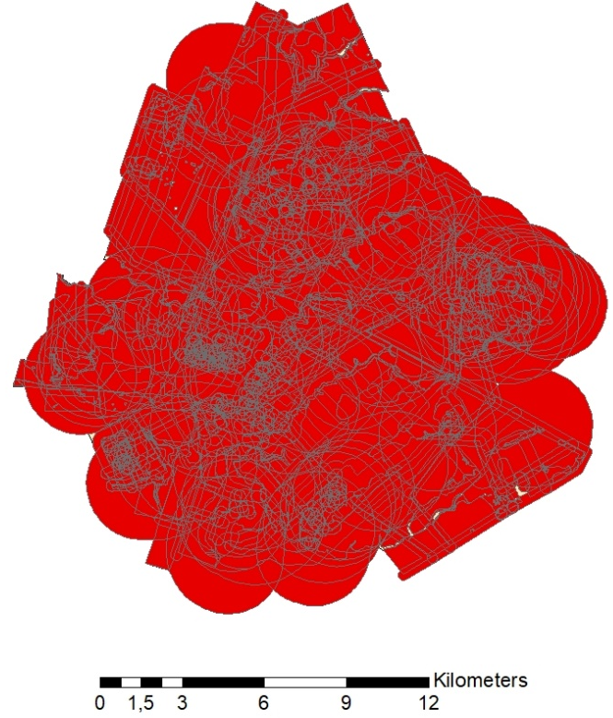 | 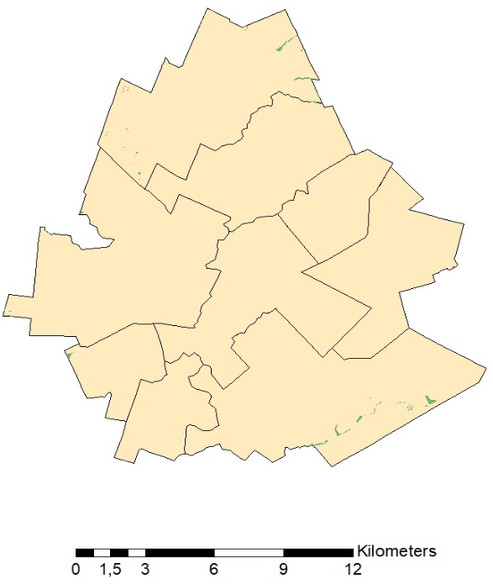
a | b
Legend: Hrebinka territorial community; 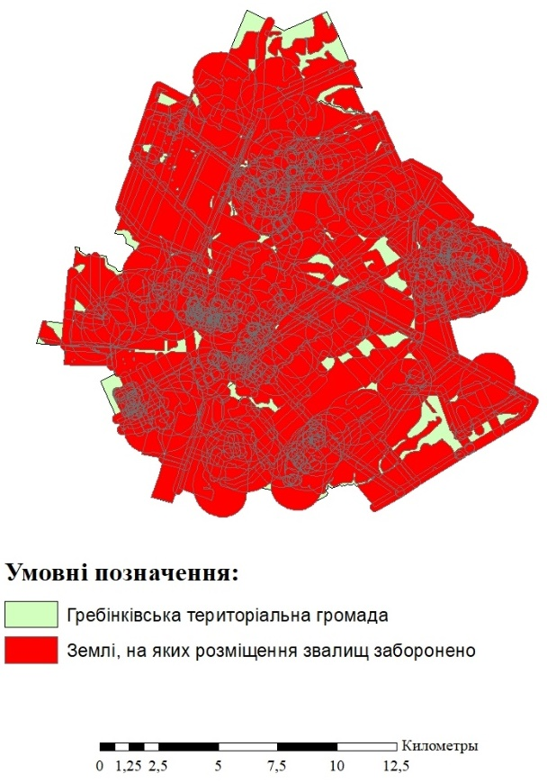 impossible location; possible location

Fig. 5. Thematic maps of the community: a - the territory of the impossible location of the disposal tips, b - the possible location of the disposal tips
Conclusions. The developed geoinformation models of geoimaging creation allow accelerating the analysis of spatial data for decision-making of definition of territories for the location of objects of non-agricultural use.
The functional model of site selection is generally common, i.e. it is necessary to determine the desired location and exclude areas with restrictions, but for each object, it is necessary to set restrictions based on the environment.
The results of the work can be used to automate the selection of areas for filling stations and disposal tips.
The prospect of further research is to develop an automated decision-making unit for planning the location of non-agricultural facilities in communities.
References
1. Karaya, RN; Onyango, CA; Ogendi, GM. (2021) A community-GIS supported dryland use and cover change assessment: the case of the Njemps flats in Kenya. COGENT FOOD & AGRICULTURE, 7(1). DOI: https://doi.org/10.1080/23311932.2021.1872852
2. Kilic, J; Jajac, N; Marovic, I. (2018) GIS-based Decision Support Concept to planning of land acquisition for realization of Urban Public Projects. Croatian Operational Research Review, Vol. 9 No. 1. P 11-24. DOI: https://doi.org/10.17535/crorr.2018.0002
3. Moskalenko А. (2021) GIS support of forming spatial decisions on land use. Mechanization in agriculture & Conserving of the resources Vol. 67, Issue 3, p. 79-81.
4. Lyashchenko A., Zakharchenko YE. (2019) Kontseptualʹne modelyuvannya ta pryntsypy realizatsiyi bazy heoprostorovykh danykh kadastru pryrodnykh likuvalʹnykh resursiv [conceptual modeling and principles of implementation of the spatial databases of the cadastre of natural healing resources] // Naukovi zapysky Ternopilʹsʹkoho natsionalʹnoho pedahohichnoho universytetu imeni Volodymyra Hnatyuka. Ser. Heohrafiya. Ternopilʹ : TNPU im. V. Hnatyuka, № 1 (46). P. 232-239.
5. Pomortseva O. YE. (2018) Modelyuvannya roztashuvannya ekolohichno nebezpechnykh ob'yektiv za dopomohoyu heoinformatsiynykh system [Modeling the location of environmentally hazardous objects using geographic information systems]. Visnyk Natsionalʹnoho Tekhnichnoho Universytetu (KHPI) Ser. Novi rishennya v suchasnykh tekhnolohiyakh. № 148, p.31-34
6. Piatkova A. V. (2016) Otsinka mozhlyvostey prostorovoyi HIS-realizovanoyi modeli ratsionalʹnoho vykorystannya zemelʹnykh resursiv [Estimation of possibilities of spatial GIS-realized model of rational use of land resources] / Visnyk ONU. Ser.: Heohrafichni ta heolohichni nauky. Tom 21, № 2 (29), p. 85-95.
7. Planuvannya ta zabudova terytoriy (2019) [Planning and development of territories]. DBN V.2.2-12:2019

Москаленко А.А., Захарова А.Ю.
Геоінформаційне моделювання вибору ТЕРИТОРІЙ для несільськогосподарського використання
Розглянуто можливості застосування геоінформаційного моделювання для підбору земельних ділянок несільськогосподарського призначення. Проведено аналіз стану вивчення питань щодо автоматизації підтримки прийняття рішень та застосування геоінформаційного забезпечення для питань екології. Розглянуто використання геоінформаційного моделювання для вибору земельних ділянок несільськогосподарського використання.
Дане дослідження описує структурування загального алгоритму встановлення територій необхідного та неможливого розташування об’єктів та їх обмежень через функціональну модель. Функціональна модель підбору територій загалом є спільною, тобто необхідно визначити бажане розташування та виключити території з обмеженнями, однак для кожного об’єкту необхідно за нормативами встановлювати обмеження з урахуванням оточення. В статті наведено аналіз вимог до вибору територій для двох типів об’єктів: АЗС та звалищ. Розроблено та реалізовано геоінформаційні моделі вибору земельних ділянок несільськогосподарського використання для розміщення визначених об’єктів.
В результаті здійсненої роботи визначено, що підбору земельних ділянок для розташування деяких об’єктів не сільськогосподарського призначення може використовуватись алгоритм, який дозволяє автоматизувати деякі етапи визначення території.
Результати роботи можуть бути використані при плануванні територій громад для формування просторових рішень щодо використання розташування об’єктів несільськогосподарського використання.
Ключові слова. геоінформаційне моделювання, модель, підбір територій, геозображення.

Москаленко А.А., Захарова А.Ю.
ГЕОИНФОРМАЦИОННОЕ МОДЕЛИРОВАНИЕ ВЫБОРА ТЕРРИТОРИЙ ДЛЯ НЕСЕЛЬСКОХОЗЯЙСТВЕННОГО ИСПОЛЬЗОВАНИЯ
Рассмотрены возможности применения геоинформационного моделирования для подбора земельного участка несельскохозяйственного назначения. Проведен анализ состояния изучения вопросов автоматизации поддержки принятия решений и применения геоинформационного обеспечения для вопросов экологии. Рассмотрено использование геоинформационного моделирования для выбора земельного участка несельскохозяйственного использования.
Данное исследование описывает структурирование общего алгоритма установления территории необходимого и невозможного расположения объектов и их ограничений через функциональную модель. Функциональная модель подбора территорий является общей, то есть необходимо определить желаемое расположение и исключить территории с ограничениями, однако для каждого объекта необходимо по нормативам устанавливать ограничения с учетом окружения. В статье представлен анализ требований к выбору территорий для двух типов объектов: АЗС и свалок. Разработаны и реализованы геоинформационные модели выбора земельных участков несельскохозяйственного использования для размещения определенных объектов.
В результате проведенной работы определено, что подбор земельных участков для расположения некоторых объектов не сельскохозяйственного назначения может использоваться алгоритм, позволяющий автоматизировать некоторые этапы определения территории.
Результаты работы могут использоваться при планировании территорий общин для формирования пространственных решений по использованию расположения объектов несельскохозяйственного использования.
Ключевые слова: геоинформационное моделирование, модель, подбор территорий, геоизображение.

