УДК 332.2:332.36

STATE AND PROBLEMS OF ESTABLISHMENT OF COMPREHENSIVE PLANS FOR SPATIAL DEVELOPMENT OF LAND USE OF TERRITORIES OF TERRITORIAL COMMUNITIES

A. Tretiak, Doctor of Economic Sciences, Professor, Chief Researcher, Bila Tserkva National Agrarian University
ORCID ID: 0000-0002-1154-4797
E-mail: tretyak2@ukr.net
V. Tretiak, Doctor of Economic Sciences, Professor, Professor of the Department of Geodesy and Land Management, Sumy National Agrarian University
ORCID ID: 0000-0001-6779-1941
T. Priadka, PhD in Economics, Associate Professor, Bila Tserkva National Agrarian University
ORCID ID: 0000-0002-6179-0128
E-mail: tetiana.priadka@btsau.edu.ua
R. Tretiak, Candidate of Economic Sciences, Head of the Department of Environmental Safety and Nature Management Assessment, LLC «Research Center for Environmental Safety and Nature Management»
N. Komarova, PhD in Economics, Assistant of the Department of Land Resources Management and Land Cadastre,
Bila Tserkva National Agrarian University,
ORCID ID:0000-0002-9347-455Х,
E-mail: komarova_nv@ukr.net

Analysis of the pilot project of the comprehensive plan for spatial development of the territory of Pisochyn territorial community showed that failure of incorporate the requirements of land legislation in the context of the formation of sustainable (balanced) land use does not improve environmental stability and capitalization of land use as components of its sustainability.
It was proposed to make changes and additions to the legislation of Ukraine on components, structure and content of the comprehensive plan for spatial development of the territories of territorial communities, zoning of lands outside the settlements which differs significantly from urban planned, especially the categories of agricultural lands, nature reserves and nature protection lands and defense lands.
Improving the components, structure and content of the comprehensive plan for spatial development of land use of the territories of territorial communities based on European experience will reduce the cost of its development by 2-3 times. This is especially important considering that the state budget includes 187, 7 million UAH of subventions for the development of 150 comprehensive plans for spatial development of the territories of territorial communities in 2022(or 1, 25 million UAH for 1 project). Prospects for further explorations consist in researching areas for improvement of components, structure and content of the comprehensive plan for spatial development of land use of the territories of territorial communities, especially about zoning of lands outside the settlements which significantly differs from urban zoning.

Key words: comprehensive plan for spatial development of territory of communities, environmental stability, capitalization of land use.

Introduction. On December 9, 2021, a community conference "Spatial Planning of Territorial Development" was held with the support of the USAID Agricultural and Rural Development Program (AGRO), which presented the first experience in establishment comprehensive spatial development plans under new legislation in Ukraine [1]. The USAID Agricultural and Rural Development Program (AGRO) is a five-year program of the United States Agency for International Development (USAID) implemented by Kimonix International. The aim of the program is to accelerate the economic development of Ukraine's rural communities that need the most help which will conduce for improving governance in the agricultural sector, which will promote more productive, modern and profitable micro, small and medium-sized agricultural enterprises. The pilot project was developed on the basis of the Pisochyn community in Kharkiv region.
According to Article 45-1 of the Law of Ukraine "On Land Management" [2] A comprehensive plan for spatial development of the territorial community is both land management documentation and urban planning documentation at the local level. In addition to the information provided by the Law of Ukraine "On Regulation of Urban Development" [3], according to Article 16-1 includes project decisions of the complex plan, in particular: boundaries and legal regimes of all regime-forming objects and all restrictions on land use (including restrictions on land use in construction), established before or during the development of the draft comprehensive plan (including boundaries and legal regimes of territories and objects of nature reserve fund and other nature protection purpose, health, recreational, historical and cultural, forestry purpose, water fund lands, coastal protection strips, water protection zones, beach zones, other protection zones).
Analysis of recent research and publications. In research works such as «Territorial and spatial planning: basic principles of theory, methodology, practice», «Territorial spatial planning of land use in Ukraine: conceptual basis in the context of vital activity security», «Legislative and regulatory introduction of land zoning by types (subtypes) of land use instead of the current land categories», «Legislative and regulatory introduction of land zoning by types (subtypes) of land use instead of the current land categories» [4, 5, 6, 7] we noted the problems of legislative regulation of the development of comprehensive plans for spatial development of communities` territory in terms of formation of sustainable (balanced) land use in the process of land management spatial planning and for compliance with legal requirements.
The purpose and objectives of the study. There is an analysis of the pilot project of the Comprehensive Spatial Development Plan of the Pisochyn Territorial Community for the implementation of legislative innovations and land management measures in the context of land use planning and other natural resources.
Methods of research. In the analysis of the pilot project of the Comprehensive Spatial Development Plan of the Pisochyn Territorial Community, the following approaches were used: abstract logical - abstract-logical - to substantiate the purpose and conclusions; monographic - in the process of analyzing scientific views and the effectiveness of innovative areas of land use planning in the field of land management and land management at the local level.
Presentation of the main material of the study. After researching the project of the Comprehensive Spatial Development Plan of the Pisochyn Territorial Community Kharkiv region we established discrepancy of data of the pilot project to the necessary requirements of the Law of Ukraine «On Land Management» (table 1).

Table 1.
The list of information of the Comprehensive plan of spatial development of the territory of the territorial community
Data according to the Law of Ukraine "On Land Management" | Data from a USAID-supported pilot project *
1. Explication of land for owners and users of land. | Unavailable
2. List of restrictions on land use and lists of land plots in respect of which restrictions on land use have been established. | Unavailable
3. Collective plan of land plots provided for ownership or use and land plots not provided for ownership or use. | Unavailable
4. Plan for the distribution of land by category, owners and users (form of ownership, type of property law), land with a reflection of existing restrictions (encumbrances). | Land distribution plan by categories, owners and users (form of ownership, type of property law) (Pic. 1)  Plan of land distribution by lands with reflection of existing restrictions (encumbrances) (Pic. 2)
- | Scheme of land management measures for perspective land use (Pic. 3)
- | The scheme of land plots formed as a result of development of planning decisions of the detailed plan of the territory, information on which is subject to entering the State land cadastre (pic. 4)
- | Plan of restrictions on land use, which are established by a comprehensive plan and registered in the State Land Cadastre (Pic. 5)
Formed on the basis of the source [8]

In the process of project establishment, the boundaries of the Pisochyn Territorial Community were studied and a number of controversial issues were identified, such as the imposition of the village council boundary (Pisochyn Village Council boundary formation project) on the Kharkiv border, which is registered in the state land cadastre (Table 2). As a result of vectorization, deviations from the accounting area of Pisochyn village council were revealed - 116.4 ha, which is a percentage of 4.0% of the council's territory.
Table 2.
Comparison of areas (actual and accounting) in terms of local councils included in the territory of Pisochyn territorial community
The council’s name | Accounting area, ha | Area (actual) in SK-63, ha | Area (actual) in USC-2000 (ISC-63), ha | Deviation from the accounting area, ha
Pisochyn village council | 2909, 4011 | 2793,1034 | 2793,0074 | -116,3937
Korotych village council | 3167,0000 | 3207,3687 | 3207,3282 | +40,3282
Berezivka village council | 1872,0000 | 1897,6833 | 1897,6716 | +25,6716
In total within the Pisochyn territorial community | 7948,401 | 7898,1554 | 7898,0072 | -50,3938

In general, the deviation to the lesser side of the registered area in the territorial community is 50.4 hectares or 0.6%. Similar deviations in the area are found in settlements. Thus, in the urban village of Pisochyn the deviation is more than 200.0 ha in the smaller direction, or 14.8%. In this regard, it is necessary to develop a land management project to change the boundaries of the territory of Pisochyn village council or Kharkiv and urban village Pisochyn.
According to Article 2 of the Law of Ukraine "On Land Management", land management provides a scientific basis for the distribution of land by purpose, taking into account state, public and private interests, the formation of a rational system of land tenure and land use, creating environmentally sustainable agricultural landscapes, etc. [2]. Analysis of materials for the development of land distribution plan by categories, owners and users and land distribution plan by lands (fig. 1 і 2) shows that such a justification is absent and no explication of land were formed for owners and users of land, a list of restrictions on land use and lists of land for which restrictions on land use have been established. Given that according to Article 1 of the Law of Ukraine "On Land Management" land management measures are "provided by the land management documentation work on the rational use and protection of land, formation and organization of territory of land management`s object, taking into account their purpose, restrictions on use and restrictions ( encumbrances) on the rights of others (land easements), preservation and enhancement of soil fertility "[2], it does not meet the requirements of the legislation and the scheme of land management measures for
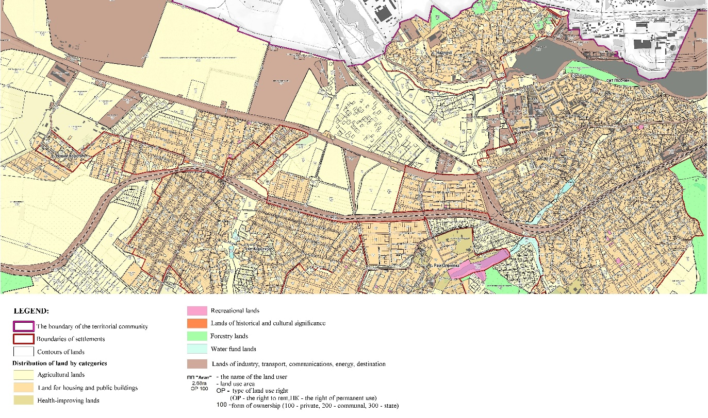
Figure 1. Fragment of the plan of land distribution by categories, owners and users (form of ownership, type of property law) in the Pisochyn Territorial Community of Kharkiv region (pilot project «USAID Program on Agrarian and Rural Development (AGRO))»)
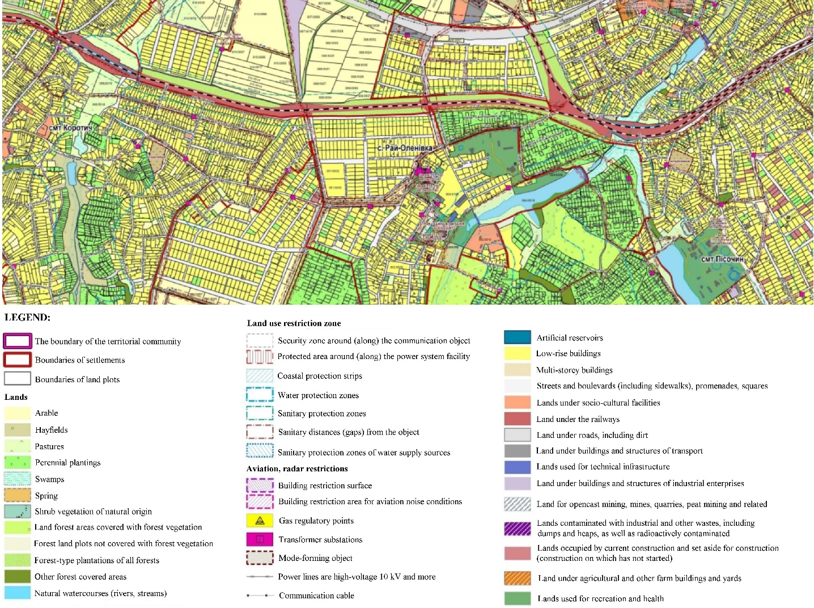
Figure 2. A fragment of the land distribution plan on land with a reflection of existing restrictions (encumbrances) on the territory of the Pisochinsky territorial community of Kharkiv region (Pilot Project «USAID Agrarian and Rural Development Programs (Agro))»)
the prospective use of land (Fig. 3). In the data of the complex plan of spatial development of the territory of Pisochyn territorial community there is no substantiation of such measures. During the making the scheme of land plots formed as a result of development of planning decisions of the detailed plan of the territory, information on which is subject to entering in the State land cadastre only one land plot is formed (fig. 4), though many design changes on target and functional use of lands are provided. When developing the plan of restrictions on land use, which are establish by a comprehensive plan and register in the State Land Cadastre (Fig. 5), a list of territorial restrictions on land use and lists of land plots for which restrictions on land use have been established have not been formed.
Let’s focus on the problems of land zoning outside settlements, which differs significantly from urban planned (Fig. 6), especially the categories of agricultural, nature reserve and conservation lands and defense lands. Therefore, the regime of use and protection of agricultural lands is associated with global processes of climate change and desertification and is characterized by territorial areas of different types (subtypes) of land use. In particular, this category of lands includes subtypes: field, soil protection, garden, grape, berry, hay and pasture, special, mixed, research, homestead, non-traditional agricultural (organic farming, growing niche crops, etc.) [4, 5.] For example, lands of nature reserve and nature protection, according to the list of territorial zones (groups of objects of the State Land Cadastre) [9] include zones of key, connecting, buffer and renewable areas of the ecological network, which in turn are divided into subtypes: nature reserve, garden reserved, recreational, research; natural resource protective, biotic protective, sanitary protective, scientific protective [4, 5].
Within the territory of Pisochyn territorial community the assessment of natural resource potential and analysis of its use has not been carried out. Despite the fact that land use of the territorial community is stable and environmentally unsustainable, it is not possible to assess the ecological stability and anthropogenic load before and after the implementation of project decisions, although the area of urbanized land is growing.

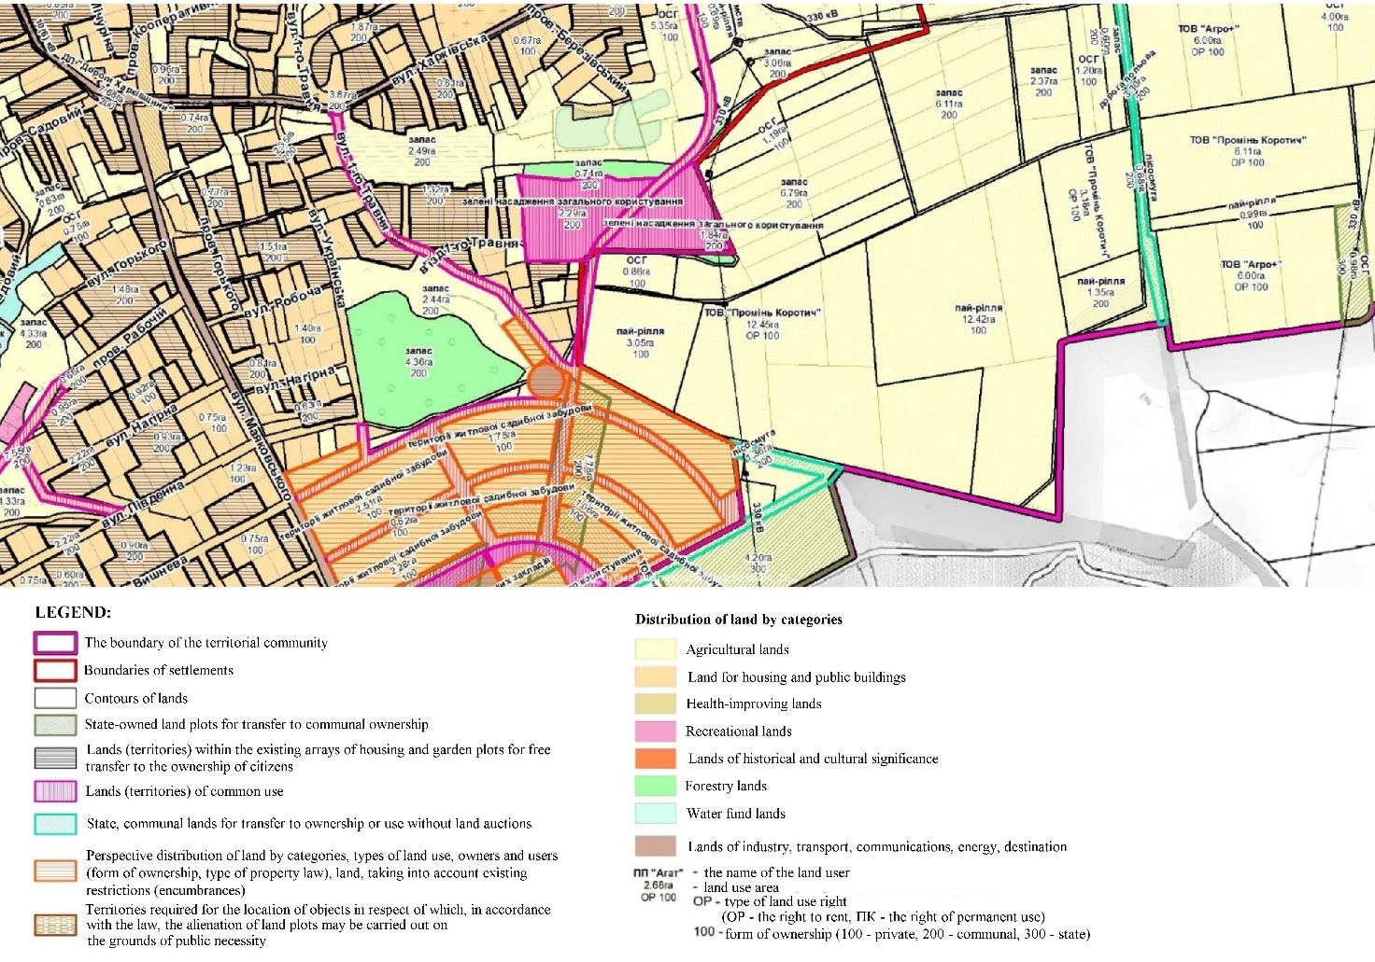
Figure 3. Fragment of the scheme of land management measures of perspective land use in the territory of Pisochyn Territorial Community of Kharkiv Region (pilot project «USAID Program on Agrarian and Rural Development (AGRO))»)

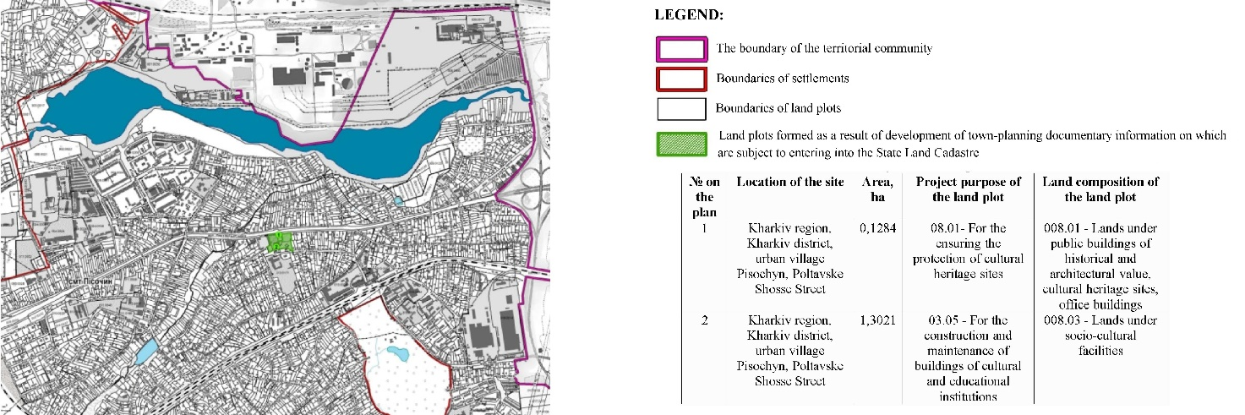
Figure 4. Fragment of the plan of land plots formed as a result of development of planning decisions of the detailed plan of the territory, information on which is subject to entering into the State Land Cadastre in the Pisochyn Territorial Community of Kharkiv region (pilot project «USAID Agricultural and Rural Development Program (AGRO))» )

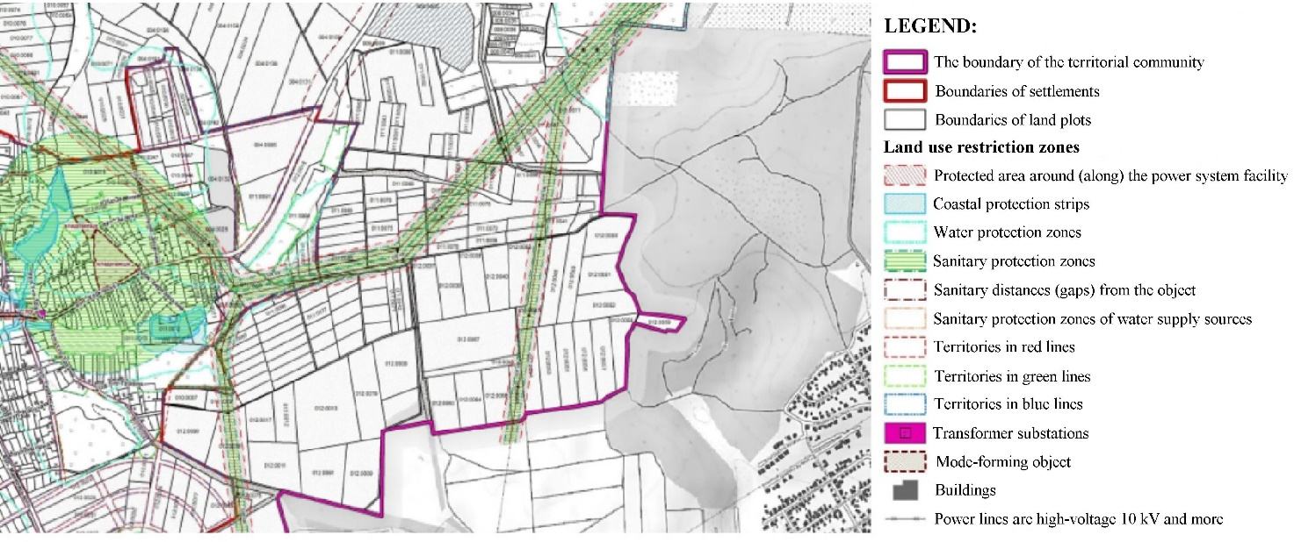

Figure 5. Fragment of the plan of land use restrictions, information to be entered into the state land cadastre on the basis of developed urban planning documentation in the Pisochyn Territorial Community of Kharkiv region (pilot project «USAID Program for Agrarian and Rural Development (AGRO))»)

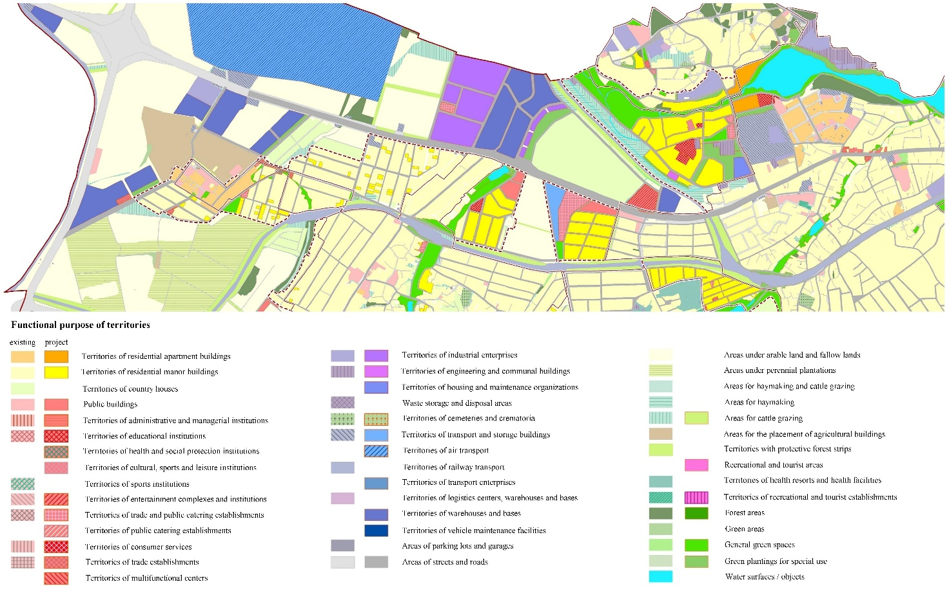
Figure 6. Fragment of the Complex plan of the territory of Pisochyn territorial community of Kharkiv region. Functional Zoning Plan (pilot project «USAID Agricultural and Rural Development (AGRO))»)

The Comprehensive Plan does not contain an analysis of the possible capitalization of land use, which is a necessary condition for determining the growth or lack of revenues to the local budget from land fees. And this is at a time when budget revenues in 2021 from land fees have decreased compared to 2020, the share of which in the community budget is about 20% [11]. Analysis of land supply and job creation in the process of land use organization is absent.
Given that in 2022 the state budget includes UAH 187.7 million. subventions for the development of 150 comprehensive plans for spatial development the territories of territorial communities, it is important to take into account existing shortcomings in their development [1]. It should also be noted that improving the components, structure and content of a comprehensive plan for spatial development of land use the territories of territorial communities, taking into account European experience [4] will reduce the cost of its development by at least half.
Conclusions. The development of a pilot project of the Comprehensive Spatial Development Plan of the Pisochyn Territorial Community showed that not taking into consideration the requirements of land legislation in the context of sustainable (balanced) land use does not improve environmental stability and capitalization of land use as components of its sustainability. Was proposed to make changes and additions to the legislation of Ukraine on land zoning outside settlements, which differs significantly from urban planned, especially the categories of agricultural land, nature reserves and nature protection and defense lands. Thereby, to allocate functional zones with the regime of use and protection of agricultural lands, which is associated with global processes of climate change and desertification and is characterized by territorial zones of different types (subtypes) of land use. In particular, this category of lands should consist of subtypes: field, soil protection, garden, grape, berry, hay and pasture, special, mixed, research, homestead, non-traditional agricultural (organic farming, growing niche crops, etc.). Lands of nature reserve and nature protection, according to the list of territorial zones (groups of objects of the State Land Cadastre) should include zones of key, connecting, buffer and renewable areas of the ecological network, which in turn are divided into subtypes: nature reserve, garden reserve, recreational, research; natural resource protective, biotic protective, sanitary protective, scientific protective. The category of defense lands should include the following types: defense security, border, internal security and subtypes: land use with a low degree of environmental and economic risk; land use with a significant degree of environmental and economic risk; land use with a high degree of environmental and economic risk; land use with a catastrophic degree of environmental and economic risk. And so on for other categories of land. Improving the components, structure and content of a comprehensive plan for spatial development of land use the territories of territorial communities, taking into account European experience will reduce the cost of its development by at least half. This is especially important given that in 2022 the state budget includes UAH 187.7 million in subventions.

References
1. USAID (2021), “Conference of communities "Spatial planning of territorial development”, available at: https://decentralization.gov.ua/news/14282 (Accessed 03 Feb 2022).
2. Verkhovna Rada of Ukraine (2003), The Law of Ukraine “On Land Management”, available at: https://zakon.rada.gov.ua/laws/show/858-15#Text (Accessed 03 Feb 2022).
3. Verkhovna Rada of Ukraine (2011), The Law of Ukraine “On Regulation of City Planning Activity”, available at: https://zakon.rada.gov.ua/laws/show/3038-17#Text (Accessed 03 Feb 2022).
4. Tretiak, A.M., Tretiak, V.M., Priadka, T.M. and Tretiak, N.A. (2021), Terytorialno-prostorove planuvannia: bazovi zasady teorii, metodolohii, praktyky [Spatial planning: basic principles of theory, methodology, practice], TOV «Bilotserkivdruk», Bila Tserkva, Ukraine.
5. Tretiak, A., Tretiak, V., Priadka, T., Skliar, Yu. and Kapinos, N. (2021), “Territorial-spatial planning of land use in Ukraine: conceptual basis in the context of vital activity security”, Agrosvit, vol. 15, pp. 3–13.
6. Tretiak, A., Tretiak, V. and Priadka, T. (2021), “Legislative and regulatory introduction of land zoning by types (subtypes) of land use to replace the current categories of land”, Zemlevporiadnyi visnyk, vol. 2, pp. 16-20.
7. Tretiak, A.M., Tretiak, V.M. and Lobunko, Yu.V (2021), “Information problems of development of complex plans of spatial development of territories of territorial communities”, Mizhnarodnyi naukovyi zhurnal «Hraal nauky», vol. 9, pp. 33-41.
8. Pisochyn village council (2022), available at: (Accessed 03 Feb 2022).
9. Cabinet of Ministers of Ukraine (2012), Resolution “On approval of the Procedure for maintaining the State Land Cadastre”, available at: https://zakon.rada.gov.ua/laws/show/1051%D0%B1-2012-%D0%BF#Text (Accessed 03 Feb 2022).
10. Tretiak, A.M. and Melnychuk, A.Iu. (2020), “Features of methodological bases of formation of land use of defense”, Zemleustrii, kadastr i monitorynh zemel, vol.1, pp. 92-98.
11. Community capacity (2021), available at: https://tdukr.maps.arcgis.com/apps/MapJournal/index.html?appid=47f24b79311f44e2863eabe27ccbdc81&fbclid=IwAR3NdmVaXZD_ojyJnqt41UF01jJ5eOuNZLfJALashZLhfl2mg8w5cdv0ohk# (Accessed 03 Feb 2022).
12. Priadka, T.M., Drebot, O.I. and Komarova, N.V. (2017), “Problemming of formation of landlines of territorial communities in the conditions of decentralization of the power”, Zemleustrii, kadastr i monitorynh zemel, vol.4, pp. 14−20, available at: http://rep.btsau.edu.ua/handle/BNAU/5530 (Accessed 03 Feb 2022).

Третяк А.М., Третяк В.М., Прядка Т. М., Третяк Р.А., Комарова Н.В.
СТАН ТА ПРОБЛЕМИ РОЗРОБЛЕННЯ КОМПЛЕКСНИХ ПЛАНІВ ПРОСТОРОВОГО РОЗВИТКУ ЗЕМЛЕКОРИСТУВАННЯ ТЕРИТОРІЇ ТЕРИТОРІАЛЬНИХ ГРОМАД

Аналіз пілотного проекту Комплексного плану просторового розвитку території Пісочинської територіальної громади показав, що не врахування вимог земельного законодавства у контексті формування сталого (збалансованого) землекористування, не покращує екологічну стабільність та капіталізацію землекористування, як складових його сталості.
Запропоновано здійснити зміни та доповнення до законодавства України щодо складових, структури і змісту комплексного плану просторового розвитку землекористування територій територіальних громад, зонування земель за межами населених пунктів, яке суттєво відрізняється від містобудівного, особливо категорії земель сільськогосподарського, природно-заповідного і природоохоронного призначення та земель оборони.
Удосконалення складових, структури і змісту комплексного плану просторового розвитку землекористування територій територіальних громад із врахуванням європейського досвіду дозволить зменшити вартість його розробки в 2-3 рази. Це особливо важливо враховуючи, що на 2022 рік у держбюджеті закладено 187,7 млн грн. субвенцій на розроблення 150 комплексних планів просторового розвитку територій територіальних громад (або 1,25 млн. грн. на 1 проект). Перспективи подальших розвідок полягають в дослідженні напрямів удосконалення складових, структури і змісту комплексного плану просторового розвитку землекористування територій територіальних громад , особливо щодо зонування земель за межами населених пунктів, яке суттєво відрізняється від містобудівного зонування.
Ключові слова: комплексний план просторового розвитку території громад, екологічна стабільність, капіталізація землекористування.

Третяк А.Н., Третяк В.Н., Прядка Т.Н., Третяк Р.А., Комарова Н.В.
СОСТОЯНИЕ И ПРОБЛЕМЫ РАЗРАБОТКИ КОМПЛЕКСНЫХ ПЛАНОВ ПРОСТРАНСТВЕННОГО РАЗВИТИЯ ЗЕМЛЕПОЛЬЗОВАНИЯ ТЕРИТОРИИ ТЕРИТОРИАЛЬНЫХ ОБЩЕСТВ
Анализ пилотного проекта Комплексного плана пространственного развития территории Песочинского территориального общества показал, что не учет требований земельного законодательства в контексте формирования устойчивого (сбалансированного) землепользования, не улучшает экологическую стабильность и капитализацию землепользования, как составляющих его постоянства.
Предложено осуществить изменения и дополнения к законодательству Украины о составляющих, структуре и содержании комплексного плана пространственного развития землепользования территорий территориальных обществ, зонирование земель за пределами населенных пунктов, существенно отличающееся от градостроительного, особенно категории земель сельскохозяйственного, природно-заповедного и природоохранного назначения и земель обороны.
Совершенствование составляющих, структуры и содержания комплексного плана пространственного развития землепользования территорий территориальных обществ с учетом европейского опыта позволит снизить стоимость его разработки в 2-3 раза. Это особенно важно учитывая, что на 2022 год в госбюджете заложено 187,7 млн. грн. субвенций на разработку 150 комплексных планов пространственного развития территорий территориальных обществ (или 1,25 млн. грн. на 1 проект). Перспективы дальнейших исследований заключаются в исследовании направлений усовершенствования составляющих, структуры и содержания комплексного плана пространственного развития землепользования территорий территориальных обществ, особенно относительно зонирования земель за пределами населенных пунктов, существенно отличающегося от градостроительного зонирования.
Ключевые слова: комплексный план пространственного развития территории обществ, экологическая стабильность, капитализация землепользования.

