UDC 332.3:631.4
FACTORS OF RATIONAL AGRICULTURAL LAND USE
O.V.Tykhenko, Candidate of Agricultural Sciences, Associate Professor,
National University of Life and Environmental Sciences of Ukraine
E-mail: olgavfrank@ukr.net
A.Y. Shamchuk, student,
National University of Life and Environmental Sciences of Ukraine
Abstract. The study of specific indicators of soil cover and their impact on land productivity is an important task for the formation of rational use of land resources. The aim of the work was to assess the condition of soils and find the optimal fertility parameters of a particular soil in the natural agricultural region. This is very important not only for the study of ways of rational land use, but also for ensuring the fiscal purposes of the cadastre, as the main territorial unit of monetary valuation of agricultural land is a natural agricultural region. This study describes the state of soils through the relationship of specific fertility indicators and the corresponding production opportunities for their use in agriculture. Correlation-regression analysis was performed, which showed that minimum tillage is preferred, as it has a moderate, strong and very strong correlation between phosphate and other soil fertility indicators. To assess the various methods of land use, it is necessary to select parameters for assessing the state of land quality. To this aim, a set of parameters of specific soil and their changes under the influence of different technologies for growing crops was analyzed. In particular, the influence of phosphate regime indicators on winter wheat yield was established. Ways to optimize rational land use for soil typical for a particular natural agricultural region have been developed. The results of the work can be used in the development of a set of measures for the rational use of land. The prospect of further research is to develop a set of indicators for land quality.
Key words: land plots, rational land use, soil, land use, natural agricultural region, land quality.
Formulation of the problem. To optimize land use, data on the quality of land are extremely important (Dorosh O., 2018). Unfortunately, in Ukraine, land inventory work may not fully provide data on land quality accounting as a component of the State Land Cadastre (Tykhenko O., 2016). Resolution of the Cabinet of Ministers of Ukraine of June 5, 2019 № 476 «On approval of the Procedure for land inventory» paragraph 2 states that the purpose of land inventory, in addition to establishing the location of land management, their boundaries, size, owner ship, etc. there is also the establishment of quantitative and qualitative characteristics of land required for the maintenance of the State Land Cadastre. The study of specific indicators of soil cover and their impact on land productivity is an important task for the formation of rational use of land resources.
Analysis of recent research and publications. Indicators of the quality of land are indicators of the use of specific land use by owners or tenants. The formation of environmentally sustainable agricultural landscapes should be carried out through the implementation of a set of land protection measures provided for in land management projects, taking into account the specific natural and economic conditions of land use (Barvinsky A., 2020). Research Taratula R., (2019) found that the economic effect can be achieved by increasing the amount of land taxes, increasing yields, improving the quality characteristics of soils.
Dobriak D. etc. (2021), Kanash O. (2013) argue that ecological assessment of the territory should be considered as suitability for economic use through the assessment of fertility factors specific to a particular area, with due regard for the compliance of factors with the basic requirements of plants.
The most important property of soil is fertility, which is formed in the process of its formation and is characterized not by one, two or even several indicators, but by their combination. Ensuring the conditions of growth and development of plants is due to the whole complex of physical, biological and chemical properties of the soil (Balaev A. and others, 2020, Pikovska O., 2013).
The study of a set of indicators of soil regime for different cultivation technologies is very important for the analysis of land use methods. Studies by Awdenegest Moges et al. (2013) proved that irrational use of land resources, excessive grazing of livestock in protected forest areas and intensive agricultural production on agricultural lands cause deterioration of soil quality.
Protection of agricultural land should be one of the main measures to regulate land relations in Ukraine, and for the rational use of land it is important to investigate a set of soil indicators in specific climatic conditions (Tykhenko O., 2017).
As fertilizer systems with different crop technologies do not always have a positive effect on the condition (health) of the soil, it is important to study in detail the complex of chemical, physical and biological indicators of the soil (Monkiedje et al., 2006).
The aim of the research was to assess the condition of soils and to find the optimal fertility parameters of specific soil on agricultural lands. To achieve this goal it was planned to solve the following tasks: to study the impact of different systems of technologies for growing crops on soil fertility; identify conditions for nutrient mobilization; to establish the relationship between soil fertility indicators and productivity of a particular crop.
Materials and methods of research. To achieve this goal, general scientific methods of cognition were used, in particular the method of correlation-regression analysis. The research was conducted in Andrushivsky natural agricultural region. The studied soil, which is typical for this natural agricultural region, is meadow chernozem leached soil. When performing field and laboratory work, they were guided by generally accepted methods. Two tillage systems were studied. The first system was traditional, based on shelf plowing at 20-22 sm. The second system was conservation tillage with a minimum tillage of 10-12 sm. Crop rotation was deployed in three fields in space and ten in time. The experiment was based on the method of split blocks: the size of the sown area - 132, accounting - 100 m². Repetition of the experiment - three times.
Research results and their discussion. Currently, soil resources in society are considered mainly as a source and means of profit, without emphasizing that without concern for the protection, preservation and reproduction of soil fertility, natural value is lost (Kanash O., 2013). This situation requires increased attention from landowners, land users, public authorities, research institutions to ensure the possibility of solving the problem of soil protection (Tykhenko O., 2010). This is relevant for those soils that are cultivated and that determine the level of agricultural production and its competitiveness in market conditions.
Our goal was to find ways to increase soil fertility. The classification of lands is based on their condition and the corresponding production opportunities for their use in agriculture. We studied such production opportunities and their impact on soil fertility.
Based on the results of correlation analysis for different methods of tillage, it is noted that minimum tillage is preferred. With such tillage, there is a moderate, strong and very strong correlation between phosphate and other soil fertility indicators. We conducted a correlation analysis between the fertility indicators of meadow-chernozem soil, as well as their relationship with yield. The highest values ​​of the correlation coefficient (Table 1) are found between the indicators of fertility and such an important indicator of the phosphate state as the content of mobile phosphates. It is closely related to the degree of phosphate mobility (r = 0,977), winter wheat yield (r = 0,976), phosphatase activity (r = 0,967) and total phosphorus content (r = 0,928). A weak relationship was found between the content of mobile phosphates and nitrate nitrogen (r = 0,528).
Phosphate activity and humus content were closely correlated with the winter wheat harvest. A strong association was also found between the organic phosphorus content and the humus content. This indicates that humus is a source of nutrition for both plants and microorganisms, it provides soil buffering, increases cation exchange properties. Humus is extremely important in the energy of soil processes as an accumulator of solar energy reserves, which is necessary for the life of plants and microorganisms.
There was a close correlation between the fractional composition of mineral phosphates and other indicators of the phosphate regime. Thus, the content of sparingly soluble fraction of calcium phosphates (Ca-RII) strongly correlated with the content of total phosphorus (r = 0.861), and the content of the most available fraction for plants (Ca-RI) - with the content of mobile phosphates (r = 0.977).
- The relationship between fertility indicators of meadow-chernozem soil
X | Y | Correlation coefficient | Regression equation
Content of mobile phosphates, mg / 100 g | Total phosphorus content,% | 0,928 | Y = 0,06 +0,01 X
Content of mobile phosphates, mg / 100 g | Degree of mobility of phosphates, mg / l | 0,977 | The regression model is adequate to expert data
Content of mobile phosphates, mg / 100 g | Phosphatase activity, mg FFNa / 10 g of soil | 0,967 | Y = 6,49 +1,04 X
Content of mobile phosphates, mg / 100 g | Nitrate nitrogen content, mg / 100 g | 0,528 | The regression model is inadequate expert. data
Content of mobile phosphates, mg / 100 g | Harvest of winter wheat, c / ha | 0,976 | Y = 0,52 +0,17 X
Humus,% | Harvest of winter wheat, c / ha | 0,974 | Y = - 368,4+105,88X
Phosphatase activity, mg FFNa / 10 g of soil | Harvest of winter wheat, c / ha | 0,921 | Y = - 27,88 + 4,88 X
Humus,% | Organic phosphorus content, mg / 100 g | 0,851 | У =-546,01+159,83Х
Content of mobile phosphates, mg / 100 g | Faction Са-Р_{І} | 0,977 | Y = - 9,03 + 1,95X
Faction Са-Р_{ІІІ} | Total phosphorus content, % | 0,861 | Y = 0,04 +0,01 X

Thus, the results of correlation analysis show that the higher the phosphatase activity of the soil, the degree of phosphate mobility, the higher the content of mobile phosphates and crop yields (r = 0,921 – 0,977).
Soil protection technologies with minimal tillage improve the phosphate regime of meadow chernozem leached soil by increasing the amount of phosphorus compounds available to plants, which is primarily due to increased biological activity and acidification of soil solution (Franko O., 2004).
Compilation of new soil maps in Ukraine on the basis of a full-scale survey of soil cover is essential. To successfully conduct a second large-scale soil survey of the territory of Ukraine today it is necessary to have: the national classification of soils of the country; nomenclature list of soils; methods of field survey of soils and mapping of soils of appropriate scale on a fundamentally new basis using the methods of GIS-technologies (Tykhonenko D., 2017).
The correlation analysis of soil fertility indicators in Ukraine proves a weak link between the main fertility indicators. This, in turn, proves the need for detailed study within a specific soil reversal.
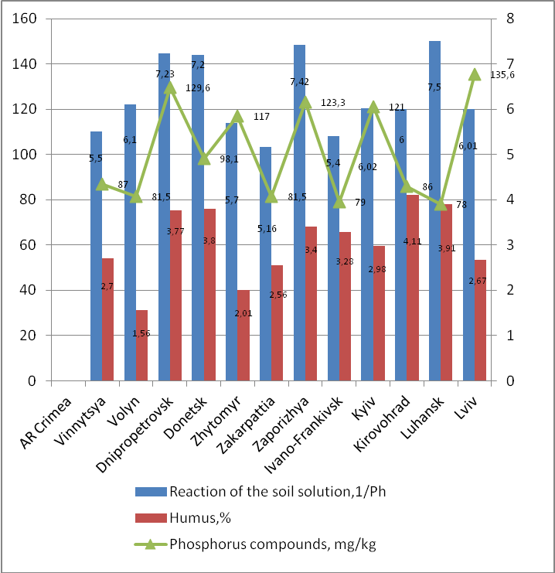 | 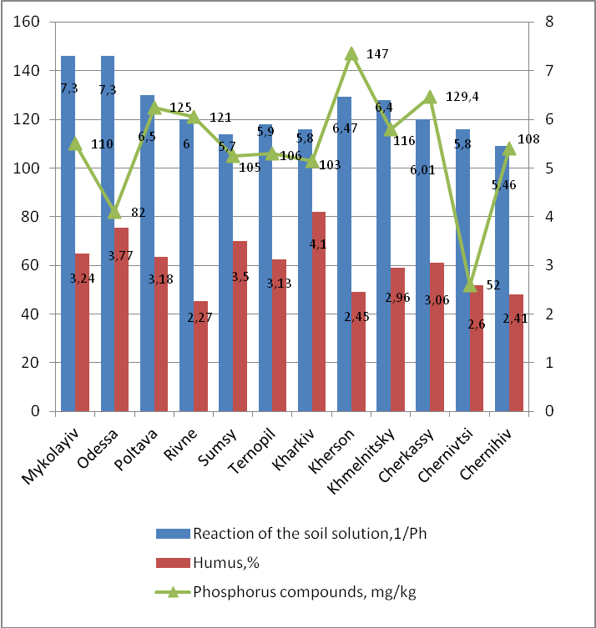
Fig. 1. Changes in the content of mobile soil phosphates depending on the content of humus and the reaction of the soil environment in the regions of Ukraine
[Compiled using source 15]
The figure shows in detail the changes in the content of mobile phosphates depending on the reaction of the soil environment in the soils of different regions. Thus, the highest content of mobile phosphates was observed in the Kherson region (147 mg/kg) in the reaction of soil solution 6,47, which confirms the statement that most plant nutrients are maximally available in the reaction of soil solution 6,4-6,9. Although, in general in the regions of Ukraine, a weak correlation was found between the content of mobile phosphates and the reaction of the soil solution.
Conclusions and prospects. The main task of landowners and land users should be to restore soil fertility, which can only be achieved through its rational use. Correlation-regression analysis was performed, which showed that minimum tillageis preferred, as it shows a moderate, strong and very strong correlation between phosphate and other soil fertility indicators. The results of the work can be used in the development of a set of measures for the rational use of land. The prospect of further research is to develop a set of indicators for land quality.

References
1. Fomenko V., Melnyk D. (2018). «The key role of land management in planning the development of the land use system within territorial communities» , Land Management, Land Cadastre and Monitoring, vol. 0(2), рp. 22-32, available at: http://dx.doi.org/10.31548/zemleustriy2018.02.022
2. Tykhenko O.V. (2017), «Problems of land quality accounting in the system of state land cadastre of Ukraine», Land Management, Land Cadastre and Monitoring, vol. 0(3), рp. 34-39, available at: doi:http://dx.doi.org/10.31548/zemleustriy2016.03.034
3. Barvinsky A.V. (2020), «Ecological and economic aspects of increasing the resilience of Polissya agrolandscapes to adverse climate changes. Proceedings of the XXI International Scientific and Practical Conference "Ecology. Man. Society», Ukraine(Kyiv), 2020, available at: https://ela.kpi.ua/bitstream/123456789/44093/1/EHS-21_2020_S1_p28-29.pdf
4. Taratula R.B. (2019), «Directions for improving the efficiency of information support for land management in Ukraine», Efficient economy, № 6, available at: http://www.economy.nayka.com.ua/?op=1&z=7689 (access date: 12.02.2022). DOI: 10.32702/2307-2105-2019.6.68
5. Dobryak D.S., Drebot O.I., Melnik P.P. (2021), «Scientific bases of classification of arable lands on productivity of soils for cultivation of the basic agricultural crops»,Balanced nature management, vol. (1), рp. 12-19, available at: https://doi.org/10.33730/2310-4678.1.2021.231861
6. Kanash, O. P. (2013), «Soils are the leading component of land resources», Land Management and Cadastre, vol. (2), рp. 68-76.
7. Tykhenko O.V. (2010), Agroecological journal. Special issu, pp. 209-211.
8. Balaev A., Tonkha O., Pikovska O., Gavrilyuk M.,Shemetun K. (2020), «Humus content and physicochemical properties of chernozems of the Forest-Steppe with minimization of cultivation and biologization of the fertilizer system», Bulletin of Agrarian Science, vol. 98 (11), рp.24-31.
9. Pikovska O.V. (2013), «The impact of minimizing tillage on the structural state of common chernozem», Scientific Bulletin of the National University of Life and Environmental Sciences of Ukraine, Series: Agronomy, vol. 183(2), рp. 193-197.
10. Awdenegest Moges, Melku Dagnachew, Fantaw Yimer (2013), «Land Use Effects on Soil Quality Indicators: A Case Study of Abo-Wonsho Southern Ethiopia», Applied and Environmental Soil Science, vol. 2013, Article ID 784989, 9 pages, available at: https://doi.org/10.1155/2013/784989
11. Tykhenko O.V. (2017), «Rational use of agricultural land: problems and prospects for their solution», Land Management, Land Cadastre and Monitoring, vol. 0 (1-2), рp.76-81, available at: doi:http://dx.doi.org/10.31548/zemleustriy2016.01.076
12. Monkiedje A., Spiteller M., Fotio D., Sukul P. The effect of land use on soil health indicators in peri-urban agriculture in the humid forest zone of southern cameroon. J Environ Qual. 2006 Oct 27;35(6):2402-9. https://doi.org/10.2134/jeq2005.0447
13. Franko O.V. (2004), «Changes in the phosphate regime of meadow-chernozem soil in the application of soil protection technologies in the conditions of Andrushivka natural agricultural region» :: author's ref. dis. for science. degree of Cand. s.-g. Science: special. 06.01.03 "agrosoil science and agrophysics" / Franko Olga Vladimirovna - Kyiv, National Agrarian University, 18 p.
14. Tykhonenko D.G. (2017), «Proposals for future repeated large-scale soil surveys of Ukraine», Agrochemistry and soil science, vol. 86, рp.79-80.
15. Cartograms of the quality of soils of Ukraine. Indicators of soil fertility of Ukraine for the X round of the survey (2011-2015). State Institution “Institute of Soil Protection of Ukraine”, available at: https://www.iogu.gov.ua/pasportizaciya/ahrohimichne-obstezhennya-silskohospodarskyh-uhid/

ЧИННИКИ РАЦІОНАЛЬНОГО СІЛЬСЬКОГОСПОДАРСЬКОГО ЗЕМЛЕКОРИСТУВАННЯ
О.В. Тихенко, А.Ю. Шамчук
Анотація. Дослідження конкретних показників ґрунтового покриву та їх вплив на продуктивність земель є важливим завданням формування раціонального використання земельних ресурсів. Метою роботи була оцінка стану ґрунтів та пошук оптимальних параметрів родючості конкретного ґрунту в природно-сільськогосподарському районі. Це дуже важливо не лише для дослідження шляхів раціонального використання земель, але й для забезпечення фіскальних цілей кадастру, оскільки основною територіальною одиницею грошової оцінки земельних ділянок сільськогосподарського призначення є природно-сільськогосподарський район. Дане дослідження описує стан ґрунтів через взаємозв’язок конкретних показників родючості та відповідні до нього виробничі можливості їх використання у сільському господарстві. Проведений кореляційно-регресійний аналіз, за допомогою якого встановлено, що перевагу має безполицевий обробіток грунту, оскільки при ньому спостерігається помірний, сильний і дуже сильний кореляційний зв’язок між показниками фосфатного стану та іншими показниками родючості ґрунту. Для оцінки різних методів землекористування необхідно підібрати параметри для оцінки стану якості земель. З цією метою було проаналізовано комплекс параметрів конкретного ґрунту та їх зміни під впливом різних технологій вирощування сільськогосподарських культур. Зокрема встановлено вплив показників фосфатного режиму на урожайність озимої пшениці. Розроблено шляхи оптимізації раціонального землекористування для типового для конкретного природно-сільськогосподарського району ґрунту. Результати роботи можуть бути використані при розробці комплексу заходів із раціонального використання земель. Перспектива подальших досліджень полягає в розробці комплексу показників із обліку якості земель.
Ключові слова: земельні ділянки, раціональне використання земель, ґрунт, землекористування, природно-сільськогосподарський район, якісний стан земель.

