UDC 332.2:528.9:004.01
THE PROBLEM OF THE SPECIFICATION OF PEERNESS OF LAND PLOTS AT THE EXCHANGE AIMING AT LAND CONSOLIDATION
М. Malashevskyi,
Еmail: mykola.malashevskyi@gmail.com
Land Management Institute of the National Academy of Sciences of Ukraine
А. Tarnopolskyi,
Еmail: andrey0037@gmail.com
Land Management Institute of the National Academy of Sciences of Ukraine
O. Malashevska,
Еmail: olenamalashevska@gmail.com
National University of Life and Environmental Sciences of Ukraine
Ye. Tarnopolskyi
Еmail: zeka0037@gmail.com
Land Management Institute of the National Academy of Sciences of Ukraine

Abstract. The article scrutinizes the problem of land plots exchange with the aim of the spatial land improvement. At the current stage, the problem of the removal of overlapping of agricultural lands in agricultural land masses, elaboration and improvement of land consolidation mechanisms; the implementation of compulsory complex land consolidation is under discussion; there are preconditions of the improvement of the technical substantiation of land plot alienation for public needs. In this context, the problem of the identification of the peerness of land plots is scrutinized, i.e. the recognition of land plots to be peer provided the difference of their values is less than 10%. The study aims at the improvement of approaches to the definition of the affordable difference of land plots values which can be considered peer at the exchange. The provisions of legislation have been analysed which precondition the peer land plots exchange and specify the affordable difference of values of such land plots. It has been revealed that due to the vague definition of the affordable difference of land plot value, there is the uncertainty of 1/110 (≈0,9%) to 13/220 (≈5,9%) of the value of land plot. The existence of such mistake is firstly the reason for the disputes of the equal land plots exchange in the court, secondly, it is a hurdle for the voluntary involvement of landowners to land exchange. The specification of the definition of the affordable difference of land plots values which can be considered to be equal has been suggested. The results gained can be used at the definition of land plots as the equal at exchange and sublease; at the implementation of complex land consolidation; at the alteration of legal acts on land consolidation; at the modeling of land reallotment based on the heuristic or optimizational approach.
Key words: land exchange, land reallotment, peer land plots, land consolidation, land evaluation.
Topicality.
The peer land plots exchange is widely used at the resolving of the actual problem of the spatial land tenure and land use improvement. The legislation of Ukraine in effect has a variety of provisions on the peer land plots exchange. Often, land plots are considered to be peer when their value by a certain evaluation type is different «by no more than 10%».
First of all, it is about the optimization of the use of agricultural land masses (the removal of strip farming) by exchange and sublease of land plots. There was an attempt to normalize this question by the Law of Ukraine № 2498-VIII «On the Alteration of Some Legal Acts of Ukraine on the Resolving the Problem of Collective Ownership of Land, the Improvement of Land Tenure Rules Within the Agricultural Land Mass, the Prevention of Ridership, and Stimulating the Irrigation in Ukraine» [1]. According to the Land Code of Ukraine [2], «the owners of land plots of all the forms of ownership, situated within an agricultural land mass, may exchange such land plots». And «the exchange of a land plot of the state or communal ownership situated within an agricultural land mass with another land plot situated in the same land mass is carried out only in case both land plots have the same normative monetary value or the difference of the normative monetary values is no more than 10 percent» [2].
According to the Law of Ukraine «On Land Lease» [3] « the owners and tenants of agricultural land plots situated within an agricultural land mass can exchange their right of using the land plot by the mutual agreement of lease or sublease of the respective land plots for a period of the lease agreement ».
The person who has the right to use the largest part of the agricultural land mass has the right to «lease the agricultural land plots situated in the land mass or sublease them when it is predefined by law provided their owner (tenant)gets the right to use (lease, sublease) another land plot placed in this land mass for the same period and at the same terms, if due to strip farming not using such a land plot creates hurdles for the rational use of land plots used by this person». «In case the agreement on the lease (sublease) is not gained, such agreement is considered as such agreed by the court decision but for cases the land plot has the normative monetary value, different from the normative monetary value of the land plot, which is provided for use instead, more than by 10 percent».
With the aim of optimization of the agricultural land tenure, the implementation of compulsory (complex) land consolidation is widely discussed, among the mechanisms of which the exchange is the key. This increases the demands for the substantiation of the peerness of land plots.
The peer land exchange is widespread in cases of the alienation for public needs. In cases of the placement of military objects, linear objects and objects of transport and energy infrastructure and objects necessary for their exploitation, objects connected to the extraction of commercial minerals, objects of nature conservation, and cemeteries, the compulsory alienation of land in case there is no agreement from the owner of land plot by the decision of the court. The legislation [4] envisages that «the compulsory alienation of land plot for the public needs is carried out if the owner gets another equal land plot if other is not agreed with the owner of the land plot to be alienated».
The process of the buying out of a land plot and other real estate objects situated on it for public needs predefines that «instead of the buying out price of the land plot and other real estate objects situated on it, the owner of such objects can get another peer land plot within the territory on which the power of the respective local authority, which had made the decision on buying out» [4]. «In case the land plot and other real estate objects situated on it is bought out for public needs, the owner(owners) of this property gets the reimbursement with money or with another peer land plot or real estate objects, the price of which is counted at the defining of the buying out price [4].
At the reimbursement of the value of a land plot and other real estate objects situated on it for public needs «with the consent of the owner (owners), they can get another land plot, or other real estate objects of larger value (but no more than by 10 percent of its expert valuation), which preconditions the compensation of the difference of the value of such property; or smaller value which preconditions the compensation of the difference of the value of such property to the owner»[4].
The working hypothesis is that the regulations according to which the value difference of peer land plots should be no more than 10%, does not set the value difference range conclusively. Further, it creates preconditions for disputing the exchange and finding it not peer.
The transparency and unambiguity of the substantiation of the peerness of land plots is a constituent of the guaranteeing the rights of landowners at compulsory measures (the alienation of land plots for public needs, complex (compulsory) land consolidation), and plays an important role at the stimulating of the involvement of land owners at voluntary measures (the alienation of land plots for public needs, voluntary land consolidation, etc.). The wrong interpretation of the peerness of land plots is an impediment for the implementation of such measures. Especially, at the stage of the agreement with land owners or exchange by the decision of the court.
The analysis of the latest researches and publications.
The modeling of peer land plots exchange in the course of land consolidation and reallotment is scrutinized in the works by F. F. Souza, D. Teijeiro, E. C. Rico, J. Porta, Н. Thorpe, R. Ligmann-Zielinska, P. Church, G. Larsson, R. Kik, R. Giovarelli and others. In the researches by J. Thomas, D. Demetriou, E. Ertunc approaches to land plot evaluation at the exchange at land consolidation are suggested; in the researches by R. Mihajloviс, M. Miladinoviс, M. Šoškiс the modeling is carried out considering the possible difference of the exchanged (reallotted) land plots. However, in the existing researches, little attention was given to the problems of the defining the possible range of the difference of value of land plots, considered to be peer.
The aim of the research is the improvement of the approaches to the defining of the possible difference of the value of land plots to be exchanged, which are considered to be peer at the exchange at land consolidation.
Materials and methods.
The exchange with a peer land plot ideally envisages that the values of land plots to be exchanged are equal. In practice, і and j land plots are considered to be equal, if:
$V_{i}−V_{j}≤±Δ$, (1)
where V are values of land plots;
Δ is the limit possible value of the difference of values of land plots.
In the modeling practice, the affordable difference of land plot values of land plots involved in the exchange as peer is used [5-8]. Considering the peculiarities of the choice of peer land plots [9], It is about the reallotment by the heuristic method in the first place [5] or at the combination of heuristic and optimizational method [6]. However, such approach is widespread at the optimizational method [7,8].
The effective legislation of Ukraine defines Δ to be equal to 10% without extra clarification, 10% from which land plot value (higher value, lower value, mean value) should be taken. Let us examine if such a vague formulation influences the range of the allowable value difference of land plots which are considered to be peer.
If we define the value V_{j} of the land plot, which is considered to be peer, by the value V_{і} of the initial land plot (for example, the interspersed one), then, considering the above mentioned demand this value can be defined by ty inequality:
$\frac{9}{\text{10}}V_{i}≤V_{j}≤\frac{\text{11}}{\text{10}}V_{i}$. (2)
Let us scrutinize the regulation on the value difference and assess if it is reasonable to apply formula (2) to all cases.
Let us address two land plots to be exchanged with values Vi and Vj. The value of a land plot is naturally higher than 0. Since there are no extra conditions, let us examine the case the values of land plots to be exchanged differ more than by 10%, irrespective of that, which land plot has less value. I.e.:
$\begin{aligned}\left\{\left|V_{i}−V_{j}\right|≤0\text{.}1V_{i} | \right.\end{aligned}$ (3)
Then, the land plot with value V_{i} is peer to the land plot with value V_{j} provided the inequality is fair:
$\frac{\text{10}}{\text{11}}V_{j}≤V_{i}≤\frac{\text{11}}{\text{10}}V_{j}$. (4)
As we can see from formula (2) and (4), the difference of extreme values of the peer land plot is 1/110 of the value of the land plot. Obviously, there is a mistake at calculating by both normative and expert monetary value. Researches [10] prove, for the case the normative monetary value is used for comparison, the mistake can grow up to 13/220 of the market value of the land plot. It is corroborated by researches on the inappropriateness of the normative monetary value with the economic basics of the calculation of rental income [11].
Thus, land plots can be considered peer when the limit possible value of the difference of values of land plots is defined by the set of equations:
$$\begin{aligned}[Δ=0,1V_{і}\overset{}{}\text{if}\overset{}{}V_{і}≤V_{j}; \\ [Δ=0,1V_{j}\overset{}{{}_{}}\text{if}\overset{}{}V_{j}≤V_{i}\text{.}\end{aligned}[$$
Results
The calculations prove, the existing interpretation of the peerness of land plots causes an inaccuracy of 1/110 from the value of the land plot by normative or expert monetary valuation. Thus, the selection of peer land plots according to the effective legislation can cause disputing the land plots exchange and finding it not peer.
In case of the exchange of land plots aiming at the spatial optimization of agricultural land masses, formed from land plots, demarcated afield as land shares; the mean inaccuracy by the regions of Ukraine is 2170.00 UAH to 260.87 UAH by normative monetary valuation (Fig. 1).

Fig. 1. The mean inaccuracy of peer land plot exchange demarcated afield as a land share by the regions of Ukraine

According to general approach, in order to optimize the land mass [21], the exchange of the interspersed land plot with a peer land plot at the edge of the land mass is scrutinized (Fig. 2).
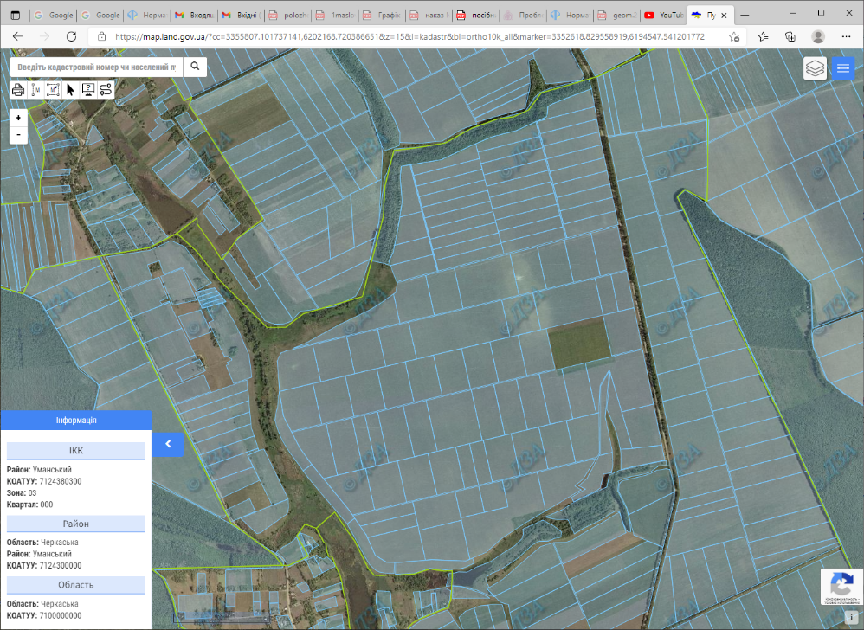
Fig. 2. The interspersed land plot, selected for exchange in the agricultural land mass
Area 6.4682 ha
Normative 217,654.93 UAH
monetary
value

In case we calculate the value of a peer land plot based on the value of the interspersed land plot, by normative monetary valuation it can be 195,889.44 UAH to 239,420.42 UAH. Formula (4) proves, the minimal value of a land plot which can be considered as a peer one, is 197,868.12 UAH. In case the owner gets a land plot with the normative monetary value from 195889.44 UAH to 197868.12 UAH for their land plot, such exchange can be disputed and considered to be not peer. Thus, the landowner can lose 1,978.68 UAH by normative monetary valuation. Landowner's potential loss by market valuation is 3,592.20 UAH, loss of area is 588 sq. m.
Conclusions and perspectives.
In the context of the actual tasks of the modern land management, the exchange of the peer land plots is very important at the implementation of land consolidation, the reallotment (reorganization) of built-up areas, or alienation for public needs. At this, the definition of the peerness of land plots is the key aspect of the mentioned measures, from which depends the effectiveness of the realization of the respective projects.
It is revealed that the approach by which the land plots are considered to be peer, the value of which is different by less than 10 %, has the inaccuracy of 1/110 (≈0.9%) of the value of the land plot. In case when for the comparison the normative monetary value is used, the inaccuracy can grow up to 13/220 (≈5.9%) of the value of the land plot.
The exchange is considered to be peer when the value of land plots to be exchanged differ by no more than 10% from the less of the values. The carried out researches prove the need for the improvement of the current legislation of Ukraine. It is applicable to the consideration of the peerness of land plots by both normative and expert monetary valuation.
The results gained are recommended to implementation at the definition of land plots as the equal at exchange and sublease; at the implementation of complex land consolidation; at the alteration of legal acts on land consolidation; at the modeling of land reallotment based on the heuristic or optimizational approach.

References
- Verkhovna Rada of Ukraine. (2018). On the Alteration of some legislative acts of Ukraine concerning the issue of the collective ownership of land, the improvement of the rules of land use in agricultural land masses, preventing raidership and stimulating the irrigation in Ukraine. Available at: https://zakon.rada.gov.ua/laws/show/en/2498-19#Text.
- Verkhovna Rada of Ukraine. (1998). Law on Land Lease: Available at: https://zakon.rada.gov.ua/laws/show/161-14?lang=en#Text.
- Verkhovna Rada of Ukraine. (2002). The Land Code of Ukraine. Available at: https://zakon.rada.gov.ua/laws/show/2768-14?lang=en#Text.
- Verkhovna Rada of Ukraine. (2018). Law on Alienation of Land Plots and Other Objects of Immovable Property Located On Them in Private Ownership for the Social Needs and on the Grounds of Social Necessity: Available at: https://zakon.rada.gov.ua/laws/card/1559-17?lang=en.
- Malashevskyi, M., Malashevska, O. (2021). The swapping approach in the course of land consolidation: case study of Ukraine. Geodesy and Cartography, 47 (4), 200-211.
- Malashevskyi, M., Kovalchuk, I., Malashevska, O. (2021). Reallotment over the Course of the Development of a Rural Settlement in Ukraine. Geomatics and Environmntal Engineering, 14(3), 115-127.
- Mihajloviс R., Miladinoviс M., Šoškiс M. (2011). Optimization of Land Distribution in Land Consolidation. Geodetski list, 2, 109-121.
- Malashevskyi, M., Malashevska, O. (2022). Land Consolidation Considering Natural Afforestation. Geomatics and Environmental Engineering, 16 (2), 5-19.
- Malashevskyi, M., Malashevska, O. (2022). The theory of combinations for land plot exchange modelling in the course of land consolidation. Geodesy and Cartography, 48 (1), 11–19.
- Malashevskyi, M., Tarnopolskyi, A., Malashevska, O. (2022). The issues of the substantiation of peer agricultural land plots exchange in Ukraine. Scientific Papers. Series "Management, Economic Engineering in Agriculture and rural development", 22 (3), 383-388.
- Ibatullin, Sh., Sakal, O., Avramchuk, B., Tarnopolskyi, Ye., Kharytonenko, R. (2022). The Role of Remote Sensing and GIS in the Implementation of the Category of Land Rent to the Content of the Normative Monetary Valuation of Agricultural Lands in Ukraine. International Conference of Young Professionals «GeoTerrace-2022», 1-5.

М. Малашевський, А. Тарнопольський, О. Малашевська, Є. Тарнопольський
ПРОБЛЕМА ВСТАНОВЛЕННЯ РІВНОЦІННОСТІ ЗЕМЕЛЬНИХ ДІЛЯНОК ПРИ ОБМІНІ З МЕТОЮ КОНСОЛІДАЦІЇ ЗЕМЕЛЬ
Анотація. У статті розглядається проблема обміну земельних ділянок з метою просторового впорядкування земель. У сучасних умовах актуальною є проблема усунення черезсмужжя земель в масивах земель сільськогосподарського призначення, розроблення та удосконалення механізмів консолідації земель, обговорюється впровадження примусової (комплексної) консолідації земель, існують передумови вдосконалення технічного обґрунтування відчуження земельних ділянок для суспільних потреб та з мотивів суспільної необхідності. У контексті зазначених питань розглядається проблема встановлення рівноцінності обмінюваних земельних ділянок, а саме визнання земельних ділянок рівноцінними за умови, що різниця їх вартості становить менше 10%. Дослідження має на меті вдосконалення підходів до встановлення допустимої різниці вартості земельних ділянок, які вважаються рівноцінними при обміні. Проаналізовано положення законодавства, які передбачають рівноцінний обмін земельних ділянок та встановлюють допустиму різницю вартості таких ділянок. Встановлено, що внаслідок нечіткого визначення допустимої різниці вартості земельних ділянок, які вважаються рівноцінними, виникає похибка від 1/110 (≈0,9%) до 13/220 (≈5,9%) вартості земельної ділянки. Наявність такої похибки, по-перше, створює передумови до оскарження рівноцінного обміну земельних ділянок у судовому порядку, по-друге, чинить перепони добровільному залученню землевласників до обміну. Запропоновано уточнення до визначення допустимої рівниці вартості земельних ділянок, які вважаються рівноцінними. Отримані результати можуть бути використані в при встановлені рівноцінності земельних ділянок при обміні і суборенді; при впровадженні комплексної консолідації земель; при внесенні змін до законодавчих актів щодо консолідації земель; при моделюванні перерозподілу земель на основі евристичного або оптимізаційного підходу.
Ключові слова: обмін земель, перерозподіл земель, рівноцінні земельні ділянки, консолідація земель, оцінка земель.
*****
Н. Малашевский, А. Тарнопольский, Е. Малашевская, Е. Тарнопольский
ПРОБЛЕМА УСТАНОВЛЕНИЯ РАВНОЦЕННОСТИ ЗЕМЕЛЬНЫХ УЧАСТКОВ ПРИ ОБМЕНЕ С ЦЕЛЬЮ КОНСОЛИДАЦИИ ЗЕМЕЛЬ
Аннотация. В статье рассматривается проблема обмена земельных участков с целью пространственного упорядочения земель. В современных условиях актуальна проблема устранения чересполосицы земель в массивах земель сельскохозяйственного назначения, разработка и совершенствование механизмов консолидации земель, обсуждается внедрение принудительной (комплексной) консолидации земель, существуют предпосылки совершенствования технического обоснования отчуждения земельных участков для общественных нужд и по мотивам общественной необходимости. В контексте указанных вопросов рассматривается проблема установления равноценности обмениваемых земельных участков, а именно признание земельных участков равноценными при условии, что разница в их стоимости составляет менее 10%. Целью исследования является совершенствование подходов к установлению допустимой разницы стоимости земельных участков, которые считаются равноценными при обмене. Проанализированы положения законодательства, предусматривающие равноценный обмен земельных участков и устанавливающие допустимую разность стоимости таких участков. Установлено, что в результате нечеткого определения допустимой разницы стоимости земельных участков, которые считаются равноценными, возникает погрешность от 1/110 (0,9%) до 13/220 (5,9%) стоимости земельного участка. Наличие такой погрешности, во-первых, создает предпосылки для обжалования равноценного обмена земельных участков в судебном порядке, во-вторых, препятствует добровольному вовлечению собственников земли в процесс обмена. Предложено уточнение к определению допустимой разности стоимости земельных участков, которые считаются равноценными. Полученные результаты могут быть использованы при установлении равноценности земельных участков при обмене и субаренде; при внедрении комплексной консолидации земель; при внесении изменений в законодательные акты по консолидации земель; при моделировании перераспределения земель на основе эвристического или оптимизационного подхода
Ключевые слова: обмен земель, перераспределение земель, равноценные земельные участки, консолидация земель, оценка земель.

