UDС 332.05
TREND ANALYSIS OF PRODUCTION DYNAMICS
AGRICULTURAL PRODUCTS
O. Kostyshyn, PhD in economics, associate professor
Lviv National Environmental University
e-mail: kostushn@ukr.net
L. Dudych, PhD in economics, associate professor
Lviv National Environmental University
e-mail: dyduchl@ukr.net
Abstract
The research is devoted to the trend analysis of the dynamics of production in agricultural sectors as a tool for forming an optimal program of their functioning in order to establish trends and forecast their further development, as well as to evaluate the method of trend analysis in relation to the scope of its application in the research of agricultural sectors. It is substantiated that the forecasting of economic indicators is possible along trend lines, if their parameters, in particular the approximation coefficient R2 and the correlation coefficient R ensure the necessary reliability of the forecast data. An assessment of the possibility and expediency of applying the technique of horizontal analysis - trend analysis and selection of a trend line was carried out. It was established that when studying the economic indicators of the Lviv region, such as the production of all agricultural products and plant products, the correlation coefficient provides such reliability (1 ≤ R ≥ 0.95), but for the livestock industry, it does not (R=0.56 ). When studying the economic indicators of the crop industry as a whole in Ukraine, such as the production of rapeseed (R=0.74), soybean (R=0.67) and wheat (R=0.48), it was established that the corresponding correlation coefficients do not provide the necessary reliability for forecasting trend lines for the economic forecast of the development of agricultural industries.
Key words: trend line, dynamics, time series, agricultural production, wheat, rapeseed, soybeans.

Formulation of the problem. In terms of agricultural potential, Ukraine is a unique country, with almost 25% of the world's most fertile chernozems. Therefore, historically, the agrarian industry is one of the main ones in the country's economy, which has been perceived as the "breadbasket of Europe" since ancient times. Ukraine has become the largest exporter of sunflower oil in the world, the second largest exporter of grain, the fourth exporter of corn and barley, the sixth exporter of wheat and soybeans, the seventh exporter of poultry and honey, and the ninth exporter of eggs [1]. The agricultural sector is dominated by crop production, the specific weight of which is 73% of agricultural products. The specific weight of commercial agricultural crops in the structure of the plant industry is approximately 60%. These are mainly cereals, legumes and sunflower. Ukraine, as a producer and exporter of agricultural products, needs to carefully monitor global trends and minimize risks. Therefore, the issues of establishing trends and forecasting the further development of the agricultural sector are becoming more relevant. In order to preserve and improve the position of Ukrainian producers in the world agricultural markets, it is necessary to increase investments, which makes it possible to reduce the cost of production, improve the quality of products, enter segments with higher added value, and improve product marketing.
The issue of regular and timely accounting of statistical and other data and their openness, availability for monitoring the process of agricultural production and analysis of its indicators remains unresolved. The results of the research can be applied to identify trends and forecast the development of various agricultural industries, for farming and other enterprises, as well as to forecast their opportunities for exporting products.

Analysis of the latest scientific research and publications. Agriculture provides employment for 14% of the population of Ukraine. But, unlike other industries, it has high unpredictability for the future in terms of macroeconomics and microeconomics due to factors such as climate change, economic downturns, etc. In addition, the goal of improving the rural economy as an industry is not just to maximize productivity, but to develop a diverse and complex environment as a whole, for example, the development of agricultural land, food products, consumer culture, etc.
Based on the fact that most of the data in the research of the main trends and trends in the agricultural sector is based on the materials of government projects and does not always coincide with the individual positions of academic authors and citizens in social networks, in work [2] the authors set the goal of comparing and analyzing positions in three directions: individual text analyzes of academic articles, research and reports on state policy, and social news articles. At the same time, 6 groups of problems (goals) were defined - plant protection; hunger and malnutrition; development of plant breeding potential; investments in agriculture; agricultural heritage system; genetic resources of animals. By the way, The Food and Agricultural Organization of the United Nations (FAO) carries out activities with 9 goals: plant protection, hunger, malnutrition, pest control, plant diseases, plant breeding, investments in agriculture, agricultural heritage system and animal genetic resources. In the process of researching the dynamics of interest in these problems (goals) in terms of the specified categories and sources of information (three types of data - political reports, scientific articles and news articles), trends regarding their further development were obtained.
However, since this study is based on data limited to a specific country - Korea - it is difficult to generalize the results on a global scale. However, the author's formulation of the problem and research methodology, built on the comparison and analysis of interest in the main problems (goals) of agricultural and related industries according to various categories and sources of information, are of interest for determining trends in the development of the agricultural industry of Ukraine.
To support agricultural production and exports of Ukraine, to mitigate the global food security crisis exacerbated by the war, the United States Agency for International Development (USAID) launched the Agricultural Resilience Initiative (AGRI) - Ukraine. The line of effort of this Initiative is to improve and increase export logistics and infrastructure, increase storage and their capacity, purchase and delivery of necessary resources to farmers who have limited stocks or limited mobility [3].
The Innovarum company has identified 10 trends of the future agricultural sector: 5 global trends and 5 trends that relate specifically to the agricultural sector of the EU. Among global trends, the following are formulated: changes in world consumption patterns affect trade flows and export and import of food products; continued outflow of labor from the agricultural sector to other industries; technologies and innovations will play a key role in the stability of agricultural and food systems; increasing demand for products that require less processing and negative perception of GMOs; environmental problems affect everyone [4].
Trends directly related to the agricultural sector of the EU: possible increase in agricultural production due to an increase in the specific weight of fodder and protein crops in combination with an increase in yield; slowing down the outflow of labor from the agricultural sector due to the change in the nature of agricultural work from manual to managerial, through the implementation of digitalization, the latest technologies and innovations; transition to a protein diet mainly of vegetable origin and awareness of the advantages of locally produced organic products; an increase in the total income of farmers due to an increase in agricultural production and an increase in product prices; acceleration of actions in the EU and other parts of the world to implement the vision and goals of the 2030 Agenda through the implementation of research and innovation programs [4].
The purpose of the study. The research is devoted to the trend analysis of the dynamics of production in agricultural sectors as a tool for forming an optimal program of their functioning in order to establish trends and forecast their further development, as well as to evaluate the method of trend analysis in relation to the scope of its application in the research of agricultural sectors.
Materials and methods of scientific research. In the analyzed foreign studies, the method of text analysis was used. It is a method of analysis that extracts meaningful and useful data or information by drawing hidden themes or relationships. The cartographic research method was used to analyze the intensity of distribution of certain processes (in our case, the production of certain agricultural crops) on the territory of Ukraine using cartograms. Tabular and calculation-graphic methods were used by us for a visual presentation of the dynamics of indicators of agricultural production in general and by individual branches and agricultural crops. The method of trend analysis is used to analyze time series of agricultural production in order to accurately identify modern trends. A trend is a regular change in a certain process over a certain long-term period, that is, it reproduces changes due to constant long-term factors that determine the prevailing trend of time series. The essence of the method of building a trend is based on the assumption that the started change of the variable will continue in the future with a similar direction and a similar speed.Among other things, indicators of agricultural production are forecast on its basis. By comparing parameters (equation ƴ, reliability of approximation R2, correlation coefficient R) of linear, exponential, logarithmic, power and polynomial trends, the type of trend is selected, which provides the closest connection in the time series and gives the most accurate result of forecast data. It can be used to compare the studied indicators in different regions and at different time intervals. The methodology has been tested on the territory of Ukraine as a whole and, in particular, in the Lviv region.
Research results and discussion. One of the main goals of the Russian invasion of Ukraine was to paralyze the country's agricultural sector. For this purpose, farms, warehouses and fields, transport infrastructure and agricultural research institutes were attacked. Transport and warehouse infrastructure suffered varying degrees of damage and destruction. fertilizer production and labor. As a result, the country did not receive agricultural products. Pre-war exports of agricultural products of Ukraine amounted to 27.8 billion dollars. According to USDA (US Department of Agriculture) data and forecasts, Ukraine exported about 17 million tons of wheat from the 2020-2021 harvest, while Ukraine's exports from the 2022-23 harvest are forecast to drop to 10 million tone The Commission for the Economic Reconstruction of Ukraine (CSIS) on agricultural issues developed recommendations [5] regarding the reconstruction of the agricultural economy of Ukraine and a number of other specific areas related to it: transport, storage, fertilizers, the work of farmers.
Transport. To restore Ukraine's ability to export agricultural products, as well as to free up space for current and future harvests, it is necessary to improve Ukraine's agricultural transport infrastructure. The problems of transporting agricultural products are related to the need to identify and strengthen alternative routes; reorientation of product transit from sea to rail, for which it is necessary to build railway lines of standard (narrower) EU gauge at the border crossing points of Ukraine, modernize wagons and bring the dimensions of grain bunkers of railway platforms into compliance with EU standards. The cost of railway transportation has increased by more than 600% due to the increase in fuel costs and the cost of insurance.
Storage. With regard to product storage, the strategy for supporting grain storage, developed by FAO, which forecasts a shortage of storage capacity, proposes the purchase of long-term modular storage units for farms, equipment for loading and unloading grain and polyethylene grain sleeves
Fertilizers. The problem of providing Ukrainian farmers with fertilizers lies in the area of ​​determining suppliers, ensuring access for farmers, and financing transportation to Ukraine. Since increasing the production of fertilizers, even with the availability of reserves and infrastructure, takes 3-5 years, in the absence of guaranteed extended supplies of fertilizers and for the long term, for the most effective use of available fertilizers, it is advisable to use technologies of precise application of fertilizers, as well as conduct soil testing, use satellite technologies and artificial intelligence technologies.
The work of farmers. The qualification requirements for the work of farmers have undergone changes due to changes in the operation of the new transport system (in connection with the reorientation of transportation from the sea model to the railway model), due to the need to use new modes of product storage, technologies of precise application of fertilizers. For this, training and retraining of the labor force is required, and this is in the conditions of its shortage in the agricultural sector. Proceeding from the fact that the previous three problems (transportation, storage, fertilizers) have outlined possible ways to solve them, the needs of the agricultural labor force in Ukraine remain a priority issue [5].
The war in Ukraine strongly influenced the trends of the global agri-food sector. The increase in the cost of production affects all links of the food chain on a global scale. This includes production, processing, distribution, transportation and sales. Let's consider the trends. which have emerged on the example of one of the EU countries - Spain [6], which occupies a high position in the world ranking of exporters of agro-food products (fourth place in the EU and seventh place in the world). After. as the country recovered from the consequences of the pandemic, the trend of its agricultural sector became positive. Employment in each individual sector reflects the dynamics of activity, so according to this indicator, the food industry sector is ahead of the primary sector. Food costs are rising due to rising prices, and rising food prices affect the amount of food consumed by households. The increase in purchases is due to the fear of a possible shortage and, accordingly, the accumulation of stocks. After the start of the war in Ukraine, expenses in supermarkets and large grocery stores increased due to Spanish cards. Moreover, a trend was revealed that, in terms of household income, they increased the most in the group of households with low incomes. This is because prices have increased on most products in their typical grocery basket due to the busy tourist season. Thanks to the high competitiveness of the Spanish sector, the export of agri-food products continues to grow. The export of legumes and vegetables, fats and oils, food products, shellfish and fresh fish, juices and beef increased especially.
In the paper [7], the authors developed an econometric vector autoregression model, thanks to which the intensity and trivality of price transfer in the food chain are measured. They displayed on the diagram how the shock of the rate of change in the price of food products in the EU affected consumer prices (for goods that already include the impact of the Common Agricultural Policy). The obtained result shows that a short-term increase in the rate of change in food prices in the EU by 10 percentage points leads to an increase in the consumer price index of food products by 2.3 percentage points a year later. This means an increase in general inflation in Spain by 0.5 percentage points.
The main agricultural crops that determine Ukraine's specialization at the international level and form its agricultural exports are grain, soybeans, and rapeseed. This is stated in the work [8, p. 23]: “…. strengthening of Ukraine's international agro-food specialization and dominance in the production of two main groups of crops (cereal and oil crops)". The main commercial agricultural crop with a high specific weight of export is sunflower. Ukraine produces sunflower cake, oil and seeds.
But we will focus on the development trends of the following industries - the cultivation of rapeseed, soybeans and wheat, a part of which is also produced in the Lviv region. Ukraine ranks sixth in the world in rapeseed production. and in terms of its export – the third [9]. In terms of soybean volume, Ukraine ranks ninth in the world, and in terms of soybean exports, it ranks seventh. Ukraine is the seventh largest producer of wheat in the world and the fifth largest exporter.
In fig. 1a) shows a diagram of the dynamics of indices of production of agricultural products of the Lviv region, and in fig. b) and c) – plant and animal products, respectively.

Fig. 1. Trend lines of the dynamics of agricultural production indices (Lviv region).
Formed by the author based on the source: [10].

Lviv region is included in the zone of intensive production of rapeseed - 7% of the national production (Fig. 2) and according to the map of the average annual production of rapeseed in Ukraine for the 5-year period from 2016 to 2020 falls into the highest group of intensity (from 100.001 to 250.0 metric tons).
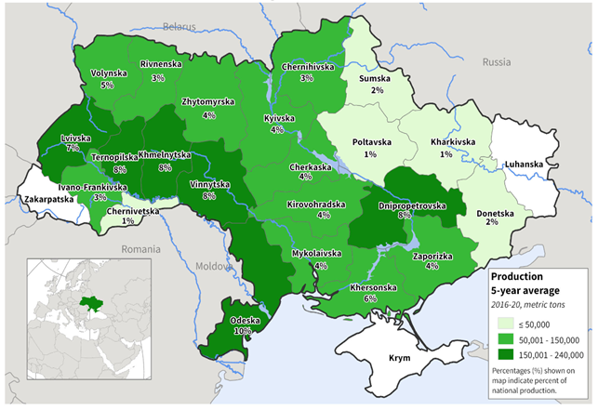
Fig. 2. Map of the volume of rapeseed production in Ukraine by administrative regions.
Source: [11].
The Lviv region produces 4% of soybeans (soybeans) from the national production, and according to the cartogram of the average annual production of soybeans in Ukraine for the 5-year period from 2016 to 2020 (Fig. 3), it falls into the middle group (from 100,001 to 250, 0 metrictones).
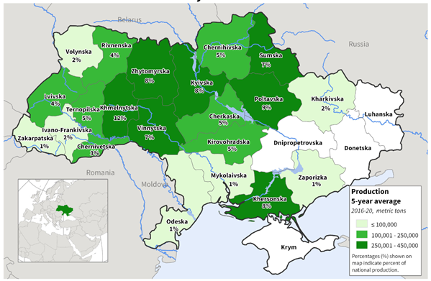
Fig. 3. Map of soybean production volumes in Ukraine by administrative regions
Source: [11].

Winter wheat makes up about 97% of the total wheat production in Ukraine. The main production of wheat is concentrated in the south-eastern region of the country and the Lviv region produces only 1% of wheat grain from the national production. According to the cartogram of the average annual production of wheat in Ukraine for the 5-year period from 2016 to 2020 (Fig. 4), the region falls into the lower group of production intensity (≤1000 metric tons).
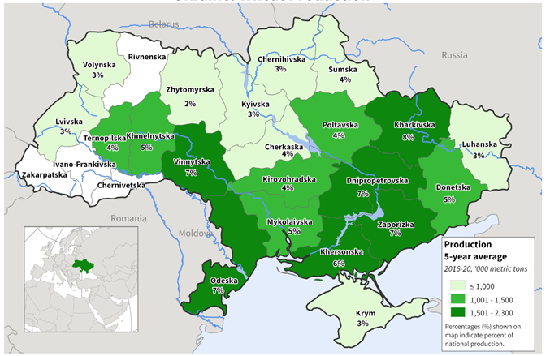
Fig. 4. Cartogram of wheat production volumes in Ukraine by administrative regions
Source: [11]

In fig. 5 shows a diagram of the dynamics of production in Ukraine: a) rapeseed; b) soybeans; c) wheat and tread lines.

Fig. 5. Trend lines of the dynamics of production of individual agricultural crops
Formed by the author based on the source: [11].

The results of the study of trend lines and their parameters (table 1) show that the maximum value of the correlation coefficients R, as a rule, belongs to the polynomial trend line, and only for the production of rapeseed does the stepwise trend line show the maximum value of R.

Table 1. Indicators of trend lines*
Trend line | Equation Y | Reliability of approximation R² | Correlation coefficient,, R
Lviv region: Total agricultural production
Linear | y = 4,321x + 95 | 0,96 | 0,98
Exponential | y = 96,01e^{0,038} | 0,97 | 0,98
Logarithmic | y = 12,90ln(x) + 96,56 | 0,86 | 0,93
Power | y = 97,22x^{0,115} | 0,89 | 0,94
Polynomial | y = 0,226x² + 2,511x + 97,71 | 0,97 | 0,98
Products of crop production
Linear | y = 6,357x + 92, | 0,97 | 0,98
Exponential | y = 94,88e^{0,053x} | 0,98 | 0,99
Logarithmic | y = 18,99ln(x) + 95,15 | 0,87 | 0,93
Power | y = 96,46x^{0,162} | 0,92 | 0,95
Polynomial | y = 0,333x² + 3,690x + 96,85 | 0,98 | 0,99
Animal husbandry products
Linear | y = 0,571x + 99 | 0,31 | 0,56
Exponential | y = 99,00e^{0,005x} | 0,31 | 0,56
Logarithmic | y = 1,766ln(x) + 99,13 | 0,30 | 0,55
Power | y = 99,13x^{0,017} | 0,30 | 0,55
Polynomial | y = -0,023x² + 0,761x + 98,71 | 0,31 | 0,56
Ukraine: Rape production
Linear | y = 0,1341x + 2,4467 | 0,35 | 0,59
Exponential | y = 2,4193e^{0,0506x} | 0,38 | 0,63
Logarithmic | y = 0,4529ln(x) + 2,4195 | 0,49 | 0,70
Power | y = 2,3954x^{0,1707} | 0,54 | 0,74
Polynomial | y = -0,065x² + 0,5891x + 1,84 | 0,52 | 0,72
Production of soybeans
Linear | y = -0,2419x + 4,7242 | 0,41 | 0,64
Exponential | y = 4,7697e^{-0,063x} | 0,41 | 0,64
Logarithmic | y = -0,577ln(x) + 4,51 | 0,29 | 0,54
Power | y = 4,5235x^{-0,153} | 0,30 | 0,55
Polynomial | y = -0,0447x² + 0,0708x + 4,3072 | 0,44 | 0,67
Wheat production
Linear | y = -0,3516x + 27,92 | 0,02 | 0,16
Exponential | y = 28,28e^{-0,02x} | 0,05 | 0,23
Logarithmic | y = -0,495ln(x) + 27,232 | 0,01 | 0,01
Power | y = 27,415x^{-0,034} | 0,02 | 0,14
Polynomial | y = -0,6968x² + 4,5263x + 21,416 | 0,23 | 0,48
*The maximum values ​​of correlation coefficients R are highlighted in the table.
Thus, the polynomial trend line provides the closest connection in the time series and gives the most accurate result of forecast data. The analysis of the table also shows that in the block of the Lviv region, in two of the three studied indicators, the value of the correlation coefficient is in the range from 0.95 to 1.0, and on this basis, we used a polynomial trend line for a forecast for one period - for the year 2022, which shown on the corresponding diagrams (see Fig. ). As a result, we received that the index of the production of agricultural products, according to the forecast, will be 132.5%, and that of plant products - 147% in relation to the indicators of 2015. That is, for the period 2015-2021, the production of agricultural products will increase by 1.3 times, and the production of crop production - by almost 1.5 times. For all other studied categories (livestock industry of Lviv region, rapeseed, soybean and wheat production in Ukraine), the correlation coefficients do not provide the necessary reliability for forecasting. In this case, forecasting for a short period can be based on the use of monitoring the condition of crops with the use of such promising agricultural technological directions as the technology of precision agriculture, vertical agriculture and smart agriculture; satellite navigation, unmanned aerial vehicles, GPS, remote control and remote sensing technology; agricultural Internet of things, robotics, cloud technology.
Discussion and suggestions. To identify trends in the development of agricultural production according to various indicators, it is advisable to use trend analysis of the dynamics of their previous development over time. At the same time, it is necessary to study all types of trend lines and, based on the analysis of their parameters (equation ƴ, reliability of approximation R2, correlation coefficient R), choose the type of trend line that ensures full reliability of the forecast.

References
1. Kovaliv, Y. (2018) Agricultural sector of Ukraine. Agroberichten Buitenland. Nаtional Investment Counet of Ukraine. Available at: https://www.agroberichtenbuitenland.nl/documenten/rapporten/2018/07/04/ua-report-investment-council-ua-agriculture
2. Solsaem, Ch. (2019) Analysis of the Agricultural Industry Based on Text Analytics. Agribusiness and Information Management, 11 (1). Available at: http://www.koreascience.or. kr/article/JAKO201919762876992.pdf.
3. Agriculture resilience - initiative (AGRI) – UKRAINE. Available at: https://www.google.com/url?sa=t&rct=j&q=&esrc=s&source=web&cd=&cad=rja&uact=8&ved=2ahUKEwirrLTq87n7AhUBlIsKHfQoAo4QFnoECAoQAQ&url=https%3A%2F%2Fwww.usaid.gov%2Fukraine%2Fagriculture-resilience-initiative-agri-ukraine&usg=AOvVaw2i5xxmzz_sSdnpl_I17zXK.
4. 10 trends for the future of the agricultural sector. Available at: https://innovarum.es/en/agrifood/10-trends-future-agricultural-sector.
5. Welsh, C., Dodd, E. (2022) Rebuilding Ukraine’s agriculture sector: emerging priorities. Center for strategic and international studies. Available at: https://www.csis.org/analysis/rebuilding-ukraines-agriculture-sector-emerging-priorities.
6. Garriga, J. M. (2022) The war in Ukraine is affecting trends in the agrifood sector. Available at: https://www.caixabankresearch.com/en/sector-analysis/agrifood/war-ukraine-affecting-trends-agrifood-sector.
7. Ondina, P. Á., Garriga, J. M. (2022) Spain’s agricultural sector and its dependence on international agricultural commodity markets. Available at: https://www.caixabankresearch.com/en/sector-analysis/agrifood/spains-agricultural-sector-and-its-dependence-international-agricultural.
8. Report of the State University "Institute of Economics and Forecasting of the National Academy of Sciences of Ukraine" for 2021. State University "Institute of Economics and Forecasting of the National Academy of Sciences of Ukraine". Kyiv. 173.
9. Ukraine agricultural production and trade. Foreign Agricultural Service U.S. Department of agriculture. Available at: https://www.fas.usda.gov/sites/default/files/2022-04/Ukraine-Factsheet-April2022.pdf.
10. Lviv region in numbers 2021: statistical collection. Main Department of Statistics in Lviv Region. Lviv. 54.
11. Country Summary. Foreign Agricultural Service U.S. Department of agriculture. Available at: https://ipad.fas.usda.gov /countrysummary/Default.aspx?id=UP.

Костишин О. О., Дудич Л. В.
ТРЕНДОВИЙ АНАЛІЗ ДИНАМІКИ ВИРОБНИЦТВА CІЛЬСЬКОГОСПОДАРСЬКОЇ ПРОДУКЦІЇ
Дослідження присвячене трендовому аналізу динаміки виробництва продукції по галузях сільського господарства як інструменту формування оптимальної програми їх функціонування з метою встановлення тенденцій та прогнозування подальшого їх розвитку, а також оцінці методу трендового аналізу щодо сфери його застосування в дослідженнях сільськогосподарських галузей. Обґрунтовано, що прогнозування економічних показників можливо по трендових лініях, якщо їх параметри, зокрема коефіцієнт апроксимації R² та коефіцієнт кореляції R забезпечують необхідну достовірність прогнозних даних. Здійснена оцінка можливості і доцільності застосування методики горизонтального аналізу – трендового аналізу та вибору лінії тренду. Встановлено, що при дослідженні економічних показників Львівської області таких як виробництво сільськогосподарської продукції усього та рослинницької продукції, коефіцієнт кореляції забезпечує таку достовірність (1 ≤ R ≥ 0,95), а для тваринницької галузі, – не забезпечує (R=0,56). При дослідженні економічних показників рослинницької галузі в цілому по Україні, таких як виробництво ріпака (R=0,74), сої (R=0,67) і пшениці (R=0,48) встановлено, що відповідні коефіцієнти кореляції не забезпечують необхідної достовірності для прогнозування трендових ліній для економічного прогнозу розвитку сільськогосподарських галузей.
Ключові слова: лінія тренду, динаміка, часовий ряд, сільськогосподарська продукція, пшениця, ріпак, соя.

