UDC 528.4:528.1

INNOVATIVE APPROACHES TO QUALITATIVE LAND ASSESSMENT AND VALUATION: USE OF MODERN TECHNOLOGIES AND GEOINFORMATION X SYSTEMS

І. Udovenko, Candidate of economic sciences, associate professor Associate Professor of the Department of Geodesy, Cartography and Cadastre Uman National University of Horticulture
E-mail: irinaudovenko8@gmail.com

M. Shemiakin, Ph.D. in Agricultural Sciences, Assistant Professor, Assistant Professor of the Department of Geodesy, Cartography and Cadastre, Uman National University of Horticulture
E-mail: misha.uman@gmail.com

N. Likhva Senior Lecturer at the Department of Geodesy and Land Management, Odessa State Academy of Civil Engineering and Architecture
E-mail: likhva_n@odaba.edu.ua

Abstract. Topicality. The article examines modern methods and technologies that can be used to increase the accuracy of land valuation. The authors analyze the current problems in the field of rating and offer ways of integrating geoinformation systems with the aim of creating a more objective and information-rich picture of land quality. The purpose of the article. Study of the potential of using the latest technologies and geoinformation systems in determining the quality and classification of land with the intention of increasing accuracy and impartiality in the assessment of land resources. Research methods. During the research, the following methods were used: comparative analysis, the method of automated image decoding, the cartographic method and the geo-information mapping method. The results. The article emphasizes the importance of geoinformation systems in the collection, processing and analysis of data, which allows taking into account a wide range of factors when evaluating land, including erosion processes, soil fertility, ecological status and other critically important indicators. Special attention is paid to the possibilities of using remote sensing and other automated methods for data collection. Conclusions. The results of the research are of practical importance, as they can be used to optimize agricultural management, plan the use of land resources, and develop strategies for their effective use and protection. Prospects for further research may include the development of new algorithms for the analysis and processing of data obtained from satellite images, as well as the improvement of existing geoinformation models for land evaluation. Integration of the obtained models and systems into the practical aspects of land use and agricultural management is also envisaged to optimize the use of land resources and increase the efficiency of land use.
Keywords: land valuation, geoinformation system, geoinformation mapping, ArcGIS PC, GPS measurement, agrochemical monitoring.

Topicality. To analyze the territory of Ukraine, agricultural maps of different territorial coverage and different scales were created. However, they do not provide a complete and unified understanding of the quality of lands and prospects for their use. Existing agricultural maps, created at different times, no longer meet the growing requirements of science and practice. There is an insufficient amount of research dedicated to mapping the current state of agricultural lands, their characteristics, ways of use and measures to improve agro-ecological properties, soil quality and their protection. There is also a lack of large- and medium-scale maps for comprehensive assessment of land.
Regional development in Ukraine is based on the justified use of land resources, which prompts a growing interest in land information as a foundation for planning, development and monitoring of natural resources. Reliable and updated information about territorial objects and processes is critical for effective management of dynamically changing territories [3, p. 27-28]. A tool that can serve this purpose is land information systems built on the basis of innovative geoinformation technologies. Modern methods of collecting, processing, visualizing and distributing information have reached a high level of development and widespread implementation in everyday life. In recent years, there has been a need to implement an adaptive approach to the qualitative assessment of lands and their valuation. This approach is taken as a key conceptual basis, a system of scientific views, which is aimed at finding methods not only for preserving and increasing the natural resource potential of agricultural lands, but also for qualitative assessment and valuation of lands using geoinformation system technologies.
Analysis of recent research and publications. Today, land mapping is one of the priority tasks of modern cartography and land management science. This direction is based on the theoretical foundations and methodological principles of cartographic science, which were developed in the scientific works of: Vertegel S., Vyshnyakov V., Gurelia V., Slastin S., Piskun O., Kharchenko S., Moroz V. [2], Lazorenko-Hevel N. [6], Piccoli F., Locatelli S., Schettini R., Napoletano P. [23] and due to modern approaches to visualization of spatial data.
Geoinformation mapping, as a specialized branch of cartography, deals with the automation of the creation and use of maps using geoinformation systems, databases and knowledge. This field is developing on the basis of the work of many scientists: Rudenko M. [8], Sitkovska A., Maslyaeva O. [9], Butora A., Solonevych B., Schwartz K., Aziz K., Su S., Mahmud M. [14], Mohd Zuki N., Mohamad A. [22], whose works laid the foundation for the current state of geoinformation mapping. Such a scientific base provides opportunities for conducting research in the direction of the use of modern technologies and geoinformation systems in order to improve the quality of land evaluation.
The aim of the study. The goal is to study and analyze the possibilities of applying innovative technologies and geo-information systems in the processes of quality assessment and valuation of land in order to increase the accuracy and objectivity of the assessment of land resources.
Research tasks include:
- analysis of the current state and main problems in the quality assessment of lands and their valuation;
- review of innovative technologies used in geoinformation systems for land valuation;
- studying the possibilities of using modern geoinformation systems in the process of land quality assessment;
- carrying out experimental assessment of land with the help of selected geoinformation systems;
- assessment of the effectiveness of the use of geoinformation systems in comparison with traditional credit rating methods.
Methods. The basis for the research was multispectral space images from satellite systems of the LandSat-8 class, received in June-August 2023 year, topographic maps, cadastral plans of the studied territories, as well as data from the Ukrainian geoportal "National Cadastral System" [4].
In the course of the work, the following research methods were used: comparative analysis, the method of automated image decoding, the cartographic method (morphometric analysis) and the geo-information mapping method.
The research is based on the fact that the creation of an attributive database is impossible without the appropriate arrangement of information, which is a necessary condition for the functioning of an effective geographic information system (GIS). Modern GIS programs and database management systems offer intuitive and convenient tools for working with data. Vector electronic maps are able to display not only the metric parameters of objects, but also their attributes and semantic features, which are recorded in the database tables of cartographic objects. Attributes of objects on the electronic map are determined using the "ArcGIS" software, which includes such data as: the name of the land layer, its number, the name of the object, the code of the object, the number of the object, the localization code, the unique key about of the object In addition to attributes, objects have individual characteristics known as semantic properties, which include qualitative and quantitative parameters of objects [24].
This study uses a relational data model, which is based on the relationships between various attributes, thereby reflecting the relationships between objects and their characteristics in the physical world. So, in order to give the informational representation of the object a "spatial" status, it is necessary to add at least one attribute to it that accurately indicates the spatial location of the object. The integration of such an attribute transforms a conventional database into a geographic information system (GIS). Spatial attributes can be defined through the relative or absolute position of an object, resulting in two main models for storing spatial data: raster (for relative position) and vector (for absolute position).
Research results. The management of agricultural holdings often does not have accurate information about the size of their own planted areas and the quality of the lands, as they undergo changes due to various natural and managerial influences, which leads to constant changes in the characteristics of the soil and vegetation on individual plots and between them. This information should be the basis for drawing up agrotechnical plans and electronic maps for each field or plot in particular. The development and implementation of systems of assessment and crediting of agricultural land are a key direction of modern development. The importance of their research, development and testing stems from the need to take into account economic and territorial aspects, as well as the need to use specialized agricultural maps [5, p. 53]. A large amount of spatial and statistical information of different time and scale requires the involvement of the potential of geoinformation mapping (GIS). Geoinformation mapping, which is a synthesis of cartography, geoinformatics and remote sensing methods, is particularly useful for comprehensive land assessments.
Features of the use of spatially oriented information are large volumes of cartographic and aerospace data, which require their effective processing and preservation with a spatial context. This stimulated the development of specialized geoinformation technologies for the analysis and storage of such information. The methods of synthesized and systematic mapping, which formed the basis of the creation of digital maps, required the development of mathematical and cartographic modeling methods, the automation of technologies for their implementation, and the formation of cartographic databases [20]. Also, the use of aerospace images for thematic mapping became impossible without the introduction of automated decoding.
This required the creation of automated mapping systems and automatic image processing systems, which eventually became key elements of GIS. Thus, it is possible to state the software and technical integration of relevant scientific disciplines on the platform of computer systems and GIS technologies. Geoinformation mapping goes beyond the use of only GIS technologies and is, first of all, a process of mapping objects and phenomena, based on methods of analysis and synthesis of their content [7]. When mapping agricultural lands, a complete methodological base developed for land management studies is used.
In fact, multi-scale geoinformation map is a global information complex, an integrated information data system (IISD), which is stored in a database and serves as an analogue of the spatial data infrastructure (ISD). The difference between them is that IPD is a universal depository, while IISD is focused on certain subject areas. Thus, IISD covers not only the data itself and technologies for their visualization, but also software for performing specialized tasks. In particular, IISD provides an opportunity to organize a new procedure for access to the storage of electronic aerospace images and plans. The IISD map takes shape only in the process of information visualization [10]. The use of electronic multiscale maps is an innovative technology that opens up new ways to solve traditional tasks of accounting and land management, and also allows to cope with new challenges in the field of land use management [8]. The implementation of such an electronic map requires the use of GIS, which can be divided into several subsystems, each of which performs certain functions.
A subsystem for establishing the borders of agricultural lands with the determination of their exact coordinates, taking into account the topography of the area. Subsystem of analysis and processing of information of land resources for making management decisions. Subsystem of registration of land identification features with indication of their characteristics and spatial reference. A subsystem for creating and processing information using identification features, including statistical and dynamic data. Information presentation and visualization subsystem. Subsystem of land condition monitoring and development of decisions regarding their use. The general system integrating all the above subsystems and information resources was implemented in the ArcGIS program [13].
The electronic field map provides support for geodetic characteristics for spatial data visualization, such as projection, ellipsoid type, coordinate system, and others. This provides an opportunity to use the map for monitoring with GPS measurements, including the determination of corner and turning points in fields, locations for soil composition analysis, agrochemical monitoring points, navigation data and other parameters. Each layer of this map is connected to a database that stores information corresponding to the theme of the layer and data on each depicted object on the map.
The land registration system was created to provide information support in the process of managing agricultural enterprises, taking into account such aspects as relief, soil composition, hydrogeological conditions, current climate and phytosanitary status. In addition, this system is equipped with an agricultural machinery monitoring module, which allows you to automatically collect information about the agrotechnical measures performed and evaluate the quality of the mechanized work performed.
The electronic map of the fields allows you to accurately plan, keep records and control all types of agricultural activity, because it is based on reliable information about the size of the fields, the length of the roads and data about the objects marked on the map. Monitoring of the forms and characteristics of the fields is carried out through GPS measurements. Data obtained from geodetic instruments, GPS equipment, raster images and photographs, information from remote sensing of the earth, as well as aerial photos and satellite images are used to create accurate border contours [16].
Information from geodetic instruments and GPS technologies are used to model three-dimensional graphics. With the help of GIS tools, you can process the data obtained from geodetic and satellite equipment and display them on the map as a network of routes and points. Each point records information about its coordinates, height, biological and chemical characteristics of soils. On the basis of these data, relief matrices, soil property matrices and even three-dimensional images of fields are formed (Fig. 1.).
It is usually necessary to have databases containing geospatial and semantic information. Integrated storage of such information is carried out using geo-information technologies and decision-making support systems in the field of territory management.

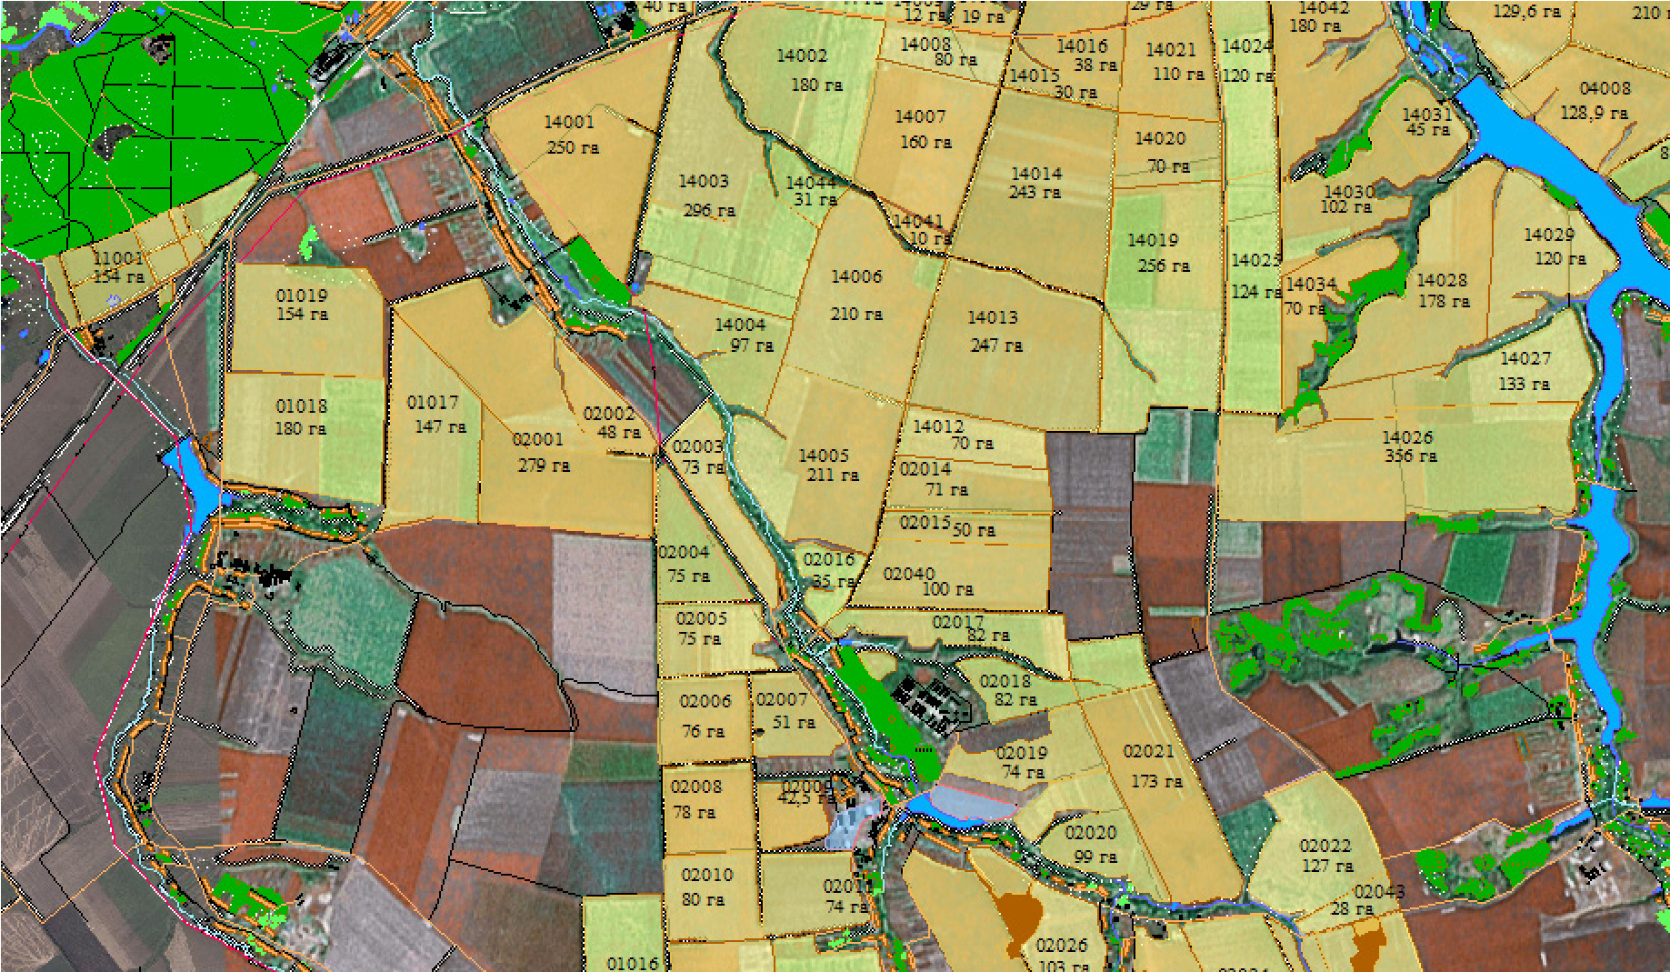
Fig. 1. An example of a map overlaying information from Google and vector information obtained using the ArcGIS PC [19]

The development of the land assessment project is carried out in the "ArcGIS" program, an example of the interface of which is shown in fig. 2. The process of creating a land information system project includes three main stages [11]:
- development of the logical, physical and conceptual structure of the land valuation model;
- creation and filling of the database with tables reflecting the state of the land fund of the territory;
- development of specialized forms for interaction with database tables and electronic maps.
The practical importance of the development of a land information system lies in the possibility of creating a unified database that will include information about territories, rules for their use, real estate objects, transport and engineering infrastructure, centralization and systematization of storage and updating of this data, as well as providing access public to open information resources of the region.
The maximum accuracy of vectorization of the borders of the treated areas is from 5 to 20 meters in plan, which is quite enough for data classification, digital determination of boundaries and management decisions.
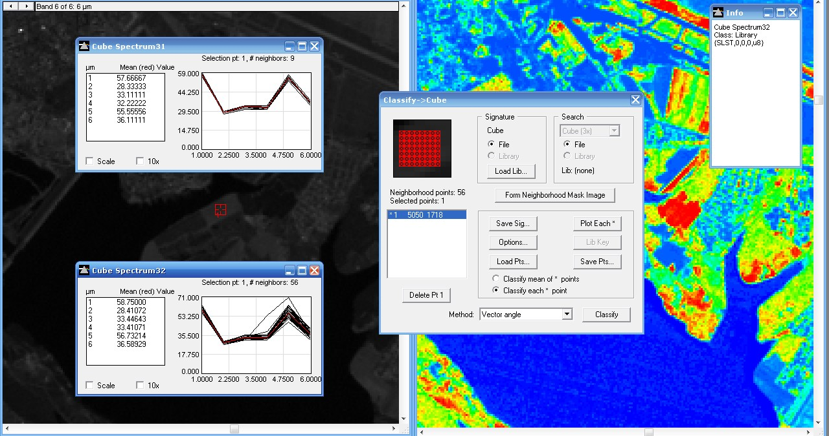
Fig. 2. Graphs of spectral luminances of agricultural land at different points of the territory in the PC " ArcGIS " (formed by the authors on the basis of satellite images [21] )

In some areas, the image resolution can reach 0.5 meters per pixel on the ground, ensuring high accuracy of mapping of most areas [15, 17].
All collected data are sorted into several categories, on the basis of which technologies for their processing, classification and storage in the database have been developed in the land accounting system - "ArcGIS". Among the key technologies, the following can be distinguished: the technology of creating and updating maps based on field data ("Geodesy" segment), the technology of creating large-scale plans and topographic maps ("Map Editor" segment), the technology of updating maps based on the results of remote sensing of the Earth and laser scanning. The process of creating electronic field maps begins with linking to the hydrographic network and the spring -beam complex, which is often supplemented by the road network and other objects visible on the soil map and cartographic basis (Fig. 3.) [9].
Data obtained from space images can be used to evaluate and analyze soil components such as erosion, salinity, and others. The shapes, sizes of the components, their location in relation to the meso-relief, the genesis of soil-forming rocks and other data based on literary sources and reports of previous studies are analyzed.

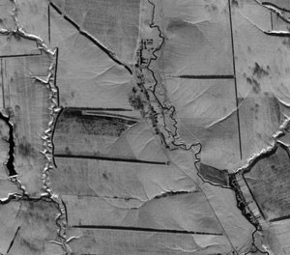
Fig. 3. Fragments of space images with existing water erosion networks

As a result, the electronic map of the fields provides all the necessary information for the development of project solutions regarding the placement and optimization of the use of the territory for agricultural crops, differentiation according to certified features, that is, for the adaptation of land cultivation technologies within the framework of the farming system and the intensification of production processes.
Analysis tools allow you to perform retrospective spatial and logical queries and information analysis, and three-dimensional data tools to form samples and graphic materials (Fig. 4.).
Fig. 4. Fragments of three-dimensional models of the electronic field map [25]

The basis of the land use accounting subsystem is the object classifier, which serves for the development of multi-level electronic maps in the agricultural sector and their use in the management of agricultural holdings. It is used to create schematic images of agricultural lands, register data about fields, conduct agrochemical monitoring of fields, thematic mapping taking into account various categories and indicators, developing land assessment maps and rating [22].
The system allows you to visually present data on various aspects of fields and work areas through the creation of thematic maps. There are the following types of thematic models: vector, raster and matrix. Such maps are developed on the basis of semantic information of objects and data obtained from the database. Creating color cartograms requires a project file that contains all the data needed to create the map, including the type, color palette, number of color gradations, legend, and other elements.
A quality matrix is a digital model that illustrates the distribution of a particular continuous property, such as air pollution, precipitation, or radiation levels. The quantities in this model change smoothly from one element to another, creating a surface simulating the distribution of the characteristic.
The quality matrix is effectively used for computer modeling of land assessment data and their valuation. For this, a specialized technique is used, which allows you to calculate quality indicators for each part of the matrix based on point test data. Spot studies represent collected data of agrochemical indicators from soil samples obtained through their selection and laboratory-chemical analysis. Such measurements can be carried out with the help of special samplers or other collection methods. Soil analysis allows you to determine the level of nutrients in the soil, which are critically important for the healthy growth and development of plants and bonito itself. The choice and dosage of applied fertilizers depends on these data, it becomes one of the key factors of success in land evaluation [18].
Point data on the map are used to form the matrix of qualitative assessment of land and grading, in the semantics of which the values of the studied characteristics are fixed, such as: nitrogen content available for plants; the content of mobile phosphorus; exchangeable potassium content; acidity level; content of humus; degree of base saturation.
The basis for an integrated information data system (IISD) is an electronic thematic map, which displays objects with relevant attribute information, statistical or dynamic data, as well as estimates and forecasts, for making informed decisions on processing certain fields, applying fertilizers, determining the main agrochemical, vegetation and phytosanitary indicators, as well as for comparing the yield of cultivated crops. The sources of this information can be individual measurements made with the help of GPS equipment by employees of the agricultural holding, or specialized equipment on agricultural machines. Therefore, continuous land monitoring is required. To collect all the mentioned data and provide statistical information, a geographic information system that covers the full range of data is needed. Thus, the electronic field map in this GIS provides detailed accounting and control over all aspects of agricultural activity, based on reliable data: field sizes, road lengths, field information. [23]. Thanks to the map, you can conduct an in-depth analysis of the conditions that affect the growth of plants in each specific field or part of it. The maps serve as a basis for developing a crop rotation structure, optimizing production to increase profitability, and quality land assessment and appraisal. Electronic maps of fields allow accurate planning, accounting and control of agrarian processes, based on accurate measurements of areas, the length of roads and other objects marked on them during their creation.
For each field, a passport containing information on its area, cultivated crop, previous crops, mechanical composition of soils, presence of slopes and degree of soil erosion, etc. is drawn up. Data on the results of agrochemical research can be attached to each work site [14].
Based on point measurements, the program creates a surface model that reflects the distribution of nutrients throughout the site. This method makes it possible to detect local differences in each work area, showing the real distribution of elements, not just their average value. However, for some calculations, it is necessary to use generalized indicators of the content of nutrients in the soil for the entire plot. The software allows you to calculate a single value based on distributed data using different methods. This approach to agrochemical monitoring is progressive and prepares the soil for differentiated fertilization [6].
In order to qualitatively assess land and carry out assessment, each type of land is analyzed for the degree of influence of such negative processes as salinization, waterlogging, erosion, deflation, flooding, desertification and others observed in the studied territory. Determining the ecological state makes it possible to identify the productive potential of lands, establish recommendations and rules for their use as a natural resource, and also develop measures to restore their characteristics.
The condition of land types is assessed according to established methodology, which includes comparative analysis and soil research data, such as soil description and soil mapping. According to this methodology, the quality state can be defined as satisfactory, insignificant, moderate, strong ecological pressure or critical and crisis. The criteria for qualitative assessment of land and carrying out appraisals are presented in Table 1.
Table 1
Criteria for qualitative assessment of the condition of lands for their valuation (formed by the authors)
Qualitative condition of lands | Manifestation of negative processes | Possible use
Satisfactory | Not are found | Intense using
Weak | The weak degree | Intense using
Average | Average degree | Limited using
Strong | Strong degree | Limited using
Critical | Very of a strong degree | Partial or full conservation
Crisis | Conditions are being created for the occurrence of environmental disasters | Withdrawal from agricultural circulation

This scale is used to determine the qualitative state of different types of land by comparing the collected points with the established regulatory parameters. The assessment is carried out in points according to a specialized scale that takes into account not only the type, but also the intensity of negative processes. This evaluation system is based on point indicators, where the highest score is assigned to the most negative degree of manifestation of the factor. As the intensity of each process decreases, the number of points decreases. The scale is defined in the range from 0 to 5 points, while the points are distributed depending on which of the assessed factors, as well as the degree of their manifestation, are the most harmful and irreversible for the studied territory and for their assessment.
The suitability group is formed by land types with the same quality condition, similar credit score and comparable productivity. Relief and soil properties that affect negative processes are the basis for the division into suitability groups. Thus, the number of groups depends on the expressiveness of the relief and the variety of soils. Depending on the suitability of land for arable land or pastures, taking into account the need for organizational and economic, agrotechnical and land reclamation measures, land should be classified into seven types:
- land that can be used for plowing;
- lands suitable for plowing using special agricultural techniques;
- lands that will become suitable for plowing after their improvement;
- lands suitable for use as pastures;
- land that can be used as pasture after improvement;
- lands suitable for pastures with the condition of carrying out complex hydraulic meliorations;
- lands that are not suitable for agricultural needs.
It is not possible to find all the above types of land in all territories; their diversity is determined by their quality and suitability for use. The selected land types are associated with specific categories of relief, as well as with similar productivity and ecological status. Land valuation serves as a basis for the development of land use characteristics [1]. Zones combine land types that are similar from a qualitative point of view, which is presented in Table 2.
The transformation of agricultural lands helped to eliminate a number of problems in land use, in particular cases of fragmentation and fragmentation of plots, and also allowed to stop the cultivation of degraded and low-productivity lands. Thanks to the use of GIS technologies, a structural and functional model of the organization of land use and crop rotation was created, which allows automating land management processes. All components of this model are interconnected and arranged in such a way that they take into account interaction with each other. The developed methods are aimed at raising agricultural production to a higher level of efficiency and ensuring the growth of its profitability [2, p. 95].
Table 2
Characterization of the condition of the lands for their assessment (improved by the authors)
Zone number | Land type number | Characteristics of the zone
1 | 1 | Includes arable arrays without manifestations or with manifestation in a weak and medium degree of deflation, salinization, waterlogging, are located on plains, reductions and gentle slopes
2 | 2 | Includes arable arrays weakly medium wetlands , medium salted on reductions
3 | 3 | Includes arable arrays medium wetlands , highly salted , weakly deflated on plains
4 | 4 | Includes fodder land without manifestation or with the manifestation of a weak and medium degree of deflation, waterlogging, salinization, are located on plains, reductions and depressions
5 | 5, 6 | Includes fodder areas with medium and strong exposure degrees of waterlogging, salinity are located on the plains, reductions and on strongly reduced areas
6 | 7 | Includes arable massifs and fodder lands on lowlands areas and depressions in a crisis and critical ecological state

All data collected during aerial photography, including information on the structure of cultivated areas, crop productivity, use of fertilizers and plant protection products, were integrated into the ArcGIS PC. Using this program provides opportunities to:
- management and storage of electronic maps of fields of agricultural holdings;
- carrying out inventory and monitoring of lands of agricultural holdings;
- keeping records of fields, land legal relations, cadastral records of the land fund, regardless of the form of ownership;
- implementation of agronomic accounting and analysis of the state of land and crops.
Conclusions and perspectives. The development and implementation of accounting systems for agricultural land is one of the key directions of today's development. The need for research, improvement and testing of these systems is due to a number of reasons, in particular, the need to make sound economic, territorial, navigational and statistical decisions. The availability and accuracy of important information can increase the efficiency of land resource management by enterprises, contributing to their development at a new level.
It was determined that the assessment of the condition of the lands for their valuation is of crucial importance for the development of lands, contributing to the selection of soils for agricultural use, increasing the productivity of agricultural crops and effective specialization of agro-industry. Agricultural landscape planning is aimed at reducing the load on land resources and creating conditions for preserving and restoring their fertility. The implementation of credit rating in management is key to balanced land use and ecosystem protection.
It has been proven that the activation of the use of intra-farm land management on the basis of land, as well as the transition to the improvement of intensive use of nature through the structuring of land within the framework of balanced management of land resources will contribute to the change of spatial and functional characteristics of land, the determination of agronomic measures and the increase of the economic return from land and the efficiency of agricultural production. The integration of GIS technologies is a key element in adaptive landscape systems, assessment of the state of land for their assessment, which leads to increased productivity and improved product quality, optimization of fertilizer application and plant protection products, as well as effective management of land assets.

Список використаних джерел
- Бутенко Є. В., Харитоненко Р. А. Продуктивний потенціал земель та принципи його оцінки в Україні. Землеустрій, кадастр і моніторинг земель. 2017. № 1. С. 58–65.
- Вертегел С., Вишняков В., Гуреля В., Сластін С., Піскун О., Харченко С., Мороз В. Розробка методики створення і оновлення картографічної основи з використанням космічних знімків від супутників «SUPER VIEW-1». Екологічна безпека та природокористування. 2022. №41(1). с. 89–101. https://doi.org/10.32347/2411-4049.2022.1.89-101.
- Горлачук В. В. Інноваційне управління земельною власністю. монографія Чорномор. держ. ун-т ім. Петра Могили, Національний гірничий університет. Миколаїв, Іліон. 2013. 179 с.
- Кадастр і реєстрація. URL: http://kyiv.land.gov.ua/icat/vedenniaderzhavnoho-zemelnoho-kadastru/ (дата звернення 02.11.2023).
- Кононенко Ж. А. Інтенсифікація як складова економічної ефективності використання землі. Ефективна економіка. 2017. № 4. С. 50–56.
- Лазоренко-Гевель Н. Ю. Створення інформаційних моделей даних моніторингу природних комплексів. Містобудування та територіальне планування. 2014. № 51. С. 275–283.
- Македон В. В., Байлова О. О. Планування і організація впровадження цифрових технологій в діяльність промислових підприємств. Науковий вісник Херсонського державного університету. Серія «Економічні науки». 2023. Випуск 47. C. 16-26. DOI: 10.32999/ksu2307-8030/2023-47-3.
- Руденко М. В. Технології цифрової трансформації сільськогосподарських підприємств. Агросвіт. 2019. № 23. С. 8–18. DOI: https://doi.org/10.32702/2306-6792.2019.23.8.
- Сітковська А. О., Масляєва О. О. Земельно-ресурсний потенціал аграрного сектору: стан та особливості використання. Агросвіт. 2023. № 9-10. С. 77–81.
- Таратула Р. Б. Роль державного земельного кадастру в інформаційному забезпеченні системи управління земельними ресурсами. URL: http://natureus.org.ua/repec/archive/1_2016/28.pdf (дата звернення 02.11.2023).
- Abbas Z., Yang G., Zhong Y., & Zhao Y. Spatiotemporal Change Analysis and Future Scenario of LULC Using the CA-ANN Approach: A Case Study of the Greater Bay Area China. Land. 2021. 10(6), p. 584. DOI: https://doi.org/10.3390/land10060584.
- ArcGIS Desktop 10.8.x system requirements. System Requirements Documentation. URL: https://desktop.arcgis.com/en/system-requirements/ latest/arcgis-desktop-system-requirements.htm. (дата звернення 02.11.2023).
- ArcGIS Pro Documentation 2021. Area Solar Radiation (Spatial Analyst) URL: https://pro.arcgis.com/en/pro-app/latest/tool-reference/spatial-analyst/area-solar-radiation.htm (дата звернення 02.11.2023).
- Butora Aaron & Soloniewicz Brent, Schwartz, Cameron, Aziz, Christian, Su, Sichang, Mahmoud, Mohammed. The Practical use of GIS in Agriculture. 2022. DOI: 10.1109/CSCI58124.2022.00270.
- GIS Data Guide. URL: https://guides.lib.purdue.edu/c.php?g=353290&p=2378621 (дата звернення 02.11.2023).
- GIS for Land Administration – Esri. URL: www.esri.com/ industries/cadastre/ (дата звернення 02.11.2023).
- GIS In Agriculture: Best Practices For AgriTech Leaders. URL: https://eos.com/blog/gis-in-agriculture/ (дата звернення 02.11.2023).
- Kamel Boulos M. N., Wilson J. P. Geospatial techniques for monitoring and mitigating climate change and its effects on human health. International Journal of Health Geographics. 2023. №22 (2). DOI: https://doi.org/10.1186/s12942-023-00324-9.
- Landsat Science. URL: https://landsat.gsfc.nasa.gov/satellites/landsat-8/ (дата звернення 02.11.2023).
- Makedon V., Mykhailenko O., Dzyad O. Modification of Value Management of International Corporate Structures in the Digital Economy. European Journal of Management Issues. 2023. №31(1). pp. 50-62. DOI: https://doi.org/10.15421/192305.
- MapTiler Satellite. URL: https://www.maptiler.com/satellite/ (дата звернення 02.11.2023).
- Mohd Zuki N. F. A., Mohamad Abdullah N. The Application of GIS in Environmental Engineering: Opportunities and Limitations. Recent Trends in Civil Engineering and Built Environment. 2022. № 3(1). pp. 1222–1230. URL: https://publisher.uthm.edu.my/periodicals/index.php/rtcebe/article/view/2782 (дата звернення 02.11.2023).
- Piccoli F., Locatelli S. G., Schettini R., Napoletano P. An Open-Source Platform for GIS Data Management and Analytics. Sensors (Basel). 2023. Apr 7. 23(8). P. 3788. DOI: 10.3390/s23083788. PMID: 37112129; PMCID: PMC10143508.
- Satellite Sensors. URL: https://www.satimagingcorp.com/satellite-sensors/ (дата звернення 02.11.2023).
- U.S. Geological Survey (USGS). All Maps. URL: https://www.usgs.gov/products/maps/all-maps (дата звернення 02.11.2023).

References
- Abbas, Z., Yang, G., Zhong, Y., & Zhao, Y. (2021). Spatiotemporal Change Analysis and Future Scenario of LULC Using the CA-ANN Approach: A Case Study of the Greater Bay Area, China. Land, 10(6), 584. https://doi.org/10.3390/land10060584
- ArcGIS Desktop 10.8.x system requirements. System Requirements Documentation. (2022). Available at: https://desktop.arcgis.com/en/system-requirements/latest/ arcgis-desktop-system-requirements.htm.
- ArcGIS Pro Documentation (2021). Area Solar Radiation (Spatial Analyst). Available at: https://pro.arcgis.com/en/pro-app/latest/tool-reference/spatial-analyst/area-solar-radiation.htm
- Butenko, Ye. V., Kharytonenko, R. A. (2017). Productive potential of lands and principles of its asstssment in Ukraine. Zemleustrii, kadastr i monitorynh zemel, no 1, pp. 58–65. (in Ukrainian).
- Butora, Aaron & Soloniewicz, Brent & Schwartz, Cameron & Aziz, Christian & Su, Sichang & Mahmoud, Mohammed. (2022) The Practical use of GIS in Agriculture. 10.1109/CSCI58124.2022.00270.
- GIS Data Guide. Available at: https://guides.lib.purdue.edu/c.php?g=353290&p=2378621
- GIS for Land Administration – Esri. Available at: www.esri.com/ industries/cadastre/
- GIS In Agriculture: Best Practices For AgriTech Leaders. Retrieved from: https://eos.com/blog/gis-in-agriculture/
- Horlachuk, V. V. (2013). Innovative land property management: monohrafiia Chornomor. derzh. un-t im. Petra Mohyly, Natsionalnyi hirnychyi universytett. Mykolaiv: Ilion. 179 p.
- Kadastr i reyestratsiya (2023). Retrieved from: http://kyiv.land.gov.ua/icat/vedenniaderzhavnoho-zemelnoho-kadastru/ (in Ukrainian).
- Kamel Boulos, M. N., Wilson, J. P. (2023). Geospatial techniques for monitoring and mitigating climate change and its effects on human health. International Journal of Health Geographics, 22(2). https://doi.org/10.1186/s12942-023-00324-9.
- Kononenko, Zh. A. (2017). Intensification as a component of economic efficiency of land use. Efektyvna ekonomika, № 4, 50–56. (in Ukrainian).
- Landsat Science. Available at: https://landsat.gsfc.nasa.gov/satellites/landsat-8/
- Lazorenko-Hevel, N. Yu. (2014). Creation of information models of monitoring data of natural complexes. Urban planning and territorial planning, No. 51, 275–283. (in Ukrainian).
- Makedon, V. V., Bailova, O. O. (2023). Planning and organizing the implementation of digital technologies in the activities of industrial enterprises. Scientific Bulletin of Kherson State University. Series "Economic Sciences", Issue 47, 16-26. DOI: 10.32999/ksu2307-8030/2023-47-3 (in Ukrainian).
- Makedon, V., Mykhailenko, O., & Dzyad, O. (2023). Modification of Value Management of International Corporate Structures in the Digital Economy. European Journal of Management Issues, 31(1), 50-62. https://doi.org/10.15421/192305.
- MapTiler Satellite. Available at: https://www.maptiler.com/satellite/
- Mohd Zuki, N. F. A., & Mohamad Abdullah, N. (2022). The Application of GIS in Environmental Engineering: Opportunities and Limitations. Recent Trends in Civil Engineering and Built Environment, 3(1), 1222–1230. Available at: https://publisher.uthm.edu.my/periodicals/index.php/rtcebe/article/view/2782
- Piccoli, F., Locatelli, S. G., Schettini, R., Napoletano, P. (2023). An Open-Source Platform for GIS Data Management and Analytics. Sensors (Basel), Apr 7, 23(8), 3788. doi: 10.3390/s23083788. PMID: 37112129; PMCID: PMC10143508.
- Rudenko, L. G. (2019). Current trends in the development of cartography in Ukraine. Edited by Kyiv: Institute of Geography of the National Academy of Sciences of Ukraine. (in Ukrainian).
- Satellite Sensors. Available at: https://www.satimagingcorp.com/satellite-sensors/
- Sitkovska, A. O., Masliaieva, O. O. (2023). Land and resource potential of the agricultural sector: state and features of use. Ahrosvit, no 9-10, 77–81. (in Ukrainian).
- Taratula, R. B. (2016). The role of the state land cadastre in the information provision of the land resources management system. Available at: http://natureus.org.ua/repec/archive/1_2016/28.pdf (in Ukrainian).
- U.S. Geological Survey (USGS). All Maps. Available at: https://www.usgs.gov/products/maps/all-maps
- Vertegel, S., Vyshnyakov, V., Gurelia, V., Slastin, S., Piskun, O., Kharchenko, S., & Moroz, V. (2022). Development of the methodology for creating and updating the cartographic base using space images from the "SUPER VIEW-1" satellites. Environmental Security and Nature Management, 41(1), 89–101. https://doi.org/10.32347/2411-4049.2022.1.89-101 (in Ukrainian).

