UDC 332.2
PROTECTION OF LANDS IN UKRAINE: SCIENTIFIC AND MANAGEMENT SOLUTIONS IN THE CONDITIONS OF MILITARY ACTIONS
А. Tretiak, Doctor of Economic Sciences, Professor, Chief Researcher,
Bila Tserkva National Agrarian University, Bila Tserkva,
е-mail: tretyak2@ukr.net,
V. Tretiak, Doctor of Economic Sciences, Professor,
Sumy National Agrarian University, Sumy,
е-mail: tretyak2@ukr.net,
T. Priadka, PhD in Economics, Associate Professor,
Bila Tserkva National Agrarian University, Bila Tserkva,
е-mail: 1435351@ukr.net
N. Kapinos, PhD in Economics, Associate Professor,
Sumy National Agrarian University, Sumy,
е-mail: natawakapinos75@gmail.com
L. Hunko, PhD in Economics, Associate Professor,
National University of Life and Environmental Sciences of Ukraine, Kyiv,
е-mail: liudmyla_g@ukr.net
R. Tretiak, PhD in Economics,
National Aviation University, Kyiv,
е-mail: tretyakra@gmail.com
N. Tretiak, PhD in Economics, Senior Researcher,
Institute for demography and life quality problems of the National Academy of Sciences of Ukraine, Kyiv,
е-mail: tretiaknatalia@ukr.net

Abstract. The research by the authors reveals that after the legislative definition of land protection content in Ukraine, neither scientific nor managerial support for the implementation of the defined tasks has been organized. To date, land protection standards have not been developed, and neither land planning nor economic instruments are being implemented. Furthermore, the situation concerning land protection has deteriorated due to ongoing military actions on Ukraine's territory. During research, the authors calculated the amount of damage from soil pollution according to the Methodology proposed by the Ministry of Environmental Protection and Natural Resources of Ukraine dated 04.04.2022 No. 167. According to the calculations, the amount of damage to 1 hectare of arable land contaminated with petroleum products will be 506 thousand UAH/ha, while the norm for the Kyiv region as of December 18, 2023 is 2,362 thousand UAH/ha, which is 4.66 times higher. The authors proposed approach to assessing the damage caused to land resources that were damaged by military actions on the regional territories and for territorial communities. Furthermore, it has been observed that for carrying out restoration works to eliminate the consequences of armed aggression and combat actions in the respective territories of Ukraine, there remains an important task of scientifically substantiated development and adoption of relevant regulatory and methodological documents. It is proposed to determine pilot projects and foreign grants for their development.
Keywords: land resources, soils, renewable value of land resources, damage, land protection.

Introduction. Ukraine is characterized by a high level of economic development of the territory, which determines the intensive impact of anthropo- and technogenesis on land resources and the surrounding natural environment. According to the approved by the Cabinet of Ministers of Ukraine in 2022, the Concept of the Nationwide Targeted Program for the Use and Protection of Lands, agricultural land has the largest share (about 70%). The level of land plowing in the country reaches an average of 54%, and in some regions, unfortunately, 70% or more. Excessive plowing of sloping lands led to a violation of the ecologically balanced ratio of land areas: arable land, natural fodder areas, forests and water bodies, which negatively affected the sustainability of land use and agricultural landscapes. As a result, land resources are degraded, polluted and depleted at an accelerated rate. Annual losses from the main types of soil degradation amount to about 40-50 billion UAH, including due to unbalanced losses of humus and nutrients: 23-28 billion UAH; from lack of production and soil loss due to erosion: 17-22 billion UAH» [3]. One of the key predictive indicators of solving the mentioned problem and combating climate change is the reduction of the level of plowing of the country's territory. For comparison, in France, 36% of the land is cultivated, and 32% is covered by forests, making the ratio 1:0.9. The forest coverage of the territory of Ukraine is less than 18%, and when compared to agricultural lands, the ratio is 1:0.3. Such a ratio between agricultural and forest lands poses an ecological problem that requires addressing, as it also affects the economic and social status of regions and the country as a whole. Although the ecological stability of land use in Ukraine as a whole belongs to stably unstable, in eight regions (Vinnytsia, Dnipropetrovsk, Donetsk, Zaporizhzhya, Kirovohrad, Mykolaiv, Odesa, Poltava regions) land use is ecologically unstable [13]. Thus, Ukraine, unfortunately, does not meet the ecological and economic requirements for the general condition. In addition, the issues of violations in land protection and other natural resources, as a result of military actions against Ukraine, is increasingly being raised. It should be noted that any armed conflicts are an invisible side, the consequence of which is gradual destruction due to damage to the surrounding environment, to people's health, their public welfare and the overall sustainable development of the country.
Analysis of the latest scientific research and publications. It should be noted that a significant number of domestic scientists in Ukraine dealt with this issue of land (soil) protection, rational use of land and natural resources, and ensuring environmental safety. Specifically, in the work of V.P. Horbulin, O.S. Vlasyuk, E.M. Libanova, O.M. Lyashenko, there is a comprehensive study of the issues related to the war in Donbas and the annexation of Crimea. The research was carried out from the standpoint of national security of Ukraine. Armed aggression is seen as a stress test for global and national security and a catalyst for resetting Ukraine's foreign policy. Forecasts were worked out regarding the development of events in the Donbass and around Crimea, as well as scenarios for the future of Ukraine in a globalized world» [4].
M.A. Khvesyk, V.A. Golyan, and V.M. Novikov have extensively detailed the environmental conditions and peculiarities of natural resource use in the Donetsk and Luhansk regions. These regions traditionally have some of the highest levels of anthropogenic impact on the surrounding natural environment, including emissions of harmful substances into the atmosphere, discharge of untreated wastewater into natural water bodies, and waste disposal. This was connected both with the natural resource factors of the formation of industries (coal and chemical industry, mining and metallurgical complex, machine building), in which the region specialized, and with the historical features of complex formation» [6].
P.P. Nadtochiy, Yu.A. Bilyavsky, T.M. Myslyva, and Yu.B. Shmagala conducted a preliminary assessment of the environmental conditions in the territory formerly occupied by the strategic missile forces within the Zhytomyr region. The authors determined that the aforementioned territories are largely unused in the national economy. Additionally, their ecological condition is deemed unsatisfactory due to contamination of the soil, water, and vegetation with heavy metals (Cu, Pb, Ni, Cd, Zn). Importantly, the concentrations of these metals significantly exceed the established Maximum Permissible Concentration (MPC) limits, as reported as early as 2009 [9].
The research by S.V. Ivanov deserves attention, in which the author investigates modern problems related to estimating the value of an enterprise, considering the impact of the war factor based on determining war losses. Special attention is paid to theoretical and methodological approaches to determining damage from war and annexation, analysis of the experience of assessing and compensating losses from military and armed conflicts, problems of ensuring the national security of the country» [5]. It must be said that military actions lead to significant changes in both the structure of land use and the structure of the soil, which clearly affects the private sector and the country in general. That is why one of the most important problems that require an urgent solution is the damage caused and its calculation for the protection of the state of land and other natural resources, which is what this study is dedicated to. Since the most difficult and not worked out to date is the problem of determining the direct damage caused to the productive potential of land (soil) and other natural resources, biodiversity and property (except for buildings and structures) for present and future generations.
The purpose of the study. Study of the peculiarities of scientific and management decisions regarding the protection of lands in Ukraine, taking into account the consequences of military actions.
Materials and methods. In the process of research, the authors used scientific publications related to solving issues of land (soil) protection, rational use of land and natural resources, ensuring environmental safety, and also used the legislative and regulatory framework. The information base of the study was made up of official statistical materials and reports of the State Service of Ukraine on geodesy, cartography and cadaster. For comparison, in the study during the calculation of the inflicted damage, the Procedure approved by the Cabinet of Ministers of Ukraine on November 17, 1997, No. 1279, and the Methodology of the Ministry of Environmental Protection and Natural Resources of Ukraine (Ministry of Environment) dated April 4, 2022, No. 167, were used.
Results and discussions. First of all, it should be noted that according to Article 164 of the Land Code of Ukraine, land protection includes: «a) substantiation and ensuring the achievement of rational land use; b) protection of agricultural lands, forest and shrub lands from unjustified removal for other needs; c) protection of lands from erosion, mudslides, flooding, waterlogging, secondary salinization, over-draining, compaction, pollution by production waste, chemical and radioactive substances and from other unfavorable natural and man-made processes; d) preservation of natural wetlands; e) prevention of deterioration of the aesthetic condition and ecological role of anthropogenic landscapes; e) conservation of degraded and unproductive agricultural lands» [15].
In figure 1, the indicated measures are presented, which are ensured by land planning and legal, as well as economic mechanisms and tools.
The content of land protection according to Article 164 of the Land Code of Ukraine.
Justification …
Land planning
Schemes of land organization
Projects of comprehensive plans for territorial and spatial planning of land use development*
Land zoning*
Ensuring …
Land planning, economic
Land organization projects of crop rotations and establishing restrictions on land use
Economic stimulation*
Protection ...
Land organization projects regarding land allocation
Reimbursement of agricultural and forestry production losses
Land protection …
Land planning, economic
Land organization projects of crop rotations
Detailed plans
Economic stimulation of ecological farming technologies*
Land planning and legal, economic
Preservation …
Land planning
Projects of the NRF organization
Land organization projects on the creation of an eco-network within the territories of amalgamated territorial community *
Prevention …
and
Conservation …
Land planning
Projects of comprehensive plans for territorial and spatial planning of land use development*
Land planning, economic
Implementation tools
Implementation mechanisms
Land organization projects
Detailed plans
Economic stimulation*
Figure 1. Mechanisms and tools for implementing land protection measures.
Note: * Tools that are highlighted by the authors are absent and require scientific support.

As it can be seen from the Figure, there are a large number of tools for the implementation of mechanisms that are currently missing and require scientific support.
The inadequate implementation of land planning, economic, and other mechanisms and tools for land protection is also evidenced by the data from the State Land Agency of Ukraine (currently - State Geocadastre). This includes various types of land survey documentation (Table 1). The table indicates that some key instruments for implementing land protection measures were scarcely executed, constituting a percentage lower than expected.
Table 1. Trends in the implementation of land planning works, %
Types of land planning documentation | Period |  | As of
Types of land planning documentation | from January 1, 1991, to December 31, 2001 | from January 1, 2002, to December 31, 2008 | 04.04.2012 | 04.04.2019
Land organization schemes and technical and economic justifications for the use and protection of lands of administrative and territorial entities | 0,05 | 0,01 | 0,01 | -
Land organization projects regarding the establishment of the boundaries of the territories of the NPZ and other nature protection purposes, recreational and historical and cultural purposes | 0,02 | 0,06 | 0,01 | 0,001
Land organization projects regarding the allocation of land plots | 6,76 | 9,95 | 10,38 | 57,7
Land organization projects that provide ecological and economic substantiation of crop rotation and land management | 0,01 | - | 0,02 | 0,01
Land organization detailed projects | 0,95 | 0,23 | 0,12 | 0,06
Technical documentation of the land organization regarding the marking of land plot boundaries on site | 20,45 | 20,14 | 7,73 | 38,0
Technical documentation of the land organization regarding the preparation of documents certifying the right to a land plot | 65,80 | 68,82 | 81,25 | -
Total | 100,0 | 100,0 | 100,0 | 100,0
Source: compiled based on operational information of the State Land Agency of Ukraine.
The biggest failure in the development of legal protection of land in Ukraine is connected with the attempt to introduce a legal mechanism for standardizing the qualitative state of land. Thus, Article 165 «Standardization in the field of land protection and reproduction of soil fertility» of the Land Code of Ukraine provides for the introduction of a system of standards [15]. The Law of Ukraine «On Land Protection» [16] defined the content of these regulations, however, neither the Land Code of Ukraine nor this Law defined clear legal mechanisms for the application of such regulations. The legislator entrusted this work to the Cabinet of Ministers of Ukraine, entrusting it with the duty to approve by its resolutions the mechanisms for the implementation «of standards in the field of land protection and reproduction of soil fertility» [15; 16]. However, neither agrarian and land management science, nor the governing bodies of the Ministry of Agrarian Policy and the State Geocadastre of Ukraine, unfortunately, have not yet organized the development of the necessary standards for land protection.
The soils of Ukraine, namely chernozems and their fertility, are a well-known and indisputable unique brand of the country, therefore their condition is an important factor for land potential, as well as one of the main components of ensuring food security. According to the State Soil Protection Agency [10], the upper soil level of Ukraine is very diverse, which determines the different suitability of territories for agricultural production. It should be noted that from the total area of agricultural land and arable land, a significant share of soils is occupied by chernozems – 58% and 65.2%, respectively. However, despite such a big plus for agricultural production, Ukrainian soils are increasingly experiencing huge ecological and economic losses. In particular, in addition to non-compliance with anti-erosion and technological requirements by agricultural producers regarding sowing (for example, sunflower [12], the accumulation of substances in the soil that negatively affect their fertility and other useful properties was added to the problems of pollution as a result of military operations. Because the damage caused will remain for decades, and in some cases for centuries, and will carry a threat even after the end of the war, as heavy metals from bombshells and military equipment get into the soil and underground water. According to the research conducted by A.A. Terebukh, N.Y. Pankiv, O.R. Royik, «Quantitative values of integral assessments of threats characterizing the environmental safety of Ukraine for each of the regions of Ukraine have been obtained (Figure 2). The authors' research has shown that the ecosystem of Ukraine is on the verge of exceeding permissible impacts, especially in the Donetsk-Dnieper region, several western and central regions of Ukraine, as well as specific areas in other regions. Therefore, the application of the methodology of environmental safety assessment and environmental risk analysis considered in the work can provide an opportunity to: determine the priority areas of the region’s development strategy; to scientifically justify the acceptable level of risk in relation to each of them, to optimize the strategy of ensuring the natural and man-made security of the regions; carry out zoning of the territory of Ukraine according to the degree of internal threats to life» [11].
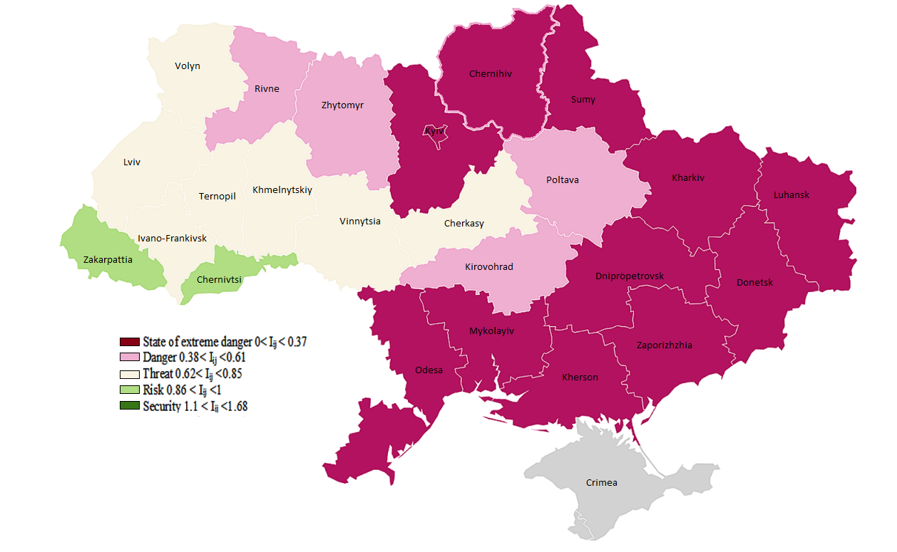
Figure 2. Resulting map of the integral assessment of the level of environmental safety of Ukraine of military actions in the conditions of Russian aggression [11]

The impact of military actions on the soil cover of Ukraine and noted that the most disturbed and destroyed are the areas of ordinary chernozems (50,390.9 ha) (Fig. 3), and the most affected regions of Ukraine are (Fig. 4) [1].
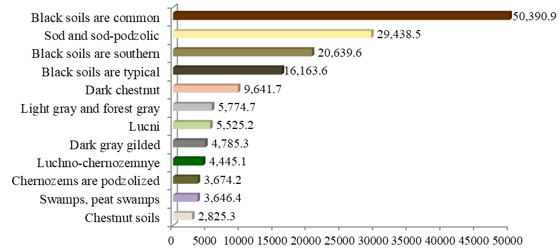
Figure 3. The area of influence of hostilities according to the main soil types of Ukraine, ha [1]
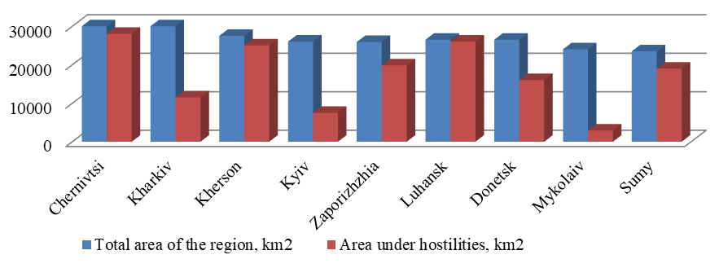
Figure 4. Soil area in the combat zone in the cross-section of regions of Ukraine [1]

The results of the war are horrifying; therefore, issues related to the restoration of land and soil gain even more attention in the affected areas. The implementation of management measures for the protection of lands that have suffered damage due to combat actions becomes crucial in this context.
In April 2022, the Ministry of Environmental Protection approved the order «On the Approval of the Methodology for Determining the Amount of Damage to Land and Soil Caused by Emergencies and/or Armed Aggression and Combat Actions During Martial Law» [7]. This methodology is designed to determine «the extent of damage from soil contamination, the overall compensation amount in the case of simultaneous contamination of a land plot by several pollutants, and the amount of damage due to land pollution» [7] (Formula 1, 2, and 3 of the Methodology).
To analyse the effectiveness of the mentioned methodology, the authors calculated the extent of damage from soil contamination by petroleum products. This calculation was performed using the example of an equal land plot of agricultural purpose, which is included in the established order as part of the eco-network of one territorial community in the Kyiv region with different areas. The calculation of the extent of damage from soil contamination according to Formula 1 is presented in Table 2.
Table 2. Calculation of the amount of damage from soil contamination, UAH (Ukrainian Hryvnia).
Value |  |  |  | Taken for calculation
AD = А × NMV × P × Ch × Cncv + Crl |  |  |  | 506 558 | 267 779 | 1 939 232
А | «specific costs for the elimination of the consequences of soil pollution of the corresponding land plot, the value of which is 1.5» [7] |  |  | 1,5
NMV | «regulatory monetary valuation of the land plot, the soil of which has been contaminated, UAH/ha» [7] |  |  | 26 531
P | «the area of the land plot, the soil of which was contaminated, ha» [7] |  |  | 1 | 0,5 | 4
Ch | «the pollutant hazard coefficient, the value of which is determined according to Appendix 1 to Method 171» [7] |  |  | 4
Cncv | «the coefficient used to take into account the environmental value of the land plot is defined in Appendix 10 to the Methodology for determining the amount of damage caused due to unauthorized occupation of land, use of land plots not for their intended purpose, spoilage of land, violation of the regime, standards and rules of their use, approved by the resolution of the Cabinet of Ministers of Ukraine dated July 25, 2007 No. 963» [7] |  |  | 3
Crl | «the cost of reclamation of lands contaminated as a result of emergency situations and / or armed aggression and hostilities during martial law is calculated using the following formula:  Crl = C(d) × C(n) × C(e)» [7] |  |  | = 1 × 1 ×29 000 = 29 000
Crl | C(d) | «difficulty coefficient: in flat terrain, the coefficient is 1, in other cases – 1.2» [7] |  | 1
Crl | C(n) | «coefficient of the number of polluted/littered areas in one territorial community» [7] |  | 1
Crl | C(e) | «the coefficient of earthworks, which is equal to:  C(e) = (P1 + P2) × S» [7] |  | = (25 000 + 4 000) × 1 = 29 000
Crl | C(e) | P1 | «basic value» [7] | 25 000
Crl | C(e) | P2 | «value per area» [7] | 4 000
Crl | C(e) | S | «the area of land plots, the soils of which are contaminated» [7] | 1
Source: compiled by the authors taking into account the formula 1.
As seen from the provided table, the larger the area, the smaller the damage per unit area. Specifically, for 0.5 hectares contaminated with petroleum products, the damage will be 267,000 UAH, for 1 hectare – 506, for 4 hectares – 1,939,000 UAH, indicating the imperfections and inefficiency of the given methodology. For comparison, according to the approved resolution of the Cabinet of Ministers of Ukraine «On the Sizes and Procedure for Determining the Compensation for Agricultural and Forestry Production Losses», dated November 17, 1997, No. 1279 [2], as of December 18, 2023, the norm for arable land in the Kyiv region will be 2,362,000 UAH/ha, which is 4.66 times higher than the calculated damage according to the mentioned methodology. However, it should be noted that when using the norms of this procedure, they need to be adjusted to the present day, as the norms for losses in agricultural and forestry production were determined as of 1997 when the exchange rate was 1.83 UAH to 1 USD [17], while as of December 18, 2023, the NBU exchange rate was 37.02 UAH [8].
Therefore, the assessment of the damage caused by the destruction of land resources within land use boundaries due to combat actions, terrorist acts, sabotage, resulting from military aggression, is proposed to be carried out using or taking into account the specified procedure with the consideration of the indexation of norms. Additionally, a similar conversion is performed for other agricultural lands (perennial plantations, hayfields, pastures) (Table 3).
Table 3. Converted norm of direct damage incurred as of December 18, 2023, per 1 hectare, thousand UAH
Regions | Agricultural lands |  |  |  | Average weighted standard of agricultural land
Regions | Arable | Perennial plantations | Hayfields | Pastures | Average weighted standard of agricultural land
Donetsk | 1,841.7 | 6,482.7 | 534.1 | 528.6 | 1,761
Zaporizhzhia | 1,403.3 | 3,001.7 | 353.6 | 320.0 | 1,287
Kyiv | 2,361.6 | 1,2448.0 | 1,402.7 | 876.1 | 2,427
Luhansk | 1,332.9 | 7,505.1 | 761.0 | 381.1 | 1,137
Mykolaiv | 1,330.7 | 4,671.8 | 351.4 | 344.7 | 1,256
Sumy | 1,971.8 | 3,951.2 | 1,023.4 | 668.4 | 1,715
Kharkiv | 1,744.8 | 6,528.9 | 502.5 | 408.2 | 1,607
Kherson | 1,566.4 | 4,702.1 | 277.3 | 255.3 | 1,497
Chernihivska | 1,888.0 | 3,170.0 | 1,365.1 | 1,059.2 | 1,805
Source: formed by the authors at the exchange rate as of December 18, 2023.

In order to calculate a preliminary hypothetical assessment of damage to land resources in the territories of regions that suffered damage from military actions, propose to calculate the weighted average standard of agricultural land for each region using real areas (Table 4).
Table 5 presents a preliminary calculation of the value of agricultural land resources on the territory of the regions, according to the standard of damage caused as a result of military operations.

Table 4. Area of land resources for agricultural and forestry production, thousand hectares
Regions | Total Area, million ha | Agricultural lands |  |  |  |  | The area of land (soil) that suffered damage according to [1]
Regions | Total Area, million ha | Total, million ha | Including:
Regions | Total Area, million ha | Total, million ha | Arable | Perennial plantations | Hayfields | Pastures
Donetsk | 2,651.7 | 2,041.1 | 1,652.7 | 57.9 | 42.6 | 287.2 | 65%
Zaporizhzhia | 2,718.3 | 2,241.7 | 1,903.6 | 38.7 | 83.3 | 216.1 | 80%
Kyiv | 2,812.1 | 1,664.2 | 1,355.5 | 44.7 | 116.7 | 134.9 | 25%
Luhansk | 2,668.3 | 1,908.6 | 1,276.6 | 29.5 | 91.7 | 463.3 | 98%
Mykolaiv | 2,458.5 | 2,006.0 | 1,699.2 | 35.7 | 3.9 | 264.1 | 10%
Sumy | 2,383.2 | 1,698.0 | 1,226.3 | 24.4 | 280.4 | 166.8 | 85%
Kharkiv | 3,141.8 | 2,411.5 | 1,933.2 | 48.9 | 117.0 | 304.9 | 40%
Kherson | 2,846.1 | 1,969.4 | 1,777.9 | 25.9 | 10.6 | 155.0 | 95%
Chernihivska | 3,190.3 | 469.7 | 330.8 | 30.2 | 40.9 | 67.8 | 97%
Source: compiled based on operational information of the State Land Agency of Ukraine and using the source [1].

Table 5. Calculation of the value of agricultural land resources in the territory of the regions, according to the standard of damage caused as a result of military operations
Regions | Hypothetical value of the damage caused
Regions | million UAH | million USD
Donetsk | 2,335,894 | 63,098
Zaporizhzhia | 2,308,912 | 62,369
Kyiv | 1,009,863 | 27,279
Luhansk | 2,125,985 | 57,428
Mykolaiv | 252,031 | 6,808
Sumy | 2,475,916 | 66,880
Kharkiv | 1,550,225 | 41,875
Kherson | 2,801,690 | 75,680
Chernihivska | 822,499 | 22,218
That's all | 15,683,015 | 423,636
Source: formed by the authors using sources [8; 17].

Thus, the total damage caused to land resources on the territory of the regions of Ukraine, which suffered from military operations, amounts to 15,683,542 million UAH, or 423,636 million USD.
The works «Land Planning and Assessment of Damage to Land Use in Territories Affected by Military Actions in Ukraine» [18] and «Features of Land Organization and Assessment of Damage in Territories Affected by Military Actions in Ukraine» [19] highlight issues related to the development or improvement of regulatory acts concerning land (soil) protection and the implementation of restoration efforts to eliminate the consequences of war in the respective territories of Ukraine. However, time has passed, and effective mechanisms and tools with scientific justification for the protection of Ukraine's national wealth have not been developed. The research underscores the importance of addressing this existing problem and calls on the scientific community and policymakers to take decisive actions. In this regard, it would be advisable to initiate pilot projects and seek foreign grants for their development. For specific territorial communities, the restoration cost of land resources will be calculated according to formula 1 [18], which suggests taking into account the indexation of the hryvnia based on the exchange rate of the US dollar up to the time of assessment:
${\text{Vvlr}}_{i}=S_{l}×S×І×\frac{B_{b}}{B_{a}}×C_{\text{іnt}}$, (1)
«where Vvlr_{і} – the amount of restoration cost (damage) of land resources, thousand hryvnias;
S_{l} – land use area of the territory, hectares;
S – standard of losses of agricultural production, which is taken from the resolution of the Cabinet of Ministers of Ukraine of November 17, 1997 No. 1279 with the corresponding changes, thousand hryvnias;
B_{b} – bonitet score of the assessed area of agricultural land;
B_{a} – agricultural land bonitet score for the corresponding region;
C_{іnt} – the coefficient of the intensity of the existing use of agricultural land before the war (the ratio of the indicator of the differential income of the assessment of arable land of the land-valuable region, in which the damage to land resources is assessed, to the similar indicator for the whole region)» [18];
І – hryvnia indexation through the US dollar exchange rate as of the time of assessment.
In cases where the restoration cost is carried out for land resources used for forestry or nature protection purposes, etc., the assessment of the cost of damage is calculated by formula 2 [18], taking into account the modifications introduced in formula 1:
$V={\text{Vvlr}}_{i}+{\text{Vvnr}}_{i}+{\text{Vnot}}_{i}$ (2)
«where V is the economic value (restoration cost) of land resources per unit area (ha) of land use (in hryvnias);
Vvlr_{і} – the restoration cost of a unit of area (ha) and those land plots according to the functional use of the territory (in hryvnias);
Vvnr_{і} – the restoration cost of a unit of area (ha) and other natural resources according to the functional use of the territory (in hryvnias). For example, for forest resources according to the Methodology for assessing damages from the consequences of man-made and natural emergencies by the Resolution of the Cabinet of Ministers of Ukraine dated February 15, 2002 No. 175;
Vnot_{і} – the cost of not using a unit of area (ha) and those land and other natural resources according to the functional use of the territory (in hryvnias)» [18].
Conclusions. The presented research has revealed that after the legislative definition of the content of land protection in Ukraine, there has been a lack of organized scientific and managerial support for the implementation of the tasks defined by the legislation. Today, the situation regarding land protection has become more acute due to military actions on the territory of Ukraine. Any armed conflict has an invisible aspect that leads to gradual destruction, causing damage to the environment, people's health, their social well-being, and overall sustainable development of the country.
It has been determined that the methodology approved in April 2022 by the Ministry of Environmental Protection and Natural Resources of Ukraine, titled "Methodology for Determining the Amount of Damage to Land and Soil Caused by Emergencies and/or Armed Aggression and Combat Actions During Martial Law," which is intended to address the important task of determining the extent of damage, is imperfect. In particular, the calculation of the damage caused by soil pollution according to the Methodology of the Ministry of Environmental Protection and Natural Resources of Ukraine showed that the larger the area of contaminated land, the smaller the damage per unit area. For example, for 0.5 hectares of land contaminated with petroleum products, the damage will be 267,000 UAH, for 1 hectare – 506, 000 UAH, for 4 hectares – 1,939,000 UAH. Additionally, the authors' comparison indicates that 1 hectare of arable land contaminated with petroleum products amounts to 13.7 thousand USD (506,000 UAH/ha), while the normative for the Kyiv region as of December 18, 2023, is 63.8 thousand USD (2,362,000 UAH/ha), which is 4.66 times higher. Therefore, the authors propose a methodological approach to assessing the damage to land resources that have suffered from military actions, both at the regional level and for specific territorial communities. Furthermore, for the implementation of restoration works on the affected land and soil in the respective territories of Ukraine, the crucial task remains the adoption of scientifically substantiated normative and methodological documents.

References
- Balyuk, S. (2022). Ukrains'kyj chornozem: suchasnyj stan, evoliutsiia, ekolohiia, okhorona [Ukrainian Chernozem: Current State, Evolution, Ecology, Protection]. National Academy of Agrarian Sciences of Ukraine. Kyiv. [in Ukrainian].
- Cabinet of Ministers of Ukraine (1997). The Resolution of «On the Size and Procedure for Determining the Losses of Agricultural and Forestry Production that are Subject to Compensation». Available at: https://zakon.rada.gov.ua/laws/show/1279-97-%D0%BF#Text. [in Ukrainian].
- Cabinet of Ministers of Ukraine (2022). The order of «Concept of the National Target Program of land Use and Protection». Available at: https://zakon.rada.gov.ua/laws/show/70-2022-%D1%80#top. [in Ukrainian].
- Gorbulin, V.P., Vlasyuk, O.S. Libanova, E.M. Lyashenko, O.M. (eds). (2015). Donbas i Krym: tsina povernennia [Donbas and Crimea: the Price of Return]. Kyiv, NISD. [in Ukrainian].
- Ivanov, S. (2015). Vplyv zbrojnoho konfliktu (vijny, bojovykh dij) na vartist' pidpryiemstva [The Impact of Armed Conflict (War, Hostilities) on the Value of the Enterprise]. Available at: https://pgasa.dp.ua/wp-content/uploads/2017/10/2.pdf. [in Ukrainian].
- Khvesyk, M., Golyan, V., Novikov, V. (2015). Vidrodzhennia Donbasu: otsinka sotsial'no-ekonomichnykh vtrat i priorytetni napriamy derzhavnoi polityky [Ecological Condition and Features of Nature Management]. Available at: http://ief.org.ua/wp-content/uploads/2015/10. [in Ukrainian].
- Ministry of environmental protection and natural resources of Ukraine (2022). The order of «The Approval of the Methodology for Determining the Amount of Damage Caused to Land and Soil as a Result of Emergency Situations and/or Armed Aggression and Hostilities During Martial Law». Available at: https://zakon.rada.gov.ua/laws/show/z0406-22#Text[in Ukrainian].
- Ministry of Finance of Ukraine (2023). Average rate in banks. Available at: https://index.minfin.com.ua/ua/exchange/nbu/curr. [in Ukrainian].
- Nadtochii, P., Bilyavskyi, Yu., Myslyva, T., Shmagala, Yu. (2009). Problemy reabilitatsii hruntovo-zemel'nykh resursiv Zhytomyrs'koi oblasti, zabrudnenykh unaslidok vijs'kovoi diial'nosti [Problems of Rehabilitation of Soil and Land Resources of Zhytomyr Region, Polluted as a Result of Military Activity]. Bulletin of the Zhytomyr National Agroecological University, 2(25), 14–32. [in Ukrainian].
- Soil Protection Institute of Ukraine (2020). Periodychna dopovid' «Pro stan gruntiv na zemliakh sil's'kohospodars'koho pryznachennia». Za rezul'tatamy X turu (2011–2015 rr.) [About the State of Soils on Agricultural Lands. According to the Results of the 10th Round (2011–2015) of the Agrochemical Land Survey]. https://www.iogu.gov.ua/?lang=en. [in Ukrainian].
- Terebukh, A., Pankiv, N., Roik, O. (2023). Integral Assessment of the Impact on Ukraine’s Environment of Military Actions in the Conditions of Russian Aggression. Ecological Engineering & Environmental Technology, 24(3), 90-98.
- Tretiak, A., Tretiak, V., Priadka, T., Lyashynskyy, V., Tretiak, N. (2021). Non-Conventional Agricultural Land Use: a way to Accelerate Ecologization and Capitalization. Scientific Papers: Management, Economic Engineering in Agriculture & Rural Development, 21(2), 661-669.
- Tretiak, V., Priadka, T., Trofymenko, P., Trofymenko, N. (2022). Zemel'ni resursy ta ikh vykorystannia [Land Resources and their Use]. Bila Tserkva: Bilotserkivdruk, LLC. [in Ukrainian].
- Tretіak, A., Druhak, V., Tretіak, N. (2011). Teoretyko-metodolohichni zasady otsinky vartosti zemlekorystuvannia terytorij pryrodno-zapovidnoho fondu iak instrumentu pryjniattia upravlins'kykh rishen' [Theoretical and Methodological Principles of Land Use Cost Estimation of Nature Reserve Fund Territories as a Tool for Making Management Decisions]. Land law of Ukraine, 3, 7–14 [in Ukrainian].
- Verkhovna Rada of Ukraine (2001). Land Code of Ukraine. Available at: https://zakon.rada.gov.ua/laws/show/2768-14#Text [in Ukrainian].
- Verkhovna Rada of Ukraine (2003). The law of Ukraine «On Land Protection». Available at: https://zakon.rada.gov.ua/laws/show/962-15#Text [in Ukrainian].
- 30 rokiv Nezalezhnosti: iak zminiuvavsia kurs dolara [30 Years of Independence: How the Dollar Exchange Rate Changed]. Word and Deed. Available at: https://www.slovoidilo.ua/2021/08/23/infografika/finansy/30-rokiv-nezalezhnosti-yak-zminyuvavsya-kurs-dolara. [in Ukrainian].
- Tretiak, A., Tretiak, V., Kapinos, N., Hetmanchyk, І., Tretiak, R. (2022). Zemlevporiadkuvannia ta otsinka nanesenoi shkody zemlekorystuvanniu na terytoriiakh, scho zaznaly vijs'kovykh dij v Ukraini [Land Planning and Assessment of Damage to Land Use in Territories Affected by Military Action in Ukraine]. Agrosvit, vol. 11-12, 3-11. [in Ukrainian].
- Tretiak, A., Tretiak, V., Kapinos, N., Hetmanchyk, І., Tretiak, R. (2022). Osoblyvosti zemleustroiu ta otsinky nanesenoi shkody na terytoriiakh, scho zaznaly vijs'kovykh dij v Ukraini [Peculiarities of land management and damage assessment in the territories that have recognized military operations in Ukraine]. Land management herald. vol. 4-5, 22-27. [in Ukrainian].

Третяк А.М., Третяк В.М., Прядка Т.М., Капінос Н.О., Гунько Л.А., Третяк Р.А., Третяк Н.А.
ОХОРОНА ЗЕМЕЛЬ В УКРАЇНІ: НАУКОВІ ТА УПРАВЛІНСЬКІ РІШЕННЯ В УМОВАХ ВОЄННИХ ДІЙ
Анотація. У результаті дослідження авторами висвітлено, що після законодавчого визначення змісту охорони земель в Україні, так і не було організовано наукове та управлінське забезпечення реалізації визначених завдань. До цього часу не розроблені нормативи охорони земель, не реалізовуються землевпорядні та економічні інструменти. Крім того, ситуація з охороною земель загострилася у зв’язку із військовими діями на території України. В процесі дослідження авторами розраховано розмір шкоди від забруднення ґрунтів за Методикою запропонованою Міністерством захисту довкілля та природних ресурсів України від 04.04.2022 № 167. Це дозволило діти висновку, про недосконалість даної Методики, зокрема, за розрахунками розмір шкоди 1 гектар орних земель забруднених нафтопродуктами складе 506 тис.грн/га, в той час як норматив для Київської області станом на 18 грудня 2023 рік складає 2 362 тис. грн/га, що в 4,66 раз більше. Саме тому, авторами запропоновано методичний підхід оцінки завданої шкоди земельним ресурсам, які зазнали шкоди від військових дій, як на території областей так і для конкретних територіальних громад. Крім того, констатовано, що для здійснення відновлювальних робіт з ліквідації наслідків збройної агресії та бойових дій на відповідних територіях України, залишається важливе завдання науково обґрунтованого розроблення та прийняття відповідних нормативно-методичних документів. Пропонується визначитися із пілотними проектами та іноземними грантами на їх розроблення.
Ключові слова: земельні ресурси, ґрунти, відновлювана вартість земельних ресурсів, шкода, охорона земель.

