UDK 332.2:332.3
SUSTAINABLE LAND DEVELOPMENT FRAMEWORK: UKRAINE CASE STUDY
Nazarenko V.A., lecturer computer systems, networks and cybersecurity department
E-mail: volodnz@nubip.edu.ua
National University of Life and Environmental Sciences of Ukraine

Under rapid urban expansion and continued use of natural land resources, it is necessary to study land use from several directions and complex data clusters. For this purpose, the data and materials provided by the scientific community, as well as from government agencies and organizations and commercial companies, had been thoroughly examined, grouped and used in research. This methodology has proven to be effective in making the right assumptions and helping build an effective development framework model for the future development of land use. Land and forest resources undoubtedly play an important role in the formation and development of cities. The quality, sheer number and their use affect the economic development and environmental situation of cities in the surrounding areas. The available forest, food and land resources are especially important for large cities. Careful planning and consideration of various factors should be aimed at restoring land and natural resources, planning the costs of introducing new energy-saving and other technologies. The focus of this research work is the case study of urban land use under sustainable development program in Ukraine, based on pre 2023 data. As a research outcome the author presents the sustainable land development framework. This framework should be considered a key part of the general urban development program. The result of using the proposed sustainable development program opens a possibility for a new land and city management policy that will result in nature resources preservation, in some case resources restoration and public quality of live improvements.
Keywords: urbanization, sustainable development, land use planning, sustainability
Introduction. The modern globalized world is becoming more globalized and urbanized. The the key economic and political levers are shifting from states to a certain number of the largest cities in the world. As a rule, larger cities are characterized by a certain narrowly focused focus in their activities at the macroeconomic level. An example of heavily urbanized areas with high GDP values are - Rhine-Ruhr metropolitan region and Munich Metropolitan Region (Germany); Paris metropolitan area (France); London (England); Tokyo and Osaka (Japan); Seul (South Korea); New York metropolitan area, Chicago and Los Angeles (US); Shanghai (China). According to current forecasts, the total GDP of the top ten such cities in the world will reach 13.5 trillion US dollars by 2035. On the other hand, we have examples of modern problems, such as changes in climatic conditions caused by rapid urbanization and irrational use of natural resources. Leading economic position relates to an increase in urbanization levels. Which in turn can be correlated with climate change in future. For city councils to implement sustainable policies while maintaining level of GDP growth it is advisable to pursue a balanced policy in the context of sustainable development. The focus of future policies should include urban areas managment and rational use of land resources with a forecast for the next 20-25 years.
Analysis of recent researches and publications. According to much prominent research works in the sustainable land use planning, the main challenge in the existing economic planning and land use is “the lack of a holistic picture, and general theoretical models that could be used in practice by institutions, scientists and officials” [1, 2]. Within the research framework of urban land management study, real estate prices, available land slots as well as other related information are crucial to make a full case study observation. One of key parameters of rapid urban expansion - population increase within cities and sub-urban areas; residents' economic migration in search of better job opportunities from the rural and remote regions towards city centers [3]. Studying the experience of the member countries of the Organization for Economic Cooperation and Development, primarily such as Finland, Japan, Canada and Germany, the author argues that Ukraine currently does not have a comprehensive approach to the issues of rational use, conservation and restoration of forest resources [4].
Purpose. Therefore, in order to resolve these issues, first of all, economic levers and regulatory framework at the national level, as well as a modern legislative framework for suburban areas and large cities, are needed. Judicial reform and amendments to the Land Code are also very important in this context. The author considers it expedient to create national and local open registers of land use in the context of natural resources and public lands. Such a system should contain information about the owners of plots, communities or individuals, data on the quality of green spaces, their age, area, etc. Also important are plans for the restoration of natural resources, namely: forest plantations and distribution according to possible options for their use in the future.
Methods and research data. The conducted studies of general economic activity and development of the largest Ukrainian cities are a continuation of the study of these issues. We have determined that the economic and environmental situation in large cities is quite uneven. The main factors influencing these indicators are - high rates of housing construction, transport infrastructure and services, as well as the concentration of enterprises in certain areas of the city. While other emerging areas require financial investment and attention from city officials to stimulate their economic development and make them attractive to citizens. In the microeconomic context, the author noted that when working on the economic model of land use in the large city and its suburbs, it is necessary to consider the costs of construction, prices for the purchase or lease of land for commercial use [2].
It should be noted that in Ukraine today there are eight large cities with a population of more than 500 thousand people [5] (pre 2023 data). Among such cities, more than one million people live in three, these are: Kyiv (2.9 million people), Kharkiv (1.4 million people), Odesa (1 million people). At the same time, a little less than a million people live in such cities as: Dnipro (990 thousand), Donetsk (900 thousand), Zaporizhia (731 thousand), Lviv (724 thousand), Kryvyi Rih (619 thousand). In terms of total area, the city: Kyiv (847 km2) is the whitest city in Ukraine, followed by Kryvyi Rih (430 km2), Dnipro (409 km2), Kharkiv (370 km2), Donetsk (358 km2), Zaporizhia (331 km2), Odesa (162 km2) and Lviv (149 km2) [2, 5].
This discrepancy between the population and the area of cities is since Kryvyi Rih, Donetsk, Dnipro and Zaporizhia have large industrial facilities that are located within the cities and occupy a large area of the city. In the case of large cities, they are mostly developed due to the accession of adjacent settlements and changes in the use of suburban areas, namely: forests, agricultural land and public land. It should be noted that in the context of new reforms, formation and development of ATCs, the use of land territories has undergone significant changes, primarily in terms of regulations and changes in their subordination.
An important component to develop sustainable land use program and framework is the analysis of current and previous models of land use, outlining the existing problems and economic inefficiency in these patterns in a large city. In the research process, we collected, analyzed and grouped the most relevant data. The data that had been used in the research was obtained from the following sources - State Statistics Service of Ukraine, the Kyiv City Council, the Municipal Enterprise "Kyivgenplan", private real estate companies, economists and the State Cadastre of Ukraine (pre 2023 data) [6]. Suburban areas are particularly important objects for such a system. As mentioned above, cities develop at the expense of surrounding areas, which often include agricultural land or forest areas. The impact on suburban areas and forest plantations may not be direct (not due to development or change of their use), but indirect. Such factors include environmental impacts (landfills, polluted water flows or harmful emissions, noise and radiation) and illegal use of territories.
Results. Without a doubt there is a negative impact of urban growth and development on the natural environment, the quality of land and natural resources, and public health problems. In this regard, various measures have been taken by international NGOs, trade unions and inter-municipal summits. Among the most widely accepted and implemented sustainability policies are the Kyoto Protocol and the Paris Agreement. It should be noted that the author considers economically developed metropolitan regions and urban industrial areas to be key contributors to environmental pollution, waste generation, natural resources and land degradation.
The author offers an example of a sustainable development program in generalized land use and land management under urbanization context (Table 1). This planning program will serve as the basis for the city's future sustainable land management plan. There are six stages of the program, starting with the initial analysis of the system and planning, leading to the action plan and its monitoring (observation). There are many factors that influence each phase, while phases 1 to 3 focus on a broader dataset, resource planning, and sequence of actions that rely on aspects of land management in relation to urban development.
To conduct the study, the author included both urban and suburban aspects of development in one column of indicators. However, each of them has unique properties and a set of data that will be covered in further research work. The sustainable land development program emphasizes effective resource planning, extensive preliminary research and public opinion research, and relies on climate agreements and general recommendations of government agencies to consider the environmental aspects of urban planning in the future.
1. Key phases of sustainable land urban development planning*
 | Phase | Influencing factors | Urban development components
1 | System Analysis | Social  Ecological  Economic  Political | Quality of life and state of resources  Infrastructure condition and coverage  Economic profile and health care  State of the Environment and Natural Resources
2 | Planning | Statement of the problem  Study & Research  Inspection & Evaluation  Usage Patterns & Cost | Land Use Planning and Allocation  Zoning & Special Zones  Construction plan  Resource Allocation
3 | Policy & Prioritization | Public opinion  Costs  Environment, Land Resources and Ecology | Land market  Spatial Location and Distribution  Climatic aspects  Quality and use of natural resources
4 | Resource Planning and Allocation | Public opinion  Costs  Environment  Land Resources and Ecology | Spatial development  Energy Supply & Infrastructure Distribution Investment & Financial Planning
5 | Policy program (framework) | Implementation Policy Timeline  Land Cost and Use  Lands and the transformation of natural resources | Layouts of houses and dwellings  Construction & Location of Industry  City management  Economic Activities and  Resource Planning
6 | Surveillance and policy updates | Policy & Monitoring System  Public Monitoring | Transport & Traffic Control  Land use and use of natural resources, restoration costs
* prepared based on the research data [7-10]
The potential of the sustainable urban areas’ development program is that it provides a set of benefits to both communities, city residents, and private organizations. In Figure 1, the author presents a set of key components of the sustainable land management program (framework). One of the main reasons for the benefits of a sustainable land management program is long-term planning. This type of planning enables policy makers to consider the complexity of urban land area management and economic development of the city. In addition, the plan can ibclude public, social and environmental aspects, together with food, water supply and waste management; electricity and critical infrastructure sustainable policies. The proposed sustainability enabled framework outputs the new version of land management policies, resource allocation, and land/real estate market regulation for urbanzied areas.
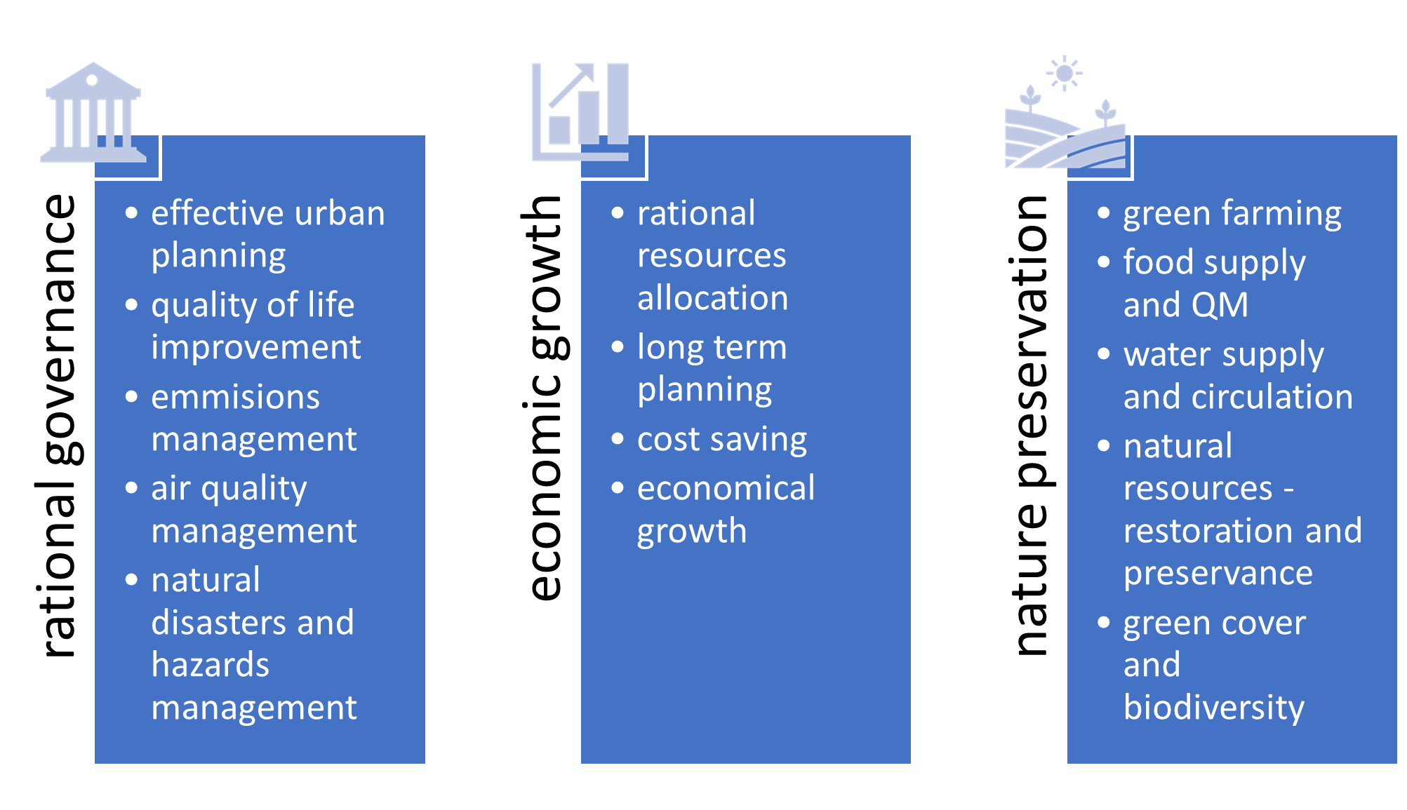
Fig. 1. Sustainable land development framework
Discussion. Based on the results of the research, it had been concluded that it is necessary to introduce the Sustainable Land Management and Planning Framework, which is based on the profiles of urban and suburban land use, focusing on their similarities and differences, using environmental and economic indicators. It is necessary to consider sustainable development, the development and allocation of resources and the construction of spatial areas. To provide forecasts, key economic parameters were identified. This data can be used in future to build linear models of function dependencies and diagrams based on computational data.
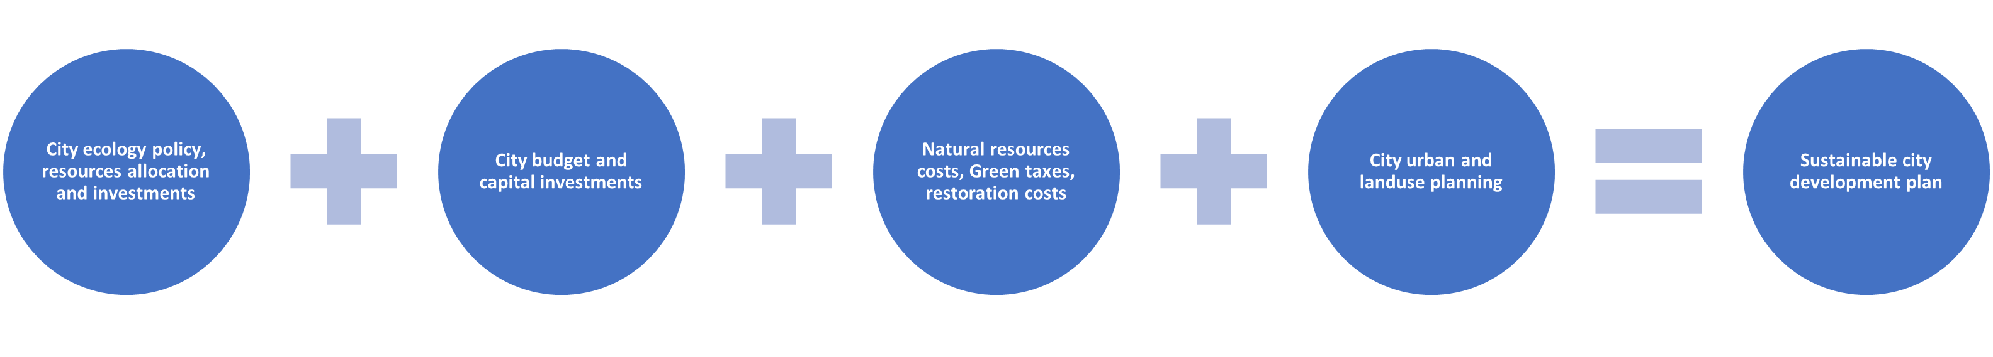Fig. 2. Sustainable urban land development plan components
It should be noted that in the past, the city developed and expanded its boundaries for various reasons, the main ones being the following: around a suitable landscaped habitat; centers of economic activity and industrial development, as well as socio-political reasons. The expansion of cities was based on new investments and the industrial development of the regions. Figure 2 highlights components for sustainable urban development planning. This plan takes into account the volume of internal and external investments under annual environmental development programs, the volume of total investments received in the development of the city, all expenditures from the city budget related to the environment and maintenance and restoration of natural resources, waste, emissions, CO2, etc., and the volume of total budget expenditures, which can be used for planning and forecasting costs associated with urbanization.

References
- Nazarenko, V. A. (2018). Suchasni vykluky urbanizaziyy – economichniy poglad [Current challenges of urbanization - economic view]. Land management, cadastre and land monitoring, 2, 97-104.
- State Statistics Service of Ukraine. (2021). Available at: http://www.ukrstat.gov.ua.
- Agency for the development of infrastructure of the stock market of Ukraine. (2021). Available at: https://smida.gov.ua.
- The publicly available information database of the National Securities and Stock Market Commission on the securities market. (2022). Available at: https://stockmarket.gov.ua.
- CIA US. The World Fact Book: Ukraine. (2020). Available at: https://www.cia.gov/library/publications/the-world-factbook/geos/up.html.
- Department of Urban Planning and Architecture. General plan of the city of Kyiv for the period until 2020 (current). (2020). Available at: https://kga.gov.ua/generalnij-plan.
- Izakoviéovå Z., Mik16s L. , Spulerovå J. (2019) Basic Principles of Sustainable Land Use Management. In: Mueller L. , Eulenstein F. (eds) Current Trends in Landscape Research. Innovations in Landscape Research. Springer, Cham. https://doi.org/10.1007/978-3-030-300692.
- Portney, K. E. (2013). Taking sustainable cities seriously: Economic development, the environment, and quality of life in American cities. MIT Press.
- Tang, Hui-Ting; Lee, Yuh-Ming. (2016). The Making of Sustainable Urban Development: A Synthesis Framework. Sustainability, 8, 5, 492. https://doi.org/10.3390/su8050492.
- Hualou Long, Yi Qu. (2018). Land use transitions and land management: A mutual feedback perspective. Land Use Policy, 74, 111-120. https://doi.org/10.1016/j.1andusepol.2017.03.021.

Назаренко В.А.
КОНЦЕПЦІЯ СТАЛОГО РОЗВИТКУ ЗЕМЕЛЬ НА ПРИКЛАДІ МІСТ УКРАЇНИ
В умовах стрімкого розширення міст і продовження використання природних земельних ресурсів необхідно вивчати землекористування з декількох напрямків і комплексу кластерів даних. Для цього були ретельно вивчені, згруповані та використаны в дослідженні дані та матеріали, надані науковим співтовариством, а також державними установами та організаціями і комерційними компаніями. Ця методологія довела свою ефективність у прийнятті правильних припущень та допомогла побудувати ефективну модель розвитку землекористування у майбутньому. Земельні та лісові ресурси безсумнівно відіграють важливу роль у формуванні та розвитку міст. Наявність, значна кількість та їх використання впливають на економічний розвиток та екологічну ситуацію міст та прилеглих до них територій. Наявні лісові, земельні та продовольчі ресурси особливо важливі для забезпечення життєдіяльності великих міст. Ретельне планування, облік та аналіз різних факторів повинні бути спрямовані на відновлення земельних і природних ресурсів, планування витрат на впровадження нових ефективних енергозберігаючих та інших сучасних технологій. У фокусі цієї дослідницької роботи – кейс-стаді міського землекористування за програмою сталого розвитку України на основі даних до 2023 року. У результаті дослідження автором представлено концепцію сталого розвитку земель. Цю концепцію слід розглядати як ключову частину загальної програми розвитку міста. Результат використання запропонованої програми сталого розвитку відкриває можливість для розробки нової політики управління земельними ресурсами та містом, результатом якої стане збереження природних ресурсів, в окремих випадках відновлення природних ресурсів та покращення якості життя мешканців міст.
Ключові слова: урбанізація, сталий розвиток, планування землекористування, сталий розвиток.

