УДК: 004.9:911.5/.9:528.94
HARMONIZATION STRATEGY OF THE SPATIAL INFORMATION INFRASTRUCTURE OF UKRAINE WITH INSPIRE. SYSTEM APPROACH
V. Chabaniuk, Ph.D., Senior Researcher,
Institute of Geography of the National Academy of Sciences of Ukraine,
E-mail: chab3@i.ua
O. Dyshlyk, CEO, Geomatic Solutions LLC,
E-mail: dyshlyk@geomatica.kiev.ua
Abstract. Van Gigch's system approach was applied to consider the option of systemic harmonization of the National Spatial Information Infrastructure of Ukraine (NSII) with INSPIRE. The article focuses on its most important part - the strategy of harmonization or, more specifically, strategic harmonization. The proposed strategic harmonization is suitable for practical implementation. For this purpose, NSII is understood as an extension of National Spatial Data Infrastructure (NSDI), and NSII and INSPIRE are represented by general systems (GS), whose practical feasibility is achieved by exemplification/interpretation by spatial information systems (SpIS) and certain their extensions - SpISb. The main attention is paid to the relation between the NSII and INSPIRE, with an emphasis on the harmonization relation. Possible alternatives to the problems or their solutions are not considered. In particular, the likely recent shift of interest from NSDI/NSII/INSPIRE to IGIF (Integrated Geospatial Information Framework) is not considered. This is possible because van Gigch's system approach used allows scaling, in this case - upwards, with the addition of higher levels of the hierarchy such as IGIF to the consideration.
It is shown that, in the context of harmonization with INSPIRE, it is necessary to examine the harmonization of GS on at least three epistemological levels. GS corresponding to these levels can be called: strategic, tactical and operational. The GS for harmonization with INSPIRE can be represented by an integrated hierarchy or a unification of three GS components of these three levels. In the case of unification, each component of the collective agreement can be considered separately, but the context of harmonization must be mandatory. In particular, in strategic harmonization, it is mandatory to define its hierarchical relations with the "corresponding" tactical harmonization.
Two main results were obtained in the article: 1) scientific - the structure of the phenomenon "harmonization of Ukrainian SII with INSPIRE" was defined, 2) practical - it was proved that the specified phenomenon is adequately represented by the GS and the corresponding SpISb.
Key words: Spatial Information Infrastructure (SII) of Ukraine (NSII), Spatial/Geospatial Data Infrastructure of Ukraine (NSDI/NGDI); strategic harmonization; methodologies of harmonization, system approaches of van Gigch and G. Klir.

Introduction. Problem
When Ukraine joins the EU, it is necessary to solve, among many others, the harmonization problem of the National Spatial Information Infrastructure (NSII) with INSPIRE, which is the main problem of the article. Its solution should be a set of harmonizations of relevant General systems (GS). The strategy of harmonization with INSPIRE is an example of a strategy, the structure of which is discussed in the article [1]. The main goal of the article is to formulate a strategy that is understandable for practical implementation with the help of spatial information systems (SpIS). For the proof, van Gigch system approach is used and the possibility of its conversion into a constructive one with the help of J. G. Klir system approach is indicated.
In practice, we first encountered the simpler harmonization problem of Ukrainian spatial (basic) data with INSPIRE in the pilot project "DRDSI Harmo.UA pilot on data harmonization in Ukraine" in 2016. Information about these DRDSI (Danube Reference Data and Services Infrastructure) pilots is given in the article [2]. According to the Terms of Reference, the purpose of the Harmo.UA pilot was "to add content and value to the DRDSI Platform...".
The DRDSI platform is mentioned in the monograph [3]. At the time of its writing, there were still Internet references on the European Location Framework (ELF) project, the result of which was supposed to be the practical implementation of INSPIRE. Therefore, at that time we had no problems with understanding the DRDSI platform either - we considered it as a regional part of INSPIRE/ELF. They were created, including for use in the Danube region (see EUSDR - EU Strategy for the Danube Region, https://danube-region.eu/, 2024-Feb-15). However, as of today, February 2024, we have no evidence to suggest that INSPIRE/ELF or DRDSI have been successful. Then what kind of harmonization with INSPIRE can we talk about? Perhaps the problem of such harmonization has no solution at all? Maybe we're misunderstanding her? Or maybe we can't find the right solution yet? In many ways, this article was written to find him.
In the article [4], we introduced the term "harmonization with INSPIRE" in the title. We interpreted the harmonization with INSPIRE as the harmonization of Ukrainian spatial data, processes and the Law "On the National Geospatial Data Infrastructure", which were discussed in one way or another in that that article. We united all three components under the term "harmonization of Spatial Information Infrastructure". Further research has shown that simply using a unifying term is not enough. In order to harmonize with INSPIRE, each component needs to be studied more deeply, having previously defined them more formally. It is also necessary to take into account that:
1. Harmonization involves transformation. "Transformation" is understood as a clearly defined action. For example, it is the conversion of data presentation formats and possibly the data itself. The concept of "harmonization" allows for many more interpretations, so it is vaguely defined.
2. In addition to the vagueness of the "harmonization" concept definition, the "input" and "output" of harmonization are, conditionally speaking, more vague. That is, it is actually unclear "what" (input) and with “whereby" (output) to harmonize.
We offer a "systemic", formalized vision of the problem and its solution, therefore we introduced the concept of the "inquiring" system, which is used to describe both the "input" and the "output" of harmonization. The system approach in the interpretation of van Gigch is used at least three times to understand the harmonization relations between: 1) SII of Ukraine as a whole and INSPIRE as a whole, 2) Spatial processes of SII of Ukraine and INSPIRE processes, 3) Spatial data of SII of Ukraine and INSPIRE data.
Usually, we understand the harmonization of each of the three listed artifacts as horizontal. In addition to horizontal harmonizations, there are harmonizations that should be called vertical. Thus, using the example of Atlas information systems (AtIS) in the monograph [3], we explained the essence of the "vertical" epistemological/reductional relations that exist between the components of the corresponding strata. In the hypothetical three-dimensional cube of relations of Relational Cartography, they were shown on the Y axis, which was understood in the same way as in the usual three-dimensional space of Euclid. "Horizontal" relations along the X axis were called "transformational" in the direction of "increase" and "verification" in the opposite direction of "decrease".
Practice needs to consider the problem of harmonization comprehensively, since "purely" horizontal transformational harmonizations are rare. To explain the last statement, it is enough to read the article [2]. There, in order to harmonize even simple basic administrative and territorial data of Odesa region with INSPIRE, it was necessary to use not only external tools (such as HALE), but also (vertical) knowledge and skills that the Ukrainian side did not have. The German HALE development company weTransform, GMBH had such knowledge and skills, which actually harmonized Ukrainian and Moldova administrative data with INSPIRE and published the corresponding WMS services. Summarizing the research, weTranform, GMBH even proposed to use systematically the so-called INSPIRE Model-Driven Approach (“The INSPIRE Model-Driven Approach” http://inspire-extensions.wetransform.to/inspire-mda.html, accessed 2024-Feb-26). It is one of the methods of Model-Based Engineering (MBE), which has reached its maturity in recent years.
An attempt to consider the horizontal and vertical harmonization relations comprehensively (together) leads to a mandatory description of the structure of such a complicated complex structure. For such a description, we use the concept of "framework", which in informatics is called "architectural pattern". Over the years of activity, we have recorded, described and repeatedly used two "systemic" architectural patterns: Conceptual framework (CoFr) and Solutions Framework (SoFr). In particular, CoFr and SoFr were applied to special SpISb, such as the expansion of Electronic Atlases (EA) and Atlas Information Systems (AtISb).
CoFr and SoFr systemic architectural frameworks are also applicable to the problem of harmonization with INSPIRE. For this purpose, we note that special SpIS and SpISb are specific representative systems of the corresponding General systems. We propose to use van Gigch three-level hierarchy of the inquiring GS to describe the harmonization problem in the so-called "context of harmonization". At the same time, SpIS and SpISb are understood as exemplifications/interpretations of GS.
The concept of "context" is defined as follows: CONTEXT (from the Latin contextus - close connection, connection) - a set of circumstances on which the understanding or meaning of any sign, expression, text, action depends; a passage of text with a complete sentence, which makes it possible to accurately determine the meaning of a single word or expression. - [ENCYCLOPEDIA of modern Ukraine, https://esu.com.ua/article-5031, accessed July 08, 2023].

System approach and general scheme of research
It is believed that consideration of the issues of NSDI (National Spatial Data Infrastructure) began with the Executive Order of US President Bill Clinton 12906 of April 11, 1994, which was called "Coordinating Geographic Data Acquisition and Access: The National Spatial Data Infrastructure". The purpose of the Order was to: "advance the goals of the National Information Infrastructure (NII); and to avoid wasteful duplication of effort and to promote efficient and economical management of resources by federal, state, local, and tribal governments."
We see that even then it was not about NSDI, but about the National Spatial Infrastructure Information (NSII) as a subset of SII (in this example – US). Although the term and concept of (N)SDI is more popular in the geoinformation industry, which is often used instead of (N)SII. In this article, we are more interested in (N)SII than (N)SDI. The Spatial Information Infrastructure (SII) in this article is defined through the Spatial Information Infrastructure (SII) of Poland. The latter is described in the Polish Law "On SII" [5] and implemented, between others, in the form of the Polish SII Portal, which is briefly described in the article [4]. If we replace Poland with Ukraine, we will get our proposed representation of the future SII of Ukraine or the National SII (NSII). At the same time, the NSII should correspond to the Product-process model of the development of the NSDI, which is described in the work [6].
In Ukraine, activities of the NSDI creation began at the end of the last century. The main attention in it during the last more than ten years was paid to the "product" part or the product model of NSDI. All these years, "proponents" of the product model in Ukraine held leading positions in state bodies involved in the formation of state policy in the field of NSDI. Apparently, that is why they managed to "lay down" the product model in the Law of Ukraine of 2020 "On the National Infrastructure of Geospatial Data", which was not about NSDI, but about its "product" part, which is called NGDI.
That is, the specified Law does not pay attention not only to the real modern development of NSII, but also to INSPIRE and regulatory documents surrounding it. This omission was critical in 2020. Today, in 2024, this omission is even harmful, as Ukraine has already begun to create an NGDI with a large number of erroneous decisions in the face of a lack of resources.
The "process" part of NSDI in Ukraine was not studied, although it includes such important processes as use. That is, government officials of Ukraine, as well as scientists associated with them, did not think about the issue of using NSDI/NGDI. Namely, the presence of the "process" part of the NSDI turns the latter into a modern and actually existing NSII. For a better understanding of the concept of "processes" in the context of the NSDI, we recommend distinguishing between the system of activities for the creation and use of the NSDI system, denoted by the National Spatial Infrastructural Activity, and the final result or results of one or some controlled or planned periods of the activity of the NSpIA, if the NSDI system is created in several queues or versions. Between the mentioned systems, there is a dualism of NSpIA ↔ NSDI, although it is intuitively clear that NSpIA is a broader concept than NSDI and then NGDI. The processes of creation and usage are included in the Product-process model of the NGDI development.
Our Product-Process Model of NSDI development [6], uses the dualism "product-process" at least, twice. In a potential NSDI, together with the product(s), the process(es) should be considered immediately. For example, if the phases of creation and use of NSDI are distinguished, then the dualism "product-process" must be applied twice - in each phase. From the above, it follows that during the phase of creation of the National NGDI Geoportal of Ukraine (UkrNGDI), defined in the Technical Specifications for it [7], special attention should be paid to the processes or even the methodology of its creation and operation. It would be even better if the project executors realized that, in addition to the "product" part of the NSDI system, there should be a "process" part of the NSDI system and it should be a subsystem of the NSpIA. In particular, thanks to the "product-process" dualism, we are sure that without the creation process (creation phase) of such complex products as NSDI, the latter cannot be created.
Equally important processes of the Product-Process Model of NSDI development are the usage processes (usage phase), which require a separate definition and study. In the article [2], we considered examples of such processes - pilot services of NSDI in the eras of Web 1.0 and Web 1.0+. As a guideline for the processes of using NSDI in the work [4], we considered the processes of using the Geoportal of Poland.

The essence of a system approach to research
It is impossible to consider the system approach without understanding the term and concept of system, there are many definitions, as well as the understanding of it. We most often use the definition from the monograph [8]. It uses a "dictionary" definition that says "a system in general is an ordered pair (A, R), where A is a set of elements and R is a set of relations that form a unity or organic whole." The elements a ∈ A and the relation r ∈ R can take on different values. We distinguish between general and information systems (GS and IS). The concept of social security is used mainly in theoretical research. The concept of IS is also used in practice.
Better understanding of the concept of system helps, for example, [9; pp. 30-31]: "Elements of the system can be concepts (notions), and in this case we are dealing with a conceptual system. Language is an example of a conceptual system. System elements can be objects, such as the parts that make up a typewriter. The elements of the system can be subjects, for example, members of a football team. Finally, a system can consist of concepts, objects, and subjects, as in a human-machine system that includes all three kinds of elements. Thus, a system is a collection of living or non-living entities or both. … For the moment, it is enough to mentally imagine that systems are made up of other systems, which we call subsystems. In most cases, we can think of a larger or older system that includes other systems and that we call the whole system or the complete system. One of the problems in working with systems arises from our inability to know how much to break down or 'decompose' a system into component systems, or how much to 'compose' or 'organize' a system into larger systems."
To research the problems of harmonization with INSPIRE, we use the concept of the inquiring system from [9; 10], with the help of which the subject of the study is presented and the selected system approach (method) to the study is described. Here, it is essential to present the complete studied system at least as a hierarchy of three component studied systems, the so-called (from top to bottom in the hierarchy): metasystem, object system, and intervention system. These concepts are used to interpret important aspects of the problem of harmonizing "something" from the Ukrainian side with "something" from the EU side. In the context of harmonization with INSPIRE, in both cases these "something" artifacts are represented by three-level hierarchies of complete inquiring systems. The relations between the constituent inquiring systems of three different levels of the hierarchy are called strategic, tactical and operational harmonizations, respectively.
Harmonization of spatial data is an operational harmonization and it belongs to the lower level of the hierarchy of constituent inquiring systems. Systems at this level of the hierarchy are called intervention systems in the context of harmonization. At the same time, they are operational systems of spatial information systems in the broader sense (SpISb) in the context of harmonization. Then we "rise" to a stratum (or level) of such inquiring systems above, as suggested by van Gigch [9]. Then we go up again and finally we can consider the harmonization problem from the viewpoint of this highest stratum. If we have in mind the representation of the inquiring systems, then for a better understanding of the harmonization problem with INSPIRE, it should always be taken into account that it is described by a hierarchy of systems of at least three classes: strategic (strategies), tactical (tactics, methodologies), operational (operations, technologies).
In order to work with the inquiring systems in practice, their "information analogues" - information systems - are needed. In the context of harmonization with INSPIRE, we use the concept of Spatial IS (SpIS). IS itself is understood in the narrow (ISn) and extended (broader, ISb) senses. For these concepts, we use the definitions from [11]. From the specified definitions, it is easy to obtain the definitions of SpISn and SpISb, if the term "spatial" is added to them in the necessary places.
There are many definitions of specific SpISn, such as Electronic Atlas (EA), Atlas Information System (AtIS), Cartographic Information System (CIS), Geographic Information System (GIS), which generally coincide with the definition of ISn. The unifying term for the listed systems is "Spatial Information System (SpIS)". All of them have an "extension/broader", the notation of which "b" we add to the designation of a specific SpIS. For example, EAb, AtISb, CISb, GISb and SpISb. Using AtIS as an example, we can recall [11; Fig. 3], which shows the relation of the inquiring (investigated) systems in a fixed period of time (repeated in Fig. 1):
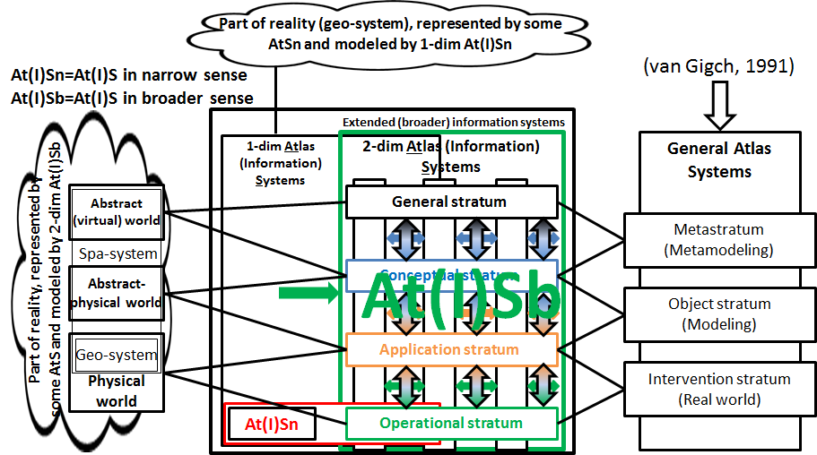
Fig. 1 The relations of the inquiring systems in a fixed period of time
The concept of extended IS (broader, ISb) turned out to be very powerful. Using it, we can represent a exemplification/interpretation of a GS (eg, the Atlas General System in Fig. 1) from the GS "space" into the IS "space" in every case where it makes practical sense. To solve the problem, an approach is used, according to which the system is first investigated using the methods of general systems theory. Then exemplification/interpretation of GS is carried out in the corresponding ISb.
In addition to the general systems theory of van Gigch, we often use the general systems theory of G. Klir [8]. The author of the preface to the Russian translation of this monograph, A. Gorlin, called it systemology and distinguished two approaches to it [13]. He called one of the approaches cybernetic or structuralist, linking it to the works of P. von Bertalanffy, W. Ross Ashby, G. Klir, and others. In a certain sense, he contrasted this approach with the second approach to systemology - the expansion and generalization of management theory, which M. Mesarovich and others were engaged in. Without going into details, we classify van Gigch's theory as structuralist. In addition, the monograph [8]/[13] describes the so-called General Systems Problem Solver, which we used to build the General system, which were exemplificated/ interpreted by the well-known SpISb. That is why G. Klir systemology is called constructive.
For confirmation, we recommend a modern understanding of the Atlas Base Map (ABM) [3]. There, the concept of the ABM General system significantly used, and with it the structuralist general systems theory. The same is done for Electronic atlases using the example of the Electronic version of the National Atlas of Ukraine. Slightly generalizing the mentioned results, we get Fig. 2.
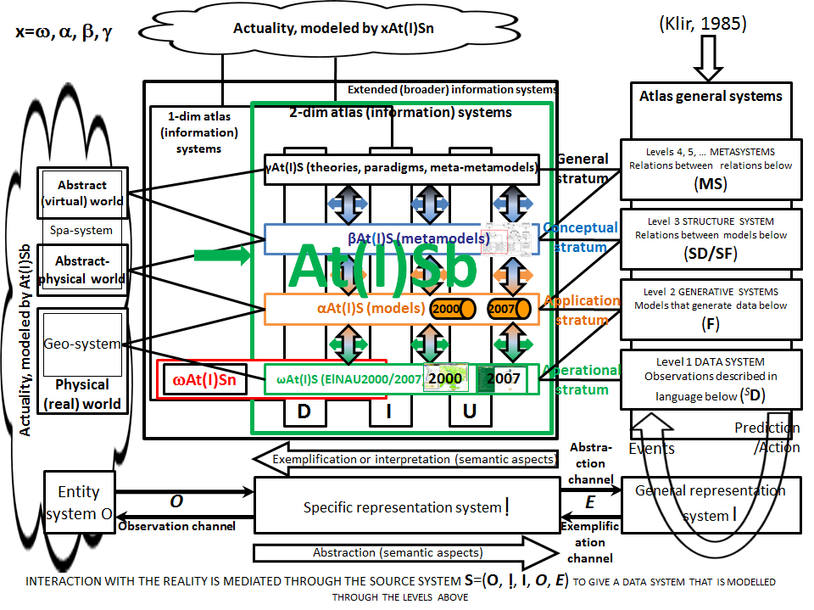
Fig. 2 Abstraction of specific broader SpIS by spatial general systems
We limited ourselves on Fig. 2 only by SpISb AtISb to make it easier to compare Fig. 1 and Fig. 2. In fact, this is not just a comparison of the two indicated figures, but a statement that the approaches of van Gigch and G. Klir are similar.
Van Gigch [9] clearly distinguishes two main ways of building (changing) systems: improvement and design. He writes about designing:
- “Like 'improvement', 'design' also involves transformation and change, but is so different from systems improvement that it is necessary to emphasize the differences between them in goals, scope, methodology, ethics and results. Design is a creative process that calls into question the premises that underlie old forms... A system approach is a research principle that considers the system as a whole, rather than its individual subsystems. Designing the system as a whole means creating the optimal configuration (structure) of the system.”
Van Gigch [14; p. 3] states: “…we believe that the design or creation of an artifact, be it a social system, a computer system, a skyscraper, a book, a play, etc., requires the participation of many different “designers” such as MANAGER, SCIENTIST, ENGINEER, EPISTEMOLOGIST, ARTIST, ETHICIST and others who work from the perspective of at least five different research systems, namely: 1) Real World Research System, 2) Modeling Research System, 3) Metamodeling Research System, 4) Epistemological Research System, 5) Ethical/Aesthetic Researched System" (Fig. 3).
Fig. 3 is a translation of Figure 1.1 from [14; see on the left] with some additions (see right). These additions are IGIF with relations and NSDI/NSII with relations. IGIF here stands for the United Nations Integrated Geospatial Information Framework (UN-IGIF) [https://ggim.un.org/UN-IGIF/, accessed 2024-Feb-20] – a UN project and framework that has been evolving in recent years. At the moment, these artifacts can even be understood as a certain replacement/development of INSPIRE/ELF, since there are works on the inclusion of NSDI in IGIF [15]. IGIF is an Epistemological inquiring system that has four lower levels of hierarchy. Its hierarchical relations are shown in blue. Harmonization of NSDI/NSII with INSPIRE is considered in this article. The right part of Fig. 3 shows that NSDI/NSII has three lower levels of hierarchy. Its hierarchical relationships are also shown in blue. At the same time, Fig. 3 shows that "above" NSDI/NSII there are at least two more levels. It is not desirable to forget about this, even if this fact is not important in this or that research.
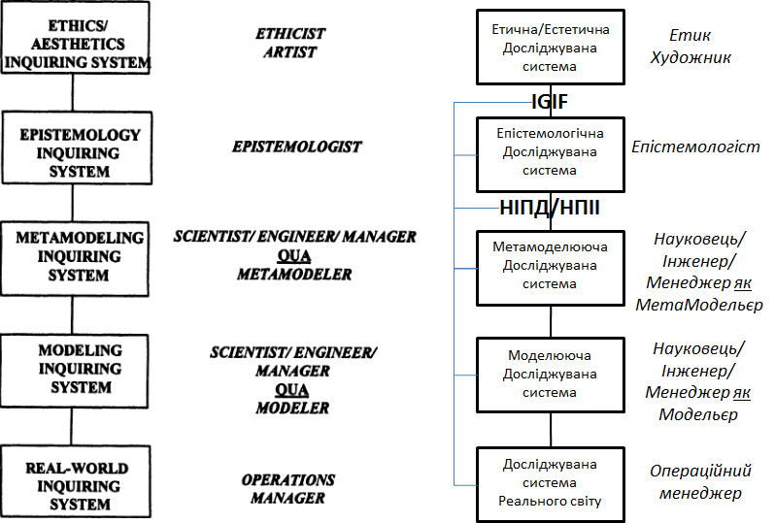
Fig. 3 Hierarchy of researched systems when creating an arbitrary artifact [14]
Remark. On Fig. 3 qua=as, where qua (preposition) means a particular instance of something or the general idea of something, for example: Qua is a musician, he lacks skill, but his playing is lively and keen [2024-Feb-10, https://dictionary.cambridge .org/ru/словарь/английский/qua].
If we limit ourselves to a certain specific context, then in many such cases it is enough to consider the three lower levels of the hierarchy. This article considers just such a case - we are interested in the context of the harmonization of SII of Ukraine with INSPIRE. For this, it is enough to use the so-called "metasystem" paradigm, which is the main one in the monograph [9]. Van Gigch believes [10] that "The metasystem paradigm postulates a hierarchy of at least three inquiring systems: at the lowest level of abstraction - the inquiring system is dedicated to IMPLEMENTATION; at the object level, the inquiring system is devoted to MODELING; and finally, at the meta-level, the inquiring system is dedicated to METAMODELING. System Design is incomplete without the intervention of these three inquiring systems, each of which plays a role in System Design. System Science draws its paradigm and epistemology from the metalevel inquiring system. In addition, this inquiring system is devoted to a methodology called METAMOLEDING, which provides the MODELING (of the lower-level inquiring system) as a source of knowledge and reasoning methods. Design is incomplete if it does not consider both MODELING and METAMODELING. METAMODELING means MODELING what Design Theory means to Design, or what Decision Making ABOUT Decision Making means to Decision Making, or what Learning to Learn means to Learning. The consequences of using an obsolete modeling paradigm are explored in relation to the discipline of operations research."
The monograph [9] deals with modeling and metamodeling of system design (System Design Modeling and Metamodeling). They correspond to the three lower levels of the hierarchy shown in Fig. 3. The levels are called: 1 – intervention, 2 – object, 3 – meta. The concept of van Gigch level essentially coincides with the concept of strata, which is used in our similar constructions [3]. Therefore, instead of the term 'level', the term 'strata' is used when appropriate. There are stable relations between levels/strata that are decisive for many spheres of human activity, as was said in the previous paragraph.
Van Gigch [9; 256] claims that there is a dialectical relation between two elements of each dyad (object stratum ↨ meta-stratum, model ↨ meta-model, world ↨ meta-world, etc.), because each element originates in the inquiring systems of different strata of abstraction or logic. When the meta-stratum is neglected, the design process from the meta-stratum, on which the lower-stratum inquiring systems are formulated, is neglected. This neglect can lead to system malfunctions and failures.

The general scheme of the research
The main result of this article is the general scheme of research on the harmonization of SII of Ukraine with INSPIRE. It is shown on Fig. 4. It is obtained by using the three lower levels/strata of the hierarchy from Fig. 3.
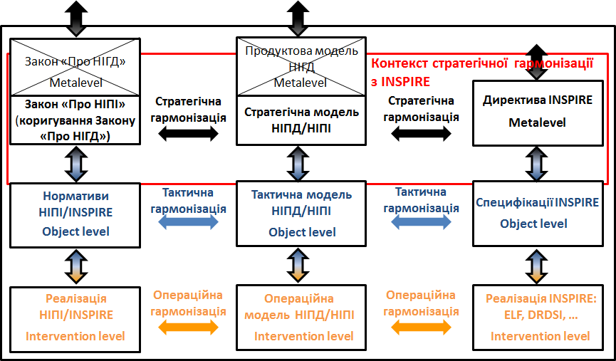
Fig. 4 General scheme of the research
Namely, it is necessary to study three artifacts, which can be represented by three hierarchical inquiring systems, as shown in Fig. 4: 1st of three columns: Law "On NSII" (amendment of the Law "On NGDI"), Norms of NSII/INSPIRE, Implementation of NSII/INSPIRE - the inquiring system, which should be the result of harmonization (to be harmonized) with INSPIRE, 2nd of three columns: Strategic model of NSD/NSII, Tactical model of NSDI/NSII, Operational model of NSDI/NSII) – inquiring "model" system through which it is proposed to harmonize NSII/INSPIRE with INSPIRE, the 3rd of three columns: Implementation of INSPIRE: ELF, DRDSI, … is a inquiring system to harmonize with.
We recommend to pay attention to the vertical two-way relations, which are shown between the identified rectangles in a variable color. Usually these are bottom-up epistemological relations and top-down reductive relations between the corresponding elements of the identified rectangles. These relations are no less important than horizontal ones such as "strategic harmonization". Horizontal strategic harmonization with INSPIRE is not enough to fully cover this context. For example, there is a question about the methodology of harmonization with INSPIRE. The methodology has the right to exist, but where does it belong in the "General scheme of research"? The choice of a methodology for harmonization with INSPIRE is a strategic issue of harmonization along with the adoption of the INSPIRE Directive or harmonization with INSPIRE of the Law "On the NSII" (correction of the Law "On NGDI")".
Note that some of the listed elements are undefined, some are defined, and some are intermediate in terms of certainty/uncertainty. For example, the Strategic Model of NSDI/NSII offers a product-process model of NSDI development. At the same time, the Tactical model of the NSDI/NSII is still undefined. And such elements as "Implementation of INSPIRE: ELF, DRDSI, ..." are insufficiently defined, because we cannot consider the known INSPIRE implementation projects, such as ELF, DRDSI, to be successful.
The fact is that the goal of each significant project must meet the expectations of, as a rule, many interested parties (stakeholders). And their interpretations are different. Sometimes they contradict each other even in the same project. We explain this fact ultimately to the different perception of the world by the parties interested in the project. And we will say right away that we do not have an optimal solution to the specified problem. We can only recommend something. This article is one such recommendation.
Fig. 4 should be "read" as follows. In the upper right corner is shown "INSPIRE Directive. Metalevel". Metalevel here means that the INSPIRE Directive refers to the Metalevel in van Gigch's sense [9]. We adhere to the definition of an EU directive in: [accessed 2024-Feb-20, https://uk.wikipedia.org/wiki/Directive_(European_Union)]. This definition also applies to the INSPIRE Directive.
As of July 23, 2023, the website of the Verkhovna Rada of Ukraine contains the document "Directive 2007/2/EU of the European Parliament and of the Council of March 14, 2007 on the creation of a Spatial Information Infrastructure in the European Community..." [https://zakon.rada .gov.ua/laws/show/984_002-07#Text, accessed July 08, 2023]. It is a translation of the Directive and is currently in force. Unfortunately, we do not know how this publication should be used - whether it is solely for familiarization or for orientation in the activity of creating the NGDI of Ukraine. Perhaps this is the recognition of the specified EU Directive as legal in Ukraine, but there is no influence of this INSPIRE Directive on the creation of NGDI in Ukraine. INSPIRE is mentioned only once, inconsequentially, in the current Law "On the National Geospatial Data Infrastructure", with corrections.
Taking into account the above, in the modern context of NSDI/NSII, we consider it inappropriate to focus only on the Product model, and the Law "On the National Geospatial Data Infrastructure" needs to be adjusted towards NSDI/NSII in the modern sense. There should be "Strategic Harmonization" between the adjusted "Law "On the NSII" and the Product-process model of the NSDI development. Currently, we can point out the following two features: 1) in the Law "On the NSII", in addition to the actual adjustment of the NGDI, it is necessary to consider the "National Spatial Infrastructure Activities" (NSpIA); 2) the Law "On the NSII" amended in this way should be harmonized with the "INSPIRE Directive".
The harmonization of spatial data is the simplest and most famous in the harmonization of SII of Ukraine with INSPIRE. This harmonization is considered “a key process in the development of spatial data infrastructure. Its purpose is to transform different data sets in such a way that they match each other both in terms of geometry and semantics" [https://inspire.ec.europa.eu/training/data-harmonisation, accessed 2023-Jun-20].

Strategic harmonization
Strategic harmonization with INSPIRE is shown in Fig. 4 by two "horizontal" relations between: 1) the Law "On the National Geospatial Data Infrastructure" as amended and the Strategic model of NSDI/NSII (Product-process model of NSDI development) at the Metalevel, 2) the Strategic model of NSDI/NSII and the EU INSPIRE Directive at Metalevel. These relations are transitive, so elements of Ukrainian legislation should have horizontal relations with the INSPIRE Directive. As shown in the same Fig. 4, in the context of strategic harmonization with INSPIRE, there are vertical relations between: 1) ‘Law "On NSII" (correction of the Law "On NGDI ")’ and NSDI/INSPIRE Norms at the Object level, 2) Strategic model of NSDI/NSII and the Tactical NSDI/NSII model at the Object level, 3) the INSPIRE Directive and the INSPIRE Specifications at the Object level.
In addition to two "horizontal" strategic harmonizations, the relation between "strategic" and "tactical" objects, shown by vertical double-sided arrows, should also be taken into account. Tactical objects are shown one level below. It would be correct to call these vertical relations strategic-tactical harmonizations. However, we did not do this work because they are not considered in the work. However, vertical relations are taken into account in the harmonization methodologies.

Harmonization of legislation
Harmonization of national legislation with EU directives can be done in different ways. For example, Poland harmonized its national legislation with EU directives by transposing, which begins with adding the following footnote to the law "On Spatial Information Infrastructure" [5]: "This Law transposes Directive of the European Parliament and the European Council No. 2007/2/EC of March 14, 2007 of the year on the creation of an infrastructure of spatial information in the European Community (INSPIRE) (Official Journal of the EU L 108, 25.04.2007, p. 1, as amended). That is, Poland "transferred" (transposed) the INSPIRE Directive into its legislation and it became the Law of Poland "On SII" in 2010.
Despite the fact that it is now 2024, and Ukraine has already started activities on the usage of the Law "On the National Geospatial Data Infrastructure" of 2020 in the creation of the NGDI, we draw attention to the possibility (need) to seriously consider the option of transposing the INSPIRE Directive into Ukrainian legislation to harmonize with INSPIRE. Of course, this transposition cannot be thoughtless. Here again, it is possible to use the experience of Poland, which "designed" INSPIRE for its state and non-state (private) structures that jointly use spatial data and information. In any case, it is necessary to make changes to the Law of Ukraine "On the National Geospatial Data Infrastructure" that will increase the guiding role of the ISPIRE directive above the current level of a possible reference to the ISPIRE directive in the absence of national provisions or specifications.
We propose as quickly as possible to create a strategy for harmonization the National Spatial Information Infrastructure of Ukraine with INSPIRE using the Product-process model of the NSDI development and to develop a draft of amendments to the Law of Ukraine "On the National Geospatial Data Infrastructure". The structure of the modern model of NSDI of Ukraine development (NSDI2022) is shown in Fig. 5, which is obtained from [6; Fig. 9], see also [3].

Product-process structure of NSDI ("correct" model)
In this subsection, we will only recall the Product-process model of NSDI development, the modern structure of which is shown in Fig. 5.
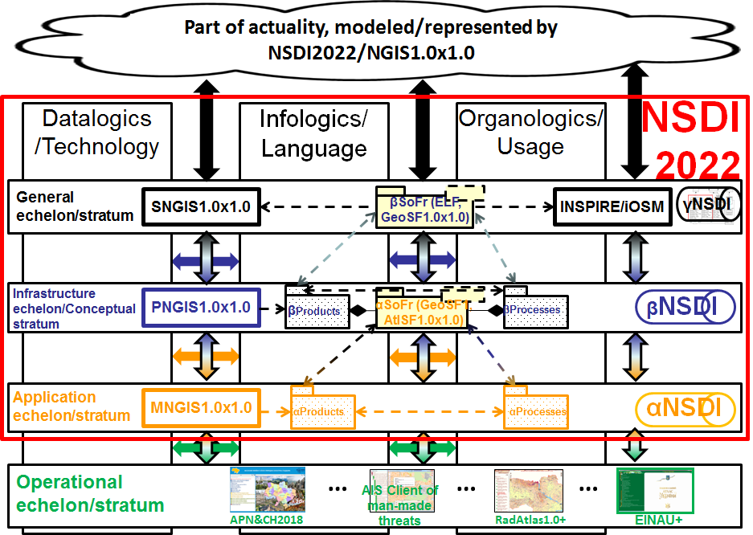
Fig. 5 Product-process structure of NSDI2022 ("correct" model)
Explanation of abbreviations in Fig. 5: 0) xNGIS, x= S - Scientific, P - Production, M - Management, NGIS - National GIS; 1) iOSM – infrastructure (i) of OpenStreetMap (OSM), which includes the OSM GeoInformation Platform (GIP); 2) βSoFr – the main triad of infrastructure (conceptual) Solution Frameworks (SoFr), for example, GeoSF1.0x1.0 (Web 1.0² GeoSolutions Framework); 3) αSoFr is the main triad of application frameworks, for example, AtlSF1.0x1.0 (Atlas Solutions Framework Web 1.0²), GeoSF1.0; 4) APN&CH – Atlas Population of Ukraine and its Natural and Cultural Heritage, RadAtlas1.0+ - renewed version of Atlas of Radioactive contamination of Ukraine, ElNAU+ – renewed Electronic version of National Atlas of Ukraine. Dotted arrows here mean the relationship of dependence. Solutions Framework (SoFr) are constructors that are allowing to design products and processes of the lower echelon/strata in relation to the top of the triad. The peak of the βSoFr triad depends on both the INSPIRE/iOSM SDI and the NNGIS1.0x1.0. The blue color of the name of this top of the triad means here that its purpose is to satisfy the needs of the creation of products and processes of the lower layer. Shown in Fig. 5 components and relations consist of more detailed. The βSoFr and αSoFr components ensure the processes and development of the NSDI of Ukraine within the framework of its NSDI2022 model.

About harmonization methodologies
The choice of methodology for harmonization NSII with INSPIRE is a strategic issue. After choosing a methodology, the researcher has to deal with the tactical artifacts of the methodology, such as the tactical model or its various tactical sub-models. Therefore, we understand the methodology as a tactic of harmonization, which significantly depends on the strategy. After all, it is very important to know how to achieve harmonization with INSPIRE, if this will be, on the one hand, a decision at the country level, and on the other hand, a set of specific actions that must be performed after a decision on harmonization with INSPIRE has been made. We do not mean slogans, but concrete actions, for example in the form of real state harmonization projects. Therefore, we propose only to understand the possible methodologies for the implementation of such projects. For this we only comment them.
The first such methodology is INSPIRE MDA with corrections. Compared to the original, we swapped columns A and B and replaced the left-right arrows between their elements with double-sided ones [4]. Development should be carried out from left to right and from top to bottom. Our replacement is not mechanical, mindless. It means that development can be started, for example, with conceptual diagram B, rather than conceptual diagram A. As a rule, it is prepared in UML, which is a more recognized standard in the information industry than OWL. There are many works that justify the validity of two-way relations between the elements of columns A and B. Another important change is the addition of a vertical relation <<conforms>>.
The INSPIRE MDA adjustment allows for a renewed approach to obtaining a Conceptual Scheme B. All of them involve a 'conceptual design' stage in the creation phase. This stage is called differently in different models of creation, which does not change its essence - to get a conceptual scheme of the future system.
Conceptual design of using the INSPIRE model was performed in a recently published article [16]. The article [4] provides the elements of multi-level conceptual modeling for the territory of the DRDSI pilot projects, which takes into account the administrative reform in Ukraine in 2020.
Fig. 6 gives an idea of the essence of the second (our) approach to harmonization with INSPIRE, which we call pattern-based. Please note that in addition to the relations "instantiates" (examplifies) and "derived", the relation "conforms" χ is used. It is the most important at the first stage of system creation, after the TR stage – stage of conceptual design. This relation is the basis of the "meta-step" pattern, which we recommend to apply systematically.
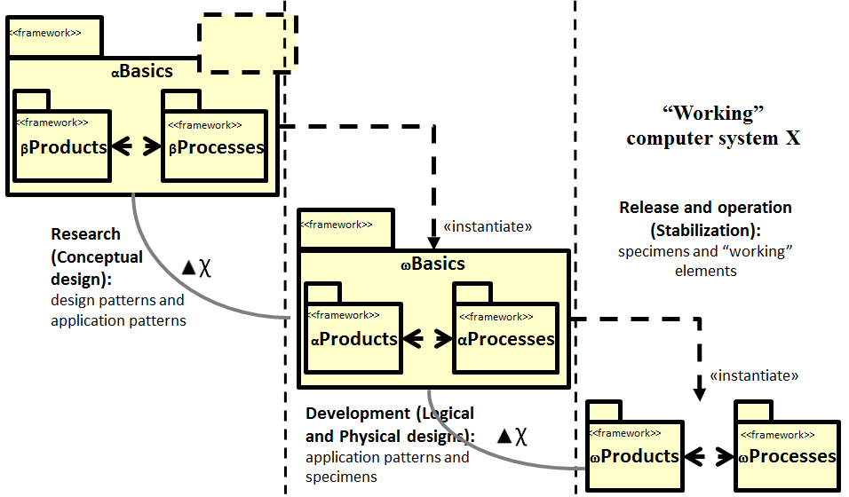
Fig. 6 Instantiation/conformance relations in our approach
The methodology depends on the technology, as evidenced by the hierarchy of concepts strategy-methodology-technology [1]. That is why, from the viewpoint of practice, we cannot neglect the methodology that results from the usage of some technology. Therefore, the third methodology that can be used to harmonize with INSPIRE is the methodology we call ArcGIS for INSPIRE [https://enterprise.arcgis.com/ru/inspire/, accessed 2024-Feb-18].
It is quite obvious that the issue of methodologies for the harmonization of SII of Ukraine with ISPIRE requires, at least, the writing of a separate article.

Conclusions
The article examines the phenomenon of harmonization of the National Spatial Information Infrastructure of Ukraine (NSII) with INSPIRE. Using van Gigch system approach, it is shown how this phenomenon is represented by the three inquiring General systems (GS), which belong to three hierarchically interconnected strata (top-down hierarchy): strategic, tactical, and operational. The harmonization strategy is correlated with the strategic GS from the side of Ukraine and from the side of the EU. The relation of harmonization between these systems is called strategic harmonization.
It is shown how van Gigch's system approach is "constructivized" with the help of G. Klir's system approach. G. Klir's approach has been used in our activities before. For example, for Atlas base maps (ABM) and for Electronic atlases [3]. Since ABM is an element of NSDI/NSII, it is proposed to use the same exemplification/interpretation between Klir's strategic GS and the corresponding SpISb. This is how it is possible to make the transition from GS to SpISb. The latter can be implemented in practice. In particular, we have the following correspondence with regard to strategic GS: strategic GS is the INSPIRE Directive, the amended Law of Ukraine "On NSII".
The results of the article will be useful both in the analysis/research and in the design of the results of the initial stages of work, such as the Technical Requirements of the NGDI [7] or the Conceptual project of the NSDI/NSII National geoportal (design), which will become possible/necessary after the amendment of the Law "On NSII". More specifically:
1. We recommend adopting the normative document "Harmonization of NSDI/NSII with INSPIRE", based on this article. Make this document mandatory for use in all work on creating NSDI/NSII.
2. The Law of Ukraine "On the National Geospatial Data Infrastructure" should be harmonized with the INSPIRE Directive as soon as possible and the result should be called the Law of Ukraine "On NSII". At the same time, should be taken into account the following main advantages of INSPIRE compared to the current Law of Ukraine "On NGDI":
2.1. The INSPIRE approach to handling fundamental and thematic data. In particular, as in INSPIRE, to use the division of data into three consecutive queues/groups of data.
2.2. Availability of the process part of INSPIRE, which are also called services. It should be incorporated into the Law of Ukraine "On NSII". Adapt all INSPIRE usage services, as well as their most successful implementations in European countries.
2.3. Availability of INSPIRE documentation, in particular, availability of specifications of important INSPIRE elements. It is recommended to use it as much as possible, so as not to start creating each necessary document from scratch.
3. Consider the issue of Normalization of the product-process model of the NSDI development, which is described in the article [6]. Normalization here means turning the model into a normative document. This action is necessary, since the Law of Ukraine "On NGDI" has been implemented for a couple of years, so certain efforts are needed to bring the Law of Ukraine "On NGDI" and its corresponding normative documents back into compliance with INSPIRE.
4. For now, we recommend that all three methodologies for the creation/development of NSDI/NSII mentioned here be considered from the viewpoint of usage. The conceptual design stage is mandatory for all methodologies. To perform conceptual design, we recommend using multilevel modeling [16].
References
1. Chabaniuk Viktor, Dyshlyk Oleksandr. (2023b). Do pytannia stratehii vykorystannia heoinformatsiinykh system i tekhnolohii dlia upravlinnia terytoriieiu. [Towards strategy of geoinformation systems and technologies use for territory management]. Zemleustrii, kadastr i monitorynh zemel, № 3, 110-130. (Ukrainian).
2. Chabaniuk V., Dyshlyk O., Tarnopolskiy A. (2022). Lessons of DRDSI pilot projects in Ukraine. Modern achievements of geodesic science and industry. Collection of scientific papers of Western Geodetic Society of USGS, Issue ІІ (44). Lviv, Lviv Politechnic Press, 2022, 69-81.
3. Chabaniuk V. (2018) Reliatsiina kartohrafiia: Teoriia ta praktyka. [Relational cartography: Theory and practice.]. Kyiv: Instytut heohrafii NAN Ukrainy, 2018. 525. (Ukrainian).
4. Chabaniuk V., Dyshlyk O., Yasko V. (2023) Harmonizatsiia Infrastruktury Prostorovoi Informatsii Ukrainy z INSPIRE (Infrastructure for Spatial Information in Europe). [Harmonization of the Spatial Information Infrastructure of Ukraine with INSPIRE (Infrastructure for Spatial Information in Europe)]. Suchasni dosiahnennia heodezychnoi nauky ta vyrobnytstva. Zbirnyk naukovykh prats Zakhidnoho heodezychnoho tovarystva UTHK, Vypusk II (46). Lviv: Vydavnytstvo Lvivskoi politekhniky, 2023. 95-105. (Ukrainian).
5. Act of the 4th of March 2010 on Spatial Information Infrastructure. Journal of Law, No76, entry 469. Warsaw: Government Legislation Centre (in Polish). English translation 10 March 2010.
6 Chabaniuk V., Dyshlyk O. (2021). Natsionalna Infrastruktura Prostorovykh Danykh (NIPD) Ukrainy: Yakymy ye yii aktualna, zdiisnenna i odnochasno "pravylna" modeli? [National spatial data infrastructure (NSDI) of Ukraine: what are its actual, feasible and simultaneously “correct” models?]. Zemleustrii, kadastr i monitorynh zemel, № 3. 104-123. (English, Ukrainian).
7. Stvorennia Natsionalnoho Heoportalu NIHD. Tekhnichne zavdannia. (2022) Derzhavna sluzhba Ukrainy z pytan heodezii, kartohrafii ta kadastru, 2022.- 226 s. [TZ-Heoportal-NIHD-13_12_2022 (1).pdf, https://bit.ly/3QiGNIH, dostup 2022-liut-02]. [Creation of the National Geoportal of NGDI. Technical task. (2022) State Service of Ukraine on Geodesy, Cartography and Cadastre, 2022, 226 p. [TS-Geoportal-NGDI-13_12_2022 (1).pdf, https://bit.ly/3QiGNIH, accessed February 02, 2022]. (Ukrainian).
8. Klir George. (1985). Architecture of Systems Problem Solving. Springer, 1985, 556.
9. van Gigch John P. (1991). System design modeling and metamodeling. Springer. 1991, 453.
10. van Gigch John P. (1993). Metamodeling: The Epistemology of System Science. Systems Practice, Vol. 6, No. 3, 1993, 251-258.
11. Falkenberg E. D., Lindgreen P., Eds. (1989). Information System Concepts: An In-depth Analysis. Amsterdam et al., North-Holland, 1989.- 357 p.
12. Rudenko L. H., Chabaniuk V. S. (2019) Oriientyry po formuvanniu infrastruktury heoprostorovykh danykh Ukrainy, s. 63-80 // v (Rudenko, red., 2019) Aktualni napriamky rozvytku kartohrafii v Ukraini. [Landmarks for the formation of geospatial data infrastructure of Ukraine. / in (Rudenko, ed., 2019) Current trends in the development of cartography in Ukraine.]. Kyiv, Instytut heohrafii NAN Ukrainy, 88. (Ukrainian).
13. Klir George. (1990) Systemolohiia. Avtomatyzatsiia vyrishennia systemnykh zavdan: Prov. z anhl. [Architecture of Systems Problem Solving, Translation from English]. M.: Radio ta zviazok, 1990, 544.
14. van Gigch John P. (2003). Metadecisions: Rehabilitating Epistemology. Springer, 2003, 341 (349).
15 Scott Greg. (2019). UN-GGIM Secretariat. The IGIF: Improving and strengthening NSDIs and geospatial information management capacities Integrated Geospatial Information Framework. First International Workshop on Operationalizing the Integrated Geospatial Information Framework, 9–11 September 2019, Celso Furtado Conference Room, ECLAC, Santiago, Chile.
16 Alvarado S.H., et al. (2022). Multilevel modeling of geographic information systems based on international standards. Software and Systems Modeling, Vol. 21, 623–666. [doi.org/10.1007/s10270-021-00901-1].

В. Чабанюк, О. Дишлик
Стратегія Гармонізації Інфраструктури Просторової Інформації України З INSPIRE. Системний Підхід
Анотація. Для розгляду варіанту системної гармонізації Національної Інфраструктури Просторової Інформації України (НІПІ) з INSPIRE застосовано системний підхід ван Гіга. Основна увага у статті приділяється найважливішій її темі - стратегії гармонізації або більш конкретно, стратегічній гармонізації. Запропонована стратегічна гармонізація придатна для практичної реалізації. Для цього НІПІ розуміється як розширення Національної Інфраструктури Просторових Даних (НІПД), а НІПІ та INSPIRE представляються загальними системами (ЗС), чия практична реалізованість досягається конкретизацією/ ілюстрацією просторовими інформаційними системами (ПрІС) і певними їх розширеннями - ПрІСш. Головна увага приділяється відношенням між Загальними Системами НІПІ і INSPIRE з акцентом на відношенні гармонізації. Можливі альтернативи ні проблемам, ні їх рішенням не розглядаються. Зокрема, не розглядається популярний останнім часом зсув інтересу від НІПД/НІПІ/INSPIRE до IGIF (Integrated Geospatial Information Framework). Це можливо тому, що використаний системний підхід ван Гіга дозволяє застосувати масштабування, у даному випадку – вгору, з доданням до розгляду вищих рівнів ієрархії, таких як IGIF.
Показується, що у контексті гармонізації з INSPIRE потрібно досліджувати гармонізацію ЗС як мінімум на трьох епістемологічних рівнях. Відповідні цим рівням ЗС можуть називатися: стратегічною, тактичною і операційною. ЗС для гармонізації з INSPIRE може представлятися інтегрованою ієрархією або об’єднанням трьох складових ЗС цих трьох рівнів. У випадку об’єднання, кожну складову ЗС можливо розглядати окремо, однак контекст гармонізації має бути обов’язковим. Зокрема, у стратегічній гармонізації обов’язковим є визначення її ієрархічного відношення з «відповідною» тактичною гармонізацією.
У статті отримано два головних результати: 1) науковий – визначено структуру явища «гармонізація ІПІ України з INSPIRE», 2) практичний – доведено, що вказане явище адекватно представляється ЗС і відповідними їм ПрІСш.
Ключові слова: Інфраструктура Просторової Інформації (ІПІ) України (НІПІ), Інфраструктура Просторових/Геопросторових Даних України (НІПД/НІГД); стратегічна гармонізація; методології гармонізації, системні підходи ван Гіга і Дж. Кліра.

