UDC 332.3.502
PECULIARITIES OF PLANNING THE ECOLOGICAL-RECREATIONAL FRAMEWORK OF LAND USE SYSTEM IN LVIV REGION

O.S. Zanchuk, PhD student of the Department of Land Cadaster,
Lviv National Environmental University, Ukraina
Email: oleksandrzanchuk9@ukr.net
ORCID ID: https://orcid.org/ 0009-0000-3775-8075

It has been elucidated that the ecological framework of the land use system comprises a set of core components with varying levels and arranged according to the principle of "from general to specific," as well as components connected by ecological corridors of the ecological network. In Lviv region, the ecological framework of the land use system serves as the foundational basis for the ecological-recreational framework. With the increasing anthropogenic activity and the growing impact of recreational activities, encompassing all forms of leisure, including tourism and other activities, it's essential to develop infrastructure that supports these activities. One way to achieve this is by creating a land use system model that combines the functions of nature conservation and recreational systems. In this case, the ecological and ecological-recreational frameworks of the land use system should be integrated.
The ecological-recreational framework refers to a territory comprising natural and recreational resources connected by ecological links. Its primary objective is to protect and conserve territories while promoting rational recreational land use. This framework involves not just natural areas but also tourist-attracting territories with current infrastructure, such as ecological-recreational clusters. These clusters aim to foster economic development, attract investments, enhance the efficiency of current recreational areas, and introduce new recreational activities in the region.
An analysis conducted in 2023 of the land use in the ecological network of Lviv region revealed that only 26.4% of the region's land has been developed. This includes the use of key territories (natural cores) at 51.4%, while connecting territories (ecological corridors), buffer territories, and restoration territories have not been developed at all. Based on this ecological framework data, the land use for recreational purposes in the region has been determined. It was concluded that only 53.4% of the projected area is currently in use, with 50% allocated for recreational and health purposes.
Urban zoning in Lviv region has identified the following main types of land use: 1) urbanization type, which includes mixed land use for residential and commercial-public buildings, agriculture, nature conservation, and recreation, with centers in Lviv, Chervonohrad, Drohobych, and Stryi; 2) agricultural land use type; 3) recreational and health resort land use type; 4) land use for industrial parks in border territories; 5) land use for transportation, including international transport corridors.
It has been observed that over a period of 12 years, there has not been any significant redistribution of land use by the main types. The agricultural land use type decreased by only 0.3% instead of the forecasted 1.5%. The area of residential and public buildings increased by only 0.1% instead of the projected 0.4%, and other construction increased by 0.6%. The area of transportation, communication, and technical infrastructure land use decreased by 0.5%. Negative changes have been observed in the transformation of natural reserve land use, which increased by 1.8% instead of the expected twofold increase from 6.1% to 10.8%. A forecasted structure of land use development by its main types has been developed across the districts of the region, with a focus on the development of recreational and health resort land use up to 2035.
Keywords: ecological-recreational framework of land use system, ecological network, land zoning by land use types.

Problem setting. Today, one of the top priorities for the socio-economic development of Lviv region is to become a "competitive region with a high level of investment and tourist attractiveness, social, transport, and engineering infrastructure, landscape diversity, and rich natural and recreational resources, developed human potential" [10]. This can be achieved by developing recreational and agricultural activities while also maintaining a strict ecological regime. Thus, to ensure comprehensive sustainable territorial development of the region, it is crucial to establish land use for the ecological network as an ecological framework of the land use system.
In this regard, establishing an ecological framework of the land use system is essential for ensuring comprehensive, sustainable development of territorial communities, land resources, economic growth and to increase the attraction of a particular territory. This framework will be a complex of interconnected objects of nature conservation, recreational, and cultural orientation, provided with necessary land management infrastructure.
Analysis of recent scientific research and publications. It is crucial to not only develop individual territories but also to organize them spatially and enhance the interaction among them. This approach aims to provide functional integrity and support the sustainable development of the entire administrative-territorial entity by employing an integrated and systemic approach [1]. Many authors agree that the creation and formation of an ecological land use network can help achieve this objective [2]. Contemporary scholars distinguish ecological, natural, natural-ecological, and natural-economic frameworks of territories or their combinations [3]. These terms have different definitions depending on the concept. However, the primary objective of creating and identifying ecological connections is to protect and conserve land and other natural resources from human impact. A.M. Tretiak states that the formation of the ecological framework depends on the spatially connected network of natural and natural-anthropogenic territories.
Research objective. This study aims to investigate the planning of eco-recreational land use framework in Lviv region, taking into account its regional characteristics.
Materials and methods. During the research, the author used scientific publications that were related to land use planning, conservation of natural resources, and environmental safety. The study also relied on legislative and regulatory frameworks. The research was based on official statistical data and reports from the State Service of Ukraine for Geodesy, Cartography and Cadastre, as well as the Ministry of Environmental Protection and Natural Resources of Ukraine.

Results and discussion. The ecological framework of land use is made up of several core components that are arranged “from general to specific”, and interconnected by ecological corridors forming an ecological network. The core territories are areas with independent conservation value such as reserves, national and nature parks, and wildlife sanctuaries. The ecological framework consists of four main components: the structural elements of the eco-network, which are areas within the eco-network distinguished by their functions. “These structural elements include key, connecting, buffer, and restoration territories. Key territories ensure the preservation of the most valuable and typical components of the landscape and biodiversity for a given region. Connecting territories, also known as eco-corridors, link key territories, facilitating animal migration and genetic material exchange. Buffer territories safeguard key and connecting territories from external influences. Restoration territories contribute to the spatial integrity of the eco-network, for which priority measures must be taken to restore the original natural state” [5].
Practical significance. The ecological framework has practical significance in land and nature management, ensuring overall sustainable development.
For Lviv region, the ecological framework of land use is the fundamental basis for the eco-recreational framework. Due to the active anthropogenic activities and the increasing impact of recreational pursuits (encompassing all forms of leisure, including tourism and other activities), there is a necessity to create a framework involving areas where territories are developed with supporting infrastructure. One way to achieve this is by developing a model of land use system that integrates nature conservation and recreational systems. In this context, it is more accurate to speak about the integration of the ecological and eco-recreational frameworks of land use.
The eco-recreational framework is a territory comprising subordinate units of natural and recreational resources, interconnected by ecological linkages aimed at protecting and conserving the areas, as well as facilitating rational recreational land use. One of the key distinctions of the eco-recreational framework is the amalgamation not only of natural territories but also of tourist-attracting areas with current infrastructure, thus encompassing elements such as eco-recreational clusters. This integration serves multiple purposes, including economic development, attracting investments to the region, enhancing the efficiency of current recreational zones, and promoting the development of new tourism activities for the region.
Within the eco-recreational framework, it is imperative to include eco-recreational clusters as part of the core components of the ecological network, which can be concentrated around natural resources, particularly protected natural areas (PNAs), and territories of historical significance. Figure 1 illustrates this concept.
Integration of structural elements of the ecological network and eco-recreational framework of the land use system
Land use area
Auxiliary elements
Nature reserve fund (eco-network cores)
Connecting territories (eco-corridors)
Buffer areas
Land use of recreation clusters
Parks, squares, green spaces in cities and other settlements,
infrastructure, etc.
Fig. 1. Components of the eco-recreational framework of land use system*
*compiled by the author based on reference [2].

The second level of land use management consists of auxiliary elements and natural territories of regional and local significance. Ecological corridors, known as eco-corridors, are part of the ecological network and comprise connecting territories such as green plantations, forest strips, animal migration routes, green zones adjacent to the core, and floodplain meadows near rivers. To ensure the system's integrity it is necessary to regulate all anthropogenic activities on both core and inter-core territories, following general planning principles [2].
To regulate activities on these land use territories, it is reasonable to establish special land use regimes and expand the practice of implementing special land management regulations (currently, there are agricultural, forestry, urban planning regulations, and regulations for the conservation and use of protected natural areas) [4].
Thus, zoning of lands by types (subtypes) of land use can be one of the tools to form various territorial frameworks [8].
Identifying multifunctional land use territories, establishing various usage and conservation regimes, and assessing their impact on adjacent objects can be achieved through different types of territorial zoning, such as land management, landscape, urban planning, restrictive, functional, etc. The authors have elaborated on this topic in previous publications [7].
As an illustration, this paper presents the key positions related to the formation of the eco-recreational framework in Lviv region. Specifically, it showcases the outcomes of ecological-functional and recreational zoning of the region in the context of shaping the structural elements of the ecological network and the eco-recreational framework. The strategy of Lviv region development for the period 2021-2027 [10] emphasizes the exploration of its natural-ecological and natural-recreational potentials and the establishment of modern ecological and recreational frameworks as the primary direction of effective state governance for the social and economic development of the region. This strategy aims to enhance the recreational attractiveness of the region by utilizing its historical-cultural and natural-recreational resources efficiently [10].
According to the Regional Report on environmental conditions in Lviv region in 2022 [6], there are 9 natural zones within the region, distinguished by geological-geomorphological structure, soil-climatic conditions, floristic and geobotanical features, including the Roztochchia park and the Carpathians. This factor plays a crucial role in the formation and territorial placement of objects within the natural reserve fund.
The natural reserve fund of Lviv region covers an area of 173.6 thousand hectares. Within this reserve, areas of national significance cover 85.9 thousand hectares, while those of local significance make up 94.4 thousand hectares (as stated in Table 1 and Figure 2) [10, 6]. The region also has 10 state nature reserves of national significance covering 3323 hectares, and 68 of local significance covering an area of 31,849 hectares.
Three objects in Lviv region have been included by the UNESCO MAB Commission in the World Network of Biosphere Reserves:
- The first is the regional landscape park "Nadsianskyi," which spans an area of 19,428 hectares. The park was established to maintain the ecological balance of the upper reaches of the Sian River, which is located on the territories of Ukraine and Poland. Since 1998, it has been part of the world's first international Ukrainian-Polish-Slovak Biosphere Reserve "Eastern Carpathians."
- The second object is the Ukrainian section of the international biosphere reserve "Roztochchia." The reserve aims to preserve biodiversity, develop local communities, and conduct ecological education activities. The Ukrainian section of the reserve spans an area of 74,416 hectares and was included in the World Network of Biosphere Reserves by decision of the UNESCO MAB Commission in 2011.
Due to joint efforts between the Ukrainian and Polish sides, on June 19, 2019, the International Coordinating Council of UNESCO’s Man and Biosphere Program decided to include the International Ukrainian-Polish Biosphere Reserve "Roztochchia" in the World Network. The total area of the reserve is 371,902 hectares. On the Polish side, the reserve covers an area of 297,015 hectares, while on the Ukrainian side, it occupies 74,887 hectares.
- Dynamics of the structure of the nature reserve fund of Lviv Region*
Categories of territories and NRF objects | as of January1, 2022 |  | as of January 1, 2023
Categories of territories and NRF objects | Number, units | Area, ha | Number, units | Area, ha
Natural reserves | 1 | 2084.5 | 1 | 2084.5
Biosphere reserves | - | - | - | -
National nature parks | 5 | 79587.52 | 5 | 79587.52
Regional landscape parks | 5 | 56540.68 | 5 | 56540.68
Wildlife sanctuaries of national significance | 10 | 3322.9952 | 10 | 3322.9952
Wildlife sanctuaries of local significance | 68 | 31839.5949 | 68 | 31839.5949
Natural monuments of national significance | 2 | 592.8 | 2 | 592.8
Natural monuments of local significance | 199 | 2347.764 | 203 | 2348.689
Protected tracts of land | 37 | 2823.3 | 37 | 2823.3
Botanic gardens of national significance | 2 | 41.2 | 2 | 41.2
Botanic gardens of local significance | 1 | 1.5 | 1 | 1.5
Dendrological parks of national significance | 2 | 64 | 2 | 64
Dendrological parks of local significance | 3 | 3.4434 | 3 | 3.4434
Zoological parks of national significance | - | - | - | -
Zoological parks of local significance | 1 | 5.9 | 1 | 5.9
Parks – monuments of landscape art of national significance | 7 | 169.76 | 7 | 169.76
Parks – monuments of landscape art of local significance | 61 | 810 | 61 | 810.8485
Total | 404 | 180235.806 | 408 | 180236.619
Categories of territories and NRF objects | as of January 1, 2022 |  | as of January 1, 2023
Categories of territories and NRF objects | Number, units | Area, ha | Number, units | Area, ha
including:
of national significance | 29 | 85862.7752 | 29 | 85862.7752
of local significance | 375 | 94373.0308 | 379 | 94373.8433
Actual area of NRF | 173605.646 |  |  | 173606.458
% actual area of NRF of the area of the administrative and territorial unit |  | 7.95 |  | 7.95
*compiled based on reference [6].
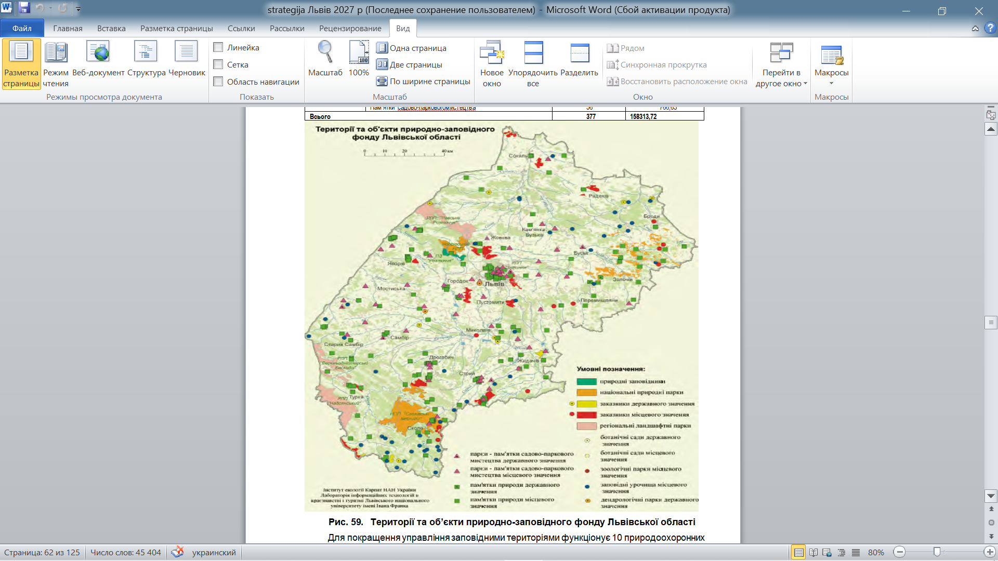
Fig. 2. Spatial distribution of land use in the nature reserve fund of Lviv region
*compiled based on [10].
The Roztochchia area has been recognized as a transboundary biosphere reserve, which is a global acknowledgment of its exceptional natural, landscape, and cultural significance.
- The Roztochchia Nature Reserve boasts a unique land plot of ancient beech forests that spans an area of 384.81 hectares. On July 7, 2017, during the 41st session of the UNESCO World Heritage Committee held in Krakow, Poland, this area was added to the Ukrainian-Slovak-German World Heritage Site "Primeval Beech Forests of the Carpathians and Ancient Beech Forests of Germany." The site has now been renamed to "Ancient Beech Forests of the Carpathians and Other Regions of Europe" and includes twelve countries: Albania, Austria, Belgium, Bulgaria, Croatia, Spain, Italy, Romania, and Slovenia, in addition to the original three (Ukraine, Slovakia, and Germany).
Lviv region is known for its natural recreational resources, which make up around 5.4% of Ukraine's natural resource potential. It is one of the leading regions in the country in this regard and is second only to Transcarpathia among the Carpathian regions.
The region boasts several valuable nature reserves, including the Roztochchia Nature Reserve, which has been recognized by UNESCO as part of the World Network of Biosphere Reserves. The national natural parks in the region, such as Skole Beskids, Yavorivskyi, Northern Podillia, Boikivshchyna, and the Royal Beskydy, are also worth visiting.
The Skole Beskids National Nature Park is a preserved area of the Eastern Carpathians, located in the southern part of Lviv region. It spans an area of ​​35,684 hectares and covers the basins of the Stryi and Opir rivers. The highest peak in the park is Mount Parashka, which stands at 1268 meters. Visitors can explore the State Historical and Cultural Reserve "Tustan," the Hukralo Waterfall on the Velyka Richka, and the Skhidnytske mineral water deposit within the park.
The Carpathian Mountains in Lviv region offer breathtaking landscapes throughout the year, with majestic mountain ridges, steep streams, and excellent skiing conditions. The peaks of Pikui, Parashka, Makivka, Yamelnytsia, and Trukhaniv are especially popular among mountain enthusiasts.

The ecological network in Lviv region consists of key territories that are considered the core areas of the framework. These key territories should be connected by "corridors", which can be protected with buffer zones to ensure their safety (known as protective zones) (refer to Fig. 3 for details). Table 2 presents the total area of structural elements of the ecological network in Lviv region.
- Characteristics of the current and projected land use of the structural elements of the ecological network in Lviv region*
Land use category according to the functional use (structural element of the ecosystem) | Current area as of 2023, thousand ha | Projected area according to the scheme, thousand ha | +, - projected area to the current one
 | Current area as of 2023, thousand ha | Projected area according to the scheme, thousand ha | thousand ha | %
1. Key areas (natural cores) | 173.6 | 337.8 | 164.2 | 48.6
2. Connecting corridors (eco-corridors) | 0.1 | 407.0 | 406.9 | 100.0
3. Buffer areas | - | 10.0 | 10.0 | 100.0
4. Restoration areas | - | 17.1 | 17.1 | 100.0
Total | 173.7 | 658.6 | 484.9 | 73.6
*compiled by the author
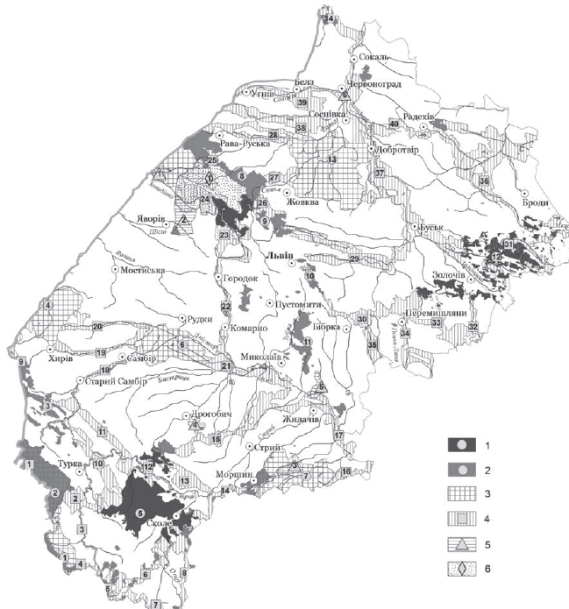
Legend: Key territories (natural cores): 1 - nature reserve, national parks; 2 - regional landscape parks, reserves, natural landmarks, wildlife sanctuaries; 3 - prospective areas of the nature reserve fund; 4 - connecting territories (eco-corridors); 5 - restoration territories; 6 - buffer territories.
Fig. 3. Working schematic map of the ecological network of Lviv region*
*formed based on [9]

The information presented in Table 2 reveals that as of 2023, only 26.4% of the land use of the ecological network's structural elements in the region has been developed, including the land use of key territories (natural cores) at 51.4%. The land use of the connecting territories (eco-corridors), buffer territories, and restoration territories is not developed at all.
Therefore, by integrating the formed elements of the ecological network into a unified system, it is possible to create a map of the key elements of the eco-recreational framework in Lviv region. Table 3 provides the characteristics of current and projected land use of recreational framework elements in Lviv region.
- Characteristics of current and projected land use of recreational framework elements in Lviv Region*
Land use category according to the functional use of the recreational framework elements | Current area as of 2021, thousand ha* | Projected area according to the Scheme, thousand ha | +, -  projected area to the current one
 | Current area as of 2021, thousand ha* | Projected area according to the Scheme, thousand ha | thousand ha | %
1. Key areas of the ecological network | 173.6 | 337.8 | 164.2 | 48.6
2. Sanitary recreational land use | 0.6 | 1.2 | 0.6 | 50.0
3. Recreational land use | 1.7 | 3.4 | 1.7 | 50.0
4. Historical and cultural land use | 1.2 | 1.3 | 0.1 | 7.7
5. Land use for recreational infrastructure | 4.7 | 5.4 | 0.7 | 13.0
6. Parks, gardens, and other urban land use | 2.1 | 2.3 | 0.2 | 8.7
7. Forestry land use | 13.3 | 18.0 | 4.7 | 26.1
Total | 197.2 | 369.4 | 172.2 | 46.6
*compiled based on [10].
According to the data presented in Table 3, the land use of recreational infrastructure elements in the region shows that the current land use as of 2023 only covers 53.4% of the projected area, with sanitary and recreational land use making up 50% of it.
By using data from the Scheme of Lviv Region Territory Planning of [11] and the urban zoning of territories based on the main types of land use in the region (as shown in Figure 4), an analysis of trends and forecasts of changes in the structure of the main types of land use in the region is presented in Table 4. Table 4 provides an analysis of the trends and forecasts of changes in the structure of the main types of land use in Lviv region.

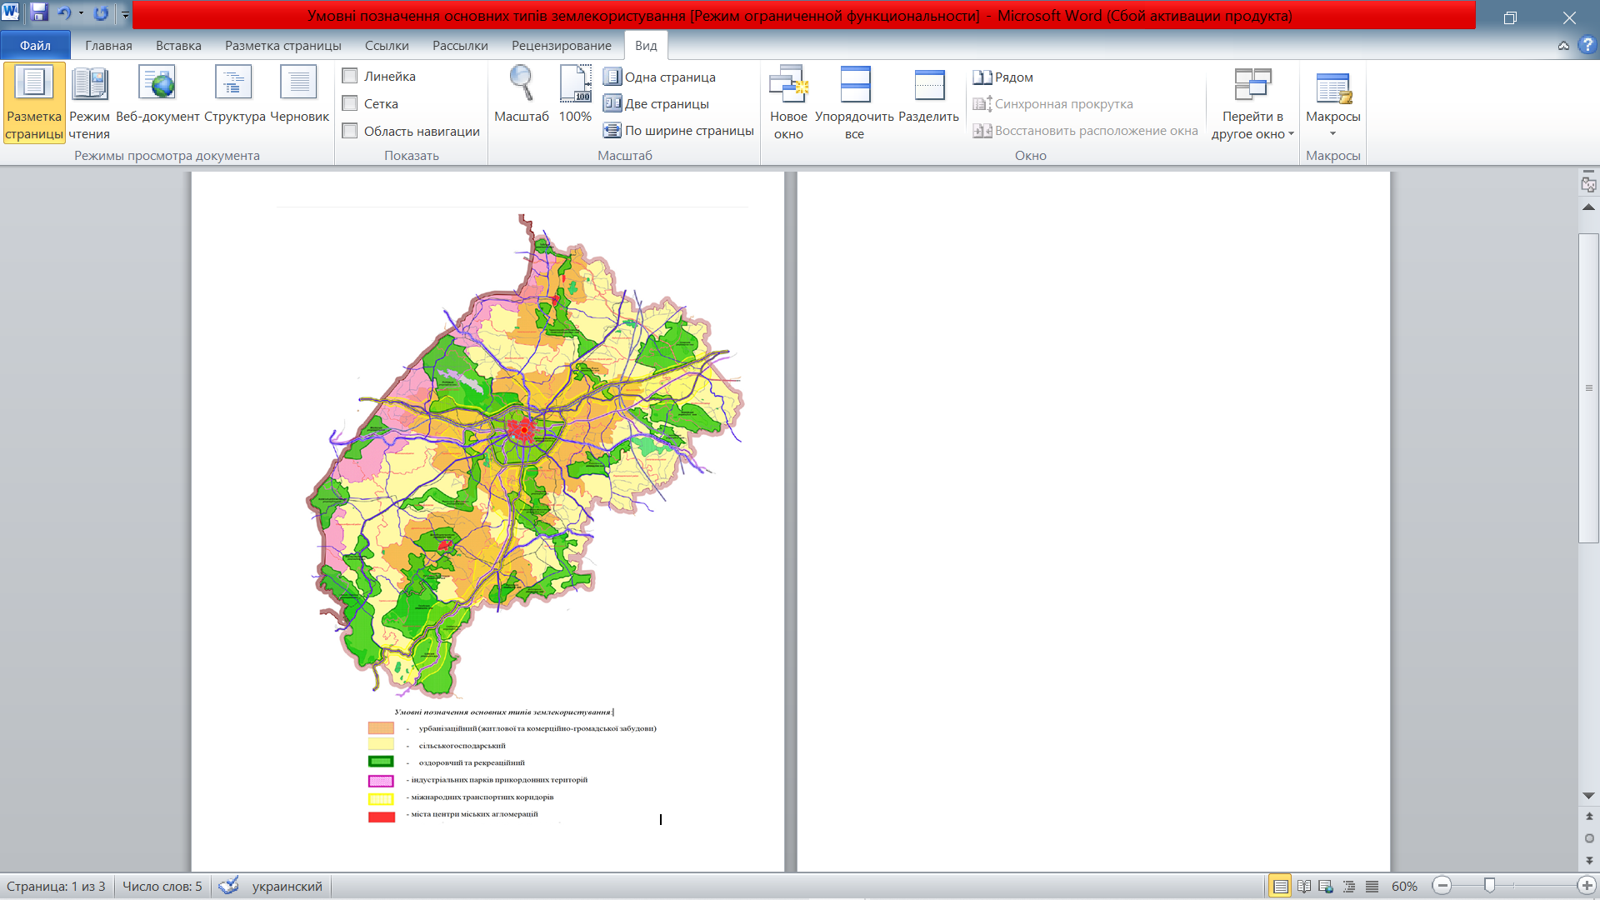
Fig. 4. Map-scheme of land zoning according to the main types of land use in Lviv region*
*developed by the author using data from [10].
- Trends and forecast of changes in the structure of the main types of land use in Lviv region till 2035*
Main types of land use | As of January 1, 2008 |  | As of January 1, 2020 |  | Forecast according to the Scheme of planning till 2031 |  | Author’s proposals till 2023
Main types of land use | thousand ha | % | thousand ha | % | thousand ha | % | thousand ha | %
Area of the region, total  including the main types of land use: | 2183.1 | 100.0 | 2183.1 | 100.0 | 2183.1 | 100.0 | 2183.1 | 100.0
agricultural | 1297.3 | 59.4 | 1290.2 | 59.1 | 1264.9 | 57.9 | 1282.0 | 58.7
forestry | 693.8 | 31.8 | 694.7 | 31.8 | 728.5 | 33.4 | 711.0 | 32.6
residential and public building | 20.2 | 0.9 | 22.7 | 1.0 | 26.3 | 1.2 | 29.0 | 1.3
transportation, communication, technical infrastructure | 45.8 | 2.1 | 35.1 | 1.6 | 37.4 | 1.7 | 40.4 | 1.9
other buildings | 43.2 | 2.0 | 57.5 | 2.6 | 51.8 | 2.4 | 75.0 | 3.4
water management | 42.7 | 2.0 | 42.8 | 2.0 | 44.7 | 2.0 | 45.0 | 2.1
nature management (swamps and other lands) | 40.1 | 1.8 | 39.8 | 1.8 | 29.5 | 1.3 | 29.5 | 1.4
Also:
recreation and healthcare | 1.9 | 0.1 | 9.1 | 0.4 | 6.4 | 0.3 | 12.3 | 0.6
nature reserve | 132.5 | 6.1 | 173.6 | 7.9 | 236.5 | 10.8 | 369.4 | 18.9
historical and cultural | 1.1 | 0.1 | 1.1 | 0.1 | 1.1 | 0.1 | 1.3 | 0.1
*compiled by the author
Urban zoning is used to identify various types of land use in Lviv region. These types include
- urban land use (a mix of residential and commercial-public buildings, agricultural, nature conservation, and recreational areas), with centers located in Lviv, Chervonohrad, Drohobych, and Stryi;
- agricultural land use;
- healthcare and recreational land use;
- industrial park land use in border areas;
- transportation land use, which includes international transport corridors.
According to Table 4, the land use by major types has not been significantly redistributed over the past 12 years. The agricultural land use decreased by only 0.3%, instead of the forecasted 1.5% in the Scheme. The area of residential and public land use increased by only 0.1%, while the Scheme anticipated a 0.4% increase. Other land use areas increased by 0.6%. The land use area for transportation, communications, and technical infrastructure decreased by 0.5%.
There have been some negative changes in the use of land in nature reserves. The protected land area has only increased by 1.8% instead of the expected almost double from 6.1% to 10.8%. This is because forest and recreational areas were not increased as planned, and measures for ecological and green tourism on agricultural lands were not implemented. Although there was an expected growth of 1.6%, the areas of forests and other forest-covered areas have remained unchanged, despite the Planning Scheme projecting an increase.
The author has developed proposals for land use development based on an analysis of the current state of the main types of land use compared to the Scheme of Lviv Region Territory Planning. However, the data verification of state statistical reporting on quantitative land registration, which was supposed to have been completed by July 1, 2016, is still ongoing. As of January 1, 2023, the StateGeoCadastre has been unable to provide statistical reports on quantitative land registration, making it impossible to analyze the development of land use in Ukraine by its main types. This study used data from the Regional Report "On the State of the Environment in Lviv Region in 2020." [11].
To address the socio-economic development challenges of Lviv region, it is necessary to tackle several major systemic problems that stem primarily from insufficient infrastructure, including recreational and tourist infrastructure. The latter is aimed not only at boosting the attractiveness of the region for tourists and recreational purposes but also carries protective functions. In this regard, a structure of land use development has been projected by main types across the region's districts (refer to Table 5).
It is important to note that the expected changes in land use structure by main types across the districts of the region can be achieved through integrated planning of the land use of territorial communities.
Additionally, it is imperative to establish and maintain a register of recreational land use. This register should include information on natural-recreational and cultural-historical objects. The issue of incorporating new objects, i.e. recreational land use (as multifunctional land use according to relevant recreational subtypes of land use), into the state land cadastre (in terms of registering boundaries of land plots) also needs to be addressed.
The creation of designated territories can help in implementing state and social measures to support clusters and cluster initiatives. These initiatives contribute to enhancing the competitiveness of territorial communities and businesses, developing nature conservation and recreational activities, preserving cultural heritage sites, and fostering innovation adoption. Furthermore, this can help reduce risks for potential investors.
By identifying similar clusters, the sustainable development of territorial communities can be ensured. Investors will receive reliable information about the actual location of plots with specific boundaries, which will help avoid problematic situations.
- Expected structure of land use development by the categories in terms of districts of Lviv region*
Main types of land use | Lviv region, total, thousand ha | including by districts
Main types of land use | Lviv region, total, thousand ha | Drohobych | Zolochiv | Lviv | Sambir | Stryi | Chervonohrad | Yavoriv
Area of the region, total  including according to the main types of land use: | 2183.1 | 145.4 | 288.7 | 497.8 | 324.7 | 389.1 | 299.7 | 237.7
Agricultural | 1282.0 | 72.4 | 186.7 | 345.0 | 177.0 | 187.6 | 198.7 | 130.4
forestry | 711.0 | 62.1 | 84.5 | 106.3 | 129.0 | 169.7 | 79.3 | 81.2
residential and public buildings | 29.0 | 2.9 | 3.3 | 8.2 | 4.2 | 3.9 | 3.6 | 2.8
transportation, communication, technical infrastructure | 40.,4 | 2.7 | 4.5 | 9.9 | 5.2 | 8.7 | 5.4 | 4.0
other buildings | 75.0 | 57.9 | 7.6 | 20.4 | 7.6 | 11.7 | 9.9 | 9.8
water management | 45.0 | 2.6 | 4.8 | 10.7 | 5.6 | 9.0 | 7.3 | 4.9
nature management | 29.5 | 19.5 | 3.4 | 4.0 | 3.4 | 6.5 | 2.4 | 10.1
Also:
recreation and healthcare | 12.3 | 3.7 | 0.7 | 2.6 | 2.0 | 2.9 | 0.5 | 1.0
nature reserve | 369.4 | 50.3 | 22.4 | 41.9 | 38.6 | 79.5 | 15.0 | 21.8
historical and cultural | 1.3 | 0.1 | 0.1 | 0.6 | - | 0.4 | 0.1 | -
*compiled by the author
CONCLUSIONS AND PROPOSALS
Based on the urban planning zoning of the territory, Lviv region has identified the following main types of land use: 1) urbanization type of land use (a mixed land use of residential, commercial and public buildings, agricultural, environmental and recreational activities) with centers in Lviv, Chervonohrad, Drohobych and Stryi; 2) agricultural type of land use; 3) healthcare and recreational type of land use; 4) land use of industrial parks in border areas; 5) land use of transportation, including international transport corridors. These types can be further detailed based on land management zoning of land by types (subtypes) of land use in the context of territorial communities.
It was found that over the past 12 years, land use by major types has not significantly changed. The type of agricultural land use decreased by only 0.3%, instead of the forecasted 1.5%. The area of residential and public land use increased by only 0.1%, while the planned increase was 0.4%, and other land use increased by 0.6%. The area of land use for transportation, communications, and technical infrastructure decreased by 0.5%. Negative changes were observed in the transformation of nature reserve land use, which increased by 1.8%, while it was expected to almost double from 6.1% to 10.8%. The author has proposed a forecast structure of land use development by its main types in the context of the newly created districts of the region. According to this proposal, the development of recreational land use until 2035 has been determined.

References:
1. Tretiak, A. M. (2015). Formuvannya ekomerezhi Ukrayiny yak ekolohichnoho karkasu pryrodookhoronnoho zemlekorystuvannya v konteksti staloho rozvytku [Formation of ecological networks in Ukraine as an ecological framework of the environmental land use in the context of sustainable development]. Ecological safety and balanced nature-use in agro-industrial production. Proceedings of International Scientific and Practical Conferences, 185–190.
2. Kahalo, O. O. (2008). Pryntsypy rozbudovy ekomerezhi ta vyboru yiyi terytorialʹnykh elementiv: ukrayinsʹka praktyka ta yevropeysʹkyy dosvid [Principles of eco-network development and choice of its territorial elements: Ukrainian practice and European experience]. Development of reservation business in Ukraine and formation of pan European ecological network: proceedings of International Scientific and Practical. Rakhiv: Ukraina. CJSC “Nadvirnianska drukarnia”, 195–200.
3. Tretiak, A. M., Tretiak, V. M., Priadka, T. M., Tretiak, N. A. (2022). Terytorialʹno-prostorove planuvannya zemlekorystuvannya [Territorial and spatial planning of land use]. Bila Tserkva : “Bilotserkivdruk” LLC, 168.
4. Tretiak, A. M., Tretiak, V. M., Hunko, L. A., Hetmanchyk, I. P. (2019). Orhanizatsiya zemlekorystuvannya dilyanok pryrodno-zapovidnoho fondu [Organization of land use of the plots of natural reserve fund]. – Monograph. Kyiv, Ukraina. PC “Komprynt”. 186.
5. Tretiak, A. M., Tretiak, V. M., Priadka, T. M., Hunko, L. A., Kapinos, N. O. (2022). Filosofiya zonuvannya zemelʹ v Ukrayini v konteksti terytorialʹno-prostorovoho planuvannya zemlekorystuvannya terytorialʹnykh hromad [Philosophy of land zoning in Ukraine in the context of territorial and spatial planning of the land use of territorial communities]. Economics and State. 4, 13–19.
6. Dorosh, Y. M., Dorosh, O. S. (2016). Teoretyko-metodolohichni zasady formuvannya obmezhenʹ u vykorystanni zemelʹ ta obtyazhenʹ prav na zemelʹni dilyanky [Theoretical and methodological fundamentals of setting limitations of land use and encumbrances on land rights]. Kherson, Hrin D.S., 652.
7. Regional report “On environmental conditions in Lviv region in 2015 and 2020”. (2021). Department of Ecology and Natural Resources of Lviv State Administration. Lviv. 212.
8. Report on the creation (transfer) of the scientific and technical documentation of analytical reporting on the results of city-planning monitoring of the scheme of Lviv region area planning (final). SE “Ukrainian State Scientific and Research Institute of City Planning “DIPROMISTO” named after Yu.M. Bilokin”. Kyiv, Ukraina: 2023. 168.
9. Law of Ukraine “On Ecological Network of Ukraine” Available at: https://zakon.rada.gov.ua/laws/show/1864-15#Text
10. Regional report on environmental conditions in Lviv region in 2021. Available at: https://drive.google.com/file/d/1QOlYQ-S07NZVOVr-b9IwrgOOZpmEzDva/view
11. Strategy of Lviv region development for 2021-2027. Available at: https://loda.gov.ua/documents/49999.
О.С. Занчук
ОСОБЛИВОСТІ ПЛАНУВАННЯ ЕКОЛОГО-РЕКРЕАЦІЙНОГО КАРКАСУ СИСТЕМИ ЗЕМЛЕКОРИСТУВАННЯ ЛЬВІВСЬКОЇ ОБЛАСТІ

З’ясовано, що екологічний каркас системи землекористування є сукупністю складових частин ядер, що мають різний рівень і розташовуються за принципом «від загального до часткового», і компонентів, об'єднаних екологічними коридорами екологічної мережі. Для Львівської області екологічний каркас системи землекористування є базовою основою для еколого-рекреаційного каркасу. Адже, активна антропогенна діяльність і все більший вплив рекреаційного виду діяльності (який охоплює всі види відпочинку, у тому числі туристичної та іншої діяльності) призвели до того, що формується необхідність створення каркасу із залученням територій, де території забудовуються обслуговуючою інфраструктурою. У зв'язку з цим одним із напрямів може стати формування моделі системи землекористування, що поєднує функції природоохоронної та рекреаційної систем, і в цьому випадку більш вірно говорити про інтегрування екологічного та еколого-рекреаційного каркасів системи землекористування.
Визначено, що під еколого-рекреаційним каркасом треба розуміти територію з підпорядкованими одиницями природних та рекреаційних ресурсів, які об'єднані екологічними зв'язками з метою захисту та охорони територій, а також забезпечення раціонального рекреаційного землекористування. Одна з ключових відмінностей еколого-рекреаційного каркасу — це, перш за все, об'єднання не лише природних територій, а й територій залучення туристів із наявною інфраструктурою, тобто включення до цієї системи, наприклад, еколого-рекреаційних кластерів, у тому числі для розвитку економіки та залучення інвестицій у регіон, підвищення ефективності використання існуючих рекреаційних зон, та створення і просування нових для регіону видів рекреації.
Здійснено аналіз землекористування структурних елементів екологічної мережі Львівської області станом на 2023 р., який показує, що в регіоні сформовано тільки на 26,4%, в тому числі землекористування ключових територій (природні ядра) на 51,4%, землекористування сполучних територій (екокоридори), буферних територій та відновних територій зовсім не сформоване. Використовуючи, дані екологічного каркасу системи землекористування нами сформовано землекористування елементів рекреаційного каркасу області, і встановлено, що його існуюче землекористування станом на 2023 р. займає від проектного тільки 53,4%, в тому числі оздоровчого і рекреаційного 50%.
Використовуючи містобудівне зонування території нами визначено такі основні типами землекористування Львівської області: 1) урбанізаційний тип землекористування (змішане землекористування житлової та комерційно-громадської забудови, сільськогосподарське, природоохоронне та рекреаційне) з центрами в м. Львів, Червоноград, Дрогобич та м. Стрий; 2) сільськогосподарський тип землекористування; 3) оздоровчий та рекреаційний тип землекористування; 4) землекористування індустріальних парків прикордонних територій; 5) землекористування транспорту (в т.ч. міжнародних транспортних коридорів).
Встановлено, що за 12-річний період землекористування за основними типами суттєво не перерозподілилося. Тип сільськогосподарського землекористування зменшився всього на 0,3%, замість намічених по Схемі - 1,5%. Площа землекористування житлової та громадської забудовані зросла лише на 0,1%, а передбачалось схемою на 0,4% та іншої забудови зросла на 0,6%. Площа землекористування транспopтy, зв’язку, технічної інфраструктури зменшилась на 0,5%. Спостерігаються негативні зміни у трансформації природно-заповідного землекористування, яке зросла на 1,8%, а передбачалось зростання майже в два рази з 6,1 до 10,8%. Розроблено прогнозну структура розвитку землекористування за основними його типами в розрізі районів області, згідно якої визначено розвиток рекреаційно-оздоровчого землекористування до 2035 р.
Ключові слова. Еколого-рекреаційний каркас системи землекористування, екологічна мережа, зонування земель за типами землекористування.

