UDC 332.3
On the prospects of land consolidation in Ukraine
Koshel A., Doctor of Economics
National University of Life and Environmental Sciences of Ukraine
e-mail:koshelao@gmail.com
Kolhanova I., PhD in Economics
National University of Life and Environmental Sciences of Ukraine
e-mail: kolganova_i@ nubip.edu.ua
Kempa O., Dr inż. (PhD)
Wroclaw University of Environmental and Life Sciences
e-mail:olgierd.kempa@upwr.edu.pl

Abstracts. The article deals with the topical issue of land consolidation in Ukraine as a tool for improving the efficiency of land use and ensuring sustainable development of rural areas. The author analyses the current state of land resources, problems of their fragmentation and irrational use that have arisen as a result of land relations reform.
Particular attention is paid to the regulatory and legal aspects of land consolidation, identification of the main obstacles to its implementation and development prospects in the context of decentralisation. The main stages and procedures of consolidation, its impact on the economic, environmental and social aspects of the functioning of territories are highlighted.
The article offers recommendations for improving the organisational and legal support of the consolidation process, introducing modern land management tools and involving communities in planning and implementing land consolidation measures.
The results of the study can be used to prepare land management projects, as well as in shaping state policy in the field of land management.
Keywords: land consolidation, land resources, land management, efficient land use, protection of agricultural land, land management.
Actuality. The current state of development of the Ukrainian economy requires the adoption of new management decisions in the field of land use and protection. A significant role in this process belongs to the formation of an effective ecological and economic balanced model of land use, which can be formed on the basis of a targeted policy of agricultural land consolidation. Consolidation is an effective way to overcome excessive parcelisation of land masses and irrational use of agricultural land due to non-compliance with crop rotations and the lack of a critical set of other agrotechnical measures.
Land consolidation is a set of legal, socio-economic and environmental measures aimed at optimising the size and spatial location of land plots, creating favourable conditions for business entities, which is carried out with the aim of organising the rational and efficient use of agricultural land in the interests of the owner or land user and society as a whole [3].
The objectives of land consolidation are: land massing (combining land plots owned by the same owner into one array); elimination of deficiencies in land ownership and land use (striping, wedging, interspersing, etc.); and consolidation of land plots by merging nearby land.
An important task of the current stage of land reform is to unite small land uses, which is achieved through land consolidation. Consolidation of agricultural land allows to ensure the optimal size of land holdings and land uses, which will ensure rational planning, optimisation of the structure and organisation of land uses [3].
Land consolidation is carried out in many countries on a large scale. These are the countries of Northern Europe, namely: Sweden, Finland, Norway, northern Poland, Romania, Bulgaria, etc. The work is carried out on the basis of special land management projects for land consolidation. They are developed by public or private companies that have the appropriate licences for land management.
The current EU 2030 strategy, in particular on rural development in Europe, is linked to the UN Sustainable Development Goals [2]. The European Commission submits an annual evaluation report on this topic (European Commission, 2019). For the 2021-2027 assistance period, the Common Agricultural Policy (CAP) has nine objectives. The concepts used to describe the objectives, which have the same meaning in both the West and the East, are land consolidation and rural development. In the international context, the term "land consolidation" represents all types of reorganisation of land ownership or only land ownership itself (as, for example, in the People's Republic of China). This concept is always closely related to land use planning and is not limited to rural areas.
The diversity of meanings of the concept of "land consolidation" is also reflected in the legal and institutional framework for consolidation measures. There are countries where land management, being a state task, is regulated by a law that covers the entire territory of the state, meets the criteria of the rule of law and provides for broad participation of citizens in the consolidation process. However, there is also land consolidation that is considered a community or even collective affair, and is carried out on the basis of self-governance principles, partly on the basis of decisions of the community council, which are not subject to the right to object and judicial review.
Analysis of the latest scientific research and publications. In recent years, scientists D.S. Dobriak, Y.M. Dorosh, T.O. Yevsiukov, V.M. Kilochok, O.V. Krasnolutskyi, P.F. Kulinich, A.G. Martin, A.Y. Sokhnych, M. G. Stupenya, L. V. Tkachuk, A. M. Tretiak, A. M. Shvorak, S. Burton, R. Bullard, D. Demetriou, T. van Dijk, M. Hartvigsen, E. Jacoby, J. Sonnenberg, J. Thomas, A. Vitikainen, etc. conducted a study of the theoretical and legal foundations, ways and methods of agricultural land consolidation, development of land relations in the context of land consolidation in Ukraine.
The purpose of the research is to investigate the status and problems of the development of the process of land consolidation on the basis of legal relations, as well as the formation of homogeneous land masses based on the suitability of soils for various crops.
Materials and methods of scientific research. The study used the following generally accepted methods of scientific research: theoretical method, monographic method, comparative method and method of generalisation.
The results. Today, Ukrainian society expects a positive resolution of the complex economic and social problems that have developed in Ukrainian agriculture. Despite the implementation of a number of important organisational, economic and legal measures related to the transition to private land ownership, the transfer of land to the ownership of peasants, the formation of market-type economic structures and the achievement of certain positive developments on this basis, agriculture has long been in a critical state.
As history shows, land relations have been and are constantly undergoing structural changes. In the early 1990s, most domestic scholars were of the opinion that the system of land relations, which operates only on the basis of state ownership of land, to some extent hinders the formation of conditions for more efficient use of land, labour and material resources. Later, these assumptions were included in the system of preconditions for the feasibility of land reform in our country as an integral part of agrarian reform. In Ukraine, when it was part of the former USSR, land was nationalised and the state was its sole owner. According to the USSR's legal system, land, its subsoil, waters and forests were exclusively owned by the state (Article 11 of the Constitution of the Ukrainian SSR of 20 April 1978). Agrarian reform, including land reform, was also prompted by the fact that in the pre-reform period, progressive processes and phenomena had developed in agriculture, but ended in failure, even in economically strong agricultural enterprises.
Given the absence of private land ownership and an impartial view of the feasibility or otherwise of land reform in the pre-Soviet period, it can be concluded that sooner or later it had to happen. The urgent need for new approaches to organising the rational use of land, its protection and restructuring of land relations with a market orientation was manifested in the adoption of the Resolution of the Verkhovna Rada of the Ukrainian SSR "On Land Reform" in 1990, which was subsequently supplemented by other regulations. In particular, the latter proclaimed that from 15 March 1991 all land in Ukraine was subject to land reform. The land reform of 1990 was different from all previous reforms. It was an integral element of the agrarian reform, in the context of which the relations of ownership of material and technical means of production, as well as other components of the functioning of the agrarian sector of the Ukrainian economy were subject to reform [6].
At the first stage of the land reform, there was a transition from administrative-planned to market relations in the agricultural sector, characterised by legislative recognition of state, collective and private ownership of land, creation of a legal framework and conditions for reforming economic relations in rural areas through demonopolisation of state property, privatisation of state property and land, formation of real owners in rural areas, development of free enterprise, and creation of appropriate conditions for profitable farming.
The second stage of the land reform resulted in the following changes in land relations: the "conditional" division of collectively owned land into land shares (units) took place. The owners of the latter received a certificate of ownership of the land share (unit); peasants-owners of land shares (units) received the right to dispose of the latter in accordance with the current legislation; owners of land shares (units) were granted the right to freely withdraw from the collective agricultural enterprise with their own land share (unit) with its subsequent allocation in kind (on the ground) and issuance of a state act on the right of private land ownership.
At the same time, provisions were made for the disposal of the received land plot in accordance with its intended purpose.
The second stage of land relations reform saw the formation of a share land fund, which was distributed among members of collective agricultural enterprises and organisations, including pensioners from among them, into land shares (units) in their conditional (cadastral) hectares, with their value indicated, and with the possibility of further allocation of land in kind (on the ground), with the issuance of a relevant document - a certificate, and later a state act on the right to a land share (unit).
As a result, almost 6 million Ukrainian citizens who were members of about 11,000 CAHs received certificates for the right to a land share, which were later replaced by state acts of private land ownership. Measures were also envisaged to accelerate the transfer of land into collective ownership to collective agricultural cooperatives and business joint stock companies, which in turn are to be distributed among members of collectives and pensioners from among them into land shares (units) without allocation in kind.
Following the implementation of the above measures, the third stage of land relations reform began, which included: the creation of new market-oriented agricultural enterprises on the basis of collective and non-state agricultural enterprises; the formation of preconditions for the creation and further effective development of the agricultural land market and its infrastructure; and the organisation of proper state control over the formation and functioning of the agricultural land market, their environmental condition and rational use.
As a result of the implementation of the Presidential Decree "On Urgent Measures to Accelerate Reform of the Agricultural Sector of the Economy" of 3 December 1999, cooperatives, associations, unions, peasant unions, private and private-rental enterprises, and 34 peasant (farm) enterprises were formed on the basis of collective and other non-state agricultural enterprises, including those created on the basis of state farms.
The peculiarity of the current land reform is that it is an element of economic reform in Ukraine. Land reform includes the transformation of not only land relations, but also production relations. This reform is aimed at eliminating the state monopoly of land ownership and restoring land relations in rural areas.
The lease mechanism of agricultural land use is an important component of a market economy and is recognised by international practice. That is why it holds a dominant position in the development of land relations. It is a fairly flexible production system that creates favourable conditions for the formation of optimal land use sizes in agricultural enterprises.
At this stage of land transformations in rural areas, the development of land lease relations is of utmost importance. From an economic point of view, the concept of land lease is considered to be a form of management based on contractual relations, which has a thousand-year history and occupies an important place in market conditions. It is a complex system of production that makes it possible to increase the scale of land use and carry out economic activities on the basis of production intensification. One of the tasks of the land reform was to introduce a rational combination of various forms of land management by creating market-type entities based on private land ownership.
Thus, over the past 20 years, various forms of management have been tested in practice, as evidenced by the transformational processes of the structure of the land fund of Ukraine.
Thus, in the course of the agrarian reform, private land ownership was introduced, land was denationalised and transferred to the ownership of collective agricultural enterprises and individuals, and the land of collective agricultural enterprises was divided into shares. Instead of the dominant collective and state farm system of management, other forms of management have been created and are being developed on an equal basis [8].
The concept of "land consolidation" in the international context represents all types of reorganisation of land ownership or only land ownership itself (as, for example, in the People's Republic of China). This concept is always closely related to land use planning and is not limited to rural areas [2].
Land consolidation is synonymous with the following concepts:
- voluntary or state-initiated exchange of privately or publicly owned land plots;
- standard land consolidation (in the German sense) with reorganisation or restructuring of rural infrastructure and mandatory participation of landowners in the consolidation procedure;
- integrated land consolidation that takes into account the requirements of state spatial development planning;
- in (former) socialist countries, where property rights were usually transferred to collective use unlimited in time and content, this term has been and is used to refer to the reorganisation of use rights in the context of land reclamation or infrastructure development over large areas.
The diversity of meanings of the concept of "land consolidation" is also reflected in the legal and institutional framework for consolidation measures. There are countries where land management, being a state task, is regulated by law, covering the entire territory of the state, meets the criteria of the rule of law and provides for broad participation of citizens in the consolidation process. But there is also land consolidation that is considered a community or even collective affair, and is carried out on the basis of self-governance principles, partly on the basis of decisions of the community council, which are not subject to the right of objection and judicial review (Thomas, 2011b). The horizontal and vertical coordination of consolidation measures within sectoral and spatial development plans is atypical for European countries. An attempt to categorise the large number of rural development topics in Europe allows us to identify three characteristic differences [2, 4]:
- The first category includes Western European countries that have a formulated rural development strategy, high-quality legislation regulating rural development instruments, and well-established state institutions for their use. These countries have successfully used national and international financial support for rural development and implemented land management tools to address multiple land use needs. Specialised agencies of the Federal Republic of Germany have at their disposal the directive "Main directions of rural development" - the most significant and broad strategic document for the implementation of rural development tasks. However, in other European countries, this task is successfully fulfilled without such a document;
- The second category includes former socialist countries of Central and Eastern Europe that managed to preserve their land consolidation legislation (from socialist or even pre-socialist times) during the transformation processes of the 1990s and are now adapting this legislation and its application to modern standards of the rule of law, participatory governance and good governance. These countries are trying to use the traditional instrument of land consolidation in combination with (sectoral) development of agricultural structures as a tool for integrated rural development;
- The third category covers former socialist countries that (no longer) have practical specialised legislation on land consolidation (e.g. Baltic States, Hungary, Bulgaria, Romania, Moldova). Based on the results of the land reforms that were carried out after the collapse of the socialist system, these countries are trying to create awareness of the need for land consolidation as a measure against the significant fragmentation of land ownership that resulted from land reforms.
As a result of "voluntary land consolidation measures" (without a legal basis and involving notaries), which are being carried out within the framework of pilot projects (on the recommendation of FAO with the support of Scandinavian and Dutch experts), attempts are being made to convince agricultural enterprises of the feasibility of land consolidation. The pilot projects were met with disappointment by most of the landowners involved, as the results fell far short of their expectations. After the completion of these projects, no practical and effective land consolidation legislation has been created in any country. The active work of national experts is often lost in "strategies or programmes for land consolidation" [2].
Rural development in these countries is currently provided mainly through financial support for agricultural investment through LEADER projects, as well as through the promotion of environmental measures in the agricultural sector, as they are a desirable tool to complement direct subsidies to agricultural enterprises [2].
The object of this study was the land use of Agro-S LLC, located within the Brovary district of Kyiv region (Fig. 1).
The land use of Agro-S LLC is represented by forty-two leased land plots (Fig. 1) owned by citizens on the right of private land ownership, provided to them for commercial agricultural production, of regular geometric shape, with a total area of 22.1252 ha, of which: 22.1252 ha - arable land, the average area of one land plot is ~ 0.5 ha.

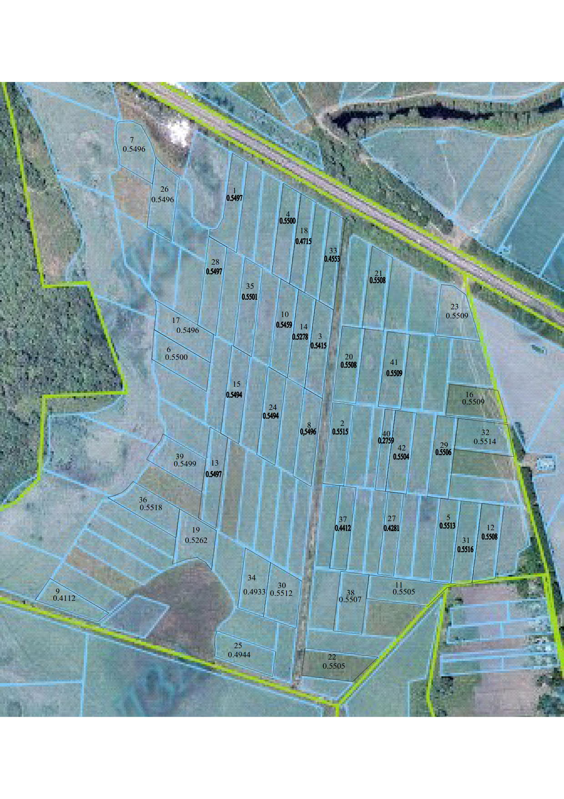
Figure 1. Location of land plots of Agro-S LLC
within the lands of Brovary district of Kyiv region

The soil cover of the land used by Agro-S LLC is represented by the following agricultural soil groups: podzolised and slightly regraded chernozems and dark grey highly regraded light loamy soils (agro-group code 41g); typical chernozems and highly regraded light loamy chernozems (agro-group code 55g); meadow-marsh undrained soils (agro-group code 141); soddy gley carbonate light loamy soils (agro-group code 181g). There is a neighbouring land use tenant in the study area - JV LLC "Niva Pereyaslavshchyny". "Niva Pereyaslavshchyny is a Ukrainian-British joint venture engaged in grain growing, feed production, pig farming and meat processing. "Niva Pereyaslavshchyny is one of the largest pork producers in Ukraine. Its land bank is 23 thousand hectares.
Legal consolidation of land. Legal consolidation of land is the organisation and streamlining of land relations aimed at consolidating land plots and optimising their use in accordance with the needs of owners, tenants and territorial communities. It is a complex multi-stage process that covers legal, economic and technical aspects of land management.
The main goal of legal consolidation of land is to eliminate the fragmentation of land plots, ensure rational land use and legal order in the field of land relations. It involves: establishing the legal status of land; reconfiguring plots: merging several small plots into one larger one or redistributing land to optimise their boundaries; settling land disputes: resolving conflicts between owners, tenants or other legal entities; amending the land cadastre: updating information on new boundaries, areas and legal status of land plots.
The most common and easiest way to consolidate land is the voluntary exchange of land plots in order to create a spatial organisation of the land use territory (compactness) that will meet the needs of land users and promote more efficient use of land resources. When exchanging unequal plots (in terms of area, quality of land), one of the parties pays the difference between their value to the other party in accordance with the exchange agreement concluded by them [7].
An example of land exchange in the study area is shown in Figure 2.
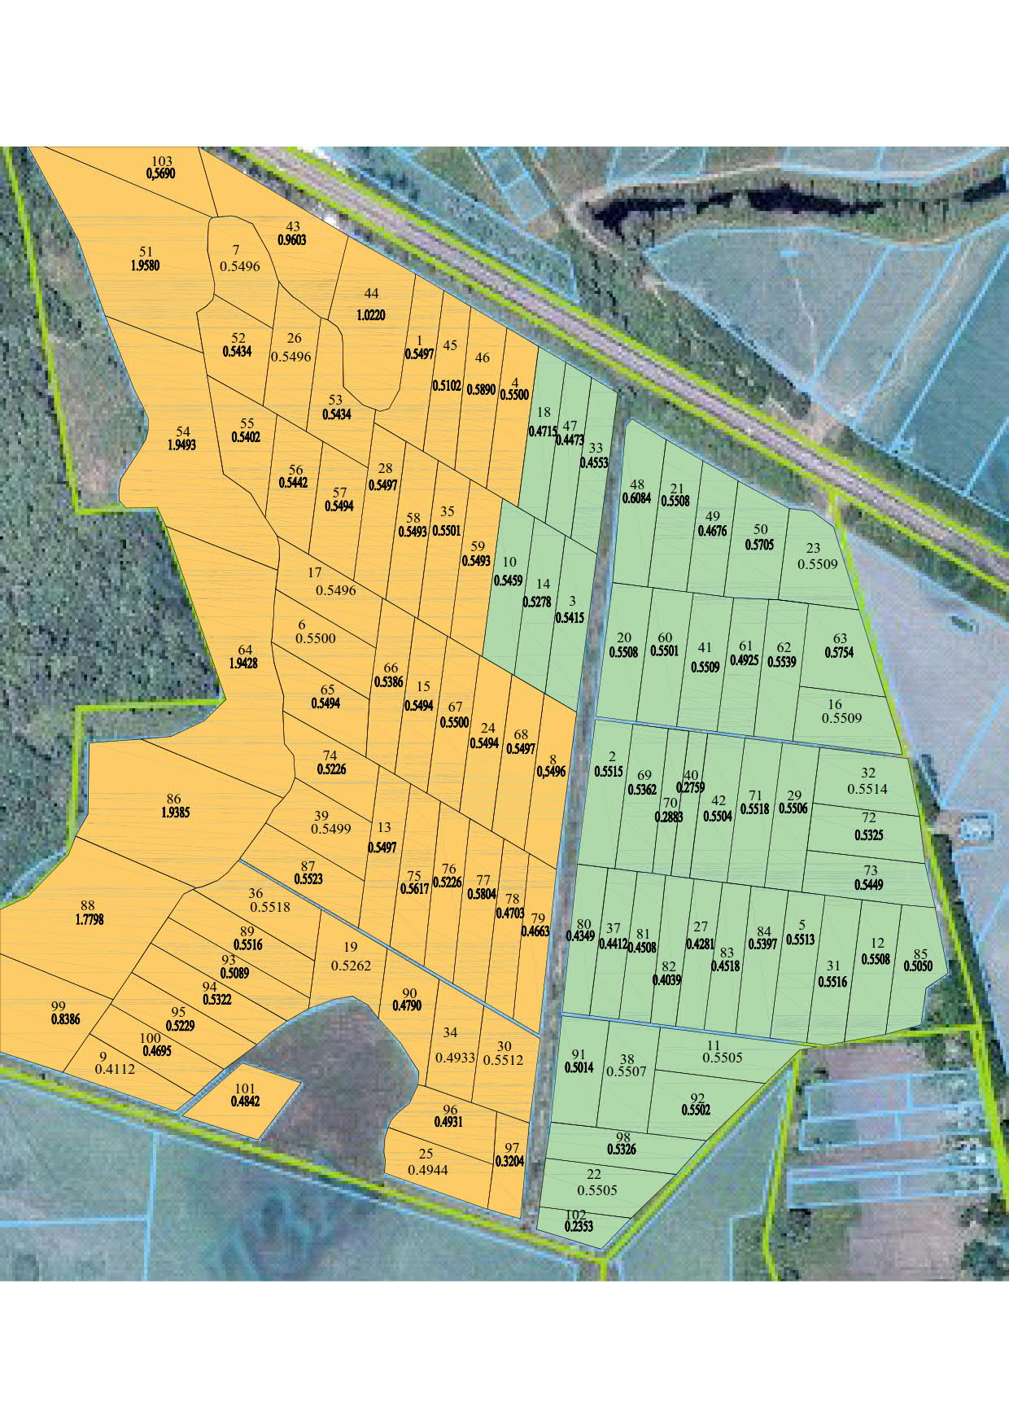
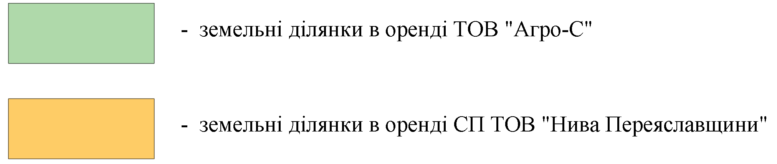
Fig. 2. Projected state of land use of Agro-S LLC after land consolidation measures

Technological consolidation of land. In order to form farming systems in accordance with agro-ecological factors, there is a corresponding grouping of them in the structural and functional hierarchy of the landscape, i.e. agro-ecological classification of land.

Land plots of the same soil suitability subclass are combined and thus form five homogeneous land masses of the corresponding soil suitability subclass. In total, there are five subclasses (Fig. 3, Table 1) of homogeneous land masses according to soil suitability for growing crops - the most suitable, medium suitable, limited suitable, low suitable, and unsuitable [1].
Subclasses of arable land suitability for crops
ІІІ
subclass (limitedly suitable land)
V
subclass (the worst land)
ІV
subclass (soils of low suitability)
І
subclass (the most suitable land)
ІІ
subclass (average suitability)
Fig. 3. Scheme of soil suitability subclasses *
* Developed on the basis of "Classification of agricultural land as a scientific prerequisite for its environmentally sound use" by I.Rozumnyi, O.Kanash, 2009.

Subsequently, fields and crop rotations are formed within homogeneous land masses.
1. Suitability of arable land for growing crops

№ | Code  agricultural  soil groups | Square ,  ha | Scale of suitability
№ | Code  agricultural  soil groups | Square ,  ha | Winter  wheat | Winter wheat | Corn | Sleepyhead
1 | 41г | 22,49 | І class | І class | ІІ class | ІІІ class
2 | 55г | 26,28 | ІІ class | ІІ class | ІІ class | ІІ class
3 | 181г | 10,46 | ІV class | V class | ІV class | ІV class
4 | 141 | 2,32 | ІV class | ІV class | ІV class | ІV class
Total |  | 61,55
According to Table 1, agro-soil groups 181 and 141 are lands of the fifth and fourth subclasses, which are classified as soils of low suitability and the worst lands.
In order to provide a scientific basis for the implementation of land consolidation, scientists have proposed the concept of a "homogeneous land mass". It is understood as a set of adjacent land uses within an elementary water intake basin, the soil cover of which is characterised by the same (or similar) subclass of agro-ecological soil suitability for growing crops [7,8].
The formation of homogeneous arrays is based on a comprehensive study of materials on natural and agricultural zoning, soil cover, climate, relief, agrobiological requirements of crops, as well as a set of technical measures that ensure the implementation of technological operations in agriculture.
Homogeneous land masses are proposed to be formed in accordance with the suitability of soils for growing major crops, taking into account the specific features of natural and environmental conditions of the environment in five subclasses of suitability.
To take into account these indicators, a map of agricultural soil groups of land uses and the relief of the territory (maps of steepness and length of slopes) is used, which shows the contours of the main agricultural soil groups and describes the conditions of their occurrence [1].
In this study, Fig. 4.-8. identifies homogeneous land masses according to soil suitability for growing major crops such as winter wheat, winter rye, corn, sunflower, where classes I and II are the most suitable, and classes IV and V are not suitable for growing.
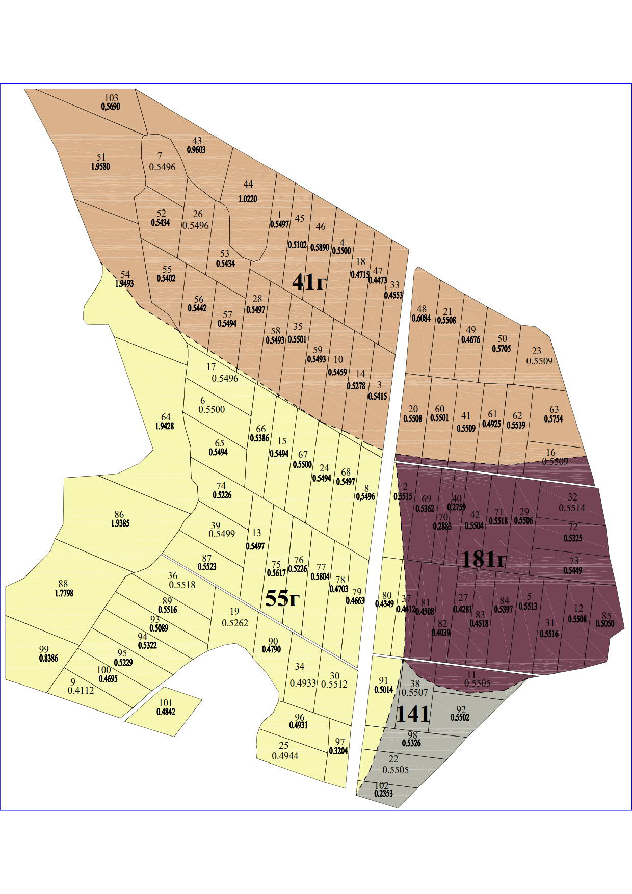
Fig. 4. Condition of agricultural soil groups in Brovary district of Kyiv region

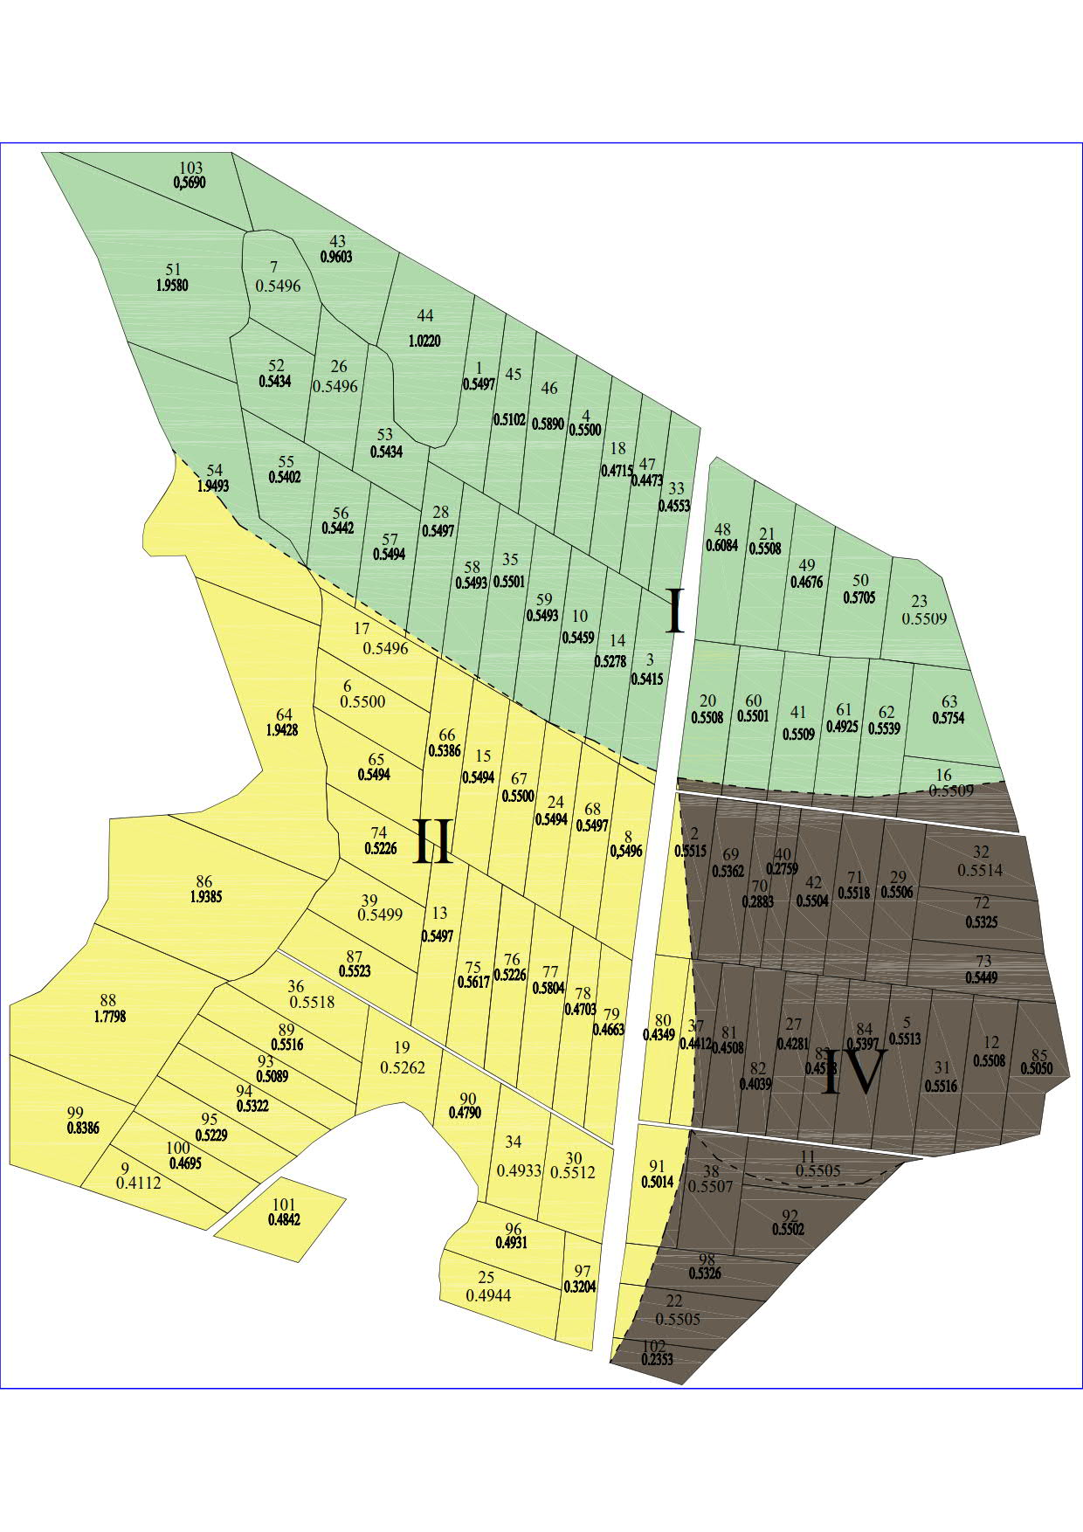
Fig. 5. Formation of homogeneous land masses based on soil suitability for winter wheat
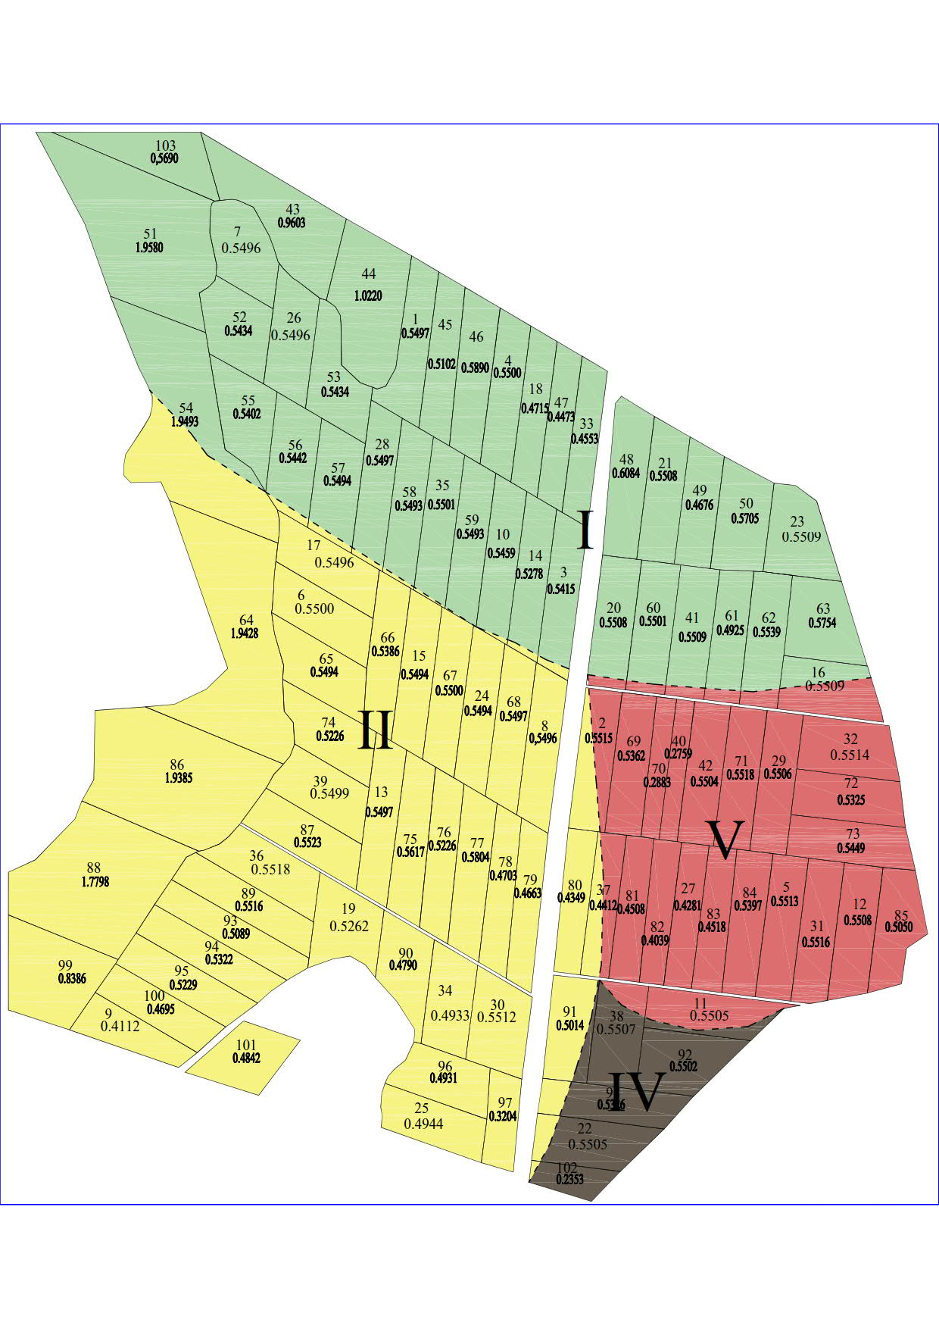
Fig. 6. Formation of homogeneous land masses based on soil suitability for winter rye

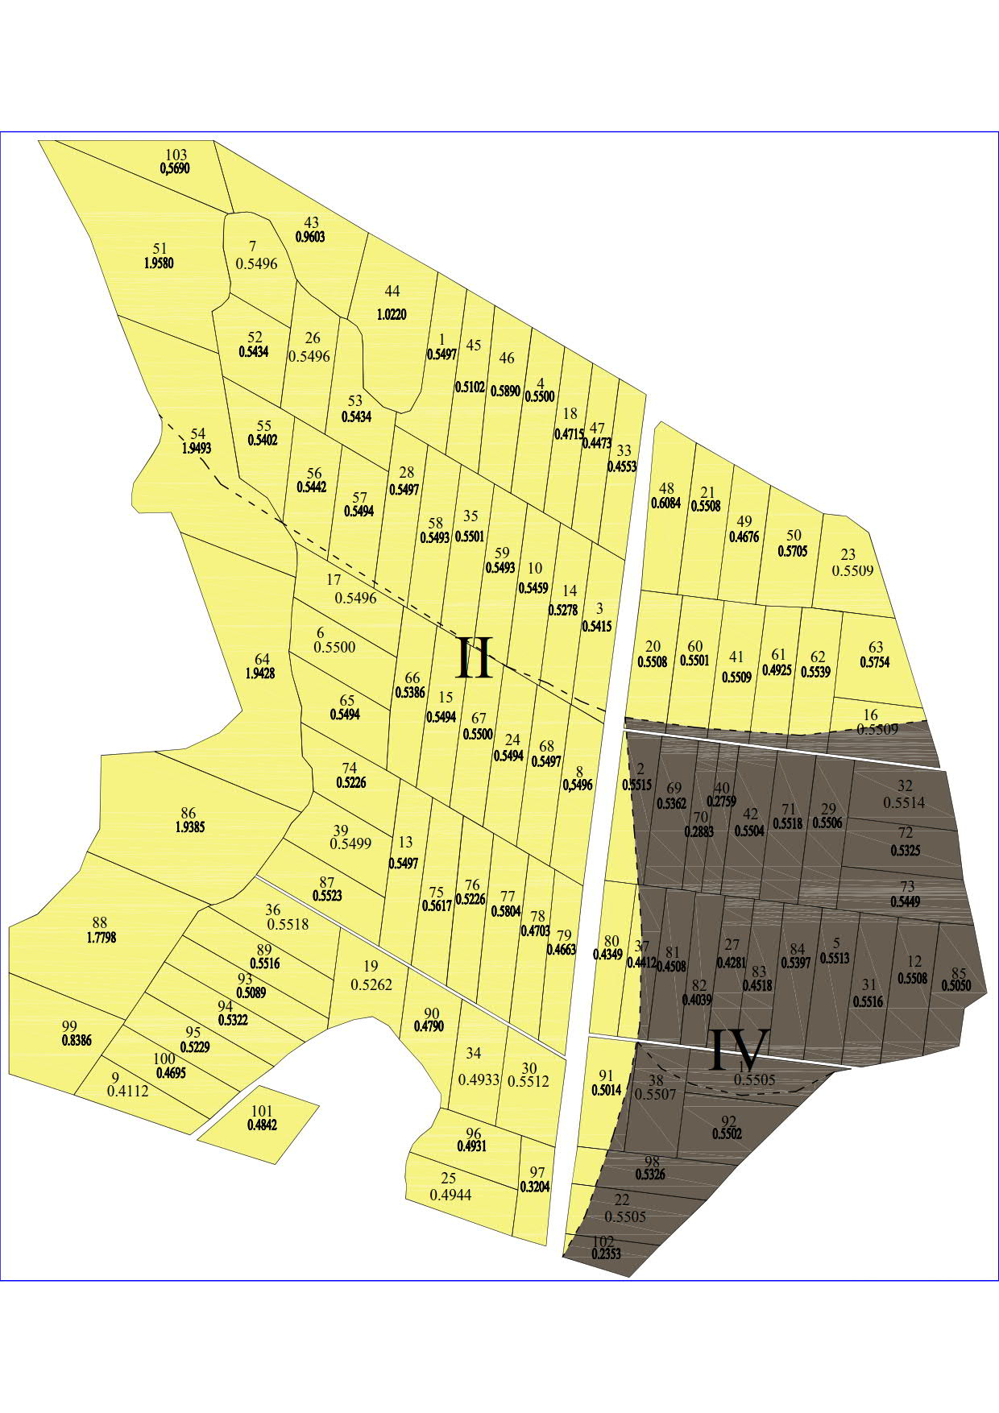
Fig. 7. Formation of homogeneous land masses based on soil suitability for maize
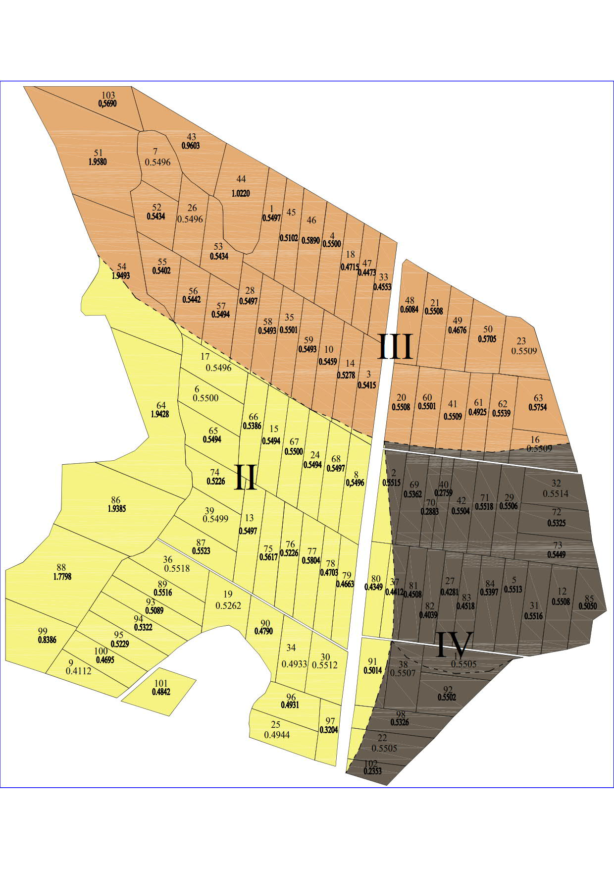
Fig. 8. Formation of homogeneous land masses based on soil suitability for sunflower

Conclusions and perspectives. The analysis of land management studies and the results of our own research confirm the view that the type and scope of agricultural land use is influenced by a number of factors: constitutional requirements for the system of society, property rights, business opportunities, individual access to land, and land management. The state and society influence agricultural land use through laws and regulations.

Land consolidation in Ukraine is an important tool for solving the problems of land fragmentation, increasing the efficiency of land use and ensuring sustainable development of territories. An analysis of the current state of Ukraine's land fund shows an urgent need to improve the regulatory framework, introduce modern methods of land management and integrate the interests of owners, tenants and local communities.
The implementation of consolidation measures will contribute to the rational use of land, increase the economic productivity of the agricultural sector, preserve the ecological balance and strengthen social stability in rural areas. Important prerequisites for the success of this process are the active participation of communities, transparency of procedures and the use of modern technologies for land planning and management.
The recommendations offered in this article can serve as a basis for improving approaches to land consolidation in Ukraine, increasing its efficiency and ensuring long-term positive consequences for territorial communities and the state as a whole.
Rationalisation of the tenure structure can help protect the environment and contribute to better land use planning and management. Land consolidation can help resolve potential conflicts over changes in land use.
It is substantiated that land consolidation is a set of legal, socio-economic and environmental measures aimed at optimising the size and location of land plots, creating favourable conditions for business entities, which are carried out with a view to organising the rational and most efficient use of land in the interests of the owner or land user and society as a whole.
It is found that the main forms of consolidation of agricultural land are lease, exchange of land plots, etc. Lease ensures effective involvement of land resources in productive agricultural turnover.
The company exchanged leasehold interests in two bordering land plots of Agro-S LLC and JV Niva Pereyaslovshchyny LLC. The number of land plots of Agro-S LLC before the consolidation was 42 land plots (22.1252 ha), after the consolidation - 45 land plots (22.7253 ha). Homogeneous land plots were also formed according to the suitability of the soil for growing major crops, such as winter wheat, winter rye, corn, sunflower, where classes I and II are the most suitable, and classes IV and V are not suitable for growing.
When exchanging unequal plots (in terms of area or quality of land), one party pays the difference between their value to the other party in accordance with the exchange agreement they have concluded.

References
1. Dobriak, D, Kanash, O, Rozumnyi, I. (2001). Klasyfikatsiia ta ekolohobezpechne vykorystannia silskohospodarskykh zemel [Classification and environmentally friendly use of agricultural land]. Kyiv: Instytut zemleustroiu UAAN [in Ukrainian].
2. Legal guide on land consolidation. FAO, 2020. https://doi.org/10.4060/ca9520en
3. Popov, A. (2018) Instytutsionalni zasady konsolidatsii zemel silskohospodarskoho pryznachennia: teoriia, metodolohiia, praktyka [Institutional foundations of agricultural land consolidation: theory, methodology, practice]. Lviv. https://www.researchgate.net/publication/330502260_Institucionalni_zasadi_konsolidacii_zemel_silskogospodarskogo_priznacenna_teoria_metodologia_praktika.
4. Yoakhim, T. (2021). Zemleustrii i konsolidatsiia zemel na silskykh terytoriiakh Nimechchyny [Land management and land consolidation in rural Germany]. Kyiv-Nizhyn: Lysenko M.M. [in Ukrainian].
5. Malashevskyi, M.., Buhaienko, O., Malashevska, O. (2014). Doslidzhennia faktoriv, shcho vyznachaiut napriam provedennia konsolidatsii silskohospodarskykh zemel v Ukraini [Study of factors determining the direction of agricultural land consolidation in Ukraine]. Mistobuduvannia ta terytorialne planuvannia, 51 [in Ukrainian].
6. Tretiak, A. (2002). Teoretychni osnovy zemleustroiu [Theoretical foundations of land management]. K. : IZU UAAN [in Ukrainian].
7. Shvorak, A. (2016). Konsolidatsiia zemel silskohospodarskoho pryznachennia [Dissertations for the degree of Doctor of Economics]. National University of Life and Environmental Sciences of Ukraine. Kyiv [in Ukrainian].
8. Shvorak, A. (2008). Teoretychni osnovy konsolidatsii zemel: zmist, meta, zavdannia, pryntsypy. [Theoretical foundations of land consolidation: content, purpose, objectives, principles]. Zemleustrii i kadastr., 4, 11-13 [in Ukrainian].

Кошель А.О., Колганова I.Г., Кемпа О.
До питання перспективи консолідації земель в Україні
Анотація. У статті розглянуто актуальне питання консолідації земель в Україні як інструменту підвищення ефективності землекористування та забезпечення сталого розвитку сільських територій. Проаналізовано сучасний стан земельних ресурсів, проблеми їх фрагментації та нераціонального використання, які виникли внаслідок реформування земельних відносин.
Особливу увагу приділено нормативно-правовим аспектам консолідації земель, визначенню основних перешкод для її впровадження та перспектив розвитку в умовах децентралізації. Висвітлено основні етапи та процедури консолідації, її вплив на економічні, екологічні та соціальні аспекти функціонування територій.
У роботі запропоновано рекомендації щодо вдосконалення організаційно-правового забезпечення процесу консолідації, впровадження сучасних інструментів землевпорядкування та залучення громад до планування й реалізації заходів із укрупнення земельних ділянок.
Результати дослідження можуть бути використані для підготовки проєктів землеустрою, а також у формуванні державної політики у сфері управління земельними ресурсами.
Ключові слова: консолідація земель, земельні ресурси, землевпорядкування, ефективне землекористування, охорона земель сільськогосподарського призначення, землеустрій.

